**Welcome to ATM Project Artifacts.**

**Initial Project Run.**

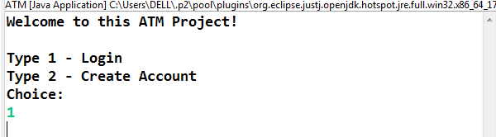

**Case 1:- Login in with wrong Account Number.**

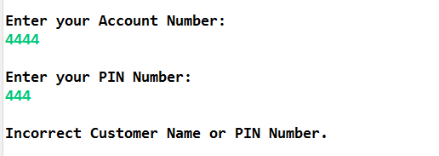

**Case 2:- Entering wrong Character.**

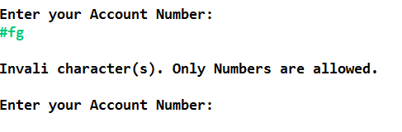

**Case 3:- Entering First Customer Credentials.**

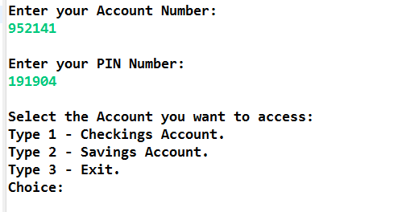

**Case 4:- First Customer Checking Account.**

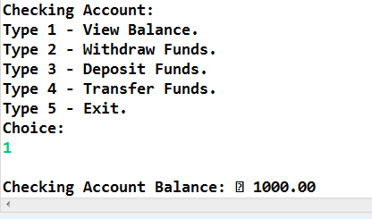

**Case 5:-**