**ASSIGNMENT-3**

**Nitheesh M**

Dataset consists of 3 Attributes → Ethnicity, Eligible, Panels:

Ethnicity describes about the ethnic categories of people in Alameda.

Eligible describes about the fraction of people eligible grouped by

ethnicity.

Panels describes about the proportion of people currently chosen for the

panel.

We have taken

Null Hypothesis: -panels were selected at random from the population of

eligible jurors.

Alternate Hypothesis: -panels were not selected at random

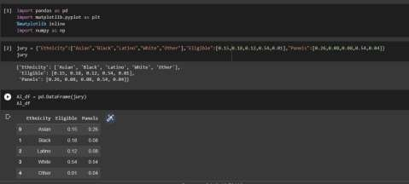

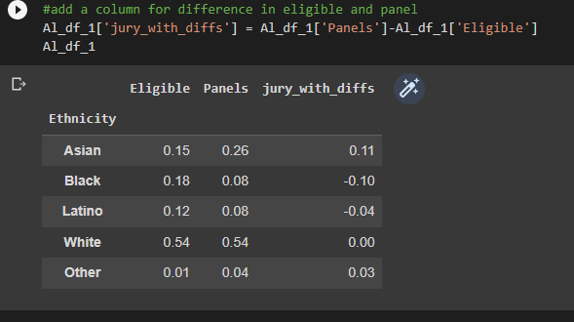

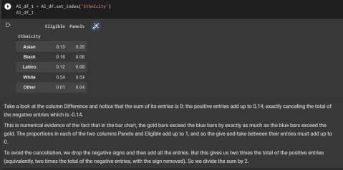

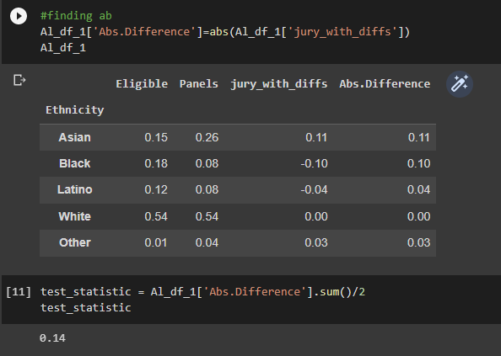

Therefore, it would only make sense logically if the number of members

selected at random that are in excess are same as the one in deficit.

14%, -14% in our case.

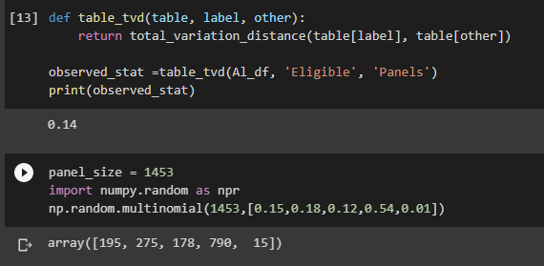

This quantity 0.14 is the total variation distance (TVD) between the

distribution of ethnicities in the eligible juror population and the

distribution in the panels.

We could have obtained the same result by just adding the positive

differences. But our method of including all the absolute differences

eliminates the need to keep track of which differences are positive and

which are not.

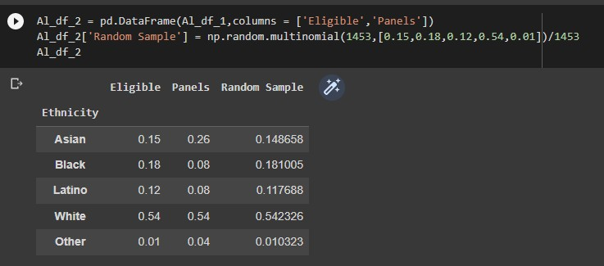

the distribution of the random sample is close to the distribution of

the eligible population and is different from the distribution of the

panels.

panel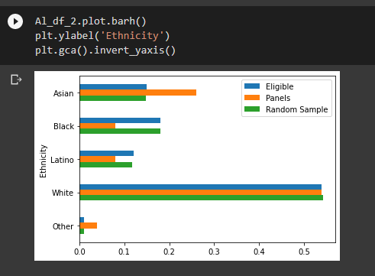

The green bar are closer in size to the blue bars than the orange bars

Are. The randomsample resembles the eligible population, but the panels

Don’t.

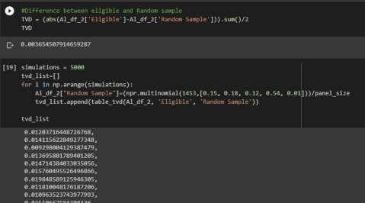

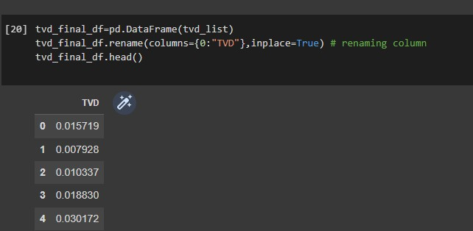

Now, we find out the Difference between Random value and the Actual

Eligible value, 0.01209222 in our case.

Repeat this task 5000 more times, and find this difference each time and

store it in a datafr.

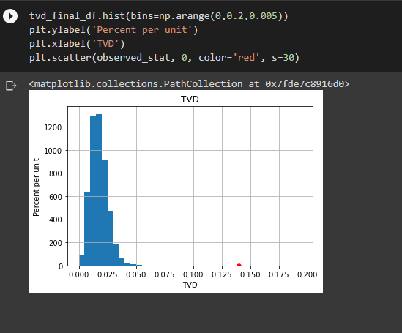

From this histogram we can see that the values what we got are far away

from the scatter plot point. By this we can say that this is because we

have sufficient proof to prove that the Alternative hypothesis turns out

to be True, meaning, there was a clear bias.

Plot a histogram to visualize such a huge data easily and also use

scatter plot to plot a point of the observed difference, and hence to

Reject our Null Hypothesis.