|  |  |  |
| --- | --- | --- |
|  | **SRI KRISHNA INSTITUTIONS**  **(AN AUTONOMOUS INSTITUTION)**  **(APPROVED BY AICTE AND AFFILIATED TO ANNA UNIVERSITY CHENNAI)**  **ACCREDITED BY NAAC WITH “A” GRADE** |  |

**SMART CLASSROOM PROJECT**

**PROJECT TITLE :** SMART CLASSROOM

**TEAM NO :** 09

**SUBMITTED BY:**

* PECHI MUTHU J

18EUMC107

* PREETHI S

18EUCS084

* NITHEESH S

18EUMC100

* RANGANAYAGI P

18EUCS090

1. **ABSTRACT :**

As the world is being developed with the new technologies,

discovering and manipulating new ideas and concepts of online education are

changing rapidly. A virtual classroom is an online classroom that allows participants

to communicate with one another, view presentations, engage with resources

in classroom. Smart Classroom makes it easy for learners and instructors to

connect inside and outside of schools and colleges. Smart Classroom saves time and paper, and makes it easy to create classes, distribute assignments, communicate,

and stay organized. The intended learning is not only in class, but also outside the classroom because students can learn wherever and whenever by accessing Smart classroom online. It consists of 3 modules: student module, teacher module, and admin module. Students can view their classroom and directly access the meet link to join their respective classes through timetable and can do their class work notes,

laboratory notes, assignment works, quizzes, ask queries in group chats, view

their mates, mark attendance, take exams and can contact their teacher through mail.

Teachers can make it easier for students to carry out learning activities. Teachers

can create a new classroom, post class work notes, laboratory notes, assignments, quizzes, clear queries in the group chats, view students, mark attendance, create

exams and can contact admin through mail.

Admin can create teachers, add teachers or even delete teacher. Admin updates timetable for all the classes. The intended learning is not only in class, but also outside the classroom because students can learn wherever and whenever by accessing Smart classroom online.

1. **EXISTING SYSTEMS:**

* In the existing system there is no attendance system so that the users have to use an external application (manual attendance or Google forms- <https://docs.google.com/forms/u/0/> )
* There is no exam portal so that the users have to use an external application (Examly - <https://examly.io/>, Toppr - <https://www.toppr.com/> )
* There is no quiz portal so that the users have to use an external application. (Quizizz - <https://quizizz.com/join> )
* There is no group chat options so that the users have to use an external application.(Whatsapp)
* Due to this lack of features and feasibility the user has to search for another application every time to do the work.
* Taking into consideration of some issues or any kind of the user’s situation they can’t use the applications in existing system precisely. Thus, resulting in incapacitate the users.

1. **PROPOSED SYSTEMS:**

* In the proposed system there is an attendance management system developed within the application so that the users don’t need to use an external application.

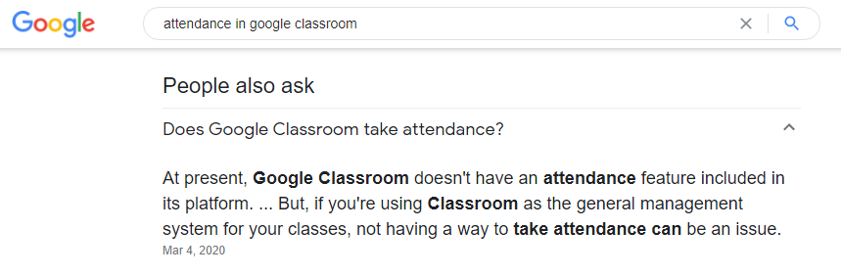

* An exam portal with web cam monitoring is developed within the application using deep learning in JAVA.

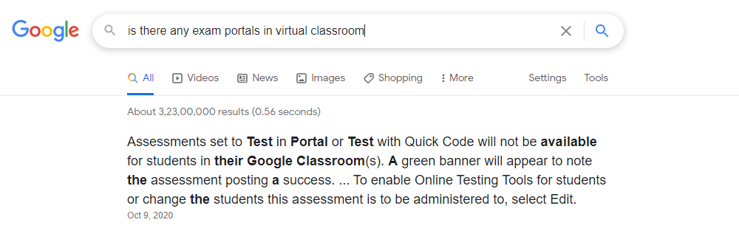

* A group chat facility is developed and incorporated within the application.

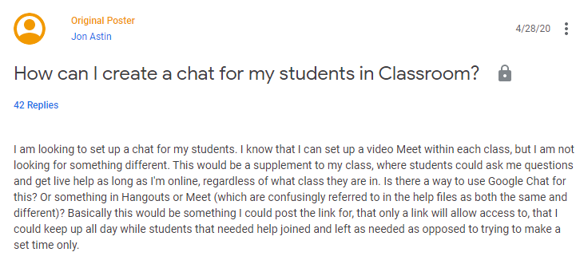

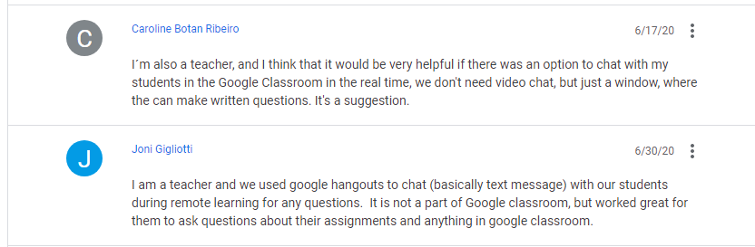

* Due to this lack of features and feasibility the user has to search for another application every time to do the work.
* Timetable is created which connects g-meet and the classrooms.

1. **SYSTEM DESIGNS:**

**STUDENT MODULE:**

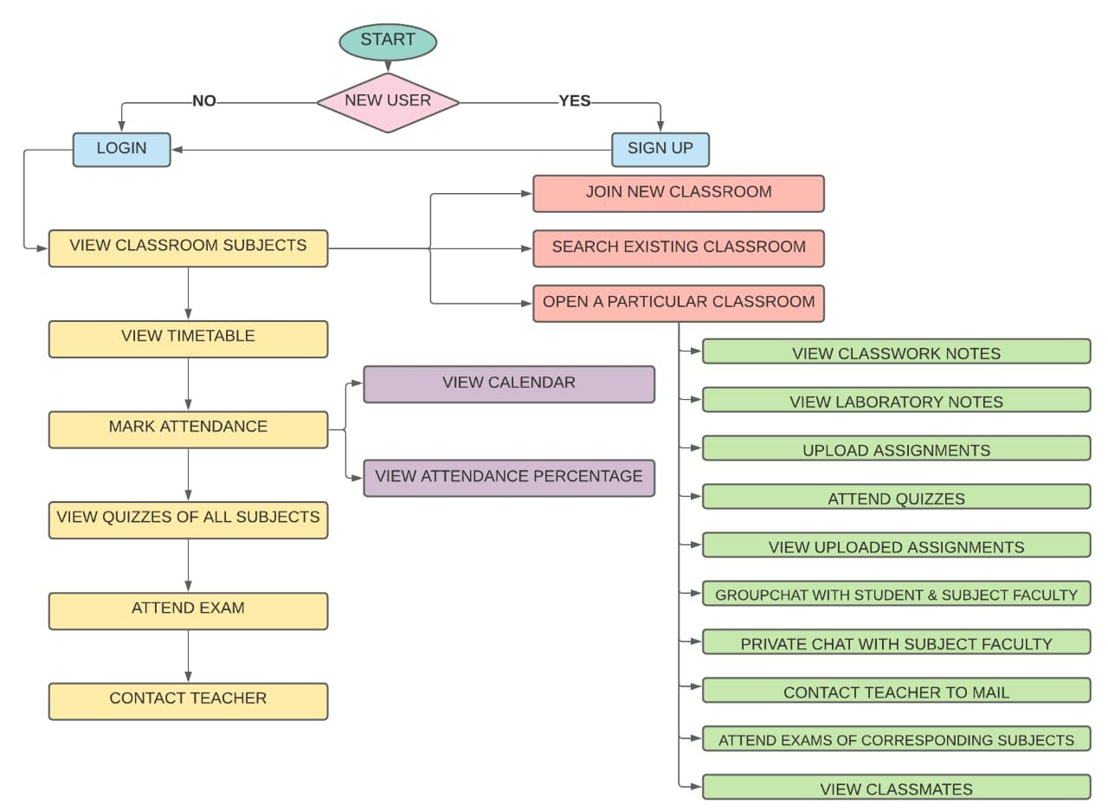

**TEACHER MODULE:**

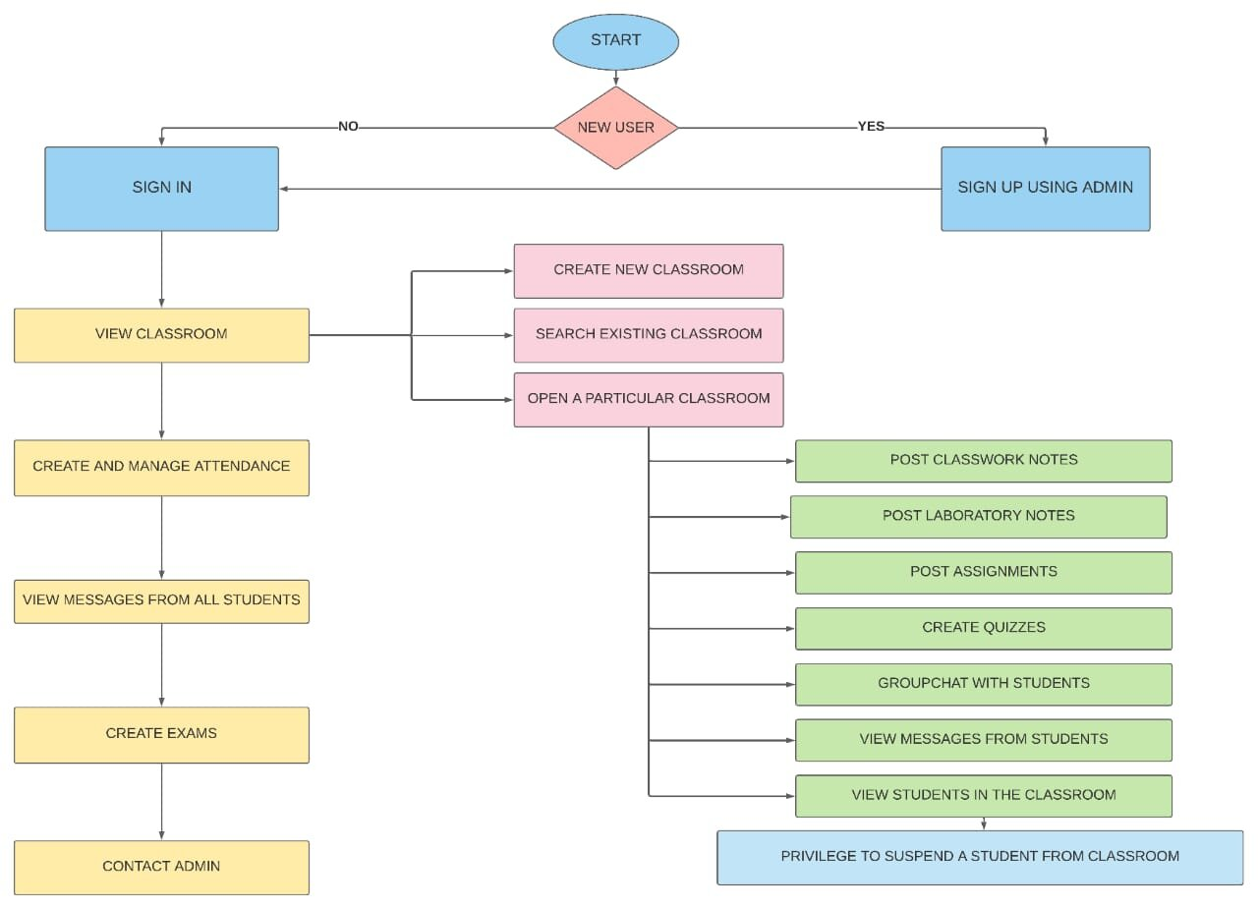

**ADMIN MODULE:**

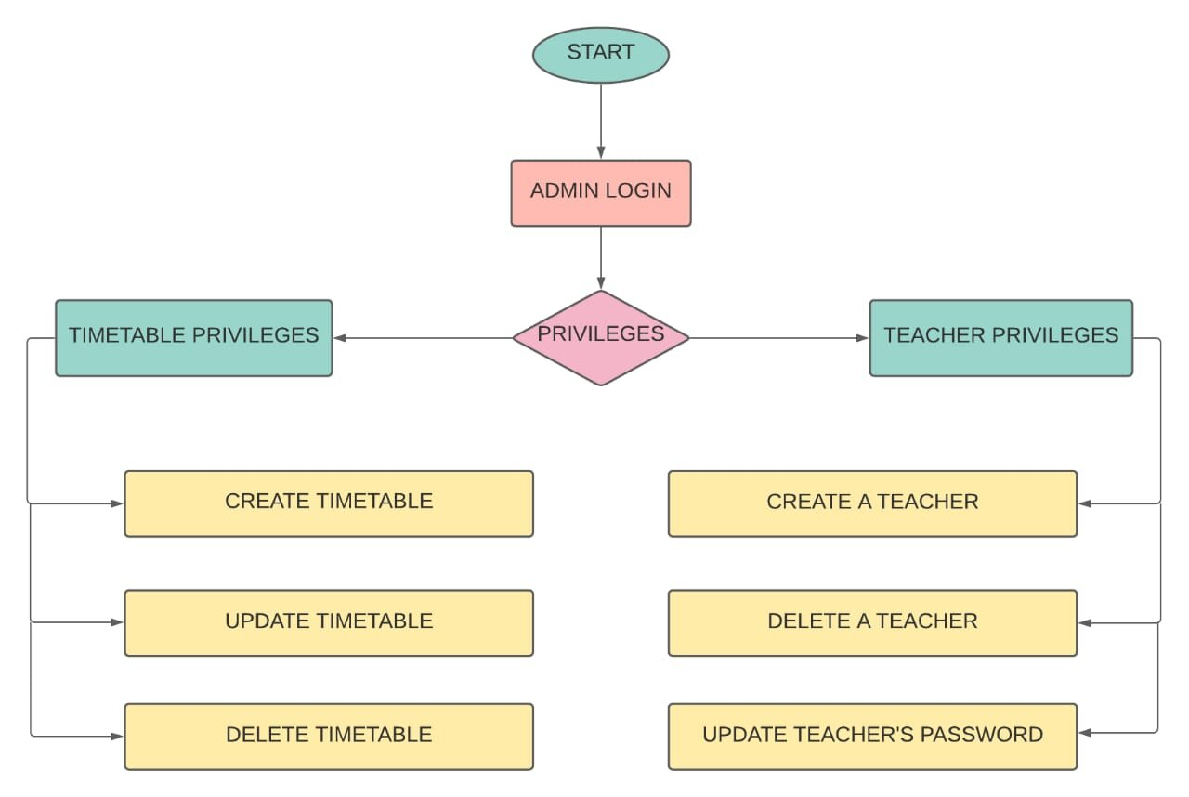

1. **SAMPLE SCREENSHOTS:**

**GROUP CHAT:**

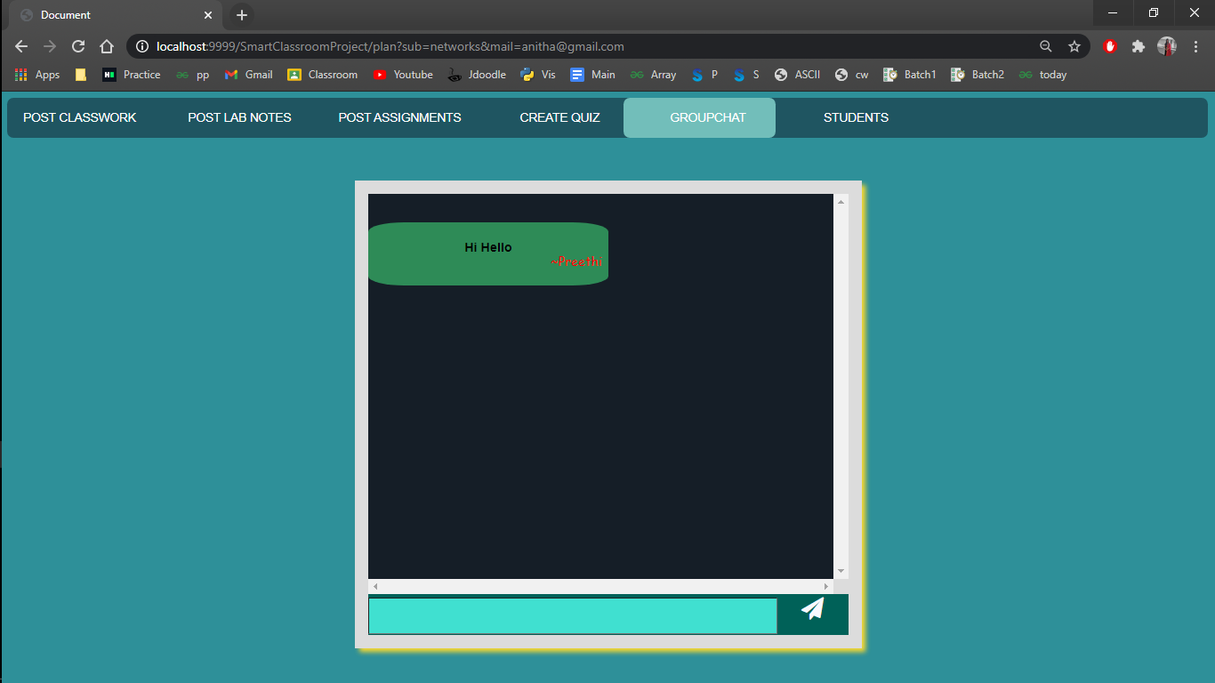

**ATTENDANCE SYSTEM:**

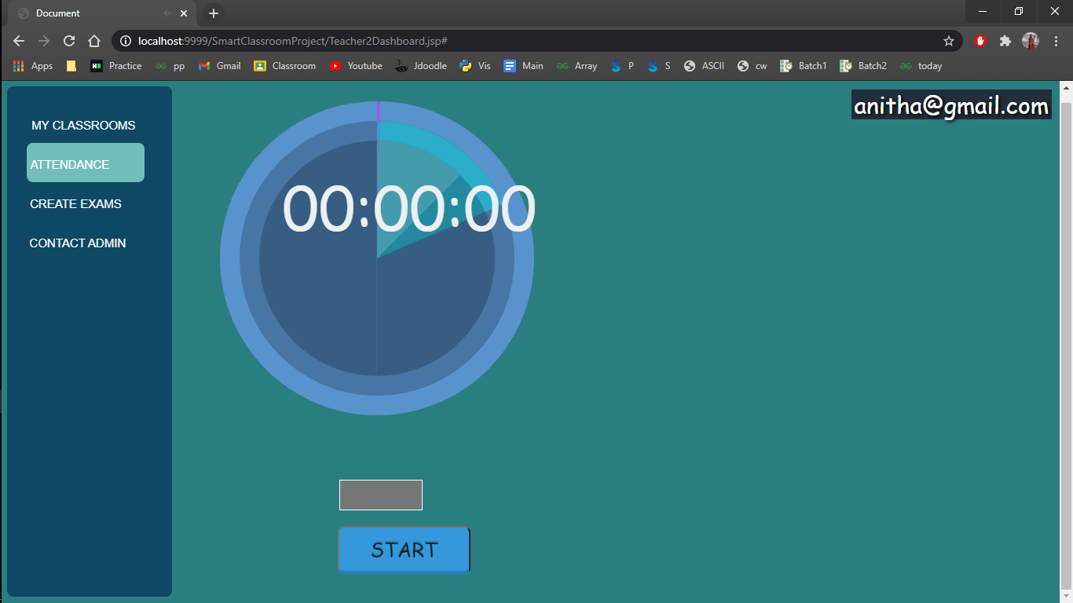

**EXAM PORTAL:**

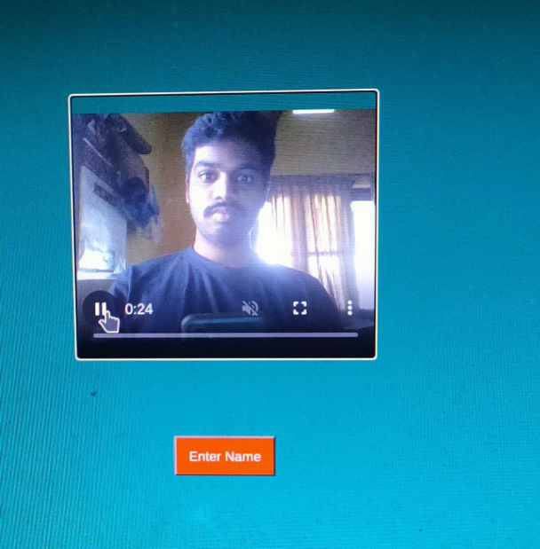

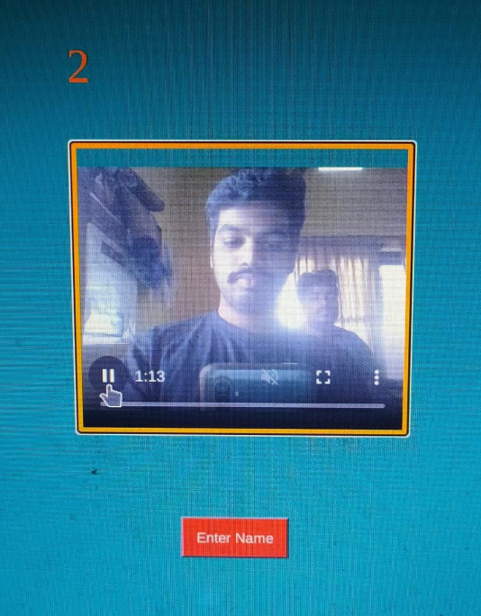

1. **ALGORITHM & PSEUDO CODE:**

**ATTENDANCE MODULE :**

**Step 1:** The Teacher will generate code to submit attendance

**Step 2:** Code will be displayed for student for 30 seconds

**Step 3:** if (student enrolled in classroom ) AND (Code is Valid) AND (Code is Not expired))

Student is marked as present

else

Invalid Code

**Step 4:**  if (time expired) && (Attendance not responded)

Student marked as absent

else

Student marked as present

**GROUP CHAT :**

**Step 1:**  The Teacher Generate Room Code

**Step 2:**  Code will be displayed for student

**Step 3:**  if (student enrolled in classroom ) AND (Code is Valid) AND (Code is Not Expired) AND (Exam is not yet Taken))

Student redirected to Exam page

else

Invalid Code

**TARGET CONSUMER:**

Target consumers of virtual classroom are schools, colleges, offices.

Consumers are admin, students, teachers, team lead, team members etc.

Smart classroom is better than other virtual classroom because

* + It has it’s own attendance system.
  + It has it’s own group chat system.
  + It has it’s own exam portal.

1. **FUTURE REFINEMENTS:**

* As of now group chats are stored in the server, based on future security issues, security can be improved for group chats
* Timed MCQ’s will be added in future to conduct small class tests.
* Quiz portal is now implemented will the help of google forms, in future a separate portal will be developed.
* Analysis of work done should be made visible to the students which urges them to complete the work as soon as possible.