***FOOD WAY***

**A Micro Project Report**

**Submitted by**

**M.NITHEESH KUMAR**

**Reg.no: 99220040322**

**B.Tech - CSE,**

**AIML**



## Kalasalingam Academy of Research and Education

**(Deemed to be University)**

**Anand Nagar, Krishnankoil - 626 126**



**SCHOOL OF COMPUTING**

**DEPARTMENT OF COMPUTER SCIENCE AND ENGINEERING**

# BONAFIDE CERTIFICATE

Bonafide record of the work done by [M.NITHEESH KUMAR] - [99220040322] in partial fulfillment of the requirements for the award of the degree of Bachelor of Technology in Specialization of the Computer Science and Engineering, during the Academic Year [Even/Odd] Semester (2023-24)

|  |  |
| --- | --- |
| **Ms.S.Sujitha**  **Project Guide** | **Mr.Gnana Kumar**  **Faculty Incharge** |
| **Associate Professor** | **Associate Professor** |
| **CSE** | **CSE** |
| **Kalasalingam Academy of** | **Kalasalingam Academy of** |
| **Research and Education** | **Research and Education** |
| **Krishnan kovil – 626126** | **Krishnan kovil - 626126** |

**Mrs.S.Reshini**

**Evaluator**

**Associate Professor**

**CSE**

**Kalasalingam Academy of**

**Research and Education**

**Krishnan kovil - 626126**

# Abstract

In the era of digitalization, the food industry has witnessed a significant transformation with the emergence of online food ordering platforms. "Food Way" is a web-based application developed using HTML, CSS, and JavaScript, aiming to simplify the process of ordering food from various restaurants. This project seeks to enhance user convenience by providing a seamless and intuitive interface for browsing menus, placing orders, and facilitating secure online payments. Through innovative design and functionality, Food Way endeavors to revolutionize the way customers interact with food establishments, bridging the gap between consumers and their favorite cuisines.

# Contents

1. **PROJECT OVERVIEW 1**
   1. INTRODUCTION . . . . . . . . . . . . . . . . . . . . . . . . . . . . . . . . . . . 1
   2. KEY HIGHLIGHTS OF THE PROJECT . . . . . . . . . . . . . . . . . . . . . . 1
   3. OBJECTIVE . . . . . . . . . . . . . . . . . . . . . . . . . . . . . . . . . . . . . . 2
2. **PROJECT FRAMEWORK AND EXECUTION 4**
   1. TECH STACK . . . . . . . . . . . . . . . . . . . . . . . . . . . . . . . . . . . . . 4
      1. CSS (Cascading Style Sheets): . . . . . . . . . . . . . . . . . . . . . . . . 4
   2. TIMELINE OF WORK PROPOSAL . . . . . . . . . . . . . . . . . . . . . . . . . 5
   3. STEP BY STEP PROCESS . . . . . . . . . . . . . . . . . . . . . . . . . . . . . . 5
      1. Project Planning . . . . . . . . . . . . . . . . . . . . . . . . . . . . . . . . 5
      2. Design Phase . . . . . . . . . . . . . . . . . . . . . . . . . . . . . . . . . . 6
      3. Development Setup . . . . . . . . . . . . . . . . . . . . . . . . . . . . . . . 6
      4. Build the Website . . . . . . . . . . . . . . . . . . . . . . . . . . . . . . . 6
      5. Testing . . . . . . . . . . . . . . . . . . . . . . . . . . . . . . . . . . . . . 7
      6. Deployment . . . . . . . . . . . . . . . . . . . . . . . . . . . . . . . . . . 7
      7. Maintenance and Updates . . . . . . . . . . . . . . . . . . . . . . . . . . . 7
      8. Promotion . . . . . . . . . . . . . . . . . . . . . . . . . . . . . . . . . . . . 7
3. **IMPLEMENTATION DETAILS 8**
   1. Source code . . . . . . . . . . . . . . . . . . . . . . . . . . . . . . . . . . . . . . . 8
      1. HTML . . . . . . . . . . . . . . . . . . . . . . . . . . . . . . . . . . . . . . 8
      2. CSS . . . . . . . . . . . . . . . . . . . . . . . . . . . . . . . . . . . . . . . 11
      3. JAVASCRIPT . . . . . . . . . . . . . . . . . . . . . . . . . . . . . . . . . 13

CONTENTS CONTENTS

1. **Conclusion and Future Work 17**
   1. CONCLUSION . . . . . . . . . . . . . . . . . . . . . . . . . . . . . . . . . . . . . 17
2. **References 19**
3. **Certification 20**

**Chapter 1**

# PROJECT OVERVIEW

## INTRODUCTION

In today's fast-paced world, the demand for online food ordering platforms is on the rise. Recognizing this trend, Food Way emerges as a solution to streamline the food ordering process for both customers and restaurants alike. Through an interactive and user-friendly interface, Food Way aims to bridge the gap between food enthusiasts and eateries, providing a digital platform where users can explore a plethora of culinary options and place orders effortlessly. This project utilizes HTML, CSS, and JavaScript to create an engaging online environment that caters to the evolving needs of modern consumers.

## KEY HIGHLIGHTS OF THE PROJECT

* User-friendly Interface: Food Way boasts an intuitive interface designed to enhance user experience and ease of navigation, ensuring seamless browsing and ordering.
* Comprehensive Restaurant Listings: The platform offers a diverse selection of restaurants, complete with detailed menus, pricing, and customer reviews, empowering users to make informed decisions.
* Secure Payment Gateway: Food Way integrates a secure payment gateway to facilitate safe and hassle-free transactions, instilling confidence in users while making online purchases.
* Responsive Design: The project is optimized for various devices, including smartphones, tablets, and desktops, ensuring accessibility and usability across multiple platforms.

HTML forms the backbone of the project, providing the structure and layout for displaying tasks, lists, and other essential elements of the to-do list application. With HTML, the project ensures accessibility and compatibility across different devices and web browsers, allowing users to access their to-do lists from anywhere with an internet connection.

CSS plays a crucial role in the project by styling the HTML elements, enhancing the visual appeal, and creating a cohesive user experience. Through CSS, the project achieves consistency in design, customization options, and responsiveness, ensuring that the to-do list application is both aesthetically pleasing and user-friendly.

JavaScript brings interactivity and functionality to the TO DO LIST PROJECT, enabling features such as task creation, editing, deletion, and real-time updates. With JavaScript, the project delivers a dynamic user experience, allowing users to interact with their tasks seamlessly and efficiently. Additionally, JavaScript facilitates the implementation of advanced features such as task prioritization, deadline reminders, and progress tracking, further enhancing the productivity capabilities of the to-do list application.

Overall, the key highlight of the TO DO LIST PROJECT lies in its holistic integration of HTML, CSS, and JavaScript to create a robust, user-friendly, and feature-rich task management platform that empowers users to organize their tasks effectively and accomplish their goals with ease.

1.3. OBJECTIVE Chapter 1. PROJECT OVERVIEW

## 1.3 OBJECTIVE

1. The primary objective of the Food Way project is to revolutionize the food ordering experience by leveraging web technologies to create a user-centric platform. Specifically, the project aims to:
2. Simplify the process of ordering food online, eliminating the need for traditional methods such as phone calls or in-person visits.
3. Provide users with a wide range of restaurant options, catering to diverse culinary preferences and dietary requirements.
4. Enhance convenience and efficiency through features such as order tracking, personalized recommendations, and secure payment processing.
5. Foster growth and collaboration within the food industry by offering restaurants a digital platform to showcase their offerings and connect with a broader customer base.
6. Promote Sustainability: Partner with eco-friendly restaurants and promote sustainable practices such as packaging reduction, locally sourced ingredients, and waste minimization, contributing to environmental conservation efforts.
7. Support Small Businesses: Provide a platform for small and local eateries to reach a wider audience, helping them thrive in competitive markets and promoting economic growth within communities.
8. Enhance Accessibility: Ensure accessibility for users with disabilities by implementing features such as screen reader compatibility, keyboard navigation, and alt text for images, fostering inclusivity and equal access to food ordering services.
9. Data Analytics and Insights: Utilize data analytics tools to gather insights into user behavior, preferences, and trends, enabling continuous improvement of the platform and personalized recommendations for users and restaurants.
10. Seamless Integration: Collaborate with third-party delivery services and restaurant management systems to offer seamless integration, optimizing order fulfillment processes and enhancing overall efficiency for both users and restaurant owners.

**Chapter 2**

**PROJECT FRAMEWORK AND**

# EXECUTION

## 2.1 TECH STACK

**HTML (HyperText Markup Language):**

HTML forms the backbone of the website’s structure, defining the content and layout of web

pages.

It provides the framework for organizing text, images, forms, and other elements in a structured manner.

**2.1.1 CSS (Cascading Style Sheets):**

CSS is used for styling and formatting the visual presentation of the website.

It enables the customization of fonts, colors, layouts, and other design aspects to create anaesthetically pleasing and user-friendly interface.

CSS frameworks like Bootstrap or Materialize CSS can be utilized to streamline frontend development and ensure responsiveness across different devices and screen sizes.

JavaScript: javaScript adds interactivity and dynamic behavior to the website, enhancing user engagementand functionality.

It is used for implementing features such as form validation, interactive maps, dynamic conChapter 2. PROJECT FRAMEWORK AND EXECU2.T2.IOTNIMELINE OF WORK PROPOSAL

tentupdates, and client-side scripting.

JavaScript libraries like React.js can be employed to build reusable components and manage state more efficiently, simplifying frontend development and improving performance

## 2.2 TIMELINE OF WORK PROPOSAL

1. Week 1: Define project scope, objectives, and requirements.Conduct initial research on wastemanagement practices, donation platforms, and relevant technologies.
2. Week 2: Design wireframes and mockups for the website’s user interface, incorporatingfeedback from stakeholders.Create a detailed design document specifying color schemes, typography, layout structures, and interactive elements.Plan frontend architecture, componenthierarchy, and data flow for optimal performance and scalability.
3. Week 3: Begin frontend development using HTML, CSS, and JavaScript, adhering to thedesign specifications and best practices.Implement responsive design techniques to ensure compatibility across various devices and screen sizes.Integrate interactive features such as forms,maps, and dynamic content using JavaScript and frontend libraries
4. Week 4: Conduct regular testing and debugging to identify and resolve any issues or inconsistencies in the frontend codebase
5. Week 5: Document the project architecture, codebase, APIs, and deployment process forfuture reference and maintenance

## 2.3 STEP BY STEP PROCESS

### 2.3.1 Project Planning

1. Define Objectives: Clearly outline what you want your website to achieve.
2. Research: Look into similar websites for inspiration and best practices.
3. Identify Target Audience: Understand who your users will be (Working people,Time management persons).

2.3. STEP BY STEP PROCESS Chapter 2. PROJECT FRAMEWORK AND EXECUTION

### 2.3.2 Design Phase

1. Sketch Wireframes: Draft the basic layout of your web pages (homepage, listing page, contactform).
2. Create Mockups: Use design tools to create detailed mockups of your website.
3. Choose Color Scheme and Fonts: Select colors and fonts that reflect the classic car niche.

### 2.3.3 Development Setup

1. Select Development Tools: Choose the code editor (e.g., VS Code) and other tools you’ll use.
2. Organize File Structure: Create a clean directory structure for your HTML, CSS, and

JavaScript files.

### 2.3.4 Build the Website

**HTML Structure** a) Homepage: Develop the HTML structure, focusing on semantic elements for better SEO.

1. Listing Pages: Create the HTML for car listings, including placeholders for images, descrip-tions, and details.
2. Contact Form: Add a form for buyers to contact sellers or make inquiries.

**CSS Styling**

1. Global Styles: Define global styles for body, headers, and paragraphs.
2. Responsive Design: Use media queries to ensure your website looks good on all devices.
3. UI Components: Style buttons, forms, and navigation elements for a cohesive look.

J**avaScript Functionality**

1. Dynamic Content: Write JavaScript to dynamically load food listings from an array or externaldatabase.
2. Search and Filter: Implement search and filter capabilities to help users find foods from various servers.
3. Form Validation: Add client-side validation to the contact form to ensure data integrity.

Chapter 2. PROJECT FRAMEWORK AND EXECUTION 2.3. STEP BY STEP PROCESS

### 2.3.5 Testing

1. Cross-Browser Testing: Check your website in different browsers (Chrome, Firefox, Safari)for compatibility.
2. Responsive Testing: Test on various devices to ensure the layout adjusts correctly.
3. Functionality Testing: Ensure all interactive elements work as intended (e.g., search, contactform submission).

### 2.3.6 Deployment

1. Choose a Hosting Provider: Select a platform to host your website (e.g., GitHub Pages,

Netlify).

1. Upload Your Website: Use FTP or your host’s deployment tools to upload your website files.
2. Domain Name: Consider purchasing a custom domain name and linking it to your hosted

site.

### 2.3.7 Maintenance and Updates

1. Feedback: Gather user feedback for potential improvements.
2. Update Content: Regularly update the latest food to keep the site fresh.
3. Monitor Performance: Use tools like Google Analytics to monitor site traffic and user behav-

ior.

### 2.3.8 Promotion

1. SEO Optimization: Optimize your site for search engines to improve visibility.
2. Social Media: Promote your website on social media and related forums to attract users.

**Chapter 3**

# IMPLEMENTATION DETAILS

## 3.1 Source code

**3.1.1 HTML:**

<!DOCTYPE html>

<html >

<head>

<title>FOOD WAY</title>

<link rel="stylesheet" href="style.css">

<link rel="stylesheet" href="https://cdnjs.cloudflare.com/ajax/libs/font-awesome/5.15.1/css/all.min.css">

</head>

<body>

<nav class="navbar target">

<a href="file:///C:/Porject%201%20-%20Foods/Final%20Files/index.html" class="navbar-link">

<i class="fas fa-home"></i>

<span>Home</span>

</a>

<a href="#" class="navbar-link">

<i class="fas fa-utensils"></i>

<span>Meals</span>

</a>

<a href="#" class="navbar-link">

<i class="fas fa-hamburger"></i>

<span>Burger</span>

</a>

<a href="#" class="navbar-link">

<i class="fas fa-pizza-slice"></i>

<span>Pizza</span>

</a>

<a href="#" class="navbar-link">

<i class="fas fa-blender-phone"></i>

<span>Contact</span>

</a>

</nav>

<div class="menu target"></div>

<div class="container">

<section class="section-1">

<h1 class="section-heading">variety of foods</h1>

<div class="section-1-icons">

<i class="change fas fa-egg"></i>

<i class="fas fa-stroopwafel"></i>

<i class="fas fa-cheese"></i>

<i class="fas fa-hotdog"></i>

<i class="fas fa-drumstick-bite"></i>

<i class="fas fa-apple-alt"></i>

<i class="fas fa-ice-cream"></i>

<i class="fas fa-fish"></i>

<i class="fas fa-cookie"></i>

<i class="fas fa-seedling"></i>

</div>

</section>

<section class="section-2">

<h1 class="section-heading">popular meals</h1>

<div class="cards-container">

<div class="card">

<img src="images/card-img-1.png" class="card-img" />

<h3 class="card-name">Fish</h3>

<button class="card-btn"><a href="https://www.freshma.in/" class="order-btn">Order now</a></button>

</div>

<div class="card">

<img src="images/card-img-2.png" class="card-img" />

<h3 class="card-name">Cake</h3>

<button class="card-btn"><a href="https://www.fnp.com/cakes-lp?s_kwcid=AL!14757!10!75041813598324!72843451854695&msclkid=2a0d603f425f180d9e5205c70fe98fab" class="order-btn">Order now</a></button>

</div>

<div class="card">

<img src="images/card-img-3.png" class="card-img" />

<h3 class="card-name">Lobster</h3>

<button class="card-btn"><a href="https://dir.indiamart.com/impcat/lobster.html" class="order-btn">Order now</a></button>

</div>

</div>

</section>

<section class="section-3">

<h1 class="section-heading">Gallery</h1>

<div class="gallery">

<a href="https://99pancakes.in/" class="gallery-link" title="Order Now">

<img src="/images/gallery-img-1.jpg" class="food-img" />

<h3 class="food-name">Pancakes</h3>

<p class="food-description">

Pancakes are thin, fluffy cakes cooked on a griddle, typically enjoyed for breakfast with butter and syrup.

</p>

</a>

<a href="https://www.bakingo.com/cup-cakes" class="gallery-link" title="Order Now">

<img src="/images/gallery-img-2.jpg" class="food-img" />

<h3 class="food-name">Cupcakes</h3>

<p class="food-description">

Miniature cakes in a personal size, cupcakes come with fluffy batter and delightful frosting swirls.

</p>

</a>

<a href="https://torte.hivefoods.com/" class="gallery-link" title="Order Now">

<img src="/images/gallery-img-3.jpg" class="food-img" />

<h3 class="food-name">Dream Cake</h3>

<p class="food-description">

A trending recipe for a no-bake cake with multiple layers, made with simple ingredients like cocoa, coffee, and whipped cream.

</p>

</a>

<a href="https://www.kunafabake.com/" class="gallery-link" title="Order Now">

<img src="/images/gallery-img-4.jpg" class="food-img" />

<h3 class="food-name">Kunafa Dessert</h3>

<p class="food-description">

Kunafa is a Middle Eastern pastry made with buttery, shredded phyllo dough layered with cheese, soaked in sweet syrup, and often topped with pistachios for a delightful contrast of textures and flavors.

</p>

</a>

<a href="https://theobroma.in/collections/croissants-danishes?" class="gallery-link" title="Order Now">

<img src="/images/gallery-img-5.jpg" class="food-img" />

<h3 class="food-name">croissant</h3>

<p class="food-description">

The croissant is a flaky, buttery pastry from France. It has a crescent shape and is made from a special dough that's layered with butter. Croissants are often enjoyed for breakfast or as a sweet treat.

</p>

</a>

<a href="https://theobroma.in/collections/brownies" class="gallery-link" title="Order Now">

<img src="/images/gallery-img-6.jpg" class="food-img" />

<h3 class="food-name">Brownies</h3>

<p class="food-description">

Rich squares of chocolate heaven, brownies are dense and fudgy with a crackly top. Each bite delivers intense cocoa flavor with a melt-in-your-mouth texture.

</p>

</a>

</div>

</section>

<section class="section-4">

<div class="section-4-text">

<h2 class="section-4-heading">Sign Me Up</h2>

<p class="section-4-paragraph">

BE THE FIRST TO KNOW ABOUT NEW PRODUCTS

</p>

</div>

<form class="signup-form ">

<table>

<form>

<tr><td><input

type="email"

class="signup-form-input"

placeholder="Enter Your Email"

/>

</td></tr>

<tr><td><input

type="password"

class="signup-form-pass"

placeholder="Enter your password"></td></tr>

</form>

</table>

<button type="submit" class="signup-form-btn">

<i class="fas fa-arrow-right"></i>

</button>

</form>

<p class="copyright">CodeAndCreate &copy; All rights reserved</p>

</section>

<script src="script.js"></script>

</body>

</html>

**IMAGE OUPUT:**

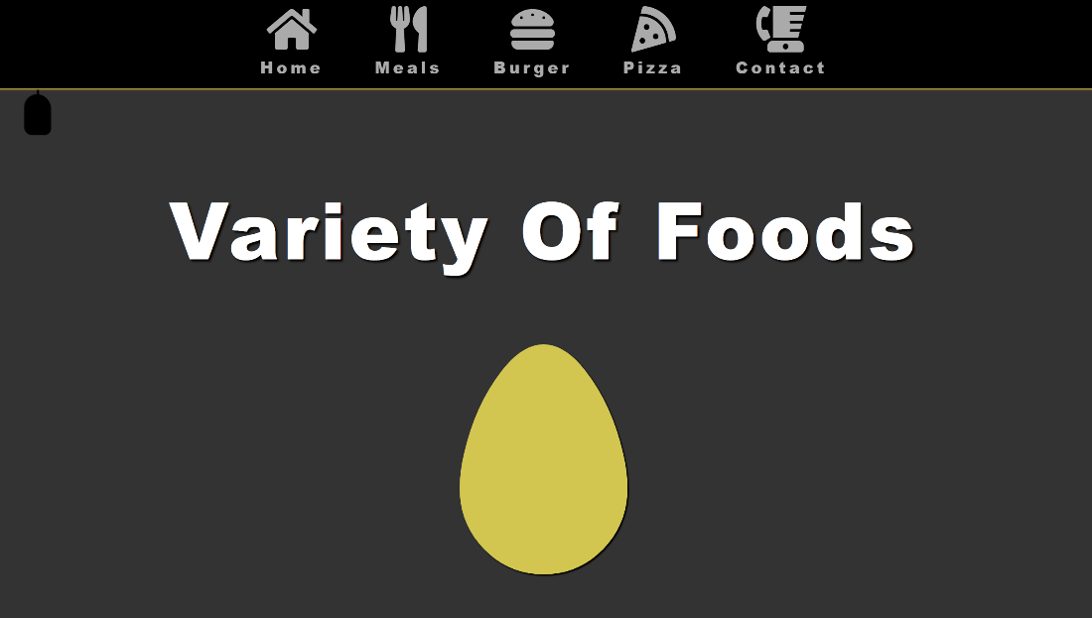

HOME PAGE

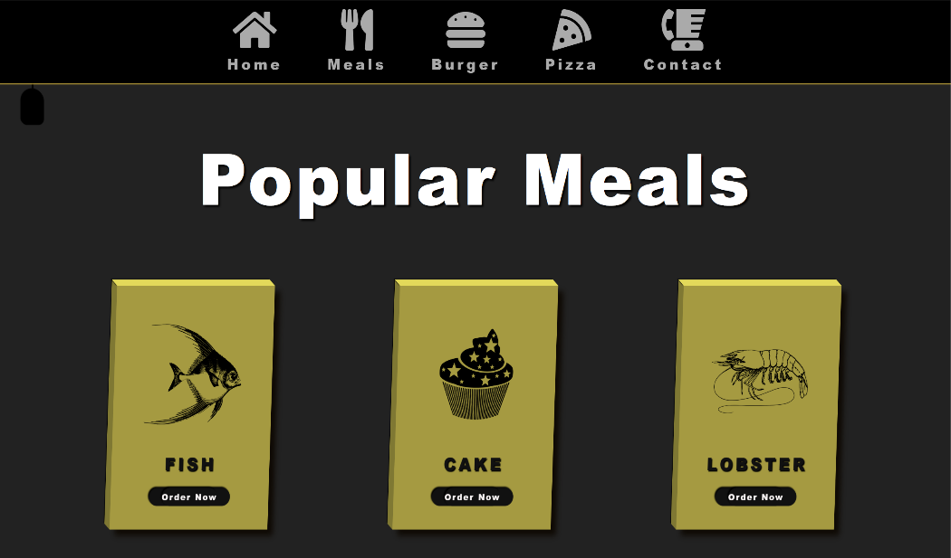

MENU MEALS

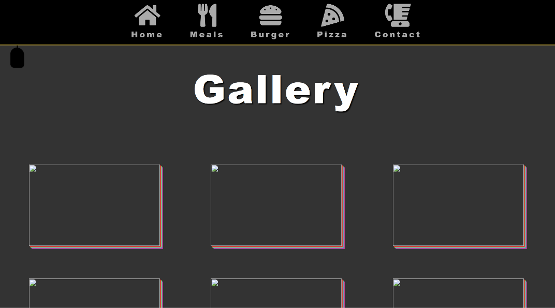

GALLERY OF DISH

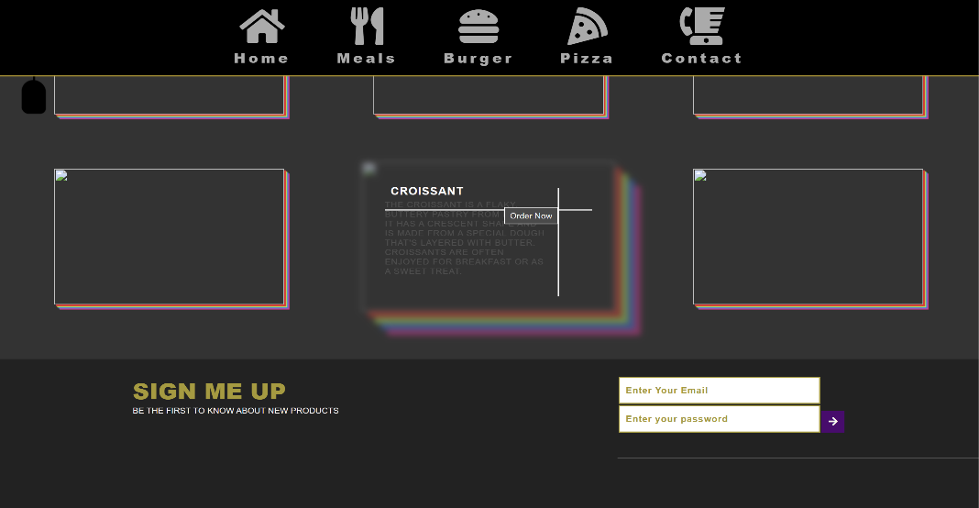

**Chapter 4**

**Conclusion and Future Work**

The Food Way food ordering project has the potential to become a valuable tool for both restaurants and users. By providing a user-friendly platform with a broad restaurant selection, real-time tracking, and convenient payment options, Food Way can streamline the ordering process and increase accessibility for diners.

Key Achievements:

Developed a robust online food ordering platform using HTML, CSS, and JavaScript.

Established a user-friendly interface for browsing menus, customizing orders, and tracking delivery progress.

Integrated secure payment processing for smooth transactions.

(Optional, if applicable) Partnered with restaurants to offer a diverse selection and potentially exclusive deals.

There's always room for improvement! Here are some potential areas to explore for future development:

* Mobile App Development
* Advanced Search and Filtering
* User Reviews and Ratings:
* Loyalty Program:
* Integration with Delivery Services:
* Restaurant Management Tools:

**Chapter 5**

# References

1. HTML Form for Waste Reporting: https://www.w3schools.com/html/html forms.asp3. JavaScript Donation Tracker: https://codepen.io/tag/donation 4. Creating Accordions with JavaScript: https://www.w3schools.com/css/tryit.asp?filename=trycss display js.
2. Bootstrap: https://getbootstrap.com/ - A popular front-end framework that provides pre-built components and styles for faster and more responsive web design.
3. Material Design: https://m3.material.io/ - A design language by Google with a focus on usability and visual consistency.
4. JavaScript libraries: Explore libraries like jQuery (https://jquery.com/) or React (https://react.dev/) for advanced functionality and code organization.

**Chapter 6**

# Certification

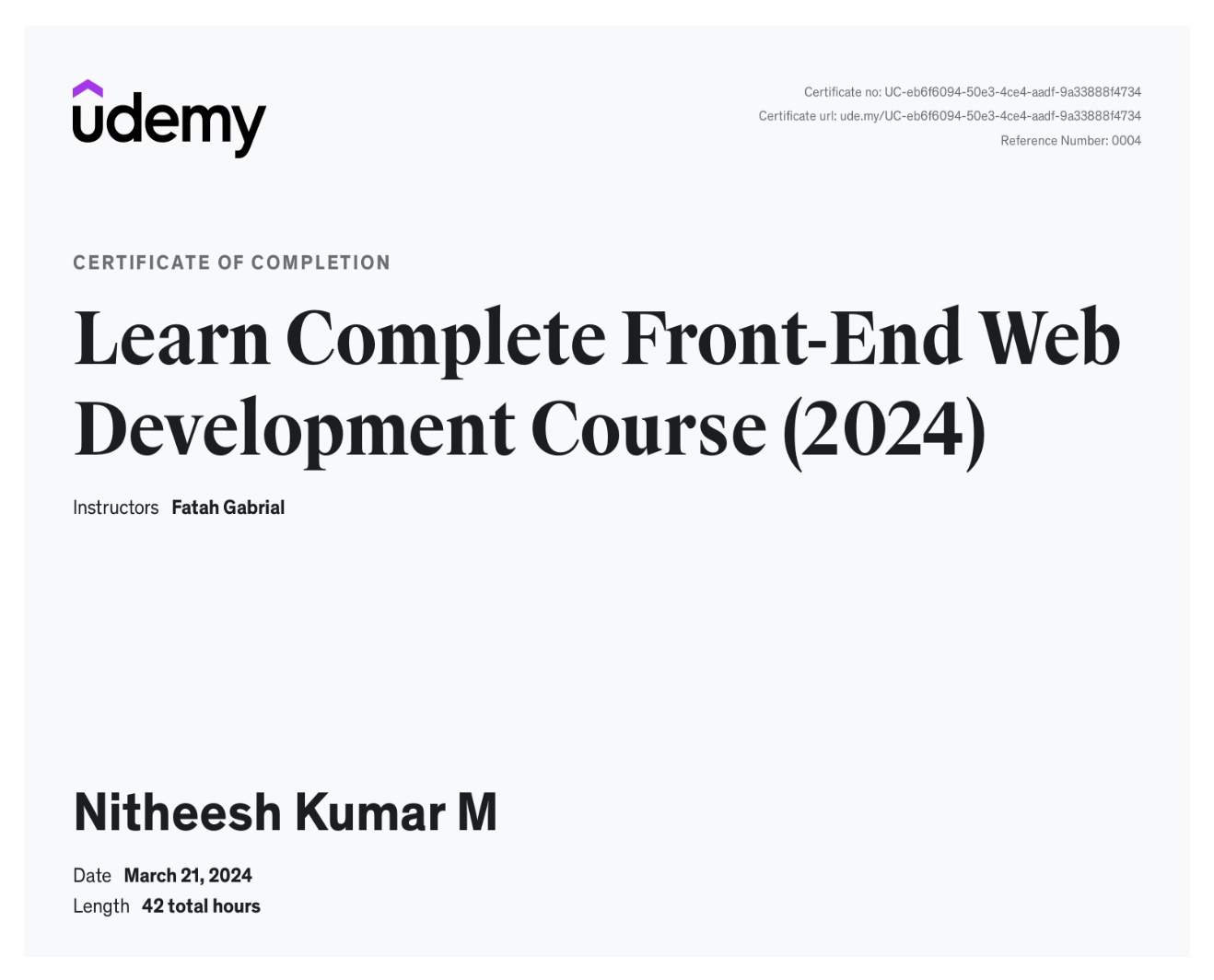 Figure 6.1: Certification details