SIMATS ENGINEERING
CSA17
Artificial Intelligence

Assessment Tool 2
Annexure A – Constraint-Based Problem Solving
Name | K Nitheesh Kumar
Register Number | 192325090
Course Name | Artificial Intelligence
Course Code | CSA17
Assessment | Assessment Tool 2 – Constraint-Based Problem Solving
Course Outcome | CO1 (BL3)
Total Marks | 10
Code of Conduct
I K Nitheesh Kumar (192325090) certify that this submission is my original work and that I have adhered to the guidelines specified for this assessment. I understand that any violation of academic integrity rules will result in disciplinary action.
Signature of the student: K Nitheesh Kumar

Constraint-Based Problem Solving: Doctor Shift Scheduling

Question
A hospital needs to assign 3 doctors (D1, D2, D3) to 3 shifts (Morning, Afternoon, Night) subject to these constraints: (i) D1 cannot work the Night shift; (ii) D2 must work before D3 (Morning < Afternoon < Night); (iii) only one doctor per shift; (iv) D3 cannot work the Morning shift; (v) all doctors must be assigned exactly one shift. Apply Backtracking Search to find a valid assignment, showing all intermediate steps and constraint checks, and state the final valid schedule.

1. Problem Understanding
This is a small Constraint Satisfaction Problem (CSP). We are not looking for the cheapest or the fastest schedule. We only need an assignment of shifts to doctors that breaks none of the five rules. Writing it in the standard CSP form makes everything clear:
CSP component | Definition for this problem
Variables | D1, D2, D3 (the three doctors)
Domain of each variable | {Morning, Afternoon, Night}, written as {M, A, N}. For comparing order, M = 1, A = 2, N = 3.
Constraints | C1: D1 ≠ N C2: shift(D2) < shift(D3) C3: D1, D2, D3 all take different shifts C4: D3 ≠ M C5: every doctor gets exactly one shift
Goal | A complete assignment that satisfies C1 to C5

How I read the wording: “D2 must work before D3” is taken to mean that D2’s shift comes earlier in the day than D3’s shift (M < A < N), as written in the bracket in the question. It does not have to be the shift right next to it. I mention at the end what changes if the stricter reading is used.
Since every doctor has exactly one shift (C5) and there are 3 doctors and 3 shifts, C3 means the schedule is simply a way of arranging the three shifts among the three doctors, so there are only 3! = 6 possible schedules in total.

2. Constraint Analysis
Before searching, I sorted the constraints by type, because this tells us when each one can be checked and which ones are the most useful for cutting down the search.
Constraint | Type | What it does | When it can be checked
C1 D1 ≠ Night | Unary (one variable) | Removes N from the domain of D1 | Straight away, before any search
C4 D3 ≠ Morning | Unary (one variable) | Removes M from the domain of D3 | Straight away, before any search
C3 one doctor per shift | Binary (all-different) | A shift already given to one doctor cannot be given to another | After every assignment, against the doctors already assigned
C2 D2 before D3 | Binary (ordering) | Compares the shifts of D2 and D3 | Fully only when both D2 and D3 are assigned, but can reject early if no later shift is left for D3
C5 everyone assigned | Global / goal test | No doctor is left without a shift | Only at the end (goal test)

Priority: the two unary constraints C1 and C4 are the cheapest and the strongest, so they are applied first. C3 and C2 are then checked during the search. C5 is the goal test.

Reducing the domains before the search
Stage | D1 | D2 | D3
Initial domains | {M, A, N} | {M, A, N} | {M, A, N}
After C1 and C4 | {M, A} | {M, A, N} | {A, N}
After C2 (D2 must be earlier than some shift left for D3, so D2 cannot be N) | {M, A} | {M, A} | {A, N}

One more observation: if D3 = A, then D2 must be M (C2), and D1 would be left with N, which C1 does not allow. So D3 can only be N. Then D1 and D2 share M and A, which leaves exactly two possible schedules, (D1 = M, D2 = A) and (D1 = A, D2 = M). I use this later only to check my answer. The backtracking search below does not use it, because it is meant to find the solution by itself.

3. Method: Backtracking Search
Backtracking search is depth-first search for CSPs. It assigns one variable at a time, and after each assignment checks whether any constraint is already broken. If one is, that value is dropped immediately (the whole branch below it is never explored). If a variable has no value left that works, the search goes back to the previous variable and tries its next value. The settings I used:
- Variable order: D1, then D2, then D3.
- Value order: Morning, Afternoon, Night.
- Checks after every assignment: C1, C4 (for the doctor just assigned), C3 against the doctors already assigned, and C2 as soon as both D2 and D3 have values. C5 is tested at the end.

Pseudocode
function BACKTRACKING-SEARCH(csp) returns a solution or failure
return BACKTRACK({ }, csp)

function BACKTRACK(assignment, csp) returns a solution or failure
if assignment is complete then return assignment // C5 satisfied
var <- next unassigned variable (D1, D2, D3 in order)
for each value in ORDER-DOMAIN-VALUES(var, csp) do // M, A, N
if value is consistent with assignment under C1, C2, C3, C4 then
add { var = value } to assignment
result <- BACKTRACK(assignment, csp)
if result is not failure then return result
remove { var = value } from assignment // backtrack
return failure

4. Solution Development: Step-by-step Trace

Part A: Search for the first solution
A ✓ means the check passed and a ✗ means it failed. “n/a” means that the check does not apply yet because the other doctor has not been assigned.
Step | Variable and value tried | Constraint checks | Decision
1 | D1 = Morning | C1: D1 is not Night ✓  C3: no other doctor assigned yet ✓ | Accept. Assignment: {D1 = M}
2 | D2 = Morning | C3: Morning already used by D1 ✗ | Reject. Try the next value
3 | D2 = Afternoon | C3: Afternoon is free ✓  C2: D3 not assigned yet (n/a), and Night is still free for D3, so it can still be satisfied ✓ | Accept. Assignment: {D1 = M, D2 = A}
4 | D3 = Morning | C4: D3 cannot work Morning ✗  (C3 also fails, Morning is used by D1) | Reject. Try the next value
5 | D3 = Afternoon | C3: Afternoon already used by D2 ✗ | Reject. Try the next value
6 | D3 = Night | C4: D3 is not Morning ✓  C3: Night is free ✓  C2: D2 = A (2) < D3 = N (3) ✓  C1: D1 = M, not Night ✓  C5: all 3 doctors assigned ✓ | Accept. Complete assignment. Goal test passed, STOP

With this ordering the first solution came without any dead end, because D1 = Morning and D2 = Afternoon happened to be a good choice. Every rejected value (steps 2, 4 and 5) was thrown out right at the moment it was tried. To see the backtracking part properly, I carried on and explored the rest of the search tree.

Part B: Continuing the search (backtracking to find the other solutions)
Step | Action | Constraint checks | Decision
7 | Go back from D3: Night was the last value, so nothing is left for D3 under D2 = A. Backtrack to D2. | – | Remove D2 = A
8 | D2 = Night | C3: Night is free ✓ C2: n/a yet | Accept. {D1 = M, D2 = N}
9 | D3 = Morning / Afternoon / Night | Morning: C4 ✗. Afternoon: C2 ✗ (D2 = N is later than A). Night: C3 ✗ (used by D2) | Dead end. All values rejected, backtrack
10 | D2 has no values left under D1 = M. Backtrack to D1. | – | Remove D1 = M
11 | D1 = Afternoon | C1 ✓ C3 ✓ | Accept. {D1 = A}
12 | D2 = Morning | C3: Morning is free ✓ C2: n/a yet, Night still free ✓ | Accept. {D1 = A, D2 = M}
13 | D3 = Morning, Afternoon, Night | Morning: C4 ✗. Afternoon: C3 ✗ (used by D1). Night: C3 ✓, C4 ✓, C2: M (1) < N (3) ✓ | Second solution: D1 = A, D2 = M, D3 = N
14 | D2 = Afternoon | C3: Afternoon used by D1 ✗ | Reject
15 | D2 = Night, then D3 = M / A / N | D3 = Morning: C4 ✗. Afternoon: C3 ✗ (used by D1). Night: C3 ✗ (used by D2) | Dead end, backtrack
16 | D1 = Night | C1: D1 cannot work Night ✗ | Reject. Search complete

The complete search tree is drawn below. Green boxes are assignments that passed all checks so far, red boxes are rejected (with the constraint that failed), and yellow boxes are complete solutions.
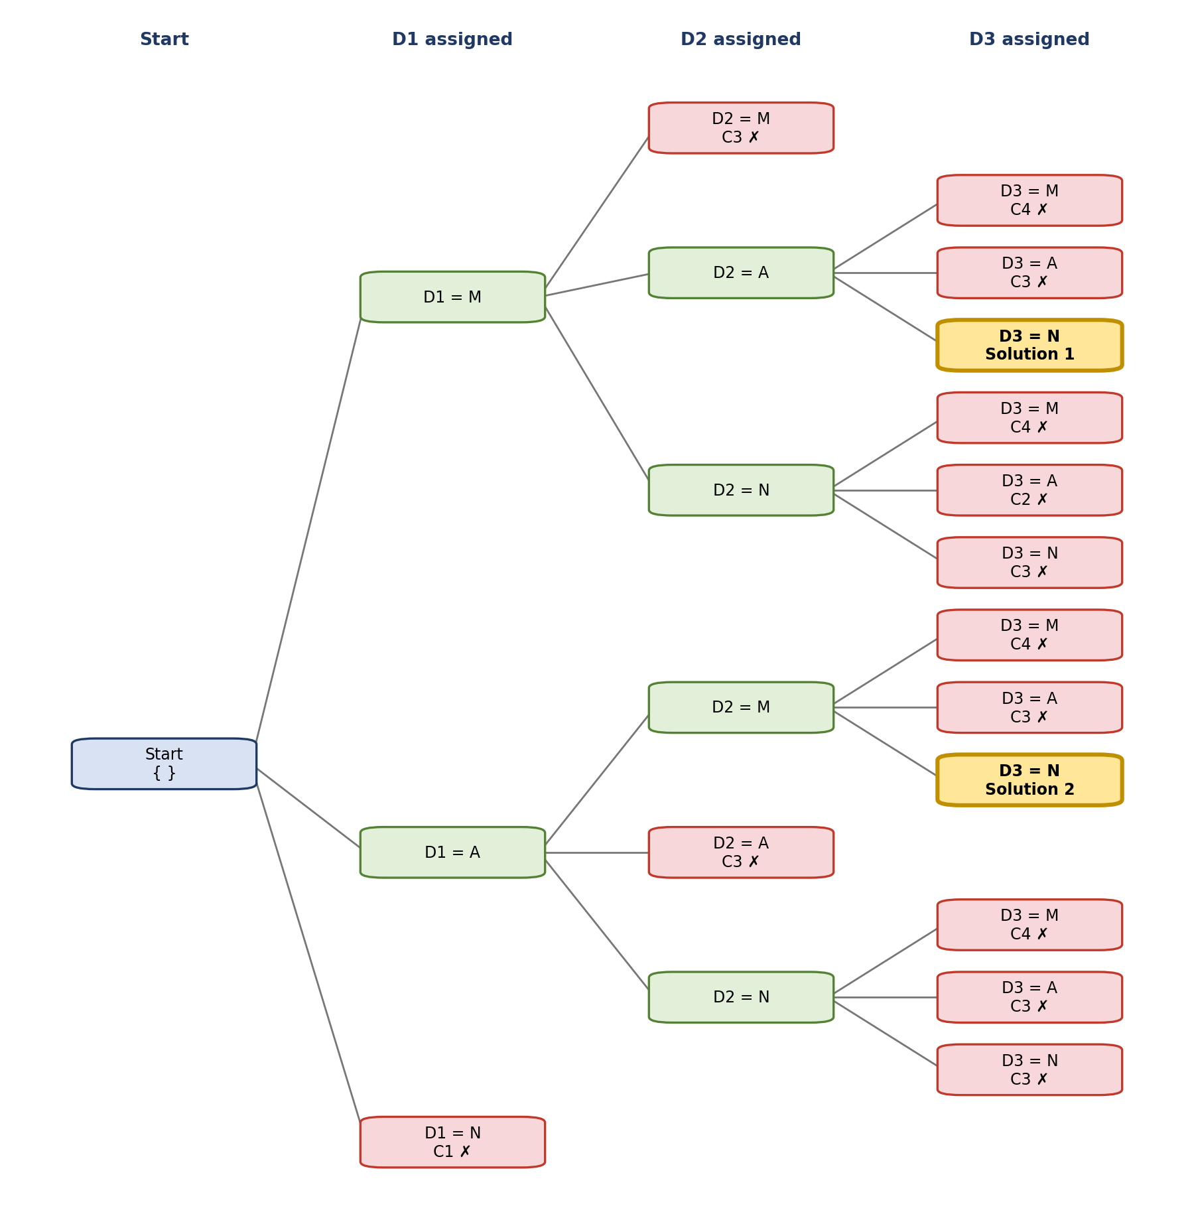
Figure 1: Full backtracking search tree (C1 to C4 refer to the constraints (i) to (iv) of the question)

Part C: A different variable order (to show a real backtrack)
To check that the answer does not depend on my choice of order, I also started from D3, which has the smallest domain after C4, with the order D3, D1, D2:
Step | Action | Constraint checks | Decision
1 | D3 = Afternoon | C4 ✓ C3 ✓ | Accept. {D3 = A}
2 | D1 = Morning | C1 ✓ C3 ✓ | Accept. {D3 = A, D1 = M}
3 | D2 = Morning / Afternoon / Night | Morning: C3 ✗. Afternoon: C3 ✗. Night: C3 ✓ but C2 ✗ (N is later than D3 = A) | Dead end. Backtrack to D1
4 | D1 = Afternoon | C3: Afternoon used by D3 ✗ | D1 has no values left. Backtrack to D3
5 | D3 = Night | C4 ✓ C3 ✓ | Accept. {D3 = N}
6 | D1 = Morning, then D2 = Afternoon | D1: C1 ✓, C3 ✓. D2: C3 ✓, C2: A (2) < N (3) ✓, C5 ✓ | Solution: D1 = M, D2 = A, D3 = N

Here the search hits a real dead end at step 3 and has to backtrack twice, but it arrives at the same schedule as Part A.

5. Verification of the Answer
As only 6 schedules are possible, I listed all of them and checked each against the constraints. This confirms the search did not miss anything.
D1 | D2 | D3 | C1 | C2 | C4 | Valid?
Morning | Afternoon | Night | ✓ | ✓ | ✓ | Yes
Morning | Night | Afternoon | ✓ | ✗ | ✓ | No
Afternoon | Morning | Night | ✓ | ✓ | ✓ | Yes
Afternoon | Night | Morning | ✓ | ✗ | ✗ | No
Night | Morning | Afternoon | ✗ | ✓ | ✓ | No
Night | Afternoon | Morning | ✗ | ✗ | ✗ | No

(C3 and C5 hold automatically in every row, as each row uses all three shifts once.) Exactly two schedules are valid, the same two that the backtracking search found.

6. Final Valid Schedule
Shift | Doctor assigned
Morning | D1
Afternoon | D2
Night | D3

Checking this schedule against every constraint:
Constraint | Check | Result
(i) D1 cannot work Night | D1 works Morning | ✓ Satisfied
(ii) D2 must work before D3 | D2 works Afternoon, D3 works Night (Afternoon comes before Night) | ✓ Satisfied
(iii) Only one doctor per shift | Morning → D1, Afternoon → D2, Night → D3 | ✓ Satisfied
(iv) D3 cannot work Morning | D3 works Night | ✓ Satisfied
(v) Each doctor has exactly one shift | D1, D2 and D3 each appear once | ✓ Satisfied

7. Justification
- Why backtracking: the problem is a CSP where a partial assignment can already be shown to be wrong. Backtracking spots this immediately and drops the whole branch. A generate-and-test method would build all 27 complete assignments (3 × 3 × 3) and check each one at the end. Backtracking reached the first solution after only 6 value checks, and even the full exploration looked at 21 nodes in total (3 for D1, 6 for D2 and 12 for D3, as drawn in Figure 1).
- Why check the constraints at every step: testing C3 and C4 as soon as a value is chosen removed bad values at once (steps 2, 4 and 5 of Part A) instead of discovering the problem at the bottom of the tree.
- Why the unary constraints first: C1 and C4 only involve one doctor, so they shrink the domains for free and no search effort is spent on shifts that can never be used.
- Why I chose D1 = Morning, D2 = Afternoon, D3 = Night as the final answer: the two valid schedules both follow the rules as written. However, the first one also satisfies the stricter meaning of “D2 works before D3”, where D2 works in the shift immediately before D3 (Afternoon then Night). The second schedule (D1 = Afternoon, D2 = Morning, D3 = Night) has a gap between D2 and D3 and would fail that stricter reading. So the first schedule is valid under both readings, and it is also the one that backtracking found first.
Final answer: Morning → D1, Afternoon → D2, Night → D3. (An equally valid alternative under the plain reading of the constraints is Morning → D2, Afternoon → D1, Night → D3.)

