SIMATS ENGINEERING
CSA17
Artificial Intelligence

Assessment Tool 3
Annexure A – Descriptive Written Test
Name | K Nitheesh Kumar
Register Number | 192325090
Course Name | Artificial Intelligence
Course Code | CSA17
Assessment | Assessment Tool 3 – Descriptive Written Test
Course Outcome | CO1 (BL3)
Total Marks | 10
Code of Conduct
I K Nitheesh Kumar (192325090) certify that this submission is my original work and that I have adhered to the guidelines specified for this assessment. I understand that any violation of academic integrity rules will result in disciplinary action.
Signature of the student: ______________________

Intelligent Agents in a Smart Home Automation System

Question
A smart home automation system is being designed to manage lighting, temperature and security based on user behaviour and environmental conditions. The system must respond to real-time inputs such as motion detection, temperature changes and time of day, while also learning user preferences over time. Explain the different types of intelligent agents (simple reflex, model-based, goal-based and utility-based) and analyse how each type would function within this system. Justify which type of agent, or hybrid approach, would be most effective for ensuring comfort, energy efficiency and security.

1. Introduction and Understanding of the Problem
An intelligent agent is anything that perceives its environment through sensors and acts on it through actuators, choosing its actions so as to do well on some performance measure. What separates one type of agent from another is *how the agent decides* what to do with the percepts it receives. A smart home is a good example to study this, because some of its jobs need an instant reaction (a door forced open at night) while others need thought and planning (keeping the house comfortable at the lowest electricity cost).
Before comparing the agent types, I describe the smart home as an agent task using PEAS (Performance measure, Environment, Actuators, Sensors):
PEAS element | Smart home system
Performance measure | Comfort of the residents, low energy use and cost, security of the house, safety (smoke, gas), few false alarms, minimum manual effort by the user
Environment | The rooms of the house, the residents and visitors, weather outside, time of day, electricity tariff
Actuators | Lights and dimmers, AC / heater / fan, blinds, door locks, siren, notifications to the user’s phone
Sensors | Motion (PIR) sensors, temperature and humidity sensors, light-level sensor, door and window contacts, cameras, clock, smart energy meter, phone location

The properties of this environment decide which agent design can work:
- Partially observable: a sensor only covers its own room, and a motion sensor cannot tell “nobody here” from “somebody sitting still”.
- Dynamic and stochastic: temperature, sunlight and the residents’ behaviour keep changing, and the effect of an action (for example, how fast a room cools) is not exactly predictable.
- Sequential: the choice made now (such as running the AC) affects the energy bill and the comfort later.
- Multi-agent in a loose sense: the residents are independent actors who may override the system at any time.
- Conflicting objectives: comfort wants the AC on, energy saving wants it off. Both cannot be maximised together.

2. Types of Intelligent Agents and Their Role in the Smart Home

2.1 Simple reflex agent
A simple reflex agent chooses its action only from the current percept, using condition–action rules (IF condition THEN action). It keeps no memory of the past and has no idea of any goal. It works well only when the right action can be decided from what the sensors show at that moment.
In the smart home, it would be a set of fixed rules such as:
- IF motion detected AND light level is low THEN switch the light ON.
- IF temperature > 30 °C THEN switch the fan / AC ON.
- IF door contact opens AND the system is in “away” mode THEN sound the siren.
- IF smoke detected THEN sound the alarm and unlock the exit door.
Strengths: very fast, simple, cheap, easy to test, and does not need a model of the house. Weaknesses: with no memory, if a person sits still reading, the motion sensor stops firing and the lights go off on them. It cannot tell whether a room is truly empty, so it cannot save energy sensibly, and it cannot learn the user’s habits. It also gives false alarms because it does not know who is at home.

2.2 Model-based reflex agent
A model-based agent keeps an internal state: its own picture of the parts of the world that it cannot see right now. It updates this state from the percept history, and uses a model of how the world works (how things change by themselves and how its own actions affect them). The action is chosen by rules, but those rules are applied to the state and not just the raw sensor reading.
In the smart home, the agent would maintain: which rooms are occupied (and when motion was last seen in each), which doors and windows are open, who is at home (from phone presence), the indoor and outdoor temperature trend, and how long the room takes to cool. With this, it can do things like:
- Keep the lights on while the room is still marked “occupied”, even if there was no motion for the last 5 minutes, and switch them off only when the person has left the room (last motion was near the exit door).
- Not switch the AC on while a window is open, since the state says the cold air would be wasted.
- Accept the door opening at 6 p.m. as normal when a known resident’s phone is near the house, but treat the same event as suspicious when everyone is away.
Strengths: handles partial observability, avoids the flicker and false alarm problems of the simple reflex agent. Weaknesses: it still only reacts. It has no objective of its own, so it cannot plan ahead (for example, start cooling before the family returns) and cannot decide between two acceptable actions.

2.3 Goal-based agent
A goal-based agent has an explicit goal, a description of the situation it wants to reach. It uses its model to ask “what will happen if I do this?” and uses search and planning to find a sequence of actions that leads to the goal. Because the goal can change, the behaviour changes without rewriting the rules.
In the smart home, goals can be set by the user or learned: “house at 24 °C when I reach home at 7 p.m.”, “all doors locked and the alarm armed by 11 p.m.”, “movie scene: lights dimmed and blinds closed”. To reach them, the agent plans:
- Pre-cool the house starting 30 minutes before the expected arrival time, since the model says the room needs about that long.
- Run a bedtime routine: check every window, lock the doors, switch off the unused lights, arm the sensors. If a window is found open, the plan adds a step to notify the user.
Strengths: flexible and proactive; can handle new situations by planning. Weaknesses: a goal is either achieved or not. The agent cannot tell which of two ways of reaching the goal is better, such as cooling quickly with high power against cooling slowly with less power. It also gives no way of settling conflicts between goals.

2.4 Utility-based agent
A utility-based agent has a utility function that gives each possible state a number showing how desirable it is. It chooses the action with the highest expected utility, which lets it weigh trade-offs and deal with uncertainty. This is what the goal-based agent lacks.
In the smart home, the utility could combine several factors, for example: U = w₁·Comfort + w₂·Energy saving + w₃·Convenience. The agent can then decide questions like how cool to keep the house when electricity is at the peak tariff, whether to use daylight instead of lamps, or whether to delay the washing machine to a cheaper hour.
A small example (the scores are illustrative values I have assumed to show the method, not measured data). The family arrives in one hour on a hot afternoon, and there are three options. Taking the weights as comfort 0.6 and energy 0.4:
Option | Comfort score | Energy-saving score | Utility = 0.6×C + 0.4×E
A: AC at 22 °C right now | 0.95 | 0.30 | 0.57 + 0.12 = 0.69
B: AC at 25 °C right now | 0.75 | 0.70 | 0.45 + 0.28 = 0.73
C: Start AC 30 minutes before arrival, target 24 °C | 0.90 | 0.60 | 0.54 + 0.24 = 0.78

The agent picks option C. A goal-based agent would see all three options as equally “good” if each reaches a comfortable temperature, so it could not make this choice.
Strengths: deals with conflicting objectives and uncertainty, and gives the most sensible all-round behaviour. Weaknesses: the utility function and its weights must be set correctly (they differ from person to person), and computing expected utility costs more time than applying a rule, so it is not suitable for emergencies that need an answer in a fraction of a second.

2.5 Learning in the system
The question also needs the system to learn user preferences over time. Learning is not a fifth type in the list above. It is an extra component (the learning element) that can be added to any of the agent types. In the smart home, it would watch what the user does: if the user keeps lowering the thermostat to 24 °C at 9 p.m., or keeps switching off a light the agent turned on, these corrections are treated as feedback and are used to update the stored preferences and the utility weights.

3. Comparison and Analysis

3.1 Behaviour of each agent in the three tasks
Agent type | Lighting | Temperature | Security
Simple reflex | Light ON when motion is detected in the dark, OFF when motion stops. Flickers if the person is still. | Fan or AC ON above a fixed temperature, OFF below it. Ignores whether anyone is home. | Alarm when a door opens or motion is seen in “away” mode. Cannot separate a resident from an intruder.
Model-based | Keeps track of occupancy, so the light stays on while the room is in use and goes off when the person has left. | Knows about open windows, outdoor temperature and room occupancy, so it avoids wasteful cooling. | Knows who is home and which doors are open, so there are fewer false alarms.
Goal-based | Sets a scene for an activity (reading, movie, sleeping) as a planned set of actions. | Plans pre-cooling or pre-heating so that the house is comfortable at the arrival time. | Plans the night routine: check, lock, arm. Notifies the user if a step cannot be completed.
Utility-based | Chooses brightness that balances comfort against energy, using daylight where it is available. | Chooses the setpoint and start time that give the best comfort–cost balance, considering the tariff. | Weighs the seriousness of an event (a cat versus a person) to decide between ignoring, notifying or sounding the alarm.

3.2 Overall comparison
The ratings below are my own qualitative judgement for this smart home, not measured values.
Feature | Simple reflex | Model-based | Goal-based | Utility-based
Uses memory / internal state | No | Yes | Yes | Yes
Plans ahead | No | No | Yes | Yes
Handles trade-offs | No | No | No | Yes
Handles partial observability | Poor | Good | Good | Good
Response speed | Very fast | Fast | Medium | Medium to slow
Comfort | Low | Medium | High | High
Energy efficiency | Low | Medium | Medium | High
Security | Medium (many false alarms) | Medium to high | High | High
Design effort / cost | Low | Medium | Medium to high | High

The table shows that no single type is best on every row. The simple reflex agent is the fastest but has the poorest comfort and efficiency, while the utility-based agent is best on comfort and efficiency but is slow and hard to design. This leads directly to a hybrid design.

4. Most Effective Approach: A Hybrid (Layered) Agent
My recommendation is a hybrid agent, in which a model-based core provides the state, goal-based and utility-based layers do the planning and decision making, a simple reflex layer takes care of emergencies, and a learning element adapts the system to the residents. Figure 1 shows how the parts fit together.
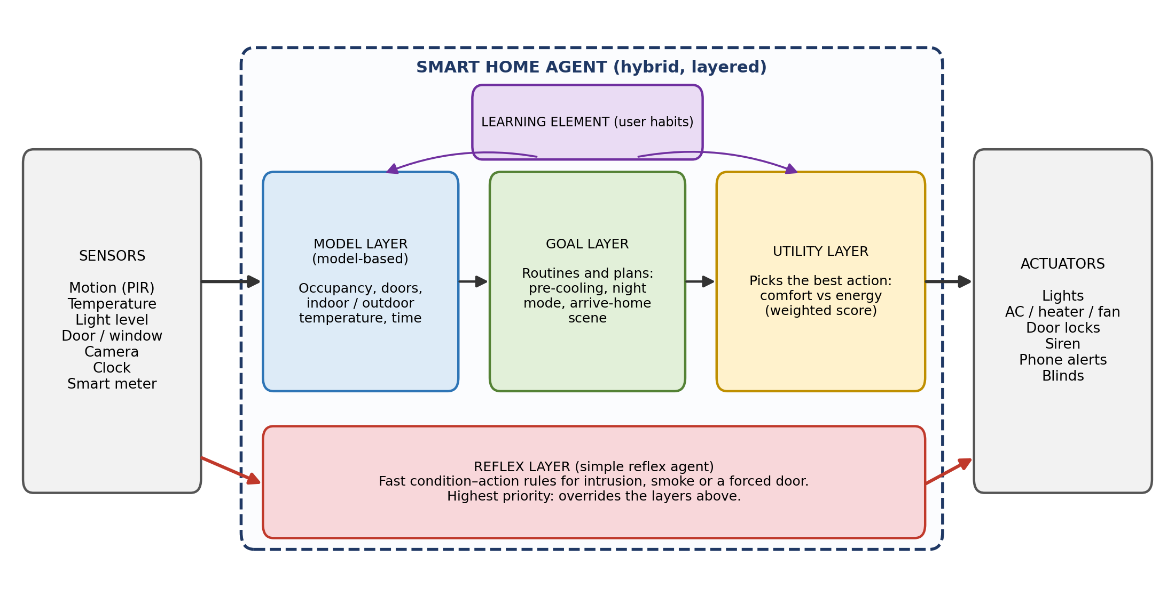
Figure 1: Hybrid layered agent for the smart home

Role of each layer
Layer | Responsibility | Why it is needed
Reflex layer | Fixed rules for intrusion, forced entry, smoke or gas, which act immediately | Security and safety cannot wait for planning or optimisation. It has the highest priority and overrides everything else.
Model layer | Keeps the state: occupancy, door and window status, who is home, indoor and outdoor temperature, time | All other layers depend on knowing what is happening in the house. It also solves the partial observability problem.
Goal layer | Turns the schedules and routines into action plans (pre-cooling, night mode, arrival scene) | Gives proactive behaviour. The comfort is ready when the user needs it, not after.
Utility layer | Selects among the possible plans using a weighted score of comfort, energy cost and convenience | Settles the conflict between comfort and energy saving, which a goal alone cannot do.
Learning element | Updates the stored preferences and utility weights from the user’s manual corrections | Makes the system match each household and improve with time, as the question requires.

Priority between the layers
When the layers disagree, the reflex layer wins. For example, in a heavy-saving mode the utility layer may decide to switch off all the lights, but if the reflex layer detects a break-in at night, it turns the lights on and sounds the siren regardless. Because of this, security is treated as a fixed constraint and not as something traded against energy cost. Inside the safe region, the utility layer is free to balance comfort and energy.

Pseudocode of the hybrid agent
function SMART-HOME-AGENT(percept) returns an action list
state <- UPDATE-STATE(state, percept, model) // model layer

if EMERGENCY-RULE-MATCHES(state, percept) then // reflex layer
return RULE-ACTION(state, percept) // siren, lock, alert

goals <- ACTIVE-GOALS(state, user_schedule) // goal layer
plans <- GENERATE-PLANS(state, goals, model) // e.g. pre-cooling
best <- argmax over p in plans of EXPECTED-UTILITY(p, weights)
return ACTIONS(best) // utility layer

procedure LEARN(user_override, state) // learning element
update preferences and weights so that the next choice is
closer to what the user just chose

How the hybrid agent handles typical situations
Situation | Layers involved | What the system does
The resident is sitting quietly on the sofa in the evening, and the motion sensor has been silent for 6 minutes | Model | State still says “room occupied”, because no one has been seen leaving. The lights stay on. A simple reflex rule alone would have switched them off.
Hot afternoon; the family usually returns at 7 p.m. and the electricity tariff is high until 6 p.m. | Model, goal, utility | The goal is a comfortable house at 7 p.m. The utility layer compares the plans and starts cooling at 6:30 p.m. at a moderate setpoint (like option C in the example above).
A door is forced open at 2 a.m. while all residents are home asleep | Reflex (then model, goal) | The reflex layer sounds the siren at once, turns the lights on, and alerts the owner. The other layers then continue with the notification and recording.
The user keeps resetting the AC from 25 °C to 23 °C after 9 p.m. | Learning, utility | The learning element raises the comfort weight and stores 23 °C as the preferred night temperature, so the user has to intervene less over the following days.

Why not use only one type?
- Only simple reflex: reacts quickly, but gives flickering lights, false alarms, wasted energy and no learning.
- Only model-based: knows the situation but never plans or optimises, so comfort and energy saving remain average.
- Only goal-based: reaches the targets, but cannot choose the cheaper or more comfortable way, and is too slow for an emergency.
- Only utility-based: gives the best trade-offs, but the computation is too slow and heavy for a break-in or a fire, and a wrongly set utility function could even trade security against savings.

5. Conclusion
The four agent types form a progression. A simple reflex agent reacts to the current percept, a model-based agent remembers the state of the world, a goal-based agent plans to achieve what the user wants, and a utility-based agent chooses the best way when objectives conflict. In a smart home, each of them solves one part of the problem and fails at another. The most effective solution is a hybrid, layered agent with a model-based core, goal and utility layers for planning and optimisation, a high-priority reflex layer for security and safety, and a learning element that adapts to the household. This design gives comfort through proactive planning and learned preferences, energy efficiency through utility-based trade-offs, and security through immediate reflex responses that can never be overridden by energy-saving decisions.

