SIMATS ENGINEERING
CSA17
Artificial Intelligence

Assessment Tool 1
Annexure A – Analytical Problem Solving
Name | K Nitheesh Kumar
Register Number | 192325090
Course Name | Artificial Intelligence
Course Code | CSA17
Assessment | Assessment Tool 1 – Analytical Problem Solving
Course Outcome | CO1 (BL3)
Total Marks | 50
Code of Conduct
I K Nitheesh Kumar (192325090) certify that this submission is my original work and that I have adhered to the guidelines specified for this assessment. I understand that any violation of academic integrity rules will result in disciplinary action.
Signature of the student: ______________________

Question 1: Water Jug Problem

Problem Understanding
We have a 4-gallon jug and a 3-gallon jug, neither having any markings, and a pump with unlimited water. The task is to end up with exactly 2 gallons in the 4-gallon jug. The only things allowed are: fill a jug completely from the pump, empty a jug on the ground, and pour from one jug into the other. Since there are no markings, the only amounts we can know for sure are “jug is empty” and “jug is full”, so the 2 gallons has to come from the difference between the two jug sizes.

Problem Formulation
Component | Definition
State | An ordered pair (x, y), where x = gallons in the 4-gallon jug (0 to 4) and y = gallons in the 3-gallon jug (0 to 3)
Initial state | (0, 0), both jugs empty
Goal state | (2, y), that is, x = 2 and y can be anything
Actions | The 8 production rules given below
Path cost | Each action costs 1, so the cost of a solution is the number of moves

Production rules (operators)
Rule | If the state is | Then it becomes | Meaning
R1 | (x, y), x < 4 | (4, y) | Fill the 4-gal jug from the pump
R2 | (x, y), y < 3 | (x, 3) | Fill the 3-gal jug from the pump
R3 | (x, y), x > 0 | (0, y) | Empty the 4-gal jug on the ground
R4 | (x, y), y > 0 | (x, 0) | Empty the 3-gal jug on the ground
R5 | (x, y), x + y ≥ 4, y > 0 | (4, y − (4 − x)) | Pour from 3-gal into 4-gal until the 4-gal is full
R6 | (x, y), x + y ≥ 3, x > 0 | (x − (3 − y), 3) | Pour from 4-gal into 3-gal until the 3-gal is full
R7 | (x, y), x + y ≤ 4, y > 0 | (x + y, 0) | Pour all of the 3-gal jug into the 4-gal jug
R8 | (x, y), x + y ≤ 3, x > 0 | (0, x + y) | Pour all of the 4-gal jug into the 3-gal jug

Method Selection
I used Breadth First Search (BFS). This is an uninformed search where all the states that are one move away are generated first, then those two moves away, and so on. I chose it for three reasons: the state space is tiny (at most 5 × 4 = 20 states), every move costs the same, and BFS is guaranteed to give the solution with the fewest moves. Repeated states are ignored so that the search does not go round in circles.

Solution
The table shows the new states found at each level of the BFS (a state that was already seen earlier is not added again).
Level (moves) | New states generated
0 | (0, 0)
1 | (4, 0) (0, 3)
2 | (1, 3) (4, 3) (3, 0)
3 | (1, 0) (3, 3)
4 | (0, 1) (4, 2)
5 | (4, 1) (0, 2)
6 | (2, 3) (2, 0) ← goal states (x = 2)

No goal state appears before level 6, so 6 moves is the minimum. Tracing back from the goal (2, 3) gives the following sequence:
Step | Rule used | Action | State (x, y)
0 | – | Start with both jugs empty | (0, 0)
1 | R1 | Fill the 4-gallon jug | (4, 0)
2 | R6 | Pour from the 4-gal jug into the 3-gal jug until it is full | (1, 3)
3 | R4 | Empty the 3-gallon jug | (1, 0)
4 | R8 | Pour the 1 gallon from the 4-gal jug into the 3-gal jug | (0, 1)
5 | R1 | Fill the 4-gallon jug again | (4, 1)
6 | R6 | Pour from the 4-gal jug into the 3-gal jug until it is full (it needs 2 more gallons) | (2, 3)
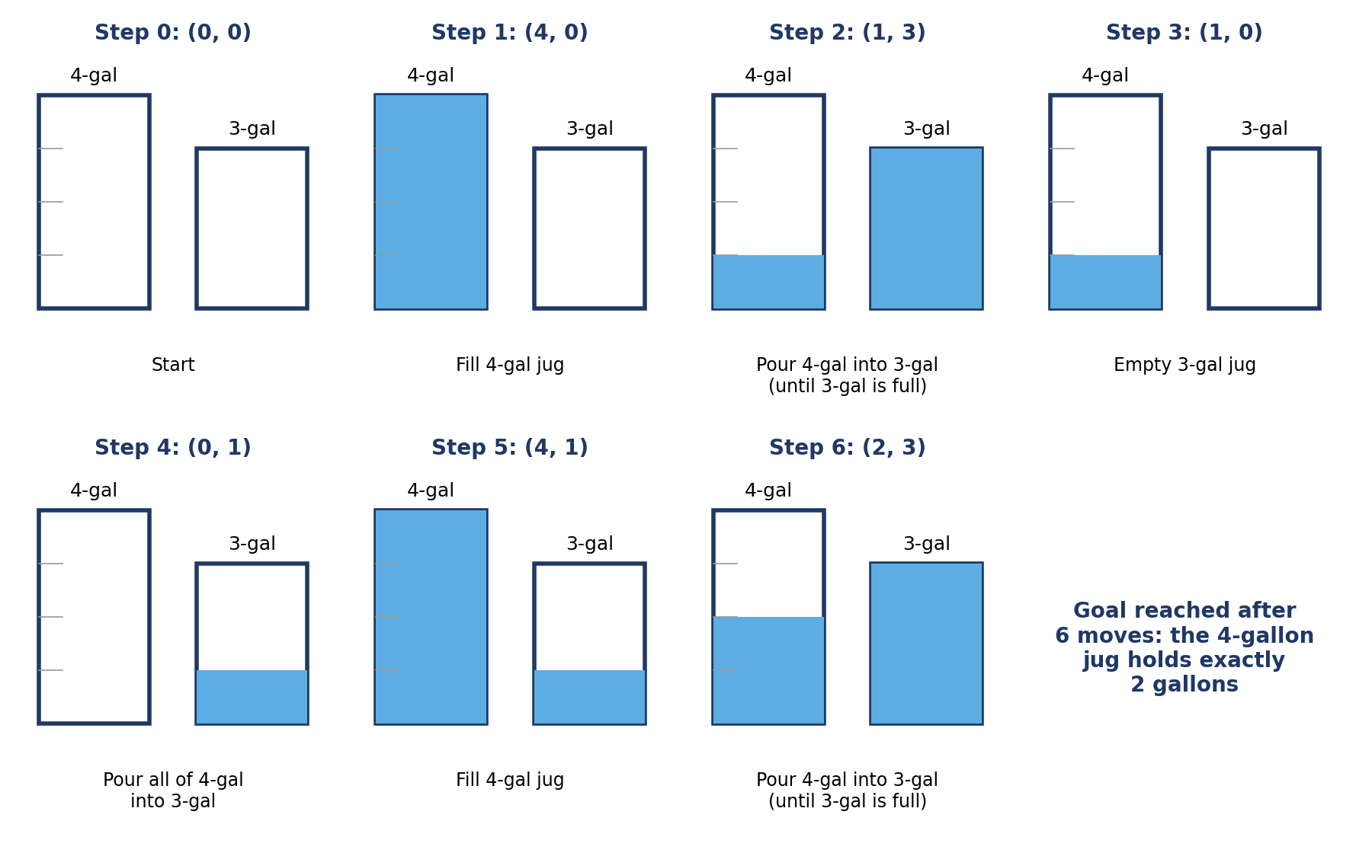
Figure 1.1: Water levels after each move of the solution
Another valid solution: if we choose the 3-gallon jug first, we get (0,0) → (0,3) → (3,0) → (3,3) → (4,2) → (0,2) → (2,0), using rules R2, R7, R2, R5, R3, R7. It also takes 6 moves and ends with 2 gallons in the 4-gallon jug and the 3-gallon jug empty, so both are equally short.

Result and Interpretation
Exactly 2 gallons can be measured in the 4-gallon jug in a minimum of 6 moves. This works because 4 and 3 have no common factor other than 1, so by repeatedly filling, pouring and emptying we can produce any whole number of gallons from 0 to 4. Since BFS checks all shorter sequences first, no solution with fewer than 6 moves exists.

Question 2: Mars Rover as an Intelligent Agent

Problem Understanding
A Mars rover is an autonomous robot that drives on the surface of Mars, collects soil and rock samples, analyses them with on-board instruments, and sends the results back to Earth. To describe it as an intelligent agent, I use the PEAS framework (Performance measure, Environment, Actuators, Sensors) and answer the five parts of the question in order.

(i) Percepts of the agent
Percepts are whatever the rover’s sensors tell it at a given moment:
- Visual: images from the navigation and hazard-avoidance cameras (terrain, rocks, slopes, craters), and close-up images of the sample.
- Sample data: readings from the spectrometers and other science instruments (mineral and chemical composition, presence of water or organic traces).
- Position and movement: wheel encoders, gyroscope / inertial unit and tilt sensors, which give distance travelled, heading and angle of the rover.
- Environment readings: temperature, wind and dust level, sunlight intensity.
- Internal status: battery level, solar panel or power output, temperature of the electronics, health of wheels and arm, and memory still free for storing data.
- Commands from Earth: instructions and the communication signal status from the orbiter or the ground station.

(ii) Characterising the operating environment
Property | Value | Reason
Observable | Partially observable | The cameras only see what is nearby. Hidden rocks, soft sand under the wheels and the inside of a rock cannot be seen directly.
Agents | Single agent (mostly) | The rover acts alone on the surface. The orbiter and the control team on Earth only send occasional commands.
Deterministic | Stochastic | The same drive command can give a different result because wheels slip on sand and slopes, and instruments give noisy readings.
Episodic | Sequential | Current actions affect later ones: a wasted battery charge or a damaged wheel affects the rest of the mission.
Static | Dynamic | Day and night, dust storms and temperature changes keep happening while the rover is thinking.
Discrete | Continuous | Position, speed, time and sensor values change continuously.
Known | Partly unknown | The terrain is new and unmapped, so the agent has to learn about it as it moves.

Because radio signals take several minutes to travel between Earth and Mars (the delay changes with the planets’ positions), the rover cannot be controlled live. It must take many decisions by itself.

(iii) Actions the agent can take
- Movement: move forward or backward, turn left or right, stop, climb or avoid a slope, choose a different path around an obstacle.
- Sampling: extend the robotic arm, scrape the surface, drill into a rock, scoop soil, and place the sample into the analysis instrument or a storage tube.
- Analysis and observation: take photographs, switch on a spectrometer, run a chemical test, rotate the mast camera.
- Communication: send data and images to Earth, receive new commands, store data when the link is not available.
- Self-maintenance: change the angle to face the sun, charge the battery, heat the instruments, go into sleep mode in a storm, or run a self-check.

(iv) Evaluating the performance of the agent
Performance measure | What is checked
Scientific value | Number and quality of samples collected and analysed, and how interesting the findings are
Coverage | Area explored and distance travelled towards the targets
Safety | No tipping over, getting stuck, falling into craters or damaging the arm and wheels
Resource use | Battery and time used per sample (energy efficiency)
Data return | Percentage of the collected data that is successfully sent to Earth
Reliability / lifetime | How long the rover keeps working, and how many days of the mission are completed without a fault

Since these measures can conflict (more driving means more science but less battery and more risk), the final score should be a weighted combination, with safety given the highest weight because a lost rover cannot be replaced.

(v) Most suitable agent architecture
I think a goal-based, utility-based agent with a model of the world, combined with a reactive safety layer (a hybrid, layered architecture) is the most suitable. The reasons are:
- It needs a model (internal state), because the environment is only partially observable. The agent keeps a map of where it has been, the state of the battery and which samples are already taken, so it can act on things it cannot currently see.
- It needs goals, such as “reach that rock” or “store sample number 5”, and it must plan a sequence of actions to achieve them. A simple reflex agent cannot plan ahead.
- It needs a utility function, because there are trade-offs between science value, battery use, time and risk. Where several goals are possible, the agent picks the one with the highest expected utility.
- It needs a fast reactive layer for emergencies (wheel slipping, steep slope, low battery). Here a condition–action rule such as “if tilt is too high then stop” must fire immediately without long planning.
- It should be able to learn (for example, to recognise which soil is risky for the wheels), but learning is an addition to the architecture and not the main reason for choosing it.
A pure simple reflex agent would be unsafe and short-sighted, and a pure model-based reflex agent would have no goals, so neither is enough for this mission. The communication delay with Earth also means that the agent has to make these decisions on its own.

Question 3: 8-Queens Problem

Problem Understanding
We must place 8 queens on an 8 × 8 chessboard so that no two queens attack each other. A queen attacks along its row, its column and both diagonals, so in a solution there must be no two queens in the same row, same column or same diagonal. The configuration shown in the question is not a solution because the queen in the first column and the queen in the last column lie on the same diagonal.

Problem Formulation
The problem can be formulated in more than one way, and the choice makes a huge difference to the size of the search space.
Component | Improved incremental (used here) | Basic incremental
States | Boards with 0 to 8 queens, where no queen attacks another | Any arrangement of 0 to 8 queens on the board
Initial state | Empty board | Empty board
Actions | Add a queen to the leftmost empty column, in a row that is not attacked by any queen already placed | Add a queen to any empty square
Transition model | Returns the board with the new queen added | Returns the board with the new queen added
Goal test | 8 queens on the board, none attacked | 8 queens on the board, none attacked
Path cost | Not important (only the final arrangement matters) | Not important

I use the improved version (middle column of the table): queens are placed one column at a time, left to right, and a queen is placed only on a square that is not attacked. Because of this, an invalid state is never generated.
Formulation | Number of possible states / sequences
Place 8 queens anywhere (ordered sequences of squares) | 64 × 63 × … × 57 ≈ 1.8 × 10¹⁴
One queen in each column, any row | 8⁸ = 16,777,216
One queen in each row and column (permutations) | 8! = 40,320
Add one queen per column, only to non-attacked squares | only 2,057 states

Method Selection: Exploring the Search Space
Every solution contains exactly 8 queens, so all the solutions are at depth 8 of the search tree. The uninformed strategies compare as follows:
Strategy | Behaviour on 8-queens | Suitable?
Breadth First Search | Explores all partial boards with 1 queen, then 2 queens, and so on. It is complete, but it must store every partial board of a level in memory, and the number grows very fast. | Works, but wastes memory
Depth First Search (backtracking) | Keeps adding queens in one branch. When no safe square is left in the next column, it goes back and moves the last queen. Only one path (at most 8 boards) is stored. | Best choice
Depth Limited Search | Same as DFS with a depth limit of 8. Since the solution depth is known to be 8, the limit does not cut off any solution. | Good (DFS with limit 8)
Uniform Cost Search | All steps cost the same, so it behaves like BFS. | No benefit

I selected depth first search with backtracking. A solution is always found at a fixed depth (8), memory is small, and wrong branches are cut early as soon as a column has no safe row.

Solution

Pseudocode
function SOLVE-8-QUEENS(board, col) returns a solution or failure
if col = 8 then return board // all 8 queens placed
for each row in 0 .. 7 do
if SAFE(board, row, col) then // no attack in row or diagonals
place a queen at (row, col)
result <- SOLVE-8-QUEENS(board, col + 1)
if result is not failure then return result
remove the queen from (row, col) // backtrack
return failure // no safe row in this column

Working of the search
Taking rows as 1 to 8 and starting with the first row for the first column, the search runs as follows:
- Place Q1 in row 1. Column 2: row 1 is the same row, row 2 is on the diagonal, so Q2 goes to row 3.
- Column 3: rows 2 and 4 are diagonal to Q2, so Q3 goes to row 5. Column 4: Q4 goes to row 2. Column 5: Q5 goes to row 4.
- Column 6: rows 1 to 5 are already taken, and rows 6, 7 and 8 are on the diagonals of Q1, Q2 and Q3 respectively. No safe row exists, so the search backtracks.
- It goes back to Q5 and tries its next safe row; whenever a column runs out of safe rows it backs up one more queen, and this continues until a complete board with 8 queens is reached.
With rows tried in order from 1 to 8, the first full solution is found after visiting about 114 partial boards, which is a tiny fraction of the 16 million column-wise arrangements.
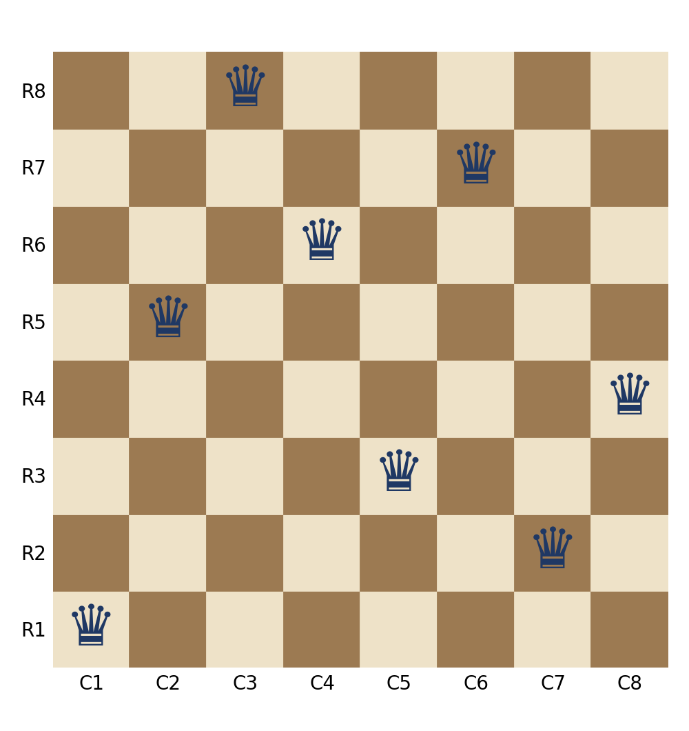
Figure 3.1: A solution found by the search. Queens (column, row): (1,1), (2,5), (3,8), (4,6), (5,3), (6,7), (7,2), (8,4)
In this solution the queens are in rows 1, 5, 8, 6, 3, 7, 2, 4 for columns 1 to 8. All 8 rows are different, and the difference between rows is never equal to the difference between the columns for any two queens, so no two queens share a row, column or diagonal.

Result and Interpretation
The problem has 92 solutions in total, of which 12 are really different once rotations and reflections of the board are treated as the same. Looking at the search space this way (adding queens column by column and rejecting attacked squares) cuts the space from about 10¹⁴ sequences to just 2,057 states, and backtracking DFS finds an answer using very little memory.

Question 4: OLA Cab Booking: Problem-Solving Agent

Problem Understanding
A customer opens the OLA app, gives a pickup location and a destination, chooses a cab type (Mini, Micro, Sedan, Shared, Prime and so on) according to comfort and price, and then wants to be taken to the destination. So the application has to do two things: (a) help to choose a suitable cab type, and (b) find a route from the pickup point to the destination.

Method Selection: Type of Agent
Agent type | Can it solve this problem?
Simple reflex | No. It reacts only to the present percept and cannot plan a route.
Model-based reflex | Not enough. It keeps track of state (for example, traffic) but has no destination to work towards.
Goal-based (problem-solving) agent | Yes. There is a clear goal, reaching the destination, and the agent has to search for a sequence of actions (road segments) that achieves it.
Utility-based | Yes, for choosing the cab. Cab types differ in fare, comfort and waiting time, so we need a utility value to compare them.
Learning agent | Could be added later to improve fare and time estimates from past trips.

Therefore the best answer is a goal-based problem-solving agent. It formulates a goal and a problem, searches for a solution and then executes it. Its cab choice step uses a utility function, which makes it a goal-based agent with a utility-based part for the selection. The environment is mostly observable (maps and GPS), sequential and dynamic (traffic changes), so the plan is re-checked while the trip goes on.

Problem Formulation
Component | Definition for the OLA problem
Initial state | The pickup location of the customer (GPS position)
Goal state | The customer’s destination location
States | Locations (road junctions / landmarks) on the road map
Actions | Travel along a road segment from the current location to a connected neighbouring location
Transition model | RESULT(location, road) = the location at the other end of that road
Path cost | Total travel time, distance and fare of all road segments (weights can be changed according to the cab type)
Solution | A sequence of road segments from pickup to destination with the lowest cost

Solution: Pseudocode
function OLA-AGENT(percept) returns an action
persistent: seq // action sequence, initially empty
state // current description of the world
goal, problem

state <- UPDATE-STATE(state, percept) // GPS, traffic, cab availability
if seq is empty then
goal <- FORMULATE-GOAL(state) // reach customer's destination
problem <- FORMULATE-PROBLEM(state, goal)
cab <- SELECT-CAB(state, problem) // utility based choice
seq <- SEARCH(problem, cab) // best route on road graph
if seq = failure then return NO-CAB-OR-ROUTE message
action <- FIRST(seq)
seq <- REST(seq)
return action

function SELECT-CAB(state, problem) returns cab type
best <- none ; bestU <- -infinity
for each cab in AVAILABLE-CABS(state.pickup) do // Mini, Micro...
u <- w1 * COMFORT(cab) - w2 * FARE(cab, problem) - w3 * ETA(cab)
if cab is a preferred type and u > bestU then
best <- cab ; bestU <- u
return best // customer confirms the choice

function SEARCH(problem, cab) returns a sequence of road segments
frontier <- priority queue ordered by path cost, containing the initial state
explored <- empty set
loop do
if frontier is empty then return failure
node <- POP(frontier)
if GOAL-TEST(node.state) then return SOLUTION(node)
add node.state to explored
for each road in ACTIONS(node.state) do
child <- CHILD-NODE(problem, node, road) // cost for this cab
if child.state not in explored and not in frontier
then INSERT(child)
else if child.state is in frontier with a higher cost
then REPLACE that node with child

Result and Interpretation
The agent first fixes the goal (reach the destination), then picks the cab type with the highest utility among the customer’s preferred options, and then finds the cheapest route using a search such as Uniform Cost Search (or A* when the straight-line distance is used as the heuristic, which makes it faster on a large city map). While the cab is moving, the agent keeps updating its state with traffic and GPS data, and if the planned route becomes blocked it formulates the problem again from the present location. This is the usual cycle of a problem-solving agent: formulate goal → formulate problem → search → execute.

Question 5: Uniform Cost Search on the Delivery Network

Problem Understanding
We have to find the least-cost path from the starting warehouse S to the destination warehouse G in a weighted directed graph, where the weight of each edge is the travel cost (fuel + time). The edges in the given figure are:
Edge | S→A | S→G | A→B | A→C | B→D | C→D | C→G | D→G
Cost | 1 | 12 | 3 | 1 | 3 | 1 | 2 | 3
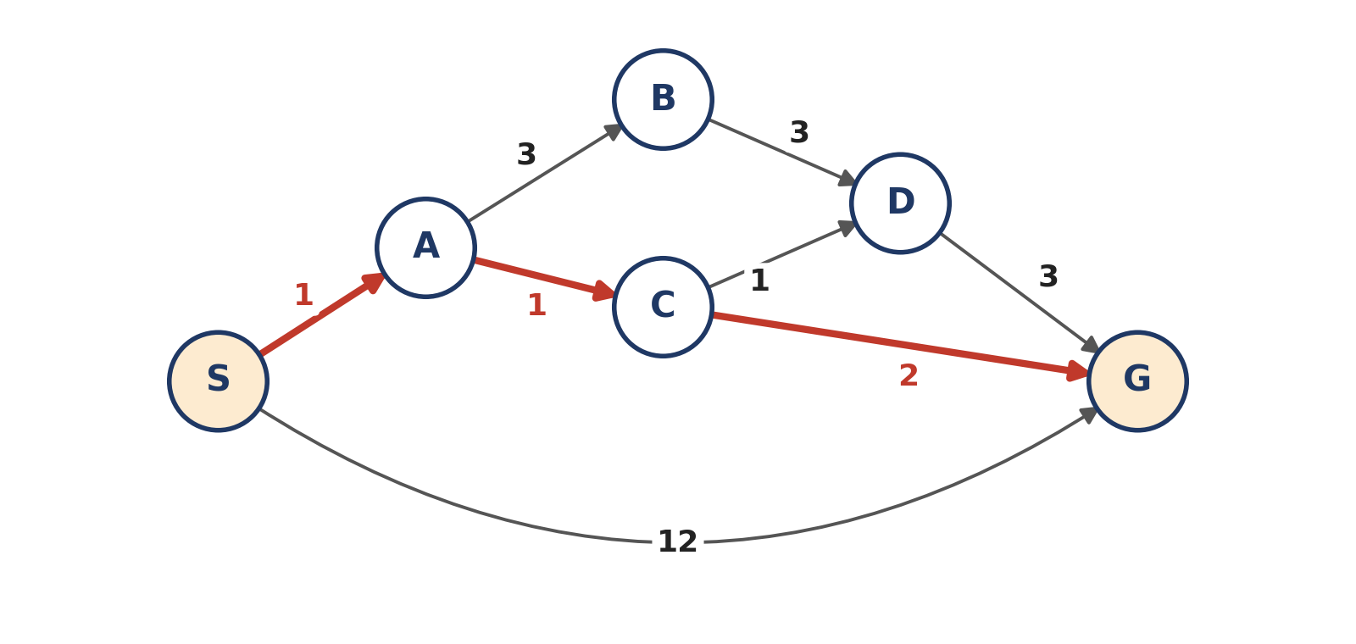
Figure 5.1: The delivery network (the least-cost path S → A → C → G is highlighted in red)

Method Selection
The edge costs are different, so Breadth First Search is not suitable: it finds the path with the fewest edges, which would be the direct route S→G with cost 12, whereas cheaper routes exist. Uniform Cost Search (UCS) expands the node with the lowest path cost g(n) first, using a priority queue. Because all the costs are positive, UCS is complete and optimal. The goal test is applied when a node is expanded (removed from the queue) and not when it is generated, otherwise the expensive direct edge to G (cost 12) would be accepted too early.

Solution
g(n) is the cost of the cheapest path found so far from S to node n. The frontier is the priority queue, written as node(cost) in increasing order of cost.
Step | Node expanded | Nodes generated (new g value) | Frontier after the step
0 | – | S(0) put in the queue | S(0)
1 | S (0) | A = 0+1 = 1; G = 0+12 = 12 | A(1), G(12)
2 | A (1) | B = 1+3 = 4; C = 1+1 = 2 | C(2), B(4), G(12)
3 | C (2) | D = 2+1 = 3; G = 2+2 = 4 (cheaper than 12, so it replaces G(12)) | D(3), B(4), G(4)
4 | D (3) | G = 3+3 = 6 (not better than 4, ignored) | B(4), G(4)
5 | B (4) | D = 4+3 = 7 (D is already expanded with cost 3, ignored) | G(4)
6 | G (4) | Goal test passed, stop | –

Order of expansion: S, A, C, D, B, G. Explored (closed) set at the end: {S, A, C, D, B}.
Tracing back the parent of each node from G gives the path S → A → C → G.
To double check the answer, here are all four possible routes from S to G:
Route | Calculation | Total cost
S → A → C → G | 1 + 1 + 2 | 4 (least)
S → A → C → D → G | 1 + 1 + 1 + 3 | 6
S → A → B → D → G | 1 + 3 + 3 + 3 | 10
S → G | 12 | 12

Result and Interpretation
The least-cost delivery route is S → A → C → G with a total cost of 4 units (fuel + time). The direct road S→G looks shortest on the map, but it costs 12, which is three times more than the route through A and C. For the company, this means the packages should be sent through warehouses A and C, which saves 8 cost units per trip compared with the direct route.
UCS expanded 6 nodes before stopping, and it never needed to look at the expensive branches (B and the direct edge) in detail, since the node G(4) was removed from the queue as soon as it became the cheapest node. As the cost of every edge is at least 1, UCS is guaranteed to give the optimal answer here. The only disadvantage of UCS is that it has no idea of the direction of the goal, so on a very large network an informed search such as A* would be faster.

