LAB EXPERIMENT
ITA0506-COMPUTER VISION
K Nitheesh Kumar -192325090
EXPNO:16 Edge Detection Using Canny Method
Aim
To detect the edges in an image using the Canny Edge Detection method in Python and OpenCV.
Algorithm
- Import the required libraries, cv2.
- Read the input image.
- Convert the image from BGR to grayscale.
- Apply Gaussian Blur to reduce noise.
- Apply the Canny Edge Detection method.
- Display the original image and detected edges.
- Press any key to close the output windows.
CODE:
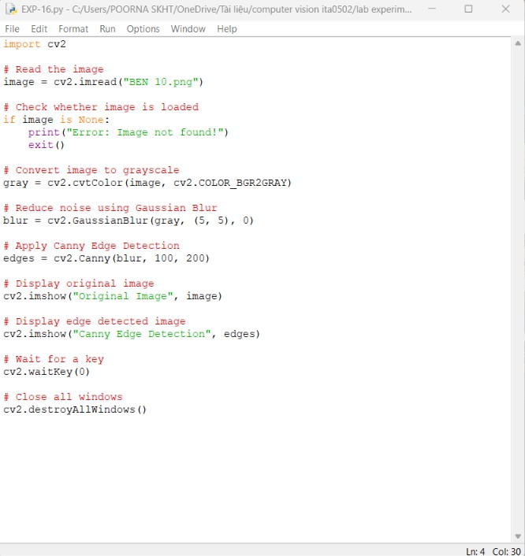
OUTPUT :


Result:
Edge detection was successfully performed using the Canny Edge Detection method. The important boundaries and edges of objects in the image were detected and displayed.

