LAB EXPERIMENT
ITA0506-COMPUTER VISION
K Nitheesh Kumar -192325090
EXPNO:17 Edge Detection Using Sobel Matrix Along X-Axis

Aim
To detect vertical edges in an image using the Sobel operator along the X-axis using Python and OpenCV.

Theory
The Sobel operator calculates the intensity change in an image.
For X-axis edge detection, the following Sobel matrix is used:
It mainly detects vertical edges in the image.

Algorithm
- Import cv2 and numpy.
- Read the input image.
- Convert the image into grayscale.
- Apply the Sobel operator along the X-axis.
- Convert the result to an 8-bit image.
- Display the original image and Sobel X output.
- Press any key to close the windows.
CODE:
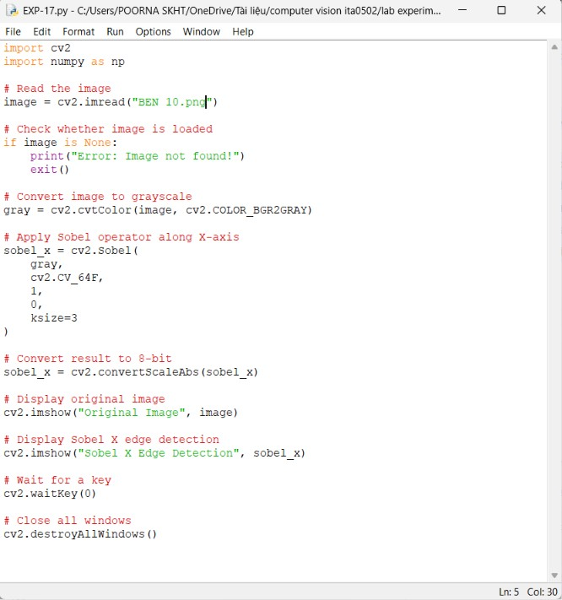
OUTPUT :


Result:
Edge detection was successfully performed using the Sobel operator along the X-axis. The vertical edges present in the image were detected and displayed successfully.

