LAB EXPERIMENT
ITA0506-COMPUTER VISION
K Nitheesh Kumar -192325090
EXPNO:18 Edge Detection Using Sobel Matrix Along Y-Axis

Aim
To detect horizontal edges in an image using the Sobel operator along the Y-axis using Python and OpenCV.

Theory
The Sobel operator detects changes in image intensity.
For Y-axis edge detection, the Sobel matrix is:
It mainly detects horizontal edges in an image.

Algorithm
- Import cv2 and numpy.
- Read the input image.
- Convert the image to grayscale.
- Apply the Sobel operator along the Y-axis.
- Convert the result into an 8-bit image.
- Display the original image and Sobel Y edge image.
- Press any key to close the windows.
CODE:
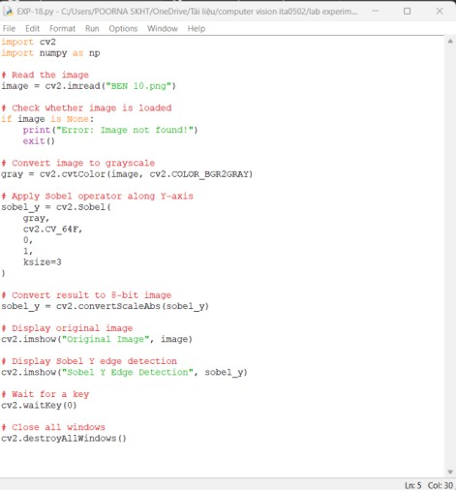
OUTPUT :

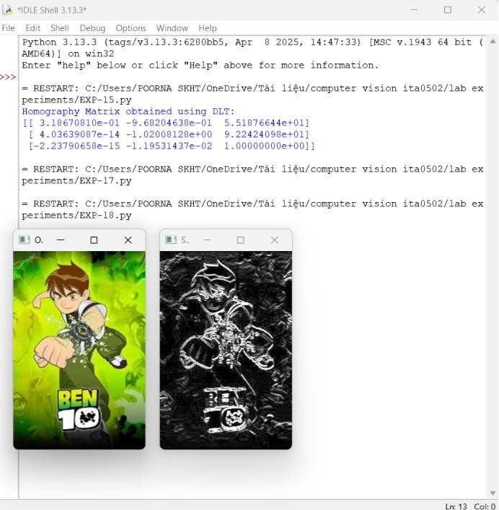
Result:
Edge detection was successfully performed using the Sobel operator along the X-axis. The vertical edges present in the image were detected and displayed successfully.

