LAB EXPERIMENT
ITA0506-COMPUTER VISION EXPNO:19
K Nitheesh Kumar -192325090
Aim:
To detect edges in an image using the Sobel operator along both the X-axis and Y-axis.
Algorithm
- Read the input image.
- Convert the image into grayscale.
- Apply Sobel operator along the X-axis.
- Apply Sobel operator along the Y-axis.
- Combine X and Y gradients to obtain the final edge image.
- Display the original and edge-detected images.
Code:
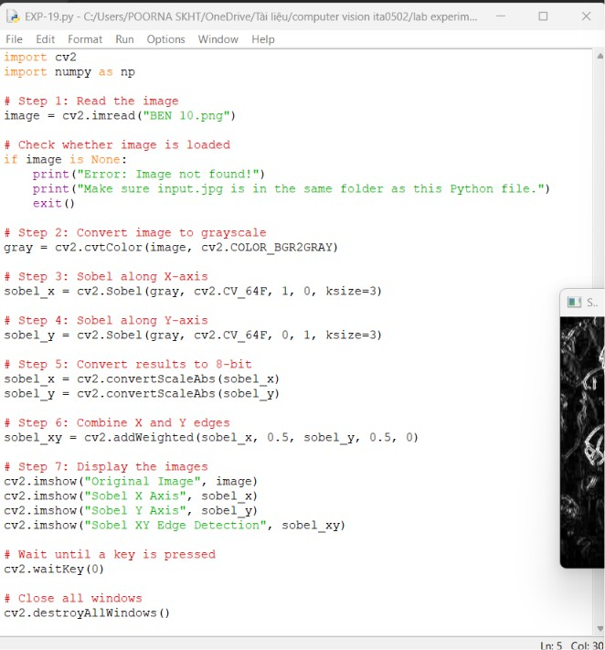

OUTPUT :
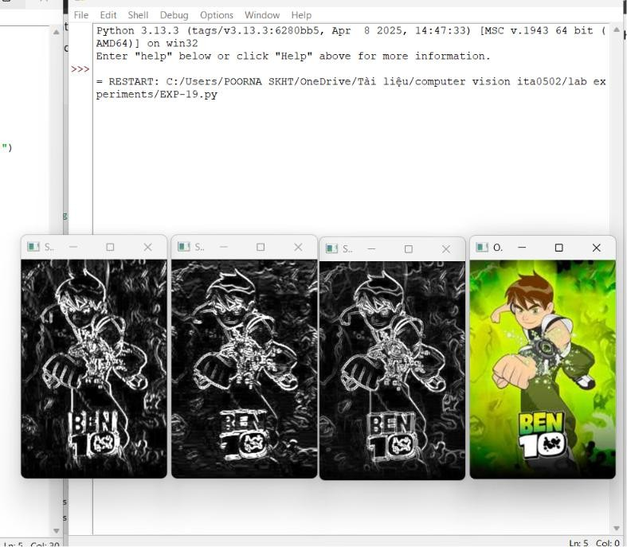
Result:
The edges of the image are successfully detected using the Sobel operator along the X and Y axes.

