LAB EXPERIMENT
ITA0506-COMPUTER VISION
K Nitheesh Kumar -192325090
EXPNO:20
Aim
To sharpen an image using a Laplacian mask with a negative center coefficient.

Algorithm
- Read the input image.
- Convert the image to grayscale.
- Define a Laplacian sharpening mask with a negative center coefficient.
- Apply the mask using convolution.
- Obtain the sharpened image.
- Display the original and sharpened images.
Code:
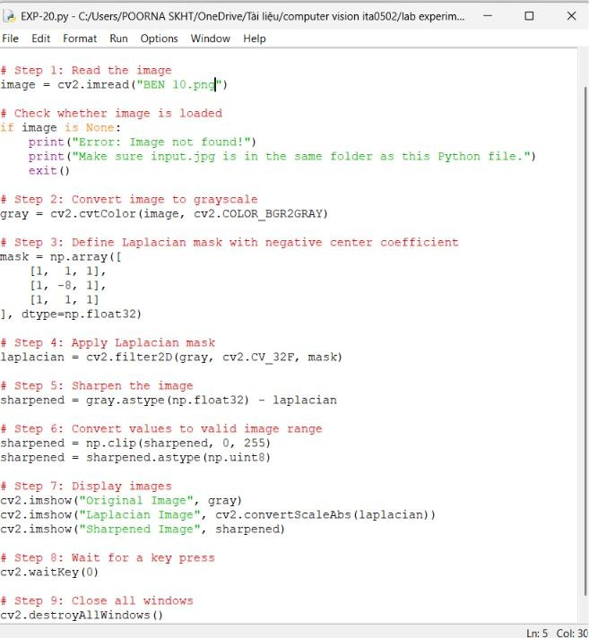

OUTPUT :
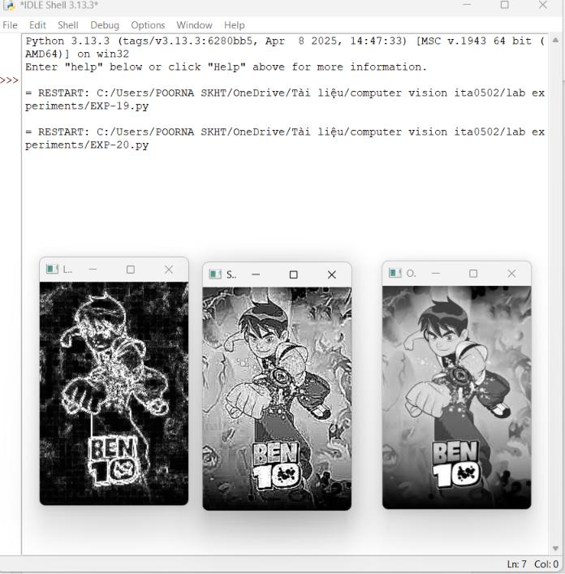

Result
The input image is successfully sharpened using a Laplacian mask with a negative center coefficient. The edges and fine details become more prominent in the sharpened image.

