LAB EXPERIMENT
ITA0506-COMPUTER VISION
K Nitheesh Kumar -192325090
EXPNO:21

Aim
To sharpen an image using a Laplacian mask implemented with an extension to diagonal neighbors.

Laplacian Mask
The 8-neighbor Laplacian mask is:
1 1 1
1 -8 1
1 1 1
Here, the four diagonal pixels are also included along with the top, bottom, left, and right pixels.
For sharpening:
Sharpened Image = Original Image - Laplacian Image

Algorithm
- Read the input image.
- Convert the image to grayscale.
- Define the 3×3 Laplacian mask with diagonal neighbors.
- Apply the mask using convolution.
- Subtract the Laplacian result from the original image.
- Clip the pixel values to the range 0–255.
- Display the original, Laplacian, and sharpened images.

Code:
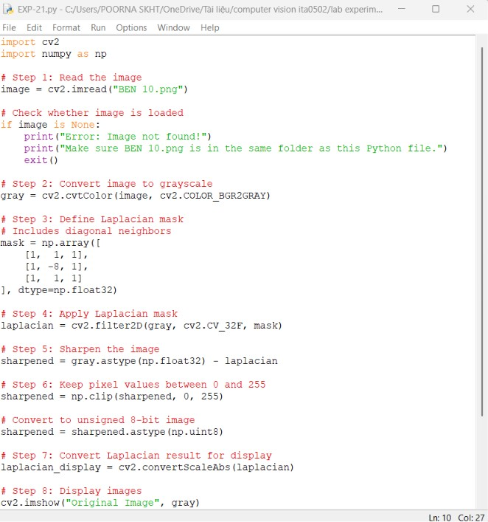

OUTPUT :
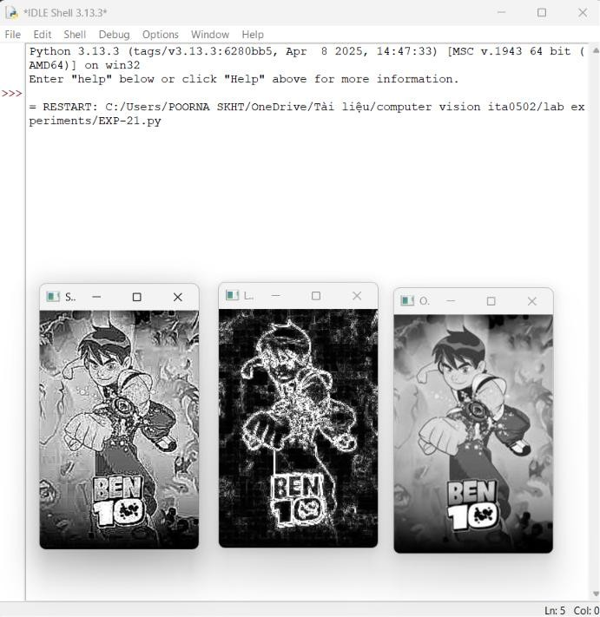

Result
The image is successfully sharpened using a Laplacian mask with diagonal neighbors. The inclusion of diagonal neighbors helps detect edges in all eight directions, making fine details and boundaries more prominent.

