LAB EXPERIMENT
ITA0506-COMPUTER VISION
K Nitheesh Kumar -192325090
EXPNO:22
Aim
To sharpen an image using a Laplacian mask with a positive center coefficient.

Laplacian Mask
A commonly used 4-neighbor Laplacian mask with a positive center coefficient is:
0 -1 0
-1 4 -1
0 -1 0
For sharpening, the Laplacian result is added to the original image:
Sharpened Image = Original Image + Laplacian Image

Algorithm
- Read the input image.
- Convert the image to grayscale.
- Define the Laplacian mask with a positive center coefficient.
- Apply the mask using convolution.
- Add the Laplacian image to the original image.
- Limit pixel values between 0 and 255.
- Display the original and sharpened images.

Code:
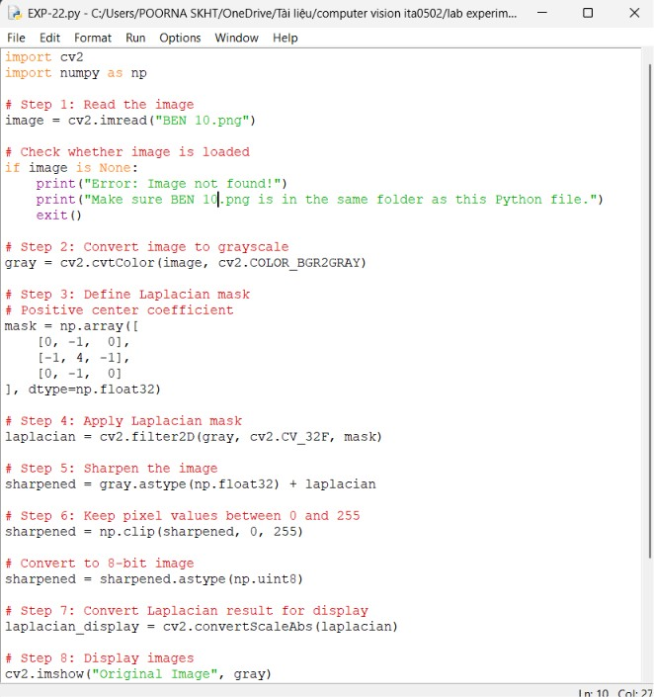

OUTPUT :
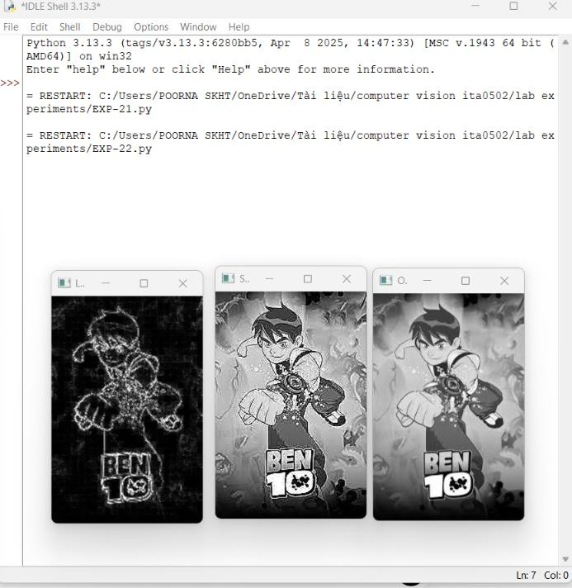

Result
The image is successfully sharpened using a Laplacian mask with a positive center coefficient. The edges and fine details of the image become more prominent.

