LAB EXPERIMENT
ITA0506-COMPUTER VISION
K Nitheesh Kumar -192325090
EXPNO:23

Aim
To sharpen an image using the Unsharp Masking technique.
Principle
Unsharp masking sharpens an image by subtracting a blurred version of the image from the original image.
Formula: where:
- = Original image
- = Blurred image
- = Sharpened image
Note: The formula in your provided image gives the high-frequency/detail mask. In practical image sharpening, the final sharpened image is usually obtained by adding this mask back to the original:
Sharpened Image = Original Image + Mask

Algorithm
- Read the input image.
- Convert the image to grayscale.
- Apply Gaussian Blur to obtain the blurred image.
- Subtract the blurred image from the original image to obtain the unsharp mask.
- Add the mask to the original image.
- Display the original, blurred, mask, and sharpened images.

Code:
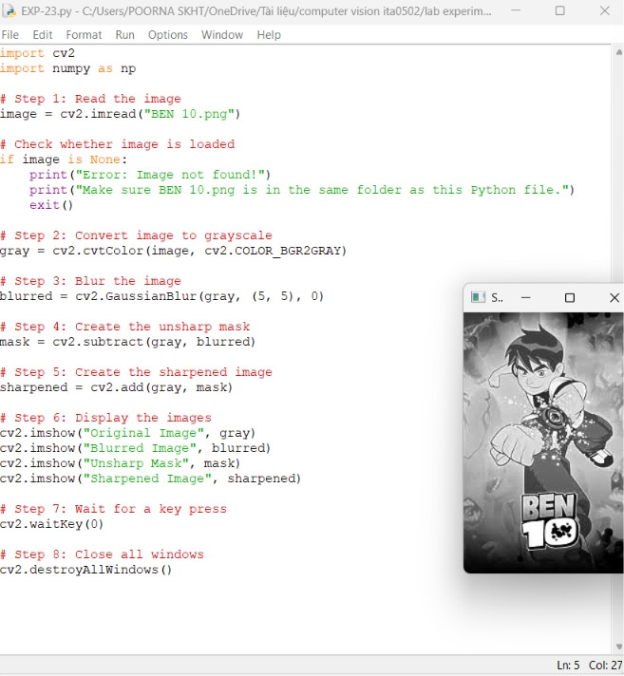

OUTPUT :
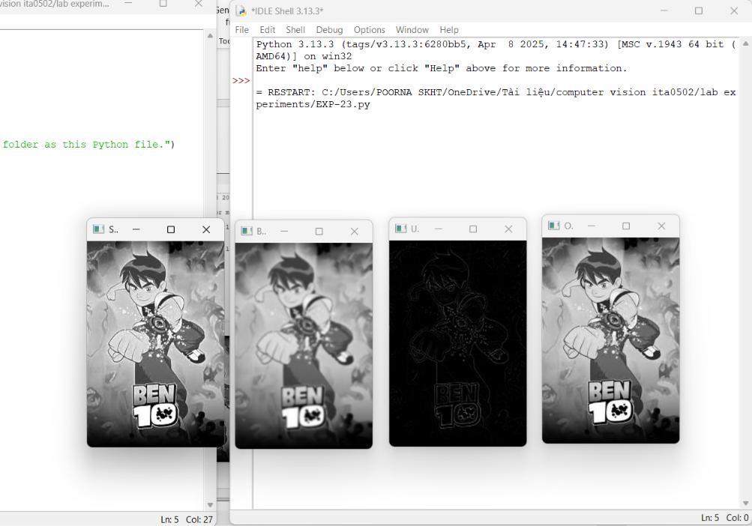

Result
The image is successfully sharpened using the Unsharp Masking technique. The blurred image is subtracted from the original to extract high-frequency details, and these details are added back to produce a sharper image.

