LAB EXPERIMENT
ITA0506-COMPUTER VISION
K Nitheesh Kumar -192325090
EXPNO:25

Aim
To sharpen an image using a High-Boost Masking technique.
Principle
High-boost filtering is an extension of unsharp masking. It increases the contribution of the original image while adding the high-frequency details.
The formula is:
where:
- = Original image
- = Blurred image
- = High-boost constant
- = Sharpened image
•
When A = 1, it becomes standard Laplacian/unsharp sharpening.
High-Boost Masks
As shown in your image, two masks can be used.
4-neighbor mask:
0 -1 0
-1 A+4 -1
0 -1 0
8-neighbor mask:
-1 -1 -1
-1 A+8 -1
-1 -1 -1
Here, we will use A = 2.

Algorithm
- Read the input image.
- Convert the image to grayscale.
- Select the high-boost value .
- Create the high-boost mask.
- Apply the mask to the image using convolution.
- Limit pixel values between 0 and 255.
- Display the original and sharpened images.
CODE:
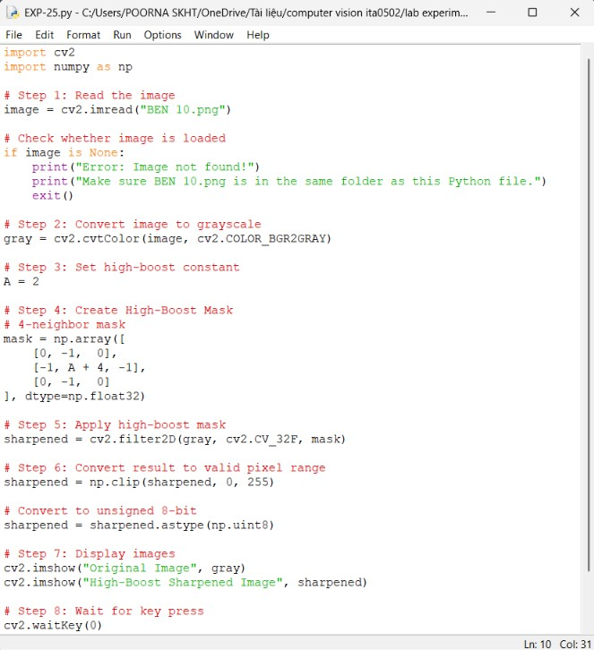

OUTPUT :
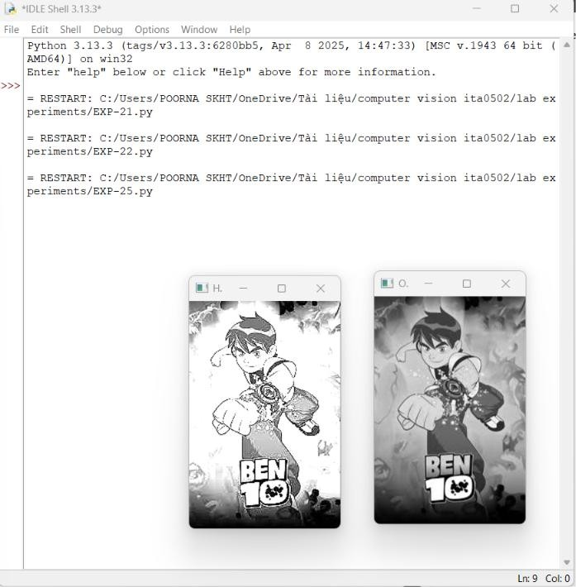

Result
The image is successfully sharpened using a High-Boost Mask. The high-boost mask enhances edges and fine details while retaining the main information of the original image.

