LAB EXPERIMENT
ITA0506-COMPUTER VISION
K Nitheesh Kumar -192325090
EXPNO:26 Insert Watermark Using OpenCV Aim
To insert a watermark text into an image using OpenCV.

Algorithm
- Import the OpenCV library.
- Read the input image BEN 10.png.
- Check whether the image is loaded successfully.
- Define the watermark text.
- Select the font, position, size, and color of the watermark.
- Use cv2.putText() to add the watermark to the image.
- Display the original and watermarked images.
- Save the watermarked image.
- Close all windows CODE:
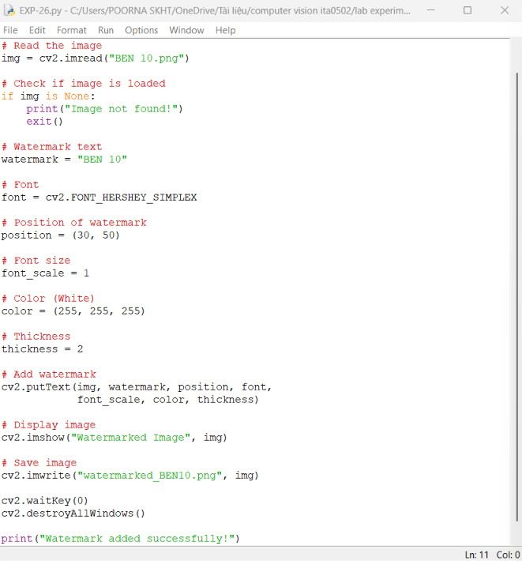

OUTPUT :
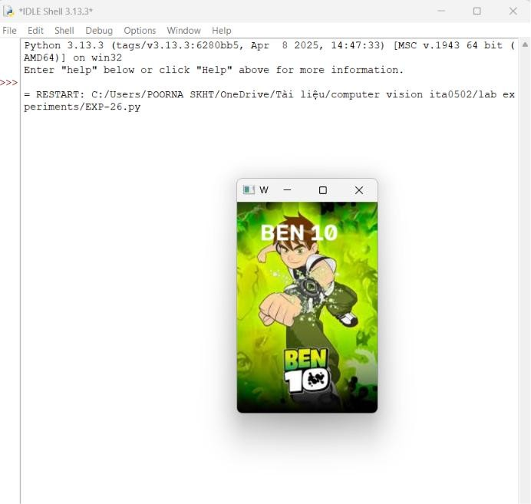

Result
The watermark text "BEN 10" is successfully inserted into the image, and the watermarked image is saved as watermarked_BEN10.png.

