LAB EXPERIMENT
ITA0506-COMPUTER VISION

K Nitheesh Kumar -192325090
EXPNO: 27. Cropping, Copying and Pasting Image Inside Another Image Using OpenCV

Aim
To perform cropping, copying, and pasting of a selected part of an image inside another image using OpenCV.

Algorithm
- Import OpenCV.
- Read the image BEN 10.png.
- Select a region of interest (ROI).
- Crop the selected region.
- Copy the cropped region.
- Paste it at another position in the image.
- Display and save the result.
CODE:
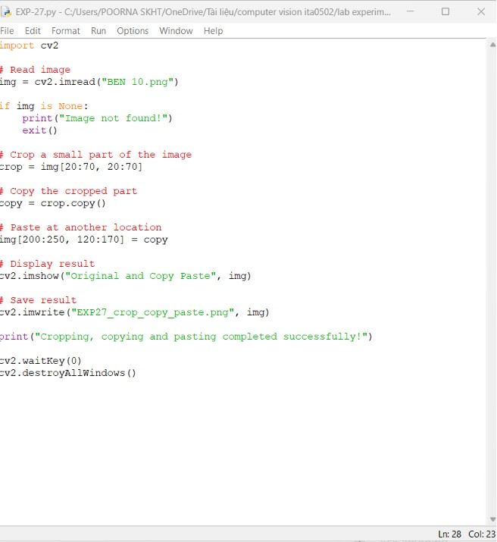

OUTPUT :
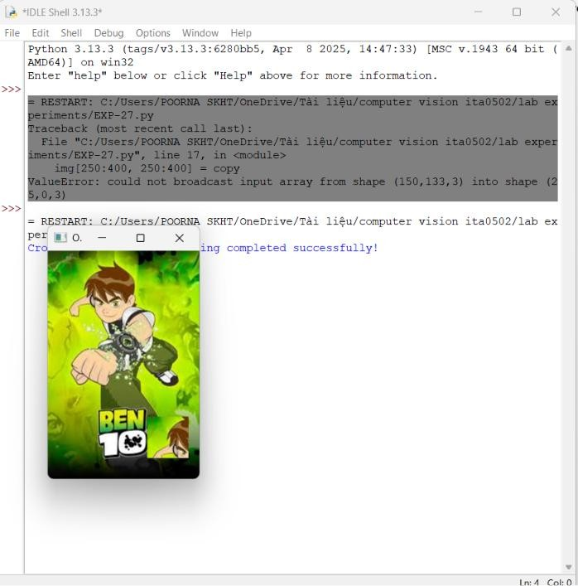

Result
The selected portion of BEN 10.png is successfully cropped, copied, and pasted at another location in the same image.

