LAB EXPERIMENT
ITA0506-COMPUTER VISION
K Nitheesh Kumar -192325090
EXPNO: 28. Find the Boundary of the Image Using Convolution Kernel
Aim
To find the boundary/edges of an image using a convolution kernel in OpenCV.
Algorithm
- Import OpenCV.
- Read BEN 10.png.
- Convert the image to grayscale.
- Define a convolution kernel.
- Apply the kernel using cv2.filter2D().
- Display the detected boundaries.
- Save the result.
CODE:
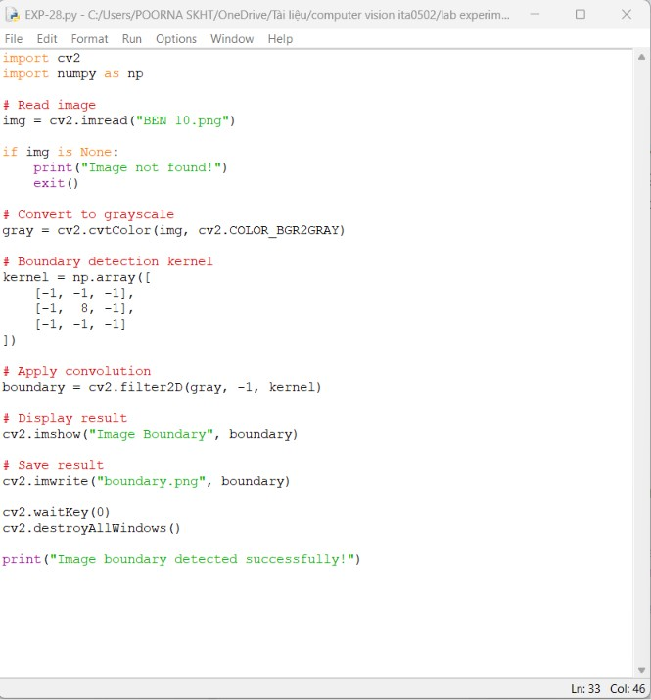

OUTPUT :
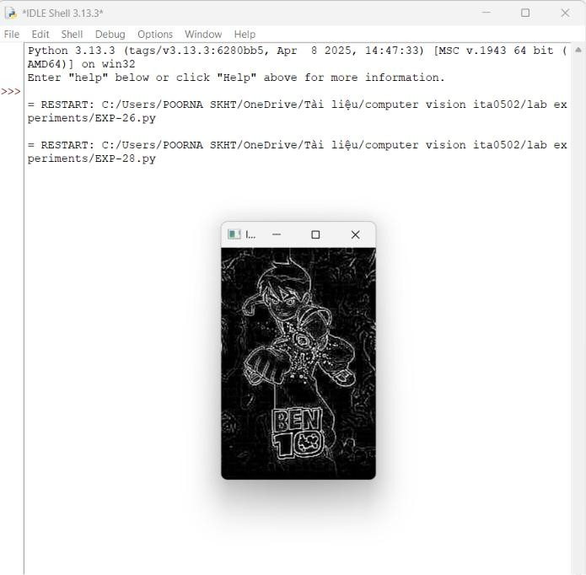
Result
The boundaries of the image are successfully detected using a convolution kernel.

