LAB EXPERIMENT
ITA0506-COMPUTER VISION
K Nitheesh Kumar -192325090
EXPNO:29. Morphological Operation Using Erosion
Aim
To perform morphological erosion on an image using OpenCV.

Algorithm
- Import OpenCV.
- Read BEN 10.png.
- Convert the image to grayscale.
- Create a morphological kernel.
- Apply erosion using cv2.erode().
- Display and save the result.
CODE:
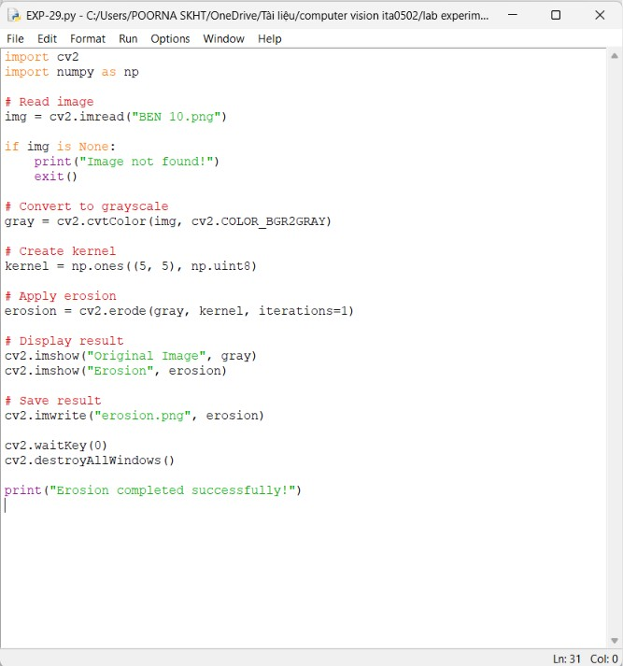

OUTPUT :
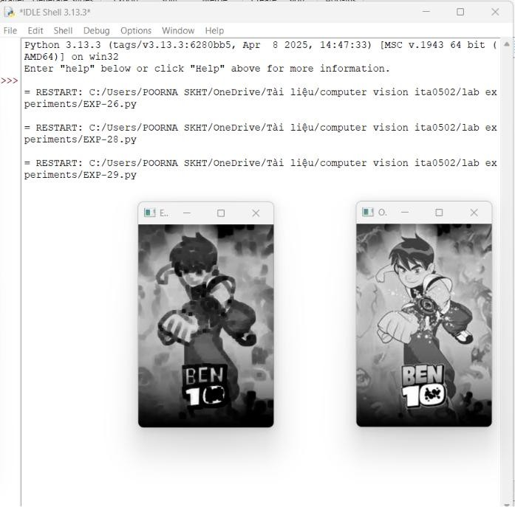

Result
Erosion is successfully performed. The objects in the image become thinner and small white regions are reduced.

