LAB EXPERIMENT
ITA0506-COMPUTER VISION
K Nitheesh Kumar -192325090
EXPNO: 30. Morphological Operation Using Dilation
Aim
To perform morphological dilation on an image using OpenCV.

Algorithm
- Import OpenCV.
- Read BEN 10.png.
- Convert the image to grayscale.
- Create a morphological kernel.
- Apply dilation using cv2.dilate().
- Display and save the result.
CODE:
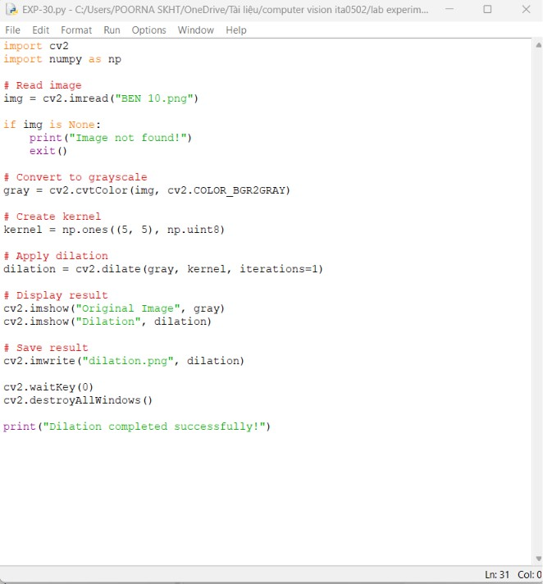

OUTPUT :
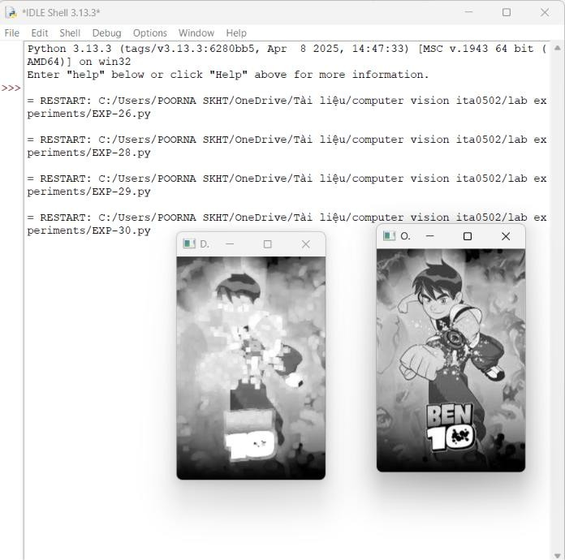

Result
Dilation is successfully performed. The objects in the image become thicker and small gaps are reduced.

