LAB EXPERIMENT
ITA0506-COMPUTER VISION
K Nitheesh Kumar -192325090
EXPNO: 31. Morphological Operation Using Opening
Aim
To perform morphological opening on an image using OpenCV.

Algorithm
- Import OpenCV.
- Read BEN 10.png.
- Convert the image to grayscale.
- Create a kernel.
- Apply opening using cv2.morphologyEx().
- Display and save the result.
CODE:
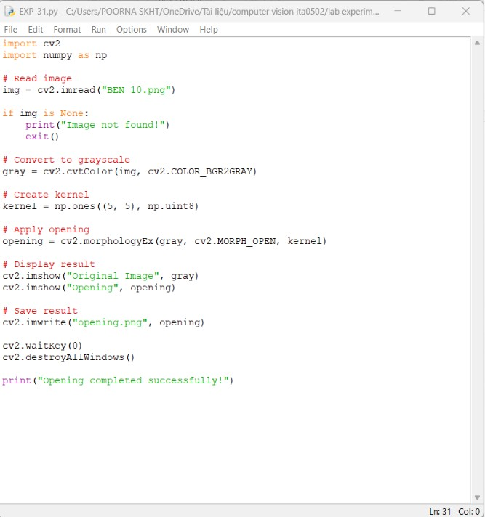

OUTPUT :
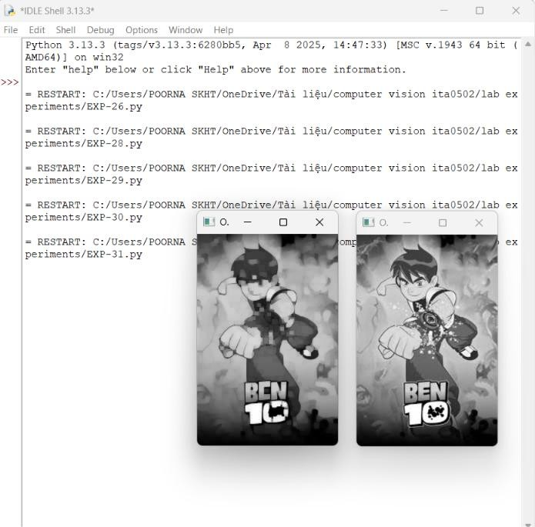

Result
Morphological opening is successfully performed. It helps remove small unwanted noise from the image.

