LAB EXPERIMENT
ITA0506-COMPUTER VISION

K Nitheesh Kumar -192325090
EXPNO: 33. Morphological Gradient Technique
Aim
To perform morphological gradient on an image using OpenCV.

Algorithm
- Import OpenCV.
- Read BEN 10.png.
- Convert the image to grayscale.
- Create a morphological kernel.
- Apply morphological gradient using cv2.morphologyEx().
- Display and save the result.
CODE:
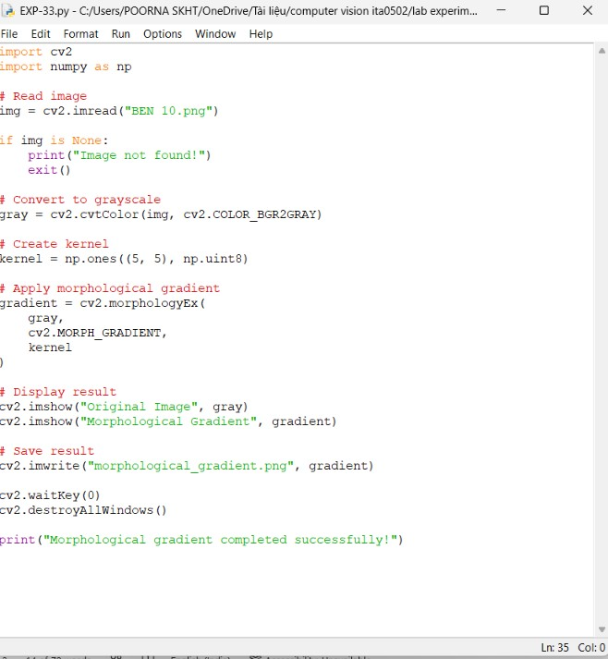

OUTPUT :
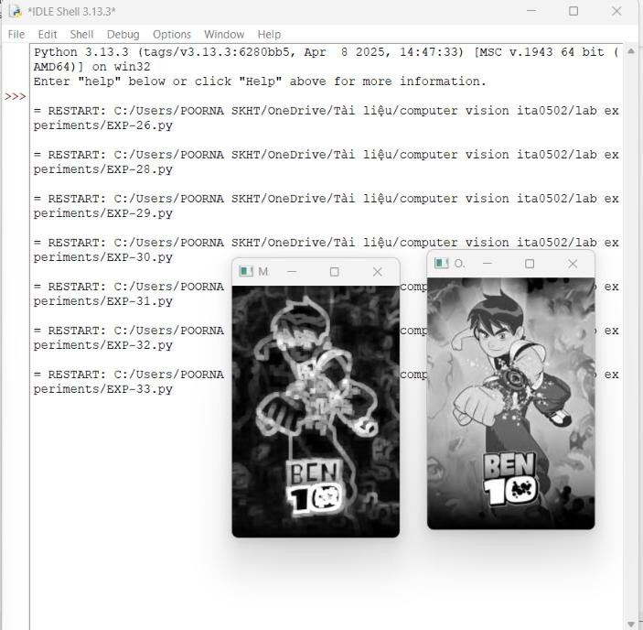

Result
The morphological gradient is successfully obtained, highlighting the boundaries of objects in the image.

