LAB EXPERIMENT
ITA0506-COMPUTER VISION
K Nitheesh Kumar -192325090
EXPNO: 34. Morphological Operation Using Top Hat
Aim
To perform Top Hat morphological operation on an image using OpenCV.

Algorithm
- Read BEN 10.png.
- Convert the image to grayscale.
- Create a morphological kernel.
- Apply Top Hat operation.
- Display and save the result.
CODE:
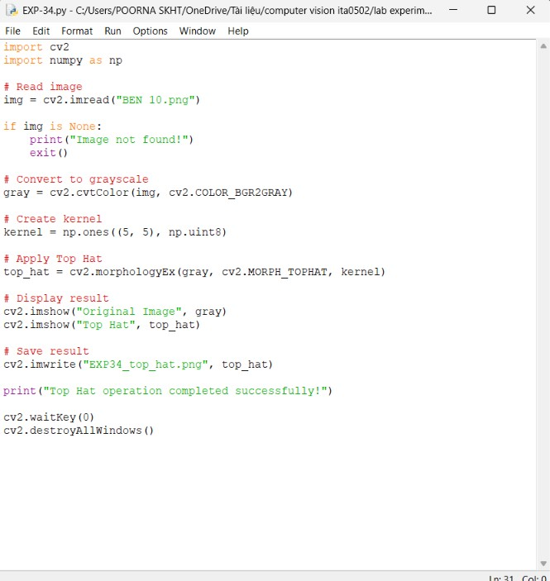

OUTPUT :
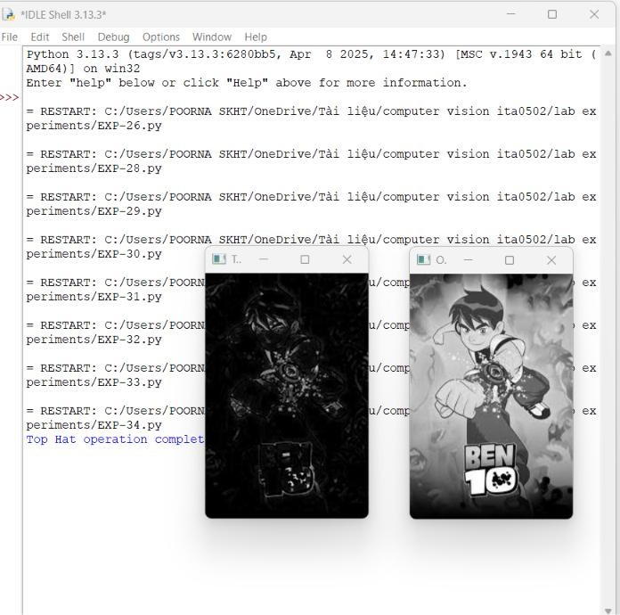

Result
The Top Hat morphological operation is successfully performed to highlight small bright regions in the image.

