LAB EXPERIMENT
ITA0506-COMPUTER VISION

K Nitheesh Kumar -192325090
EXPNO:35 Morphological Operation Using Black Hat Aim
To perform Black Hat morphological operation on an image using OpenCV.
Algorithm
- Read BEN 10.png.
- Convert the image to grayscale.
- Create a morphological kernel.
- Apply Black Hat operation.
- Display and save the result
CODE:
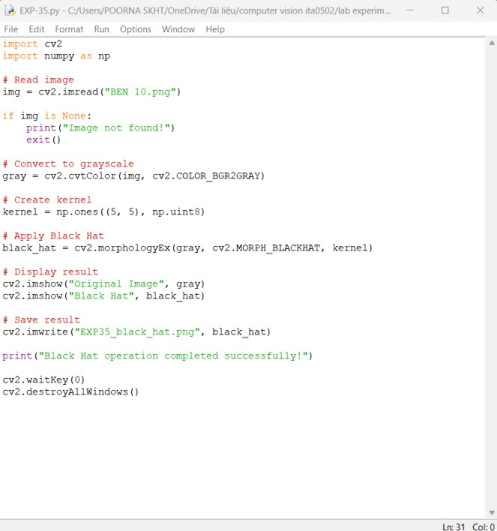
OUTPUT :
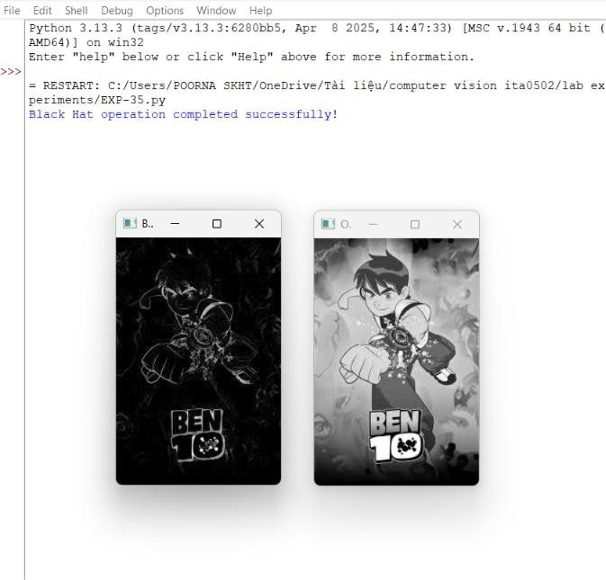
Result
The Black Hat morphological operation is successfully performed to highlight small dark regions in the image.

