LAB EXPERIMENT
ITA0506-COMPUTER VISION
K Nitheesh Kumar -192325090
EXPNO: 36. Recognise Watch Using OpenCV
Aim:
To recognize a watch from the given image using OpenCV.
Algorithm
- Import OpenCV.
- Read the image WATCH.PNG.
- Convert the image into grayscale.
- Apply Gaussian blur to reduce noise.
- Detect the circular watch region using Hough Circle Transform.
- Draw a circle around the detected watch.
- Display and save the result.
CODE:
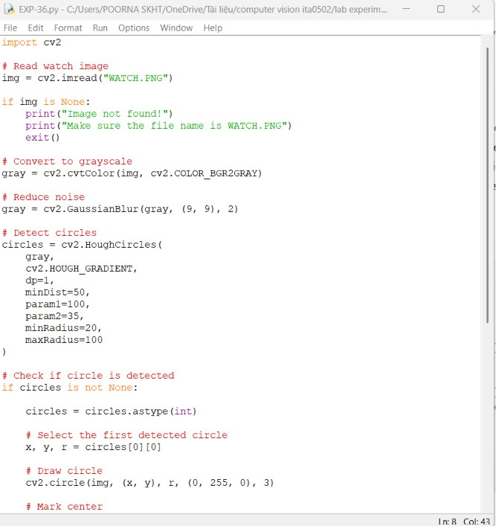
OUTPUT :

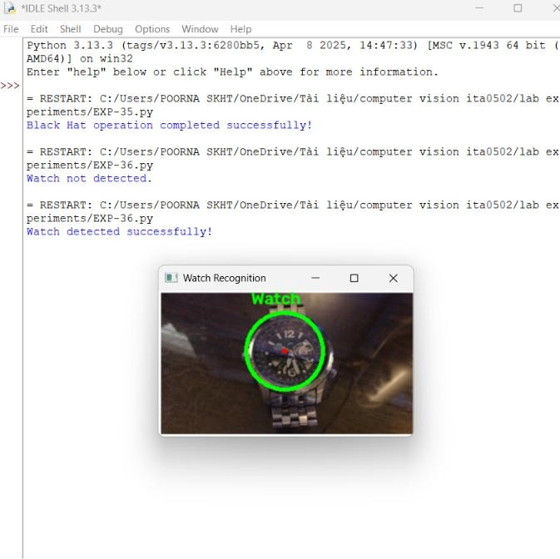
Result
The circular region corresponding to the watch is detected and marked using OpenCV.

