LAB EXPERIMENT
K Nitheesh Kumar -192325090
EXPNO: 37. Using OpenCV to Play Video in Reverse Mode
Aim
To play a car video in reverse mode using OpenCV.
Algorithm
- Import OpenCV.
- Read the video file CAR.mp4.
- Store all video frames.
- Read the frames from the last frame to the first frame.
- Display the video in reverse.
- Press ESC to stop.
- Close the video window.
CODE:
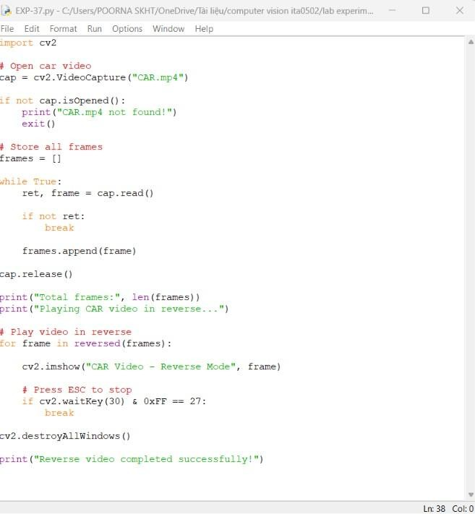
OUTPUT :

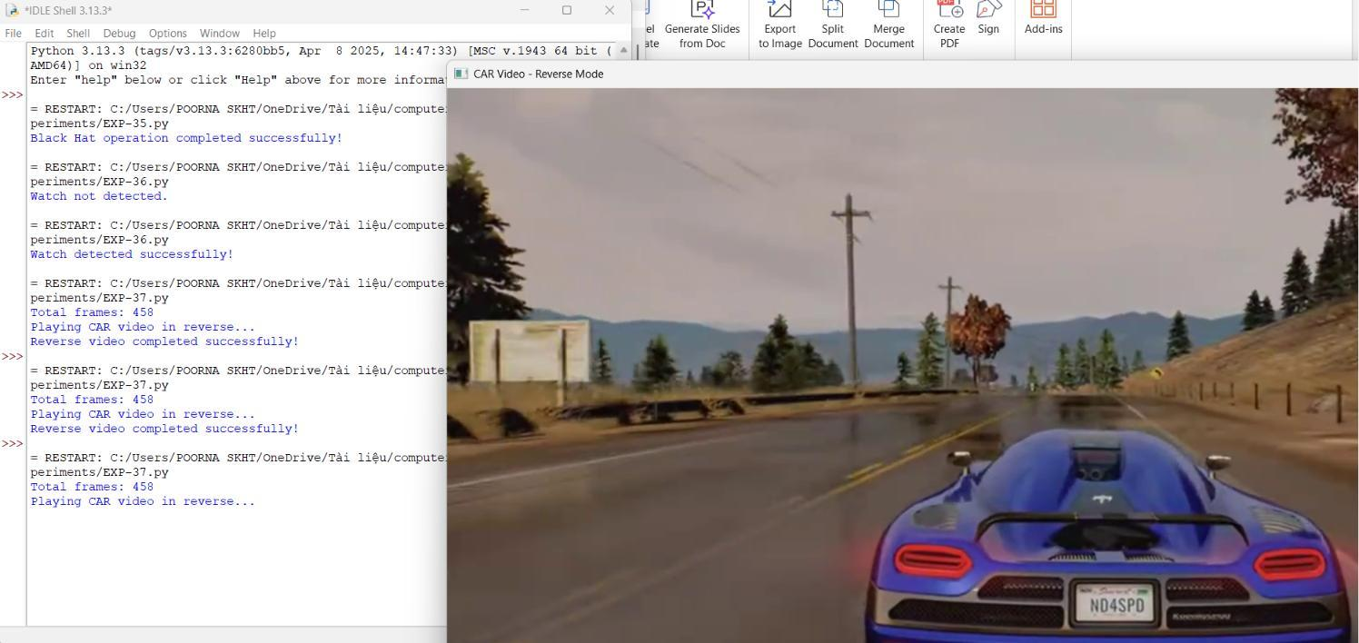
Result
The CAR.mp4 video is successfully played in reverse mode using OpenCV.

