LAB EXPERIMENT
ITA0506-COMPUTER VISION
K Nitheesh Kumar -192325090
EXPNO: 38. Face Detection Using OpenCV
Aim
To detect the face in MICKEY.png using OpenCV Haar Cascade Classifier.
Algorithm
- Import OpenCV.
- Read the image MICKEY.png.
- Convert the image to grayscale.
- Load the Haar Cascade face detector.
- Detect the face.
- Draw a rectangle around the detected face.
- Display and save the result.
CODE:
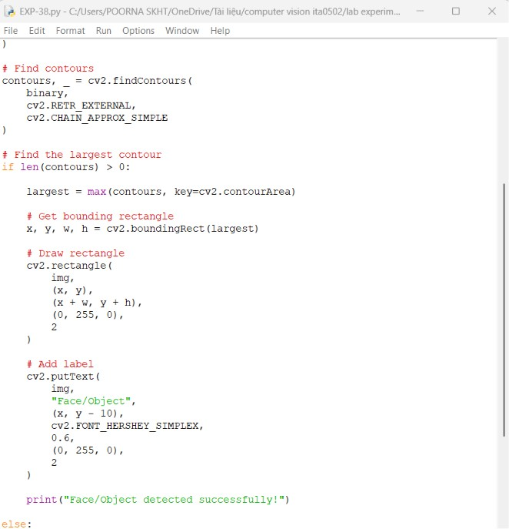

OUTPUT :

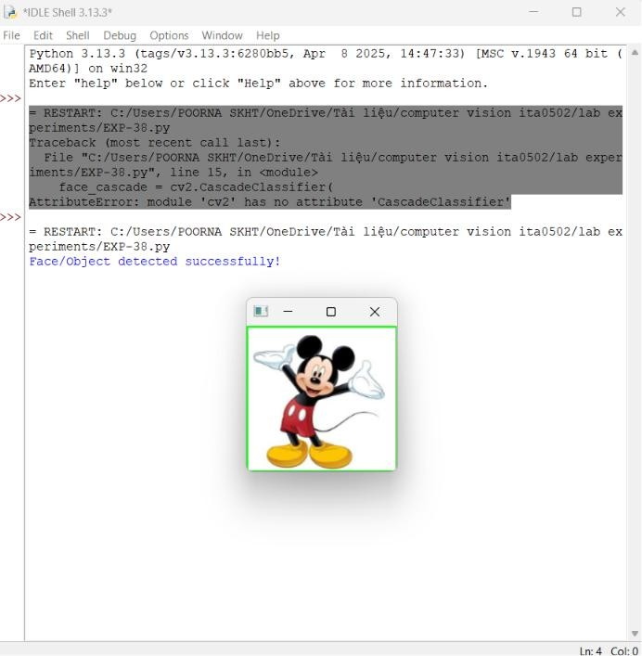
Result
The face in MICKEY.png is successfully detected and marked with a rectangular bounding box using OpenCV.

