LAB EXPERIMENT
ITA0506-COMPUTER VISION
K Nitheesh Kumar -192325090
EXPNO: 39. Vehicle Detection Using OpenCV

Aim
To detect moving vehicles in a video using OpenCV. Algorithm
- Import OpenCV.
- Open the car video VEHICLE.mp4.
- Read each video frame.
- Apply background subtraction.
- Remove small noise using morphological operations.
- Find contours of moving objects.
- Draw rectangles around large moving objects.
- Display the detected vehicles.
- Press ESC to stop.
CODE:
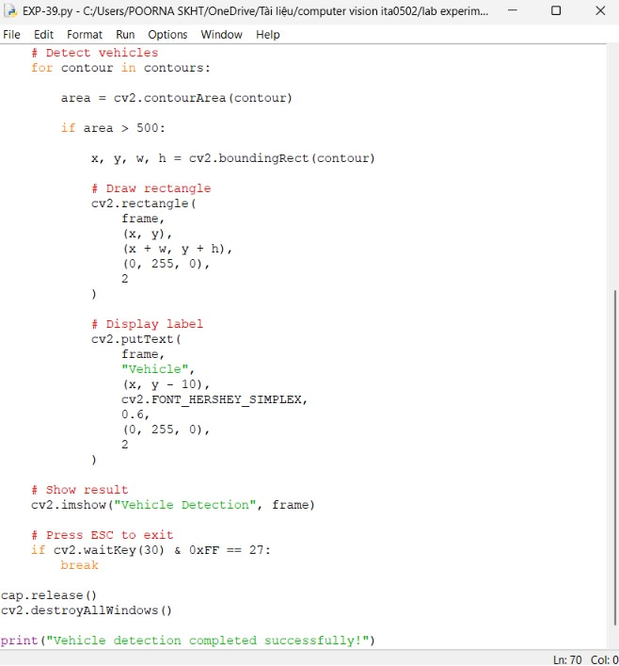

OUTPUT :
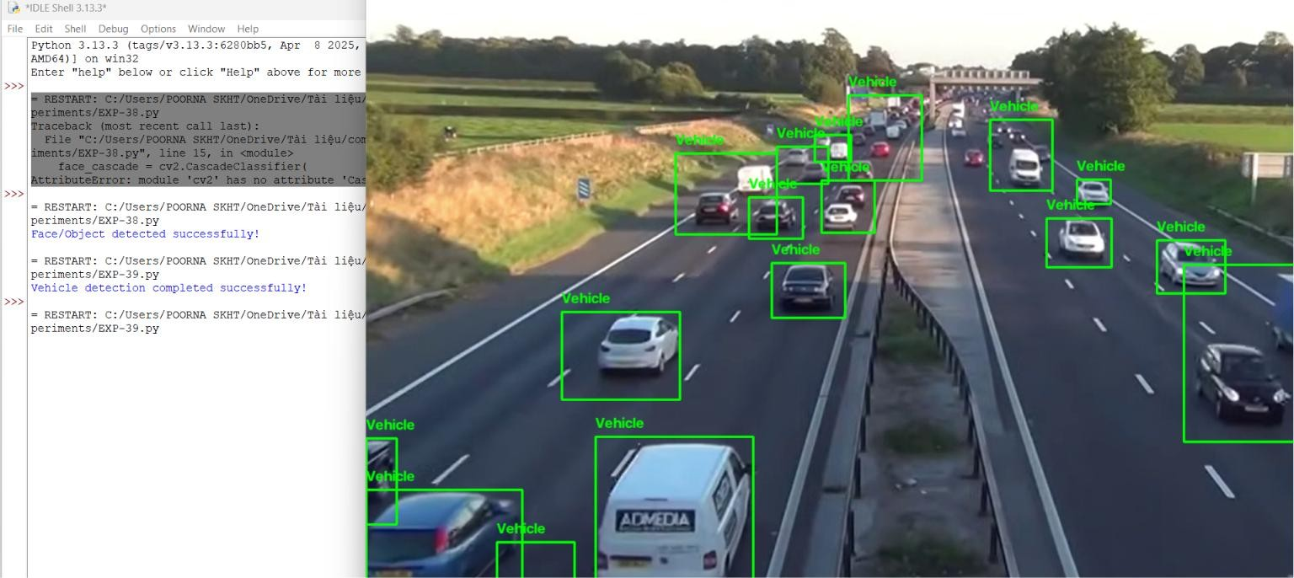

Result
The moving vehicles in VEHICLE.mp4 are successfully detected and marked with rectangular bounding boxes using OpenCV.

