LAB EXPERIMENT
ITA0506-COMPUTER VISION
K Nitheesh Kumar -192325090
EXPNO: 40. Draw Rectangle and Extract Object Using OpenCV
Aim
To draw a rectangular bounding box around an object and extract the object from BEN 10.png using OpenCV.
Algorithm
- Import OpenCV.
- Read the image BEN 10.png.
- Convert the image to grayscale.
- Apply thresholding.
- Find contours in the image.
- Find the largest object.
- Draw a rectangle around the object.
- Extract the object using the rectangle coordinates.
- Display and save the result.
Code:
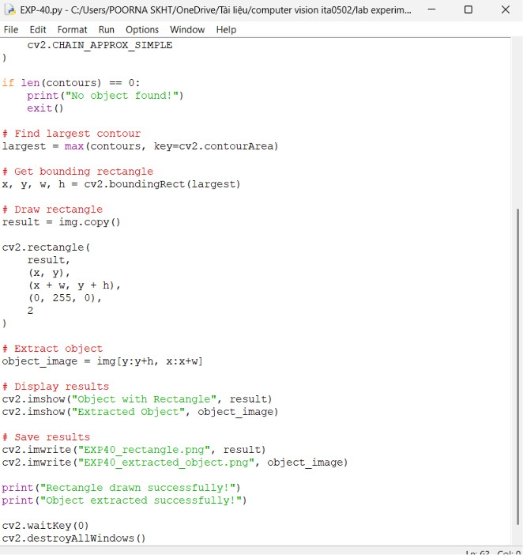
OUTPUT:
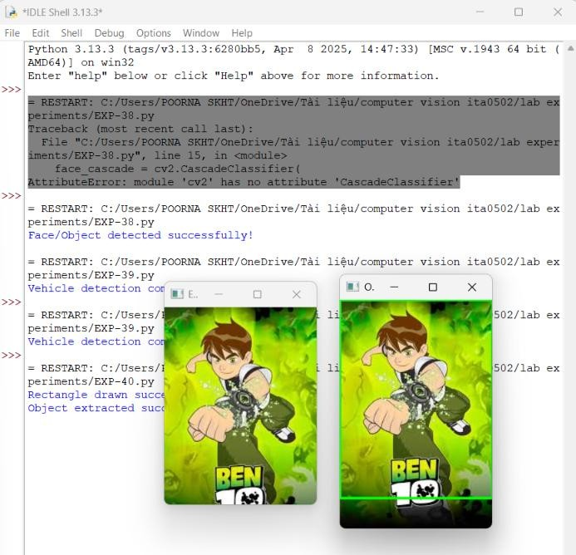

Result
The object in BEN 10.png is successfully enclosed within a rectangular bounding box and extracted using OpenCV.

