**E-COMMERCE APPLICATION ON IBM CLOUD FOUNDRY**

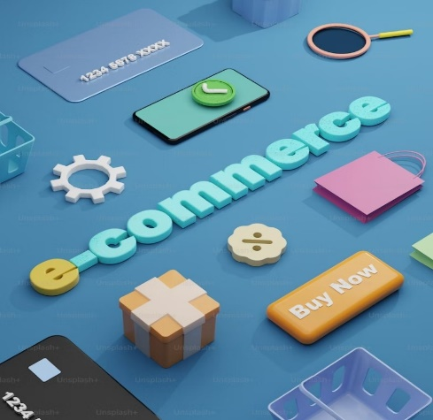

**SUBMITTED BY**

SANDIP MONDAL

SRINITHESH

SURYA

SADURDEVA

**PHASE 3 SUBMISSION DOCUMENT**

**Phase 3:** Development part1

**Topic:** Design the platform layout and create a database to store product information.

**Problem Statement**:

In this part you will need to understand the problem statement and create a document on what have you understood and how will you proceed ahead with solving the problem. Please think on a design and present in form of a document.

**Steps to create E-Commerce Application**

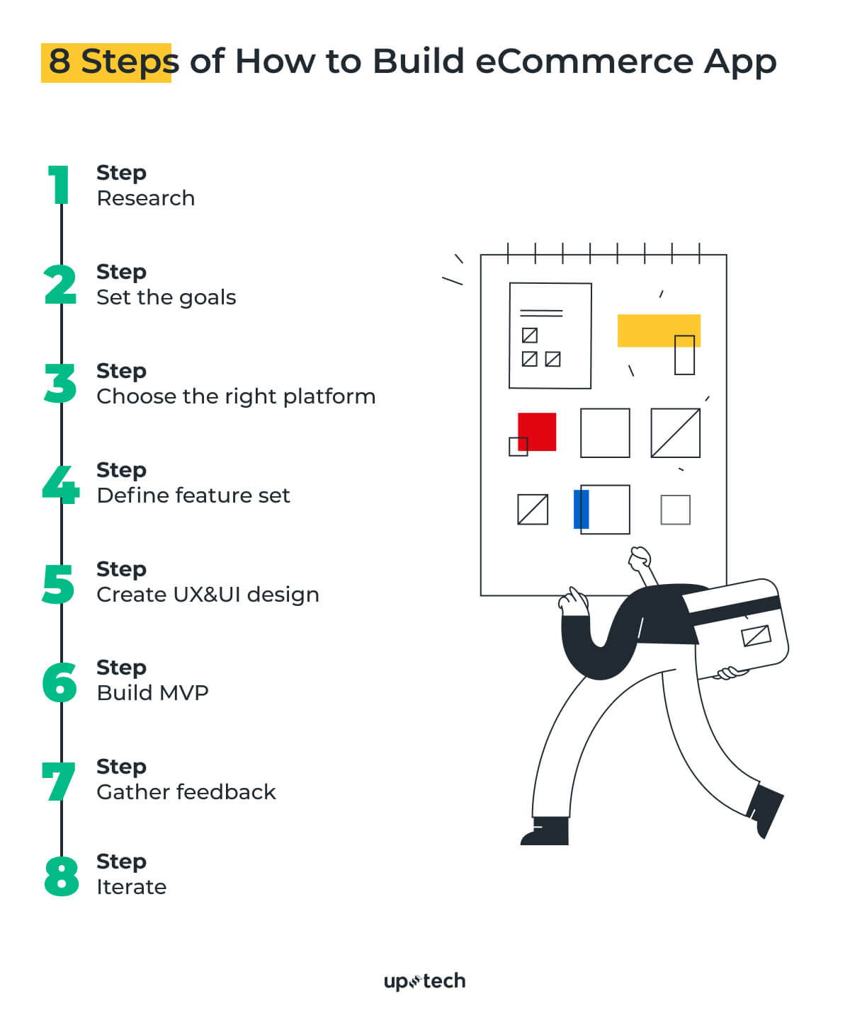

**Design e-commerce platform layout and create database to store product information coding**

1. **Planning and Design**:

* Start by creating wireframes or mockups of your e-commerce platform's layout. Tools like Adobe XD, Sketch, Figma , or even simple pen and paper can be used for this.
* Plan the user interface (UI) design, including navigation, product listings, product pages, shopping cart, and checkout process.

1. **Front-End Development:**

* Develop the front-end using web technologies such as HTML, CSS, and JavaScript. You can use popular frameworks like React, Angular, or Vue.js for this purpose.
* Implement the layout and user interface design in your front-end code.

**3. Back-End Development:**

* Choose a programming language and framework for your back end. Common choices include Python with Django, Ruby on Rails, or Node.js with Express.
* Create an API for your front end to communicate with the back end.
* Implement user authentication, including registration and login.

**4.Database Design:**

* Choose a database system, such as MySQL, PostgreSQL, or NoSQL databases like MongoDB, based on your requirements.
* Design the database schema to store product information, user data, orders, and other necessary information.

**5. Database Implementation:**

* Write SQL or NoSQL queries to create tables and define relationships.
* Populate the database with sample data for testing and development.

**6. Product Information:**

* Create a table to store product details, including attributes like name, description, price, stock, and images.
* Implement an admin panel or a data entry system to add, update, and delete products.

**7. Connect Front-End to Back-End:**

* Use API calls to retrieve and display product information on your e-commerce platform.
* Implement shopping cart functionality to allow users to add and manage products.

**8. Security and Payment Processing:**

* Implement secure payment processing using a payment gateway such as Stripe or PayPal.
* Ensure that your platform follows security best practices to protect user data.

**9.Testing:**

* Test your e-commerce platform thoroughly, including functionality, user experience, and security.
* Fix any bugs or issues that arise during testing.

**10. Deployment:**

* Choose a hosting environment for your application, such as AWS, Heroku, or a dedicated server.
* Deploy your front-end and back-end code, along with the database.

**11. Monitoring and Maintenance:**

* Set up monitoring tools to track the performance of your platform.
* Plan for regular maintenance and updates to keep your platform secure and up to date.

**Create a New Cloud Foundry Application:**

* Use the IBM Cloud CLI to create a new Cloud Foundry application.
* This will allocate the necessary resources for your app.

CODE: **ibmcloud cf create-service**

**Set Up Your Development Environment:**

* Create a new project directory on your local machine.
* Initialize a version control system (e.g., Git) to track your code changes.

**Code Your E-commerce Application:**

* Write the code for your e-commerce application using your chosen programming language and framework.
* Implement features such as product listings, product detail pages, shopping cart functionality, and user authentication.

**Database Integration:**

* Connect your application to a database service on IBM Cloud, such as IBM Db2 or a NoSQL database like Cloudant.
* Configure your application to use this database for storing product information, user data, and order history.

**Payment Integration:**

* Integrate a payment gateway (e.g., Stripe or PayPal) to handle online transactions securely.

**Testing:**

* Thoroughly test your application, including both functionality and security.
* Ensure that user data is handled securely and that payment transactions work as expected.

**Deploy to IBM Cloud Foundry:**

* Use the IBM Cloud CLI to deploy your application to the IBM Cloud Foundry.

CODE : ibmcloud cf push <your-app-name>

**Configure Environment Variables:**

* Set environment variables for your application, including any secrets or configuration values.

CODE : ibmcloud cf set-env <your-app-name> ENV_VARIABLE_NAME ENV_VARIABLE_VALUE

ibmcloud cf restage <your-app-name>

**Monitoring and Scaling:**

* Set up monitoring tools to track the performance of your application.
* Configure auto-scaling rules to handle traffic fluctuations.

**Monitoring and Scaling:**

* Set up monitoring tools to track the performance of your application.
* Configure auto-scaling rules to handle traffic fluctuations.

**Secure Your Application:**

* Implement security best practices, such as using HTTPS, securing APIs, and protecting user data.

**E-commerce Application on IBM Cloud Foundry**

* Our goal is to develop a user-friendly ecommerce application on IBM Cloud Foundry that meets the demands of businesses wanting to sell products and services online.

* This application is efficient order management, scalability,

* The goal is to empower businesses in the digital marketplace by providing a reliable e-commerce solution that ensures a seamless shopping experience while safeguarding customer data.

**Design Thinking**

**Empathize**

* In this phase, we will conduct survey with peoples to get their informations about the existing e-commerce sites. This will help us to build our application more efficiently.Design Thinking.

**Define**

* Identify the key functionalities and features of our application by using the insites were collected from peoples.Design Thinking.

**Ideate**

* Brainstorm possible solutions. Encourage creative thinking and consider various approaches to building the application. Think about how technology, user experience, and business goals can intersect.Design Thinking.

**Prototype**

* Create a prototype of our e-commerce application. This could be paper sketches, wireframes, or a basic digital mockup. The goal is to quickly visualize and test your ideas.Design Thinking.

**Test**

* Finally test our application. Get the user’s suggestion and redesign the prototype untill it reaches the user satisfication.

**Development Phases**

* In first first phase of we have developed front end for User Interation and designed Database for storing necessarry user’s data. We used HTML, CSS and Javascript for the front end development.

* In the second phasem, we have developed back end for the application with user authentication, cart functionalities and order checkout functionality .We used Laravel for the back end development. Laravel is the php framework.

Top of Form

