BIRLA INSTITUTE OF TECHNOLOGY & SCIENCE, PILANI
Work Integrated Learning Programmes Division

Post Graduate Program
in
Artificial Intelligence and Machine Learning

Guidelines for preparation of the Final Report

Some formats are provided for preparation of the abstract, cover page, title page, certificate from the Supervisor, and reference / bibliography. The student should adhere to these formats while preparing the report. A checklist of items to be included in the Final Report is also provided. One submission of Project Report from a group is expected. The following sequence should be followed in the presentation of the Final Report:

- Cover Page. -1
- Title page (inner cover) -1
- Acknowledgements -1
- Certificate from the Mentor -1
- Dissertation Abstract -1
- List of Symbols & Abbreviations used -1
- List of Tables -1
- List of Figures -1
- Table of contents -2
- Chapters 1, 2, 3, etc. (Refer to following Chapter Design for details) – 2 ,3 and 5
- Conclusions / Recommendations - 5
- Directions for future work - 5
- Bibliography / References - 5
- Appendices - 5
- Duly Completed Checklist -5

Chapter Design:
The chapters of the report should typically contain the following items

- Problem statement (what is the problem being addressed) -2
- Objective of the project -2
- Machine Leaning process flow (Consolidated Approach / Solution Architecture) - 2
- Resources needed for the project, including people, hardware, software, etc. - 2
- Potential data challenges & risks in doing the project - 2
- Detailed Plan of Work - 3
- Pre-Processing Steps (Data processing/Feature preprocessing/Outlier detection & Visualization for Summarization) - 3
- Machine Learning Modelling & Techniques Applied - 3
- Code & Screenshots (Full screenshot without cropping the system date-time) -3
- Interpretation - 4
  - Justification of Measures / Metrics used -4
  - Project output in terms of above measures/metrics -4
  - Visualization Plots -4 ?
- Future Work & Extension or Scope of improvements - 4

Check list of items for the Final report

- Is the Cover page in proper format? Y / N
- Is the Title page in proper format? Y / N
- Is the Certificate from the Mentor in proper format? Has it been signed? Y / N
- Is Abstract included in the Report? Is it properly written? Y / N
- Does the Table of Contents page include chapter page numbers? Y / N
- Does the Report contain a summary of the literature survey? Y / N
  - Are the Pages numbered properly? Y / N
  - Are the Figures numbered properly? Y / N
  - Are the Tables numbered properly? Y / N
  - Are the Captions for the Figures and Tables proper? Y / N
  - Are the Appendices numbered? Y / N
    - Does the Report have Conclusion / Recommendations of the work? Y / N
    - Are References/Bibliography given in the Report? Y / N
    - Have the References been cited in the Report? Y / N
    - Is the citation of References / Bibliography in proper format? Y / N

Note: A copy of this checklist should be included as the last page of the Final report. This checklist, duly completed and signed by the student, should also be verified and signed by the evaluators. Evaluators are requested to ensure that the students have submitted their reports properly.

Illustrative examples of citation of bibliography / references:

1. Book:
A. Gelb, Applied Optimal Estimation. Cambridge, M.A.; M.I.T. Press, 1974.

2. A paper in a Conference or Symposium Proceedings edited and published by a book publishing company:
R.E. Kalman, ‘New Methods in Wiener Filtering Theory’, in Proc. First Symposium on Engineering Applications of Random Function Theory and Probability’ J.L. Bogdanoff and F. Kozin, Editors. New York; Wiley, 1963, pp 270-388.

3. A Journal Paper:
R.E. Kalman and N.S. Pucy, ‘New results in linear filtering and prediction theory’, Trans. ASME, J. Basic Eng., Vol. 83-D, pp. 95-108, Mar. 1961.

4. A Conference Paper:
M. Vidyasagar and N.K. Bose, ‘Input-output stability of linear systems defined over measure spaces’, in Proc. Midwest Symp. Ciro. Syst., Montreal, P.O. Canada, Aug. 1975, pp 394-397.

5. A Ph.D. thesis or Dissertation:
A.C.G. Viera, ‘Matrix orthogonal polynomials, with applications to autoregressive modeling and ladder forms’, Ph.D. Dissertation, Stanford Univ., Stanford, CA, Dec. 1977.

6. A Private Communication:
W.M. Wonham (1982) Private Communication.

I. Format of the Cover Page of the Dissertation

(Title of the Capstone Project)

CAPSTONE PROJECT

Submitted in partial fulfillment of the requirements of the

Post Graduate Certification Program
in
Artificial Intelligence and Machine Learning

By

(Name of the student)
(BITS ID No.)

Under the supervision of

(Name of the Mentor)

Project work carried out at

BIRLA INSTITUTE OF TECHNOLOGY AND SCIENCE
Pilani (Rajasthan) INDIA

(Month, Year)

II. Format of the Title Page (inner cover page) of the Dissertation

PCAM ZC321 CAPSTONE PROJECT

(Title of the Project)

Submitted in partial fulfillment of the requirements of the

PGP - Artificial Intelligence and Machine Learning

By

(Name of the student)
(BITS ID No.)

Under the supervision of

(Name of the Mentor)

Project work carried out at

BIRLA INSTITUTE OF TECHNOLOGY AND SCIENCE
PILANI (RAJASTHAN)

(Month, Year)

III Format of Certificate from the Supervisor

BIRLA INSTITUTE OF TECHNOLOGY AND SCIENCE, PILANI

CERTIFICATE

This is to certify that the Capstone Project entitled_____________________________________
_____________________________________

and submitted by Mr./Ms.______________________________ ID No._____________________

in partial fulfillment of the requirements of PCAM ZC321 Capstone Project, embodies the work

done by him/her under my supervision.

Place : ______________ Signature of the Mentor

Date : _______________ Name : ________________

IV. The following format for Dissertation Abstract should be used

BIRLA INSTITUTE OF TECHNOLOGY & SCIENCE, PILANI
SECOND SEMESTER 2019-20

PCAM ZC321 CAPSTONE PROJECT

Project Title : __________________________________________________________

Name of Mentor : __________________________________________________________

Name of Student : __________________________________________________________

ID No. of Student : __________________________________________________________

Abstract

(Contents of the abstract is to be given here)

Abstract (in about 500 words)

Key Words:

(Note: The Abstract should briefly describe the work done with respect to the goals, in about 500 words. The Abstract in the above format should be included in the bound Report, after the Acknowledgements and immediately before the Table of Contents.).

1 – Arvind
2 – Ganesh
3 – Nithesh
4 -Vibha
5- Aditya

Twitter Sentiment Analysis

CAPSTONE PROJECT

Submitted in partial fulfillment of the requirements of the

Post Graduate Certification Program
in
Artificial Intelligence and Machine Learning

By

Aditya Baskaran 2019AIML028
Aravind V 2019AIML127
Ganesh Sharma 2019AIML014
Nitesh Balakrishnan 2019AIML049
Vibha Kumar 2019AIML153

Under the supervision of

Gautam Gangopadhyay

Project work carried out at

BIRLA INSTITUTE OF TECHNOLOGY AND SCIENCE
Pilani (Rajasthan) INDIA

(November 2020)

BIRLA INSTITUTE OF TECHNOLOGY AND SCIENCE, PILANI

CERTIFICATE

This is to certify that the Capstone Project entitled Twitter Sentiment Analysis and submitted by Mr./Ms.

Aditya Baskaran (2019AIML028),
Aravind V (2019AIML127),
Ganesh Sharma (2019AIML014),
Nitesh Balakrishnan (2019AIML049),
Vibha Kumar (2019AIML153)

in partial fulfillment of the requirements of PCAM ZC321 Capstone Project, embodies the work done by him/her under my supervision.

Place : Bangalore Signature of the Mentor

Date : 8th November2020 Name : Gautam Gangopadhyay

BIRLA INSTITUTE OF TECHNOLOGY & SCIENCE, PILANI
SECOND SEMESTER 2019-20

PCAM ZC321 CAPSTONE PROJECT

Project Title : Twitter Sentiment Analysis

Name of Mentor : Gautam Gangopadhyay

Name of Students : Aditya Baskaran (2019AIML028),
Aravind V (2019AIML127),
Ganesh Sharma (2019AIML014),
Nitesh Balakrishnan (2019AIML049),
Vibha Kumar (2019AIML153)

Abstract

Twitter allows businesses to reach a broad audience and connect with customers without intermediaries. On the downside, there’s so much information that it’s hard for brands to quickly detect negative social mentions that could harm their business. Listening to customers on Twitter allows companies to understand their audience, keep on top of what’s being said about their brand, and their competitors, and discover new trends in the industry. The sentiment analysis of twitter can also be applied to analyze the political views of the people which would help in decision of the voting of the political party.

Sentiment analysis is the automated process of identifying and classifying subjective information in text data. Since sentiment analysis tools are able to sort Twitter data automatically 24/7, quickly and accurately, you can gain up-to-the-minute insights from your social mentions. Performing Twitter sentiment analysis can help you quickly understand the tone and context of those social mentions. Twitter sentiment analysis allows you to listen to the customers and understand what they need. By introducing sentiment analysis tools into your workflows, you can automatically organize unstructured information (which includes Twitter data) in real-time, at scale, and accurately.

There are various benefits in analysing the sentiment of the users. In marketing field companies use it to develop their strategies, to understand customers’ feelings towards products or brand, how people respond to their campaigns or product launches and why consumers don’t buy some products. In political field, it is used to keep track of political view, to detect consistency and inconsistency between statements and actions at the government level. It can be used to predict election results as well! Sentiment analysis also is used to monitor and analyse social phenomena, for the spotting of potentially dangerous situations and determining the general mood of the blogosphere.

List of Symbols & Abbreviations used

List of Tables

List of Figures

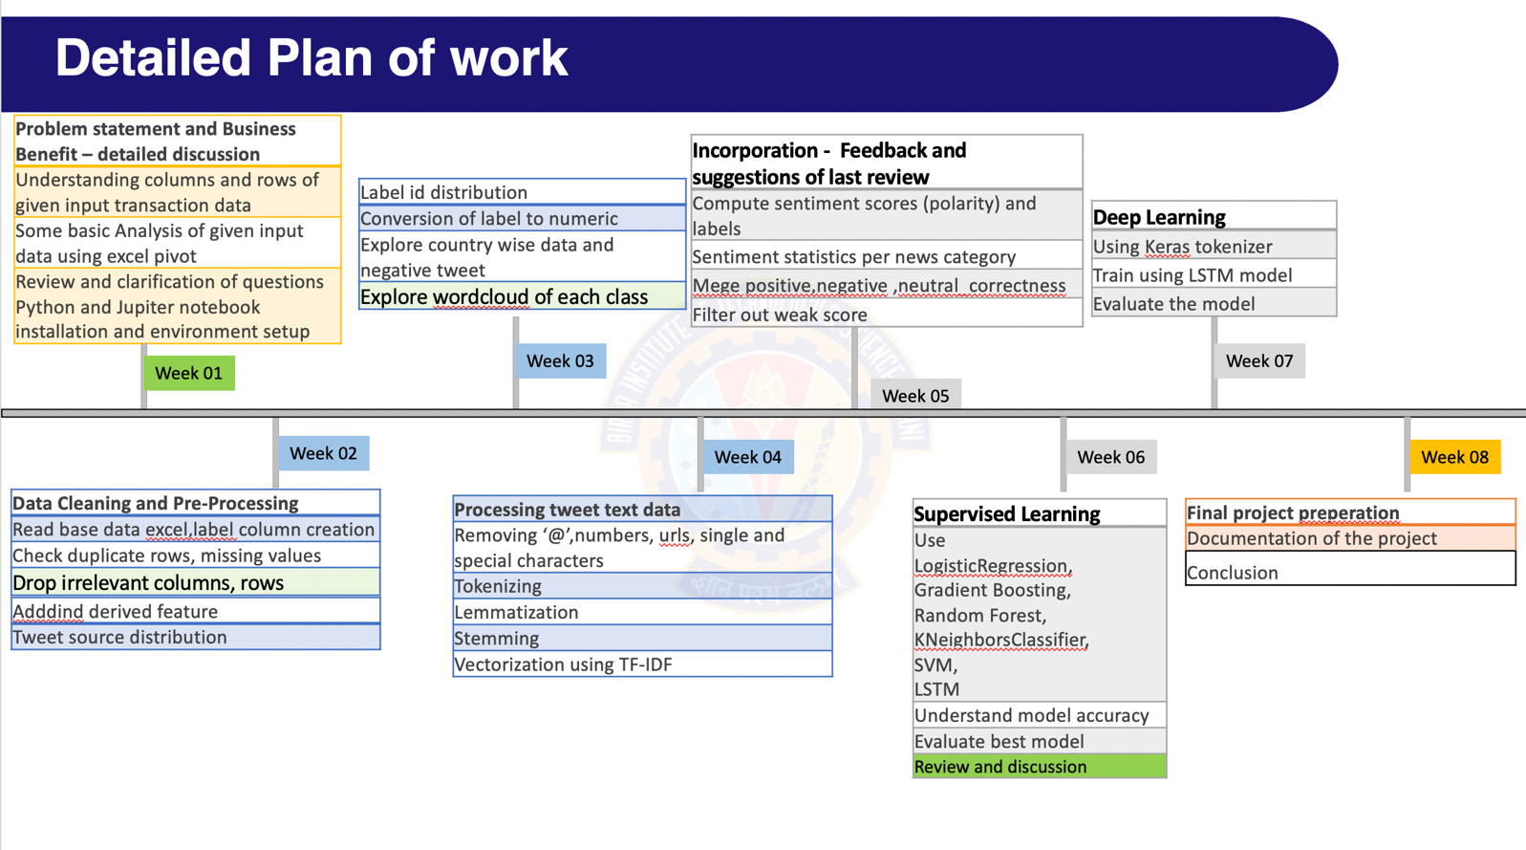

Pre-Processing Steps (Data processing/Feature preprocessing/Outlier detection & Visualization for Summarization):

- Read base data excel – this data has no Label (class)
- Label column creation
- Check duplicate rows, check columns having constant value
- Check missing values in each column and imputation if required.
- Delete rows which are nor relevant
- Drop columns which are nor relevant
- Add derived features
- Finding Tweet_source distribution
- Determining Label ID distribution
- Convert label to numeric
- Explore Negative tweet and its category
- Country wise positive, Negative and Neutral
- WordCloud of each positive, negative and neutral class
- Save first round cleaned data
- Removing user handles starting with @
- Removing numbers and special characters
- Removing urls
- Removing single characters
- Tokenizing
- Removing stopwords
- Expanding not words
- Lemmatizing the words
- Stemming the words
- Using TextBlob for sentiment analysis
- WordCloud of each positive, negative and neutral class with clean tweet
- Vectorization using TF-IDF - Term frequency and Inverse Document frequency
- Removing the neutral class to obtain better results
- Tokenizing using Keras

Machine Learning Modelling & Techniques Applied:

We have used a combination of supervised and deep learning models for evaluation of the accuracy of the model.

Also, we have built the models using multi-class labels (positive, negative, neutral) and binary-class labels(positive, negative) to determine the performance of the models.

Models used:
Random Forest Classifier(Multi-Class and Binary Class)
Gradient Boosting Classifier(Multi-Class and Binary Class)
Support Vector Machine(Multi-Class and Binary Class)
Logistic Regression
KNeighbors Classifier
LSTM

Model | Precision |  |  | Recall |  |  | F1 |  |  | Accuracy
Multi Class | 0 | 1 | 2 | 0 | 1 | 2 | 0 | 1 | 2
Random Forest | 0.9 | 0.92 | 0.85 | 0.87 | 0.77 | 0.96 | 0.88 | 0.84 | 0.9 | 0.88
Support Vector Machine | 0.91 | 0.93 | 0.82 | 0.84 | 0.73 | 0.96 | 0.87 | 0.82 | 0.89 | 0.86
Gradient Boosting | 0.91 | 0.94 | 0.73 | 0.72 | 0.56 | 0.97 | 0.8 | 0.7 | 0.83 | 0.79

Model | Precision |  | Recall |  | F1 |  | Accuracy | Area under Curve
Binary Class | 0 | 1 | 0 | 1 | 0 | 1
Logistic Regression | 0.92 | 0.91 | 0.89 | 0.93 | 0.91 | 0.92 | 0.91 | 0.91
Support Vector Machine | 0.9 | 0.91 | 0.9 | 0.91 | 0.9 | 0.91 | 0.9 | 0.9
Random Forest | 0.9 | 0.89 | 0.88 | 0.91 | 0.89 | 0.9 | 0.89 | 0.89
LSTM |  |  |  |  |  |  | 0.89 | 0.89
Gradient Boosting | 0.93 | 0.81 | 0.76 | 0.94 | 0.84 | 0.87 | 0.85 | 0.85
Kneighbours Classifier | 0.61 | 0.62 | 0.57 | 0.66 | 0.59 | 0.64 | 0.61 | 0.61

Conclusion:

- This project was successfully able to classify tweets as ‘positive’, ‘negative’ and ‘neutral’ at the highest possible accuracy by applying multiple suitable models;
- accuracy_score was chosen as the best metric to obtain the accuracy of the model in line with the objective of selecting the best model;
- The score is also comparable to the f1-score whose trends align with the same and allows us to minimize both false negative and false positive predictions while making true predictions;
- The use of the NLTK_Polarity model also allows each tweet to be allocated a Polarity score which can be used as an identity metric;
- Among the models used, SVM shows the highest accuracy for multi-class instances while Logistic Regression is the most accurate for binary classes, with SVM showing near-peak accuracy with both classes, it can be considered the best model to apply for a tweet-based dataset;
- The model effectively classifies tweets on a spectrum from positive to negative, which has great potential in a business environment where social media perception is rapidly affecting the nature of marketing and sales of any and all product available in the market today.

Future References:

- A fixed reference data set has been applied to all models, real-time data streaming could be used in the future in order to ascertain immediate polarity of a trend;
- Hyper-parameter tuning can be undertaken to improve accuracy of the models with EDA allowing the selection of particular parameters;
- An API can be produced in such a way that an end-user can make use of the model to understand the nature of polarity of the Twitter trends with respect to their particular product;
- The scope of the project can be further attuned as per client-specific ideas;
- More domain knowledge can be brought into the project with methods to improve feature engineering, or to use more ensemble methods and retraining the models with more historical data to improve accuracy;
- Auto-ML models like H2O can also be used to see if the more accurate models can be created.

Bibiliography:

Textbooks:

- Christopher M. Bishop - Pattern Recognition and Machine Learning - Springer (2006)
- Pang-Ning Tan, Michael Steinbach, Vipin Kumar - Introduction to Data Mining - Pearson (2013)
- Gareth James, Daniela Witten, Trevor Hastie, Robert Tibshirani - An Introduction to Statistical Learning – Springer (2013)

Online References:

Twitter Sentiment Analysis using Python - https://www.geeksforgeeks.org/twitter-sentiment-analysis-using-python/

Twitter Sentiment Analysis using NLTK, Python - https://towardsdatascience.com/twitter-sentiment-analysis-classification-using-nltk-python-fa912578614c

How to Do Sentiment Analysis on a Twitter Account - https://medium.com/better-programming/twitter-sentiment-analysis-15d8892c0082

