**ASSIGNMENT – 1**

**TIME TABLE**

**PROGRAM:**

<!DOCTYPE html>

<html>

<head>

<style>

#header {

margin: auto;

padding: 10px;

width: 100%;

background: #ffffff;

color: black;

height: 50px;

font-size: 40px;

opacity: 0.6;

text-align: center;

}

.form {

font-family: sans;

width:1000px;

font-weight: bold;

font-size: 15px;

background-color: #ffffff;

margin: 120px auto;

border: 1px solid black;

height: 685px;

opacity: 0.8;

}

table, td, th {

border: 1px solid black;

}

table {

border-collapse: collapse;

width: 800px;

}

th,td{

padding: 15px;

}

tr:nth-child(odd){

background-color: #edbef1

}

th {

background-color: #8505ac;

color: white;

}

</style>

<title>Time Table</title>

</head>

<body background="https://www.desktopbackground.org/download/o/2015/10/17/1027563_full-hd-1080p-solid-wallpapers-hd-desktop-backgrounds-1920x1080_1920x1080_h.jpg">

<div id="header" align="center">TIME TABLE</div>

<div class="form">

<form>

<h3>VII semester:</h3>

<table align="center">

<tr align="center" width="100px">

<th>Day/Period</th>

<th>9.00-9.50</th>

<th>9.50-10.40</th>

<th>10.50-11.40</th>

<th>11.40-12.30</th>

<th>1.30-2.20</th>

<th>2.20-3.10</th>

<th>3.20-4.05</th>

<th>4.05-4.50</th>

</tr>

<tr align="center">

<td>Monday</td>

<td>OBM752</td>

<td>CS8792</td>

<td>IT8075</td>

<td COLSPAN="4">CS8711/IT8761</td>

<td>PT</td>

</tr>

<tr align="center">

<td>Tuesday</td>

<td colspan="2">Weekly Cyclic Test</td>

<td>OBM752</td>

<td>CS8791</td>

<td>MG8591</td>

<td>CS8792</td>

<td>IT8075</td>

<td>PT</td>

</tr>

<tr align="center">

<td>Wednesday</td>

<td>MG8591</td>

<td>OBM752</td>

<td>CS8791</td>

<td COLSPAN="4">IT8761/CS8711</td>

<td>PT</td>

</tr>

<tr align="center">

<td>Thursday</td>

<td>Test</td>

<td>MG8591</td>

<td>CS8792</td>

<td>OBM752</td>

<td colspan="3">IBM</td>

<td>PT</td>

</tr>

<tr align="center">

<td>Friday</td>

<td>CS8792</td>

<td>AWM</td>

<td>MG8591</td>

<td>IT8075</td>

<td>CS8791</td>

<td>IT8075</td>

<td>CS8791</td>

<td>PT</td>

</tr>

</table>

<br>

<ul>

<li><pre>MG8591 - PRINCIPLES OF MANAGEMENT - Mrs.S.V.Anandhi, AP/CSE</pre></li>

<li><pre>CS8792 - CRYPTOGRAPHY AND NETWORK SECURITY - Mrs.P.Chanthiya, AP/CSE</pre></li>

<li><pre>CS8791 - CLOUD COMPUTING - Dr.D.Kesavaraja, ASP/CSE</pre></li>

<li><pre>OBM752 - HOSPITAL MANAGEMENT - Mrs.R.R.Bhavani, ASP/CSE</pre></li>

<li><pre>IT8075 - SOFTWARE PROJECT MANAGEMENT - Dr.R.Jensi, ASP/CSE</pre></li>

<li><pre>IBM NAALAIYA TIRAN ELECTIVE LAB - Mrs.D.Sindhu, AP/CSE</pre></li>

<li><pre>IT8761 - SECURITY LABORATORY - Mrs.P.Chanthiya, AP/CSE</pre></li>

<li><pre>CS8711 - CLOUD COMPUTING LABORATORY - Dr.D.Kesavaraja, ASP/CSE</pre></li>

<li><pre>AWM - Mrs.R.R.Bhavani, ASP/CSE & Mrs.D.Sindhu, AP/CSE</pre></li>

</ul>

</table>

</form>

</div>

</body>

</html>

**OUTPUT SCREENSHOT:**

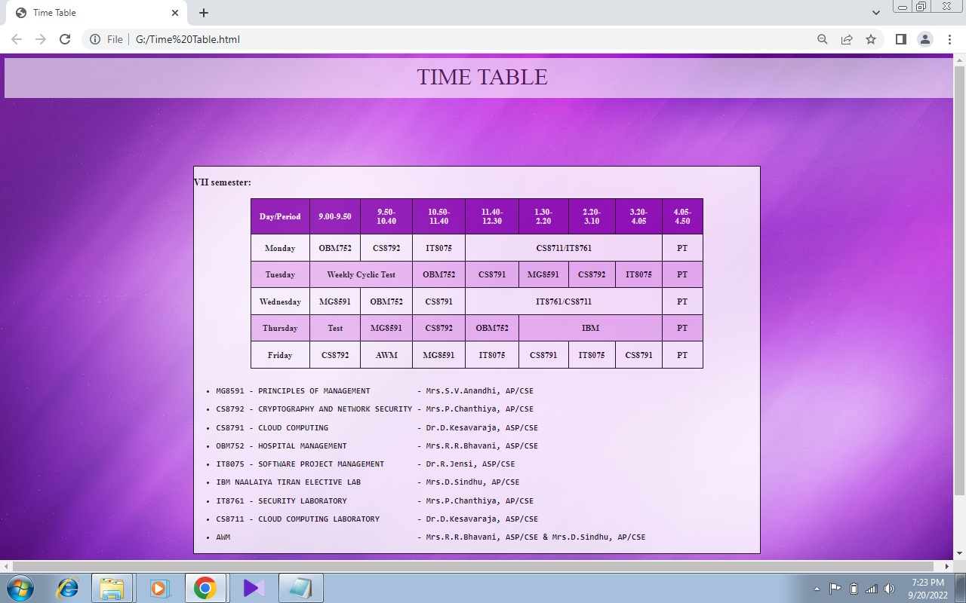

**REGISTRATION WEBPAGE USING HTML, CSS AND JS**

**PROGRAM:**

**index.html**

<html>

<head>

<title>Registration Form</title>

<link rel="stylesheet" href="style.css" type="text/css" />

<script src="valid.js"></script>

</head>

<body bgcolor="Pink">

<div id="header" align="center">

Exam Registration form

</div>

<div class="form-style">

<h2> *All Fields are mandatory*</h2>

<form name="form1" method="post" action="#" onsubmit="return fncValidate();" autocomplete="off">

<p>Student details</p>

<table width="600" border="0">

<tr>

<td width="124">&nbsp;First name:</td>

<td width="180">

<div class="input-group">

<input type="text" name="first_name" size="20">

</div>

</td>

</tr>

<tr>

<td width="124">&nbsp;Last name:</td>

<td width="180">

<div class="input-group">

<input type="text" name="last_name" size="20">

</div>

</td>

</tr>

<tr>

<td>&nbsp;DOB:

</td>

<td>

<div class="input-group">

<input id="dob" type="date" name="DOB" size="20">

</div>

</td>

</tr>

<tr>

<td>

&nbsp;Gender:

</td>

<td>

<span id="gen">

<input type="radio" name="gender" value="male" id="male"> Male

<input type="radio" name="gender" value="female" id="female"> Female

</span>

</td>

</tr>

<tr>

<td>&nbsp;Register No:</td>

<td>

<div class="input-group">

<input type="text" name="regno">

</div>

</td>

</tr>

<tr>

<td>

&nbsp;Course:

</td>

<td>

<div class="input-group">

<select id="course">

<option value="">Choose a course</option>

<option value="IT">B.Tech. - Information Technology</option>

<option value="CSE">B.E. - Computer Science and Engineering</option>

<option value="CE">B.E. - Civil Engineering</option>

<option value="EEE">B.E. - Electrical and Electronics Engineering</option>

<option value="ECE">B.E. - Electronics and Communication Engineering</option>

<option value="ME">B.E. - Mechanical Engineering</option>

</select>

</div>

</td>

</tr>

<tr>

<td>&nbsp;Moblie No:</td>

<td>

<div class="input-group">

<input type="text" name="phone">

</div>

</td>

</tr>

<tr>

<td>&nbsp;Email:</td>

<td>

<div class="input-group">

<input type="text" name="email">

</div>

</td>

</tr>

<tr>

<td>

</td>

<td>

<input type="submit" name="sub,it" value="Submit" class="btn">&nbsp&nbsp

<input type="reset" name="reset" value="Reset" class="btn">

</td>

</tr>

</table>

</div>

</body>

</html>

**style.css**

#header

{

background:#EC5578;

width:100%;

height:50px;

color:white;

font-size:36px;

}

.form-style{

font-family: sans;

width: 600px;

padding: 30px;

background: #FFFDD0;

margin: 50px auto;

}

.form-style h2{

background: #98FB98;

font-family: sans;

color: black;

font-size: 18px;

font-weight: 100;

padding: 20px;

margin: -30px -30px 30px -30px;

}

.input-group{

margin: 10px 0px 10px 0px;

}

.input-group input{

height:30px;

width: 95%;

padding: 5px;

font-size:16px;

border-radius: 5px;

border: 1px solid gray;

}

p {

text-align: center;

font-size: 30px;

font-family: Times New Roman;

color: red;

}

.input-group select{

width: 95%;

padding: 5px;

border: 1px solid gray;

border-radius: 4px;

box-sizing: border-box;

margin-top: 6px;

margin-bottom: 16px;

resize: vertical;

}

.btn{

padding:10px;

font-size:15px;

color:white;

background: orange;

border-radius: 5px;

border: none;

}

}

**valid.js**

function fncValidate()

{

var fn=document.form1.first_name.value;

var ln=document.form1.last_name.value;

var patt = /[^a-z]/i;

var first_name = patt.test(fn);

var last_name = patt.test(ln);

if(fn == "")

{

alert('Enter First name!');

return false;

}

if ( fn == null || first_name == true )

{

alert("Enter valid input!");

return false;

}

if(ln == "")

{

alert('Enter Last name!');

return false;

}

if ( ln == null || last_name == true )

{

alert("Enter valid input!");

return false;

}

var d=document.getElementById("dob");

if(d.value == null || d.value == "")

{

alert("select the DOB!");

return false;

}

var m = document.getElementById('male');

var f = document.getElementById('female');

if ( (m.checked == false ) && (f.checked == false ) )

{

alert ( "Please choose Gender" );

document.getElementById("gen");

return false;

}

var r=document.form1.regno.value;

if(r == null || r == "")

{

alert("Enter register number!");

return false;

}

if(r.length>12)

{

alert("Enter 12 digits");

return false;

}

if(r.length<12)

{

alert("Enter 12 digits");

return false;

}

var c = document.getElementById("course")

if(c.value == null || c.value == "")

{

alert("Select a course");

return false;

}

var p=document.form1.phone.value;

if(p == null || p == "")

{

alert("Enter Mobile number!");

return false;

}

if(p.length>10)

{

alert("Enter 10 digits");

return false;

}

if(p.length<10)

{

alert("Enter 10 digits");

return false;

}

var em=document.form1.email.value;

var atpos=em.indexOf("@");

var dotpos=em.lastIndexOf(".");

if(em == "")

{

alert("Enter Email id!");

return false;

}

if(atpos<1 || dotpos<atpos+2 || dotpos+2>=em.length)

{

alert("Ivalid email id");

return false;

}

alert("Registration successful!");

document.form1.submit();

}

**OUTPUT SCREENSHOT:**

