JAVA – JDK17

IDE – Eclipse – Photon (R)

**Add-ins**

Cucumber

Nature file

Maven –project

ChromeDirver

WebDriver

Application url: https://www.myntra.com

Create Maven Project

* Create new packages
  + Runner
    1. MainClass.JAVA
  + Steps
    1. TestCases.java
* Installed – Addin

Cucumber

Nature file

* Create new folder
  + Create new file
    1. myTes.fature

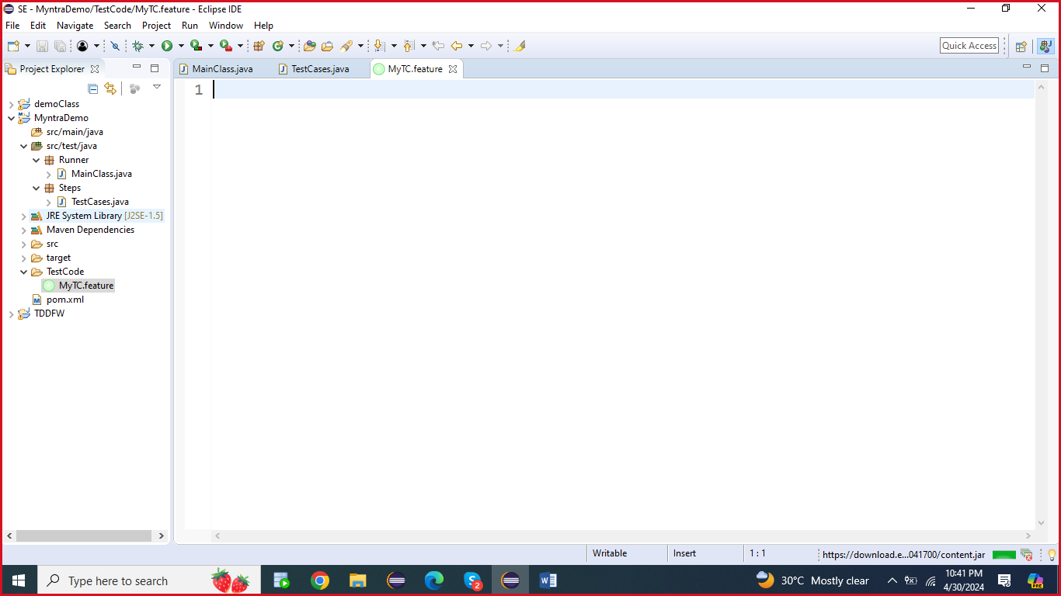

Main menu validation

Open chrome browser and application

Select men menu

Select women menu

Select Kids menu

Select homeliving

Copy and paste the above mentioned code into cucumber file

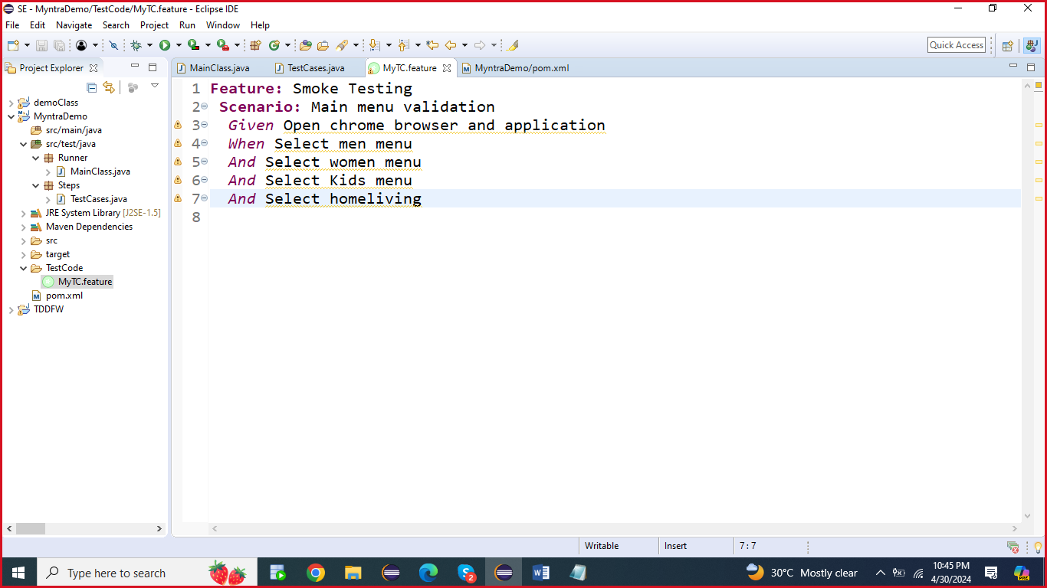

Update Maven POM File jar files

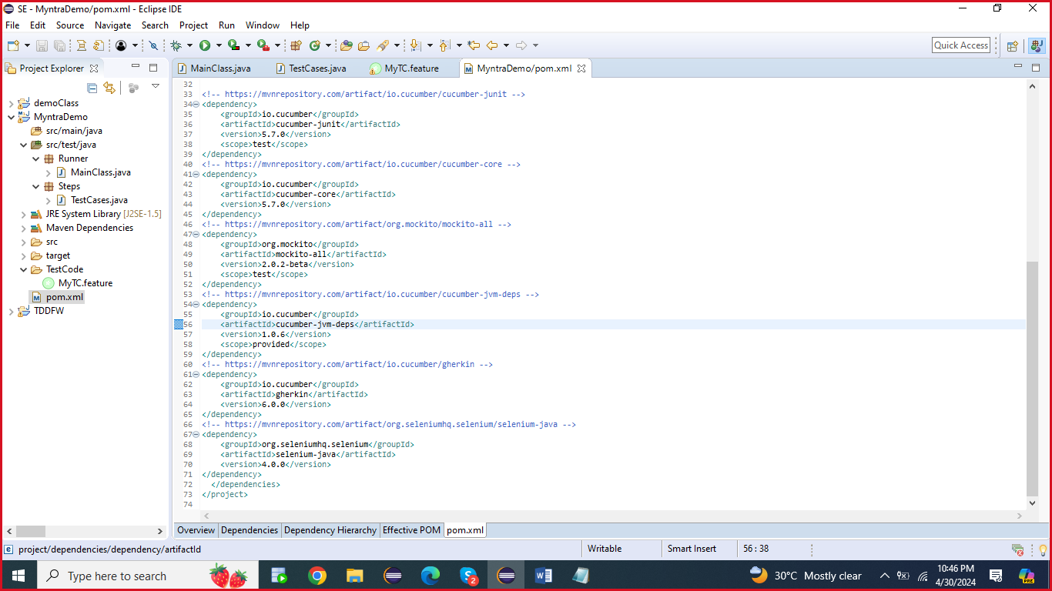

Update the below mentioned jar files into POM.xml

<dependency>

<groupId>io.cucumber</groupId>

<artifactId>cucumber-java</artifactId>

<version>5.7.0</version>

</dependency>

<!-- https://mvnrepository.com/artifact/junit/junit -->

<dependency>

<groupId>junit</groupId>

<artifactId>junit</artifactId>

<version>4.13</version>

<scope>test</scope>

</dependency>

<!-- https://mvnrepository.com/artifact/io.cucumber/cucumber-junit -->

<dependency>

<groupId>io.cucumber</groupId>

<artifactId>cucumber-junit</artifactId>

<version>5.7.0</version>

<scope>test</scope>

</dependency>

<!-- https://mvnrepository.com/artifact/io.cucumber/cucumber-core -->

<dependency>

<groupId>io.cucumber</groupId>

<artifactId>cucumber-core</artifactId>

<version>5.7.0</version>

</dependency>

<!-- https://mvnrepository.com/artifact/org.mockito/mockito-all -->

<dependency>

<groupId>org.mockito</groupId>

<artifactId>mockito-all</artifactId>

<version>2.0.2-beta</version>

<scope>test</scope>

</dependency>

<!-- https://mvnrepository.com/artifact/io.cucumber/cucumber-jvm-deps -->

<dependency>

<groupId>io.cucumber</groupId>

<artifactId>cucumber-jvm-deps</artifactId>

<version>1.0.6</version>

<scope>provided</scope>

</dependency>

<!-- https://mvnrepository.com/artifact/io.cucumber/gherkin -->

<dependency>

<groupId>io.cucumber</groupId>

<artifactId>gherkin</artifactId>

<version>6.0.0</version>

</dependency>

<!-- https://mvnrepository.com/artifact/org.seleniumhq.selenium/selenium-java -->

<dependency>

<groupId>org.seleniumhq.selenium</groupId>

<artifactId>selenium-java</artifactId>

<version>4.0.0</version>

</dependency>

Update the Runner.java file code

**package** Runner;

**import** org.junit.runner.RunWith;

**import** io.cucumber.junit.Cucumber;

**import** io.cucumber.junit.CucumberOptions;

@RunWith(Cucumber.**class**)

@CucumberOptions(features="TestCode")

**public** **class** MainClass {

}

===Run Cucumber code…..

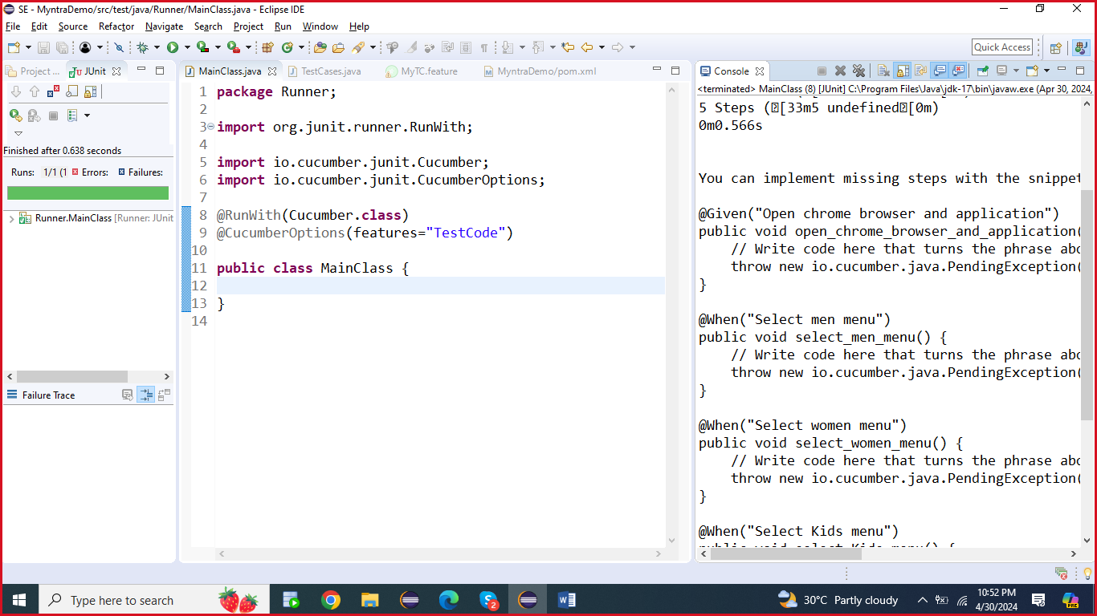

Copy and paste -> Cucumber runner class generated code… with method

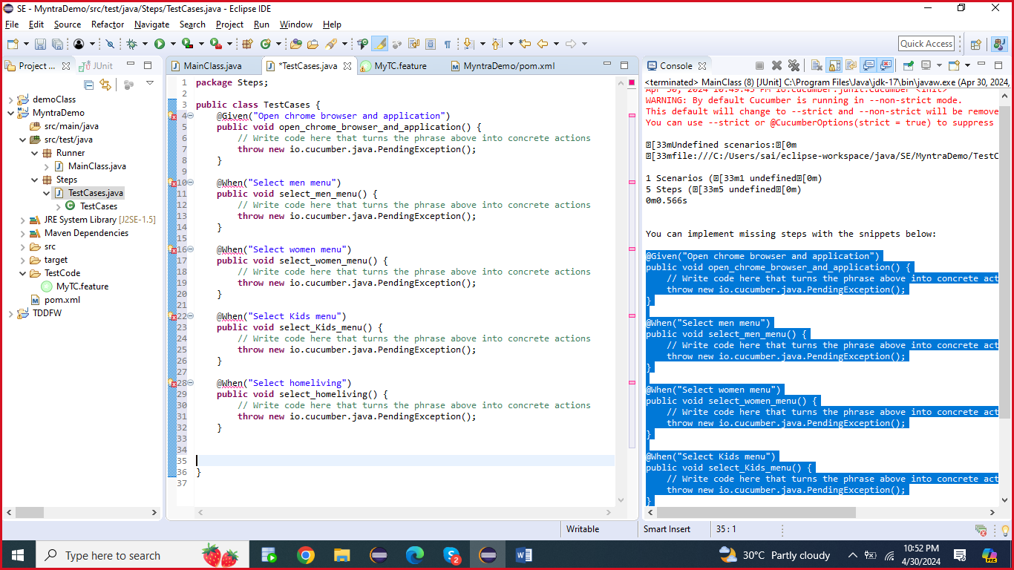

After update the steps code, and update the glue link with test cases package name

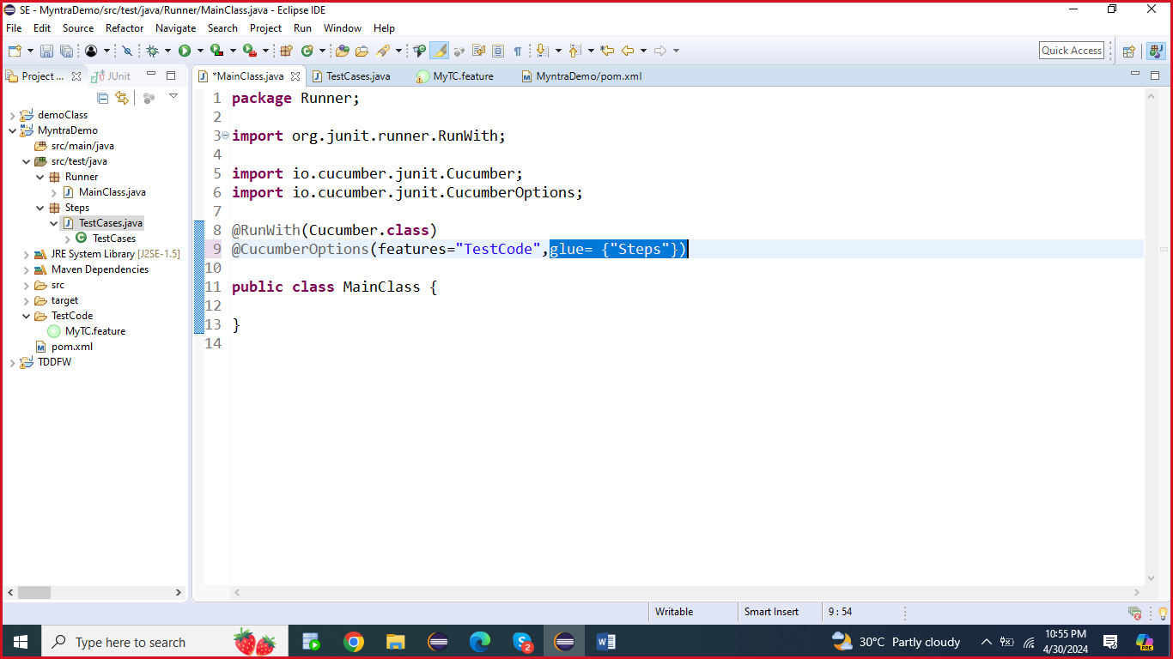

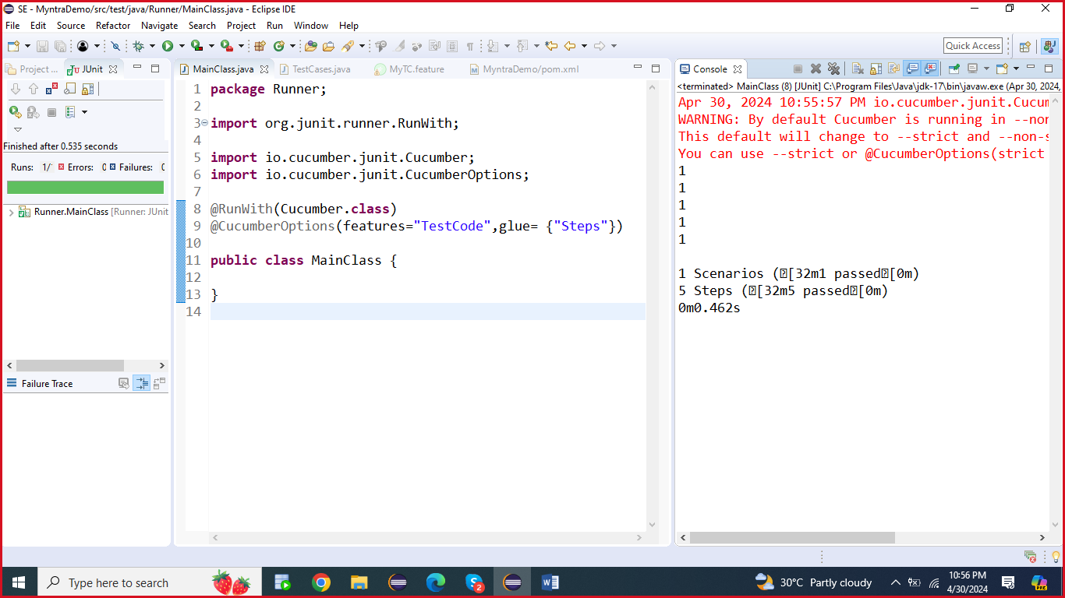

Update the test case with selenium code….

**Feature:** Smoke Testing

**Scenario:** Main menu validation

*Given* Open chrome browser and application

*When* Select men menu

*And* Select women menu

*And* Select Kids menu

*And* Select homeliving

package Runner;

import org.junit.runner.RunWith;

import io.cucumber.junit.Cucumber;

import io.cucumber.junit.CucumberOptions;

@RunWith(Cucumber.class)

@CucumberOptions(features="TestCode",glue= {"Steps"})

public class MainClass {

}

**package** Steps;

**import** org.openqa.selenium.By;

**import** org.openqa.selenium.WebDriver;

**import** org.openqa.selenium.chrome.ChromeDriver;

**import** org.openqa.selenium.chrome.ChromeOptions;

**import** io.cucumber.java.en.Given;

**import** io.cucumber.java.en.When;

**public** **class** TestCases {

ChromeDriver dr;

@Given("Open chrome browser and application")

**public** **void** open_chrome_browser_and_application() {

System.*setProperty*("webdriver.chrome.driver", "C:\\SeleniumDemo\\drivers\\chromedriver.exe");

ChromeOptions options = **new** ChromeOptions();

options.addArguments("--remote-allow-origins=*");

ChromeDriver dr = **new** ChromeDriver(options);

dr.manage().window().maximize();

dr.get("https://www.myntra.com");

}

@When("Select men menu")

**public** **void** select_men_menu() {

System.***out***.println(dr.getCurrentUrl());

System.***out***.println(dr.getTitle());

}

@When("Select women menu")

**public** **void** select_women_menu() {

dr.findElement(By.*xpath*("//*[@id=\"desktop-header-cnt\"]/div[2]/nav/div/div[1]/div/a")).click();

}

@When("Select Kids menu")

**public** **void** select_Kids_menu() {

dr.findElement(By.*xpath*("//*[@id=\"desktop-header-cnt\"]/div[2]/nav/div/div[3]/div/a")).click();

}

@When("Select homeliving")

**public** **void** select_homeliving() {

dr.findElement(By.*xpath*("//*[@id=\"desktop-header-cnt\"]/div[2]/nav/div/div[4]/div/a")).click();

}

}