DATABASE MANAGEMENT SYSTEMS – CSA0513

Q.1.

|  |  |  |  |  |  |  |  |  |  |  |  |  |  |  |  |  |
| --- | --- | --- | --- | --- | --- | --- | --- | --- | --- | --- | --- | --- | --- | --- | --- | --- |
| Create Employee table for the following details   |  |  |  |  | | --- | --- | --- | --- | | S.No | Name | Designation | Branch | | 1 | Suresh | Manager | Chennai | | 2 | Ramesh | Supervisor | Madurai | | 3 | Hari | Assistant | Trichy |   Perform the following:   * Alter the table by adding a column **Salary** * Alter the table by modifying the column **Name** * Describe the table **employee** * Rename table **employee** as **emp** * Delete the Second row from the table * Drop the table |

Q.2. Create a Table as **bank** and the details are

|  |  |  |  |  |
| --- | --- | --- | --- | --- |
| S.No | Cust_Name | Acc_no | Balance | Cus_Branch |
| 1 | Ramesh | 12378 | 100000 | Adyar |
| 2 | Sam | 12367 | 152500 | Mylapore |
| 3 | Harish | 12345 | 250000 | Anna Salai |

Perform the following:

* Simple Select
* Select with **where** clause
* Select with **comparison operator >**
* Select with**between** in the field **Balance**
* Update the **Cus_Branch** in the second row as **Poonamallee**

Q.1.

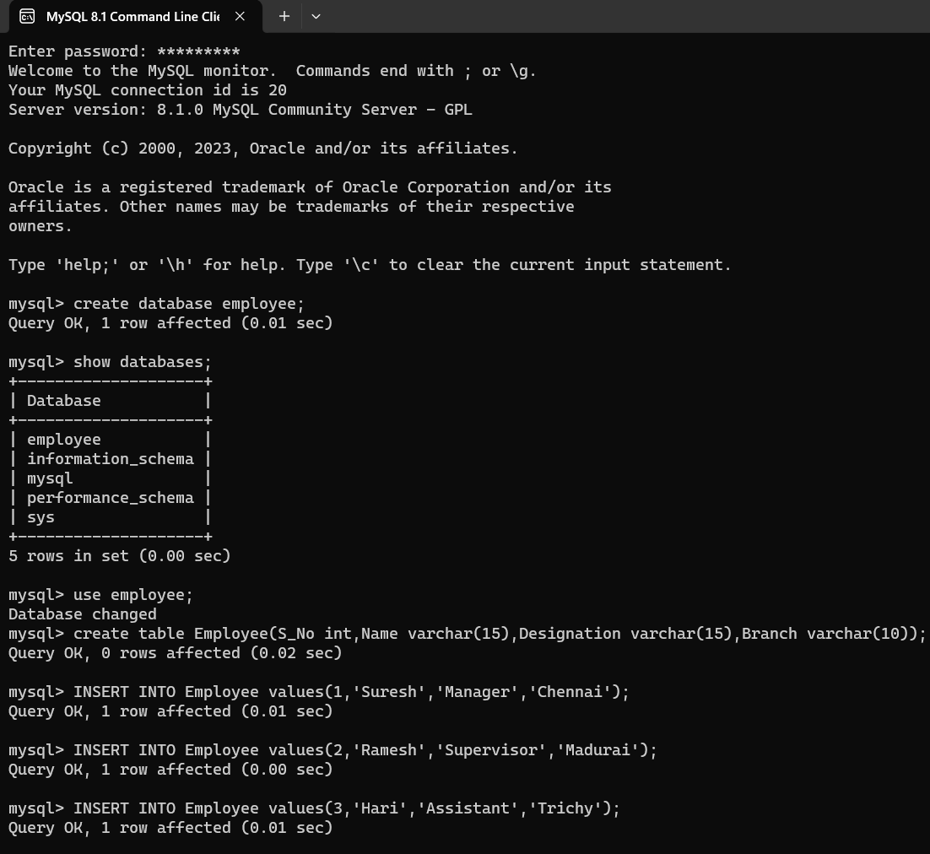

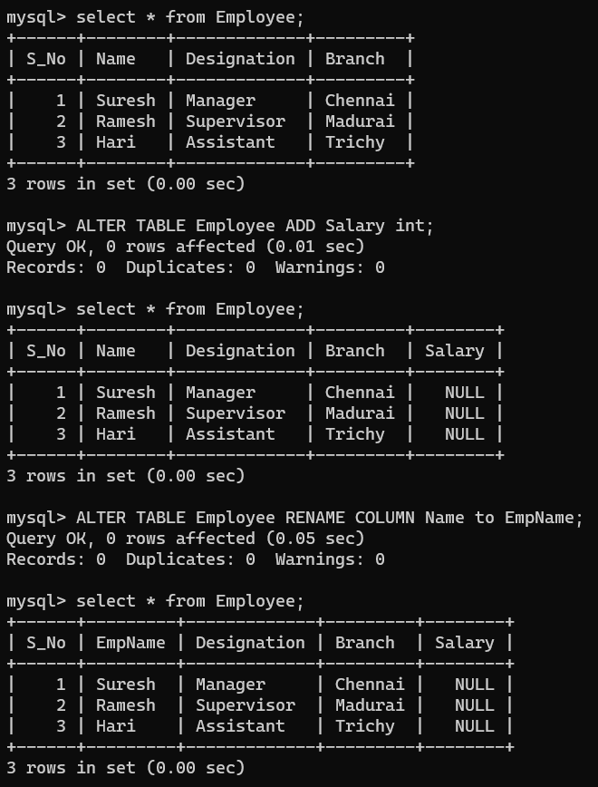

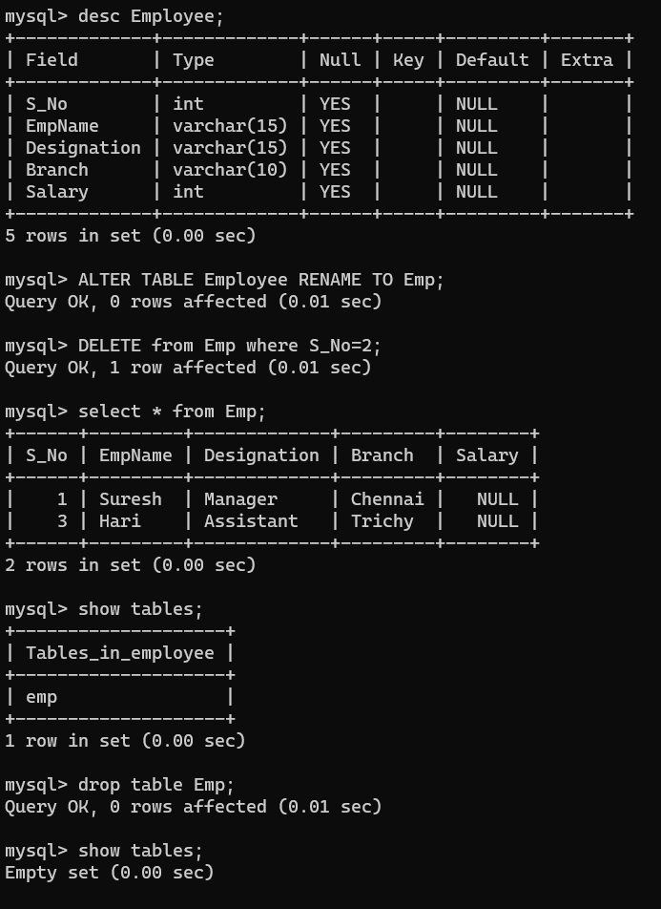

**DML Commands** – INSERT, SELECT, UPDATE, DELETE

2. Q.3&Q.6

Create a table Bank with the fields S_No ,Cust_Name, Acc_No,Balance, cus_Branch. Insert five rows into the table. Give a select statement using Simple Select * for selecting all fields in the table. Then **Update** theCus_Branchin the second row asPondicherr**y.** SELECT with various clause.

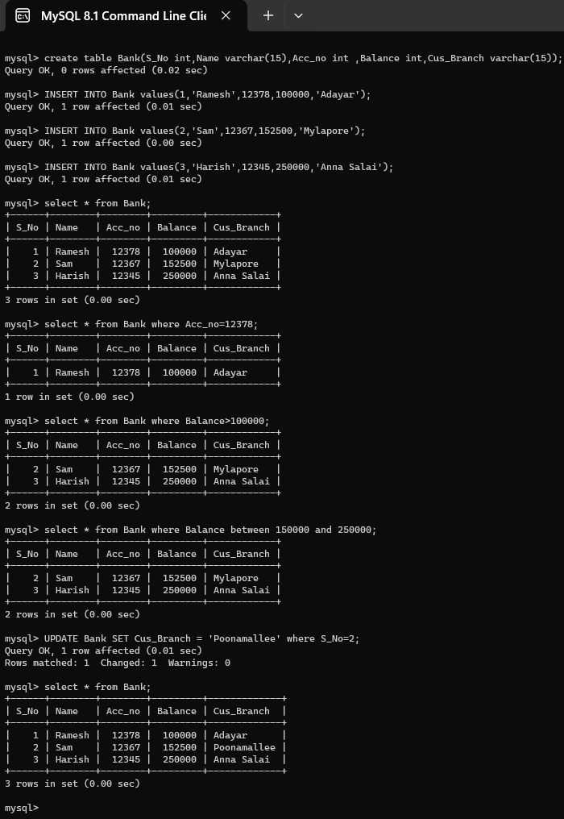

3. Create a Table as **book** and the details are

|  |  |  |  |  |
| --- | --- | --- | --- | --- |
| S.No | B_Name | Author | Price | Publisher |
| 1 | DBMS | Seema Kedhar | 250 | Charulatha |
| 2 | TOC | John Martin | 400 | Tata McGraw Hill |
| 3 | C | Balagurusamy | 300 | Technical |

Perform the following:

* + Use **Select** keyword and display the table
  + Display the book which is => 300
  + **Insert a** rowand add new book to the book table
  + Drop **Author** column

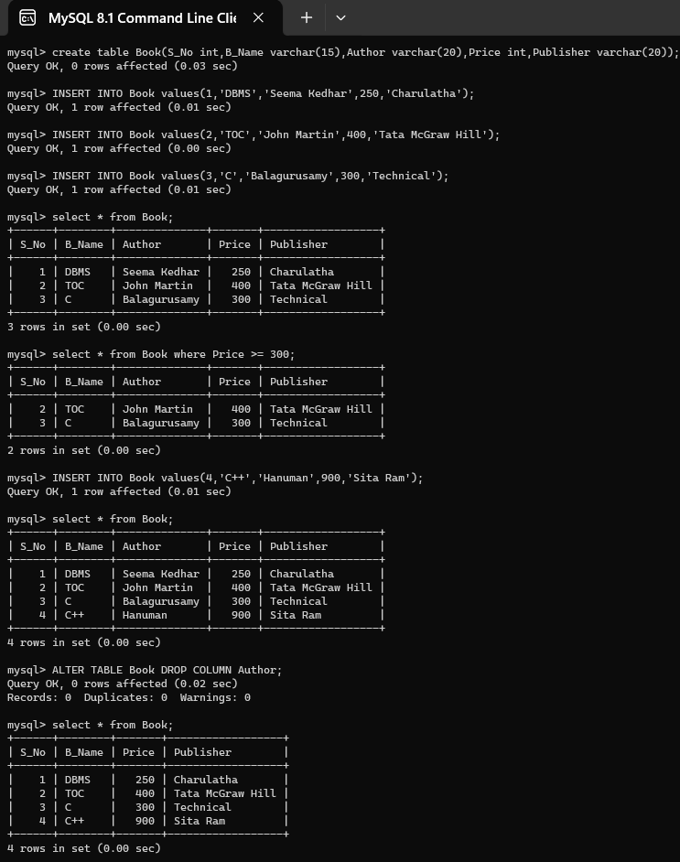

4. Create a Table as **workers** and the details are

|  |  |  |  |
| --- | --- | --- | --- |
| S.No | Name | Designation | Branch |
| 1 | Kannan | Manager | Chennai |
| 2 | Mahesh | Supervisor | Madurai |
| 3 | Maruthi | Assistant | Trichy |

* + Alter the table by adding a column **Salary**
  + Alter the table by modifying the column **Name**
  + Describe the table **employee**
  + Copy the table **employee** as **emp**
  + Delete the Second row from the table
  + Drop the table

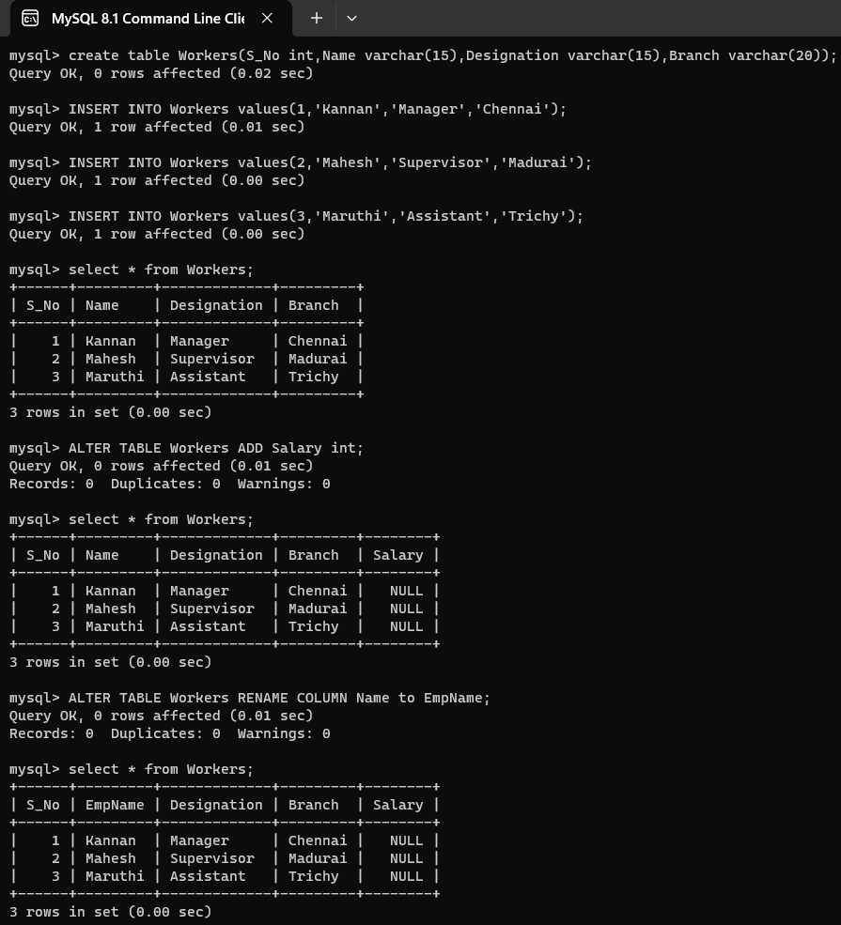

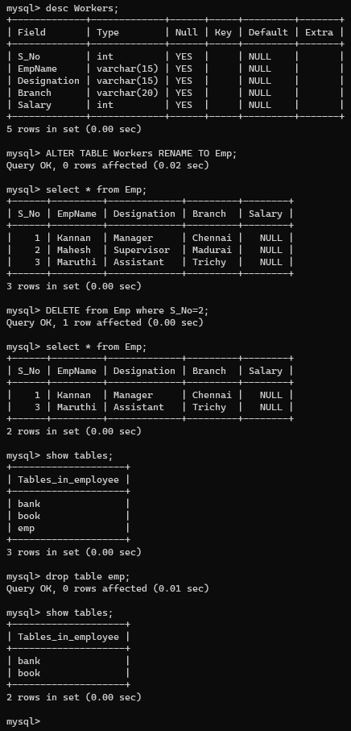

5. Create a Table as **Student** and the details are

|  |  |  |  |
| --- | --- | --- | --- |
| S.No | Name | Subject | Mark |
| 1 | Somu | OS | 75 |
| 2 | Sankar | DBMS | 66 |
| 3 | Mahesh | MOBILE COMPUTING | 92 |

Perform the following:

* + Alter the table by adding a column **Grade**
  + Alter the table by modifying the column **Name**
  + Describe the table **Subject**
  + Copy the table **Subject** as **sub**
  + Delete the Second row from the table
  + Drop the table

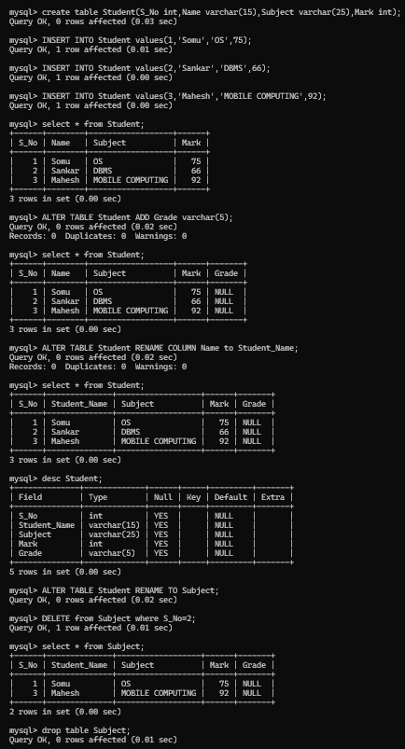

**DDL Commands** – CREATE, ALTER, DROP, TRUNCATE - Create a Table as Worker swith the fields S_No, Name, Designation, and Branch. Alter the Table by adding a column Branch. Drop the table

Q.2.

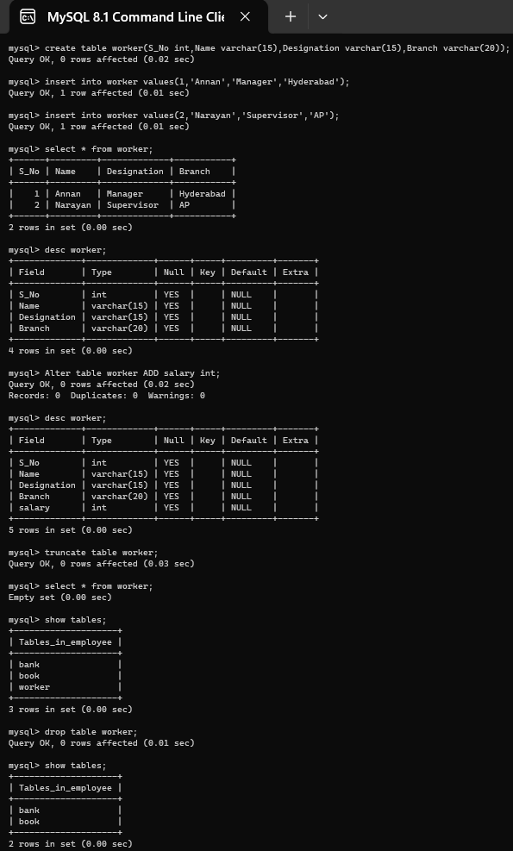

Q.4. **DDL Commands with Constraints – PRIMARY, FOREIGN, UNIQUE KEY, CHECK -** Create a Table Employee with fields S_No, name, Designation Branch with primary key as S_No. Create a table Workers with the same fields and make the field S_No as foreign key.

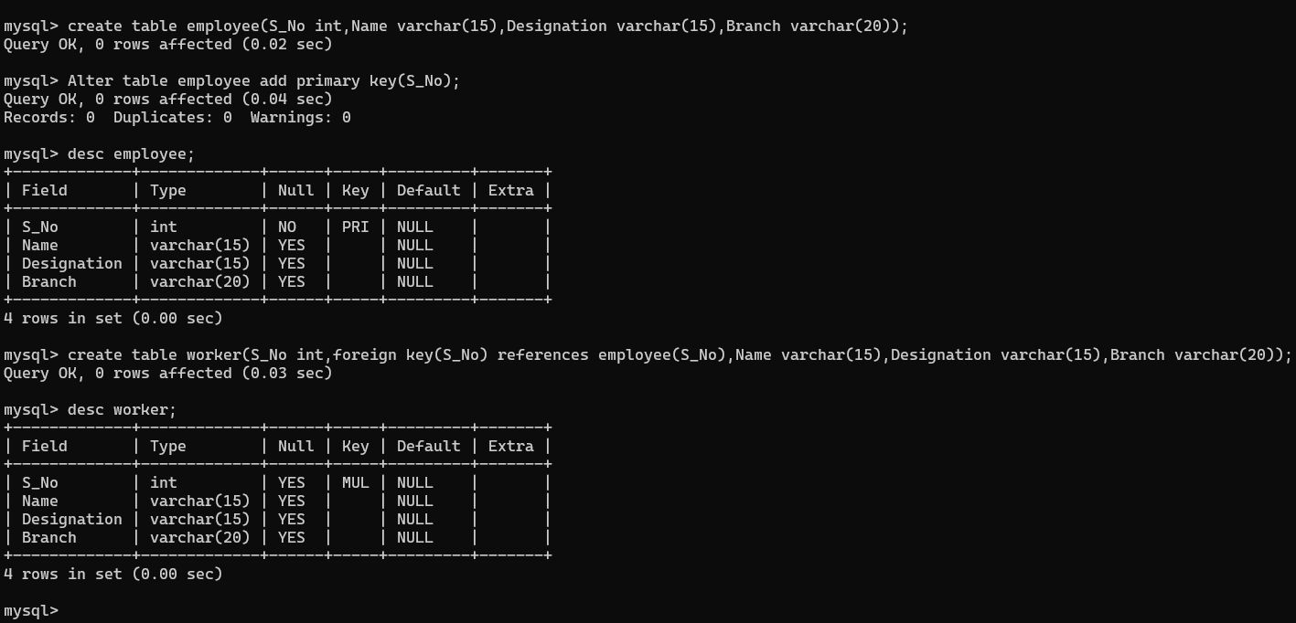

**DCL and TCL Commands**

Create a Table Book with the fields S_No, B_Name, Author, Price, and Publisher. Create a **save point** for the table **book** as **B . Rollback** the table **book** after inserting four and five rows respectively. Execute the commands Grant & Revoke and finally Commit the table.

Q.5.

TCL COMMANDS

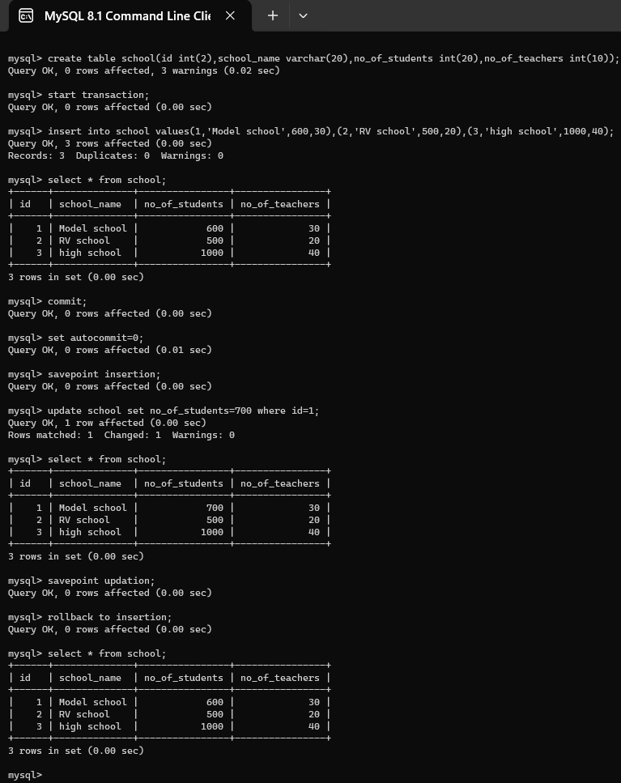

DCL COMMANDS

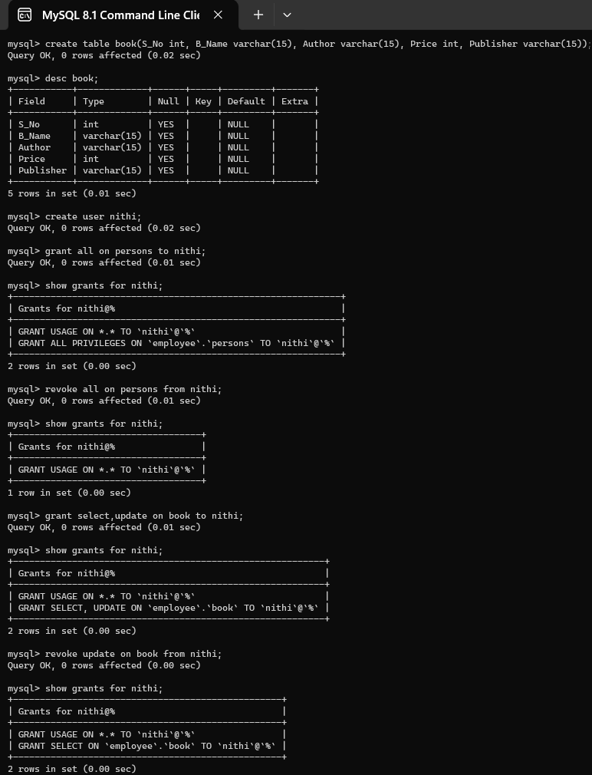

**Q.7. SELECT with various clause** – GROUP BY, HAVING, ORDER BY

Create table Project with the fields S_No, P_Name, Coordinators, P_Price, and Location. Select the rows in the table using Group by clause for Location. Select the rows in the table order by Coordinators.

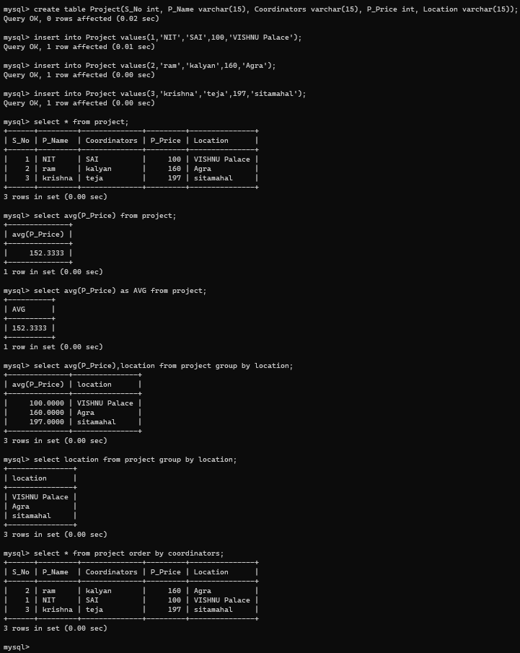

**Q.8.1 Sub Query & Correlated Query**

1. Create a student table with fields name, score, assessment and answer the following query.
2. Which of the student’s score is greater than the average score?
3. Which of the students’ have written more than one assessment test?
4. List the course and score of assessments that have the value more than the average score each Course

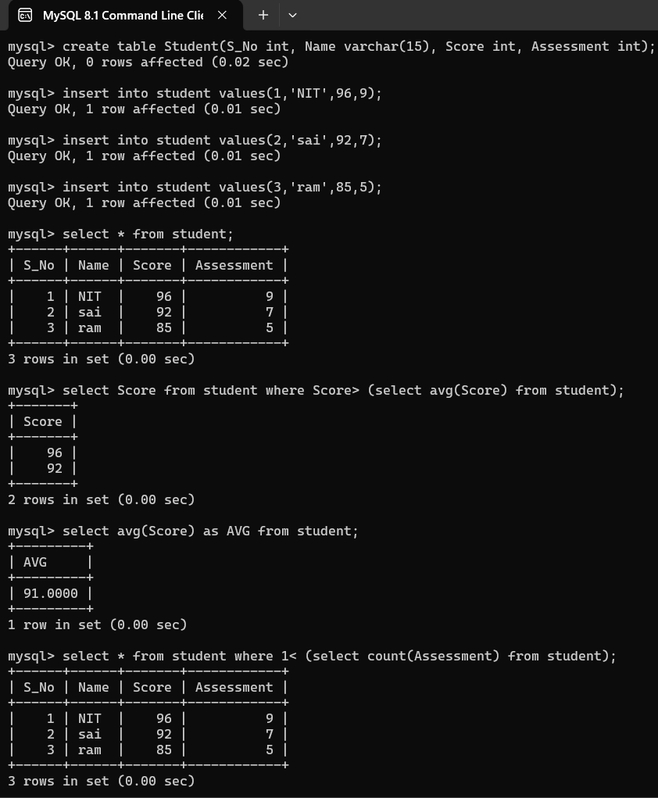

Q.8.2. Create a faculty table with fields name, DOB, gender and DOJ. Select the faculty who joined recently and when?

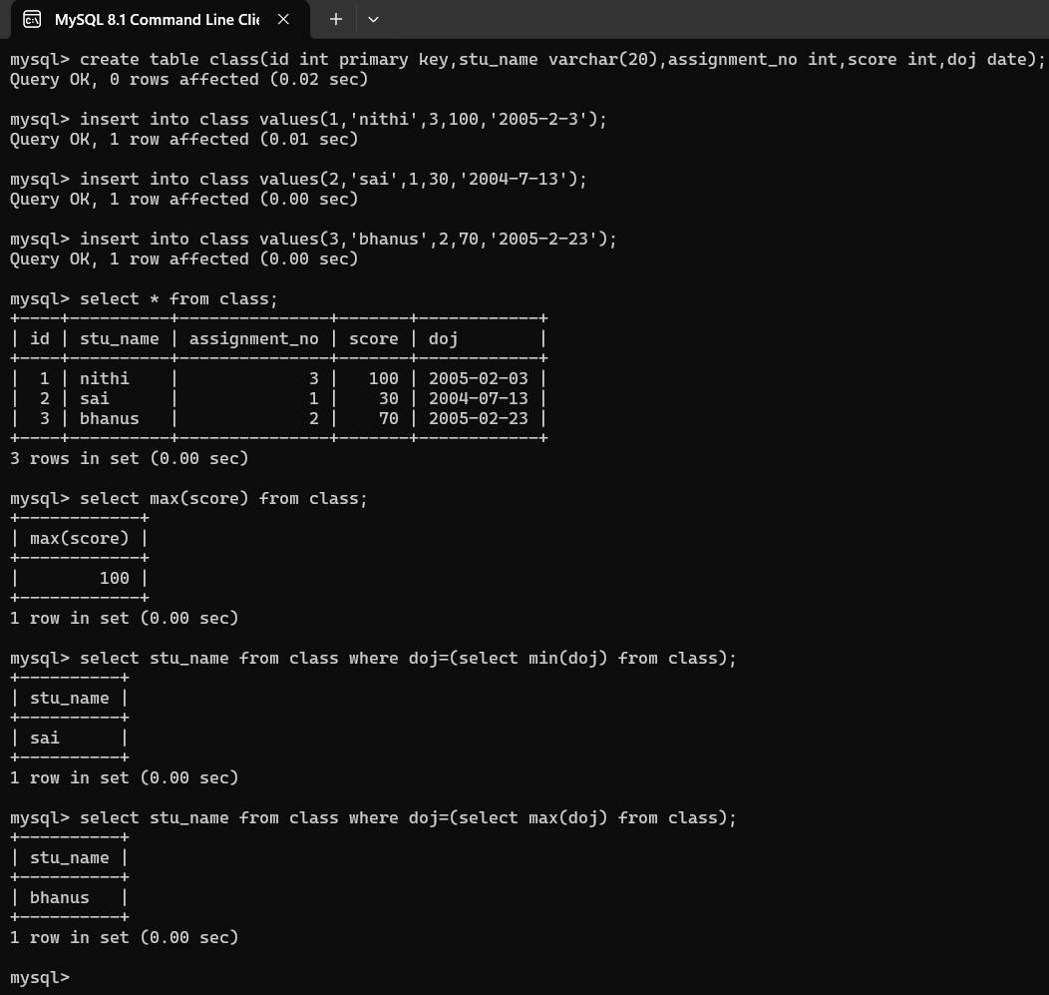

Q.9. VIEW - Create a view table with the fieldsS_No, name,Designation, Branch in the Employee table and insert more records in the table.

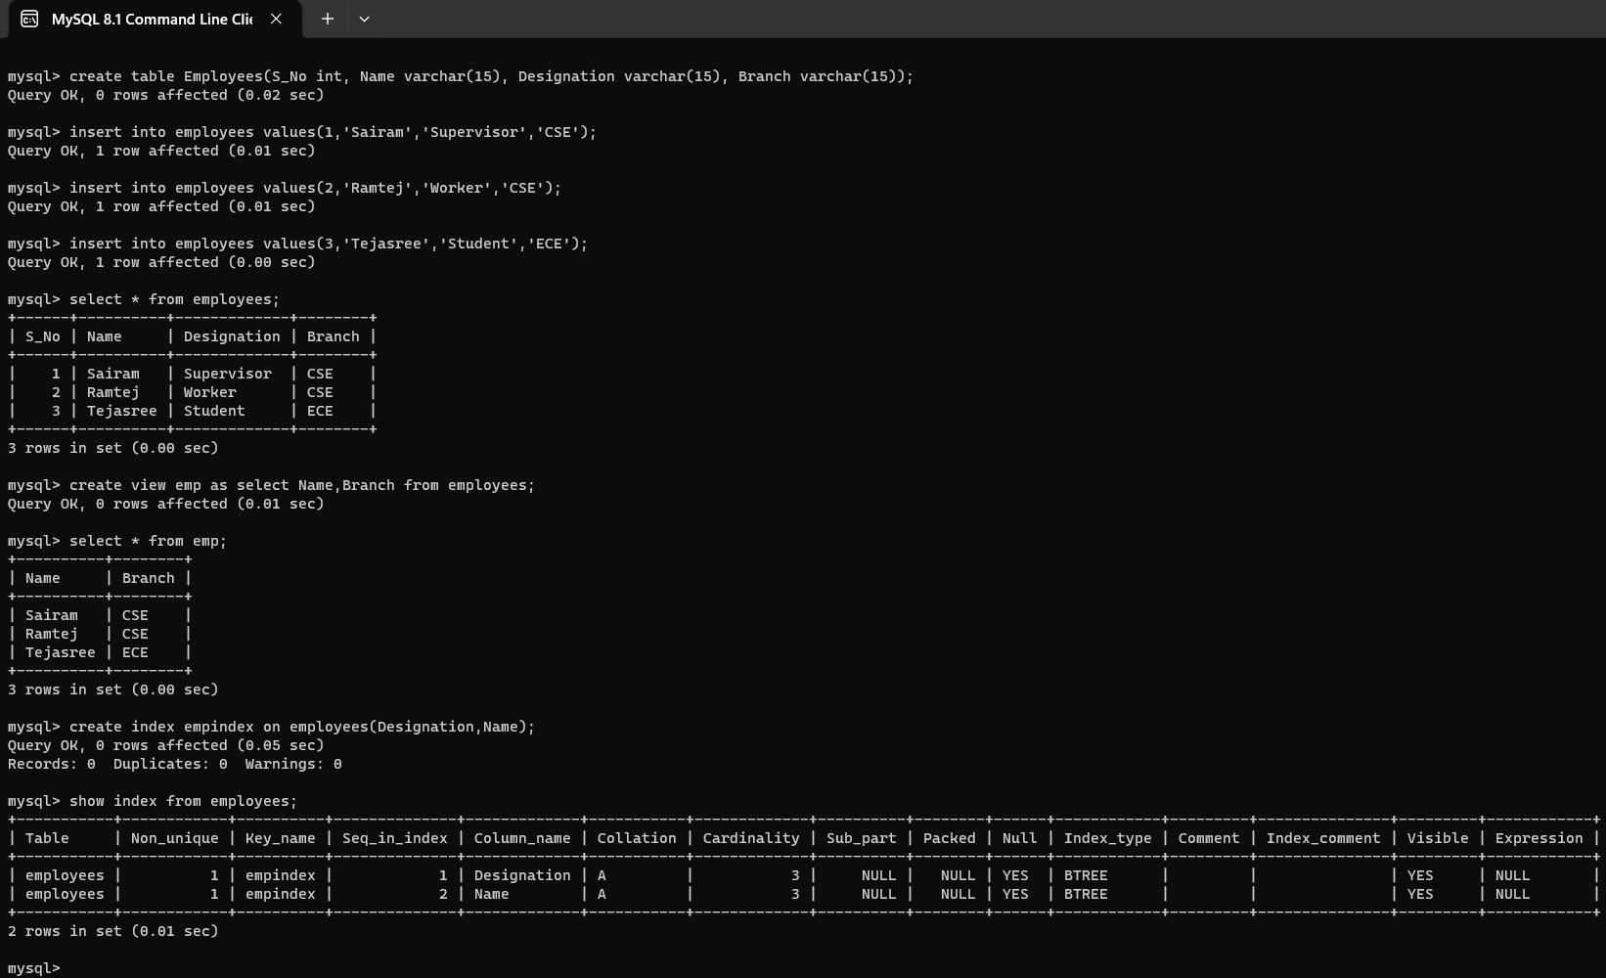

1. Populate register number using auto increment in DBMS_Stud table.
2. Manually populate register number
3. Drop the auto increment.

Q.10. AUTO INCREMENT – SEQUENCE

