**Exercise 1: Control Structures**

**Scenario 1:** The bank wants to apply a discount to loan interest rates for customers above 60 years old.

**Question:** Write a PL/SQL block that loops through all customers, checks their age, and if they are above 60, apply a 1% discount to their current loan interest rates.

SET SERVEROUTPUT ON

DECLARE

v_age NUMBER;

BEGIN

FOR c IN (SELECT CustomerID, Name, DOB FROM Customers) LOOP

-- Calculate age

v_age := TRUNC(MONTHS_BETWEEN(SYSDATE, c.DOB) / 12);

IF v_age > 60 THEN

DBMS_OUTPUT.PUT_LINE('Customer: ' || c.Name || ' (Age: ' || v_age || ') - Eligible for discount');

-- Update loan interest

UPDATE Loans

SET InterestRate = InterestRate - 1

WHERE CustomerID = c.CustomerID;

DBMS_OUTPUT.PUT_LINE('→ Loan interest rate updated for Customer ID: ' || c.CustomerID);

ELSE

DBMS_OUTPUT.PUT_LINE('Customer: ' || c.Name || ' (Age: ' || v_age || ') - Not eligible');

END IF;

END LOOP;

COMMIT;

END;

/

**OUTPUT:**  
  
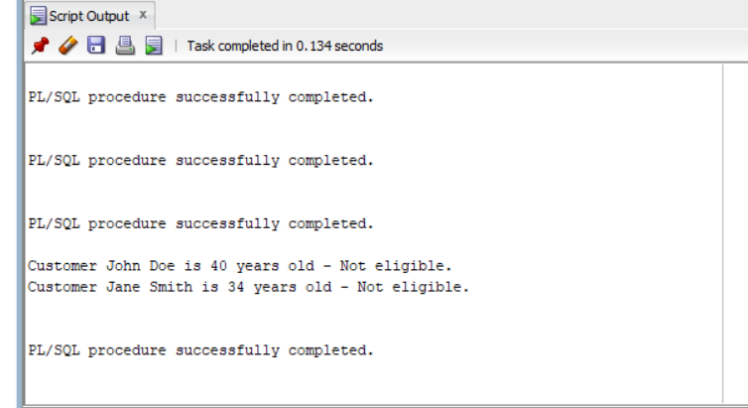

**Scenario 2:** A customer can be promoted to VIP status based on their balance.

**Question:** Write a PL/SQL block that iterates through all customers and sets a flag IsVIP to TRUE for those with a balance over $10,000.

SET SERVEROUTPUT ON;

BEGIN

FOR c IN (SELECT CustomerID, Name, Balance FROM Customers) LOOP

IF c.Balance > 10000 THEN

UPDATE Customers

SET IsVIP = 'TRUE'

WHERE CustomerID = c.CustomerID;

DBMS_OUTPUT.PUT_LINE('Customer ' || c.Name || ' is now a VIP!');

ELSE

UPDATE Customers

SET IsVIP = 'FALSE'

WHERE CustomerID = c.CustomerID;

DBMS_OUTPUT.PUT_LINE('Customer ' || c.Name || ' is NOT a VIP.');

END IF;

END LOOP;

COMMIT;

END;

/

OUTPUT:  
  
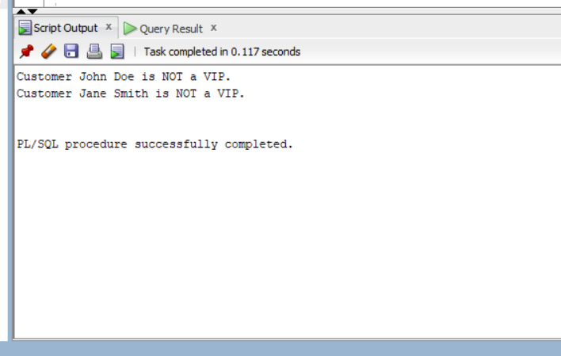

**Scenario 3:** The bank wants to send reminders to customers whose loans are due within the next 30 days.

**Question:** Write a PL/SQL block that fetches all loans due in the next 30 days and prints a reminder message for each customer.

SET SERVEROUTPUT ON;

BEGIN

FOR loan IN (

SELECT l.LoanID, l.CustomerID, l.EndDate, c.Name

FROM Loans l

JOIN Customers c ON l.CustomerID = c.CustomerID

WHERE l.EndDate BETWEEN SYSDATE AND SYSDATE + 30

) LOOP

DBMS_OUTPUT.PUT_LINE('Reminder: Customer ' || loan.Name ||

' (Customer ID: ' || loan.CustomerID || ')' ||

' has a loan (Loan ID: ' || loan.LoanID || ') due on ' ||

TO_CHAR(loan.EndDate, 'DD-MON-YYYY') || '.');

END LOOP;

END;

/

OUTPUT:

