**Exercise 2: Error Handling**

**Scenario 1:** Handle exceptions during fund transfers between accounts.

**Question:** Write a stored procedure **SafeTransferFunds** that transfers funds between two accounts. Ensure that if any error occurs (e.g., insufficient funds), an appropriate error message is logged and the transaction is rolled back.

CREATE OR REPLACE PROCEDURE SafeTransferFunds(

p_FromAccountID IN NUMBER,

p_ToAccountID IN NUMBER,

p_Amount IN NUMBER

) AS

v_FromBalance NUMBER;

BEGIN

-- Check available balance in source account

SELECT Balance INTO v_FromBalance FROM Accounts WHERE AccountID = p_FromAccountID FOR UPDATE;

IF v_FromBalance < p_Amount THEN

RAISE_APPLICATION_ERROR(-20001, 'Insufficient funds in source account.');

END IF;

-- Deduct from source

UPDATE Accounts

SET Balance = Balance - p_Amount, LastModified = SYSDATE

WHERE AccountID = p_FromAccountID;

-- Add to destination

UPDATE Accounts

SET Balance = Balance + p_Amount, LastModified = SYSDATE

WHERE AccountID = p_ToAccountID;

-- Insert transaction records (simplified)

INSERT INTO Transactions (TransactionID, AccountID, TransactionDate, Amount, TransactionType)

VALUES (Transactions_SEQ.NEXTVAL, p_FromAccountID, SYSDATE, p_Amount, 'TransferOut');

INSERT INTO Transactions (TransactionID, AccountID, TransactionDate, Amount, TransactionType)

VALUES (Transactions_SEQ.NEXTVAL, p_ToAccountID, SYSDATE, p_Amount, 'TransferIn');

COMMIT;

EXCEPTION

WHEN OTHERS THEN

ROLLBACK;

DBMS_OUTPUT.PUT_LINE('Error during fund transfer: ' || SQLERRM);

END;

/

CREATE SEQUENCE Transactions_SEQ START WITH 3;

OUTPUT:

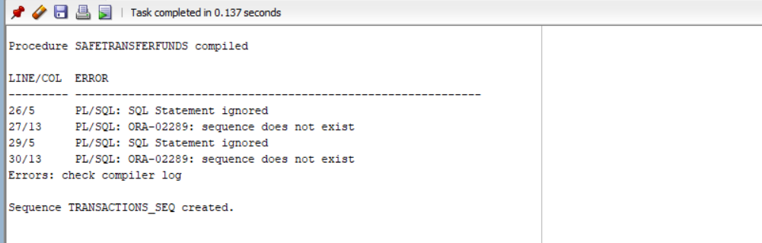

**Scenario 2:** Manage errors when updating employee salaries.

**Question:** Write a stored procedure **UpdateSalary** that increases the salary of an employee by a given percentage. If the employee ID does not exist, handle the exception and log an error message.

CREATE OR REPLACE PROCEDURE UpdateSalary(

p_EmployeeID IN NUMBER,

p_Percentage IN NUMBER

) AS

BEGIN

-- Try updating the salary

UPDATE Employees

SET Salary = Salary + (Salary * p_Percentage / 100)

WHERE EmployeeID = p_EmployeeID;

IF SQL%ROWCOUNT = 0 THEN

-- No rows affected -> invalid EmployeeID

RAISE_APPLICATION_ERROR(-20002, 'Employee not found.');

END IF;

COMMIT;

EXCEPTION

WHEN OTHERS THEN

ROLLBACK;

DBMS_OUTPUT.PUT_LINE('Error updating salary: ' || SQLERRM);

END;

/

OUTPUT:

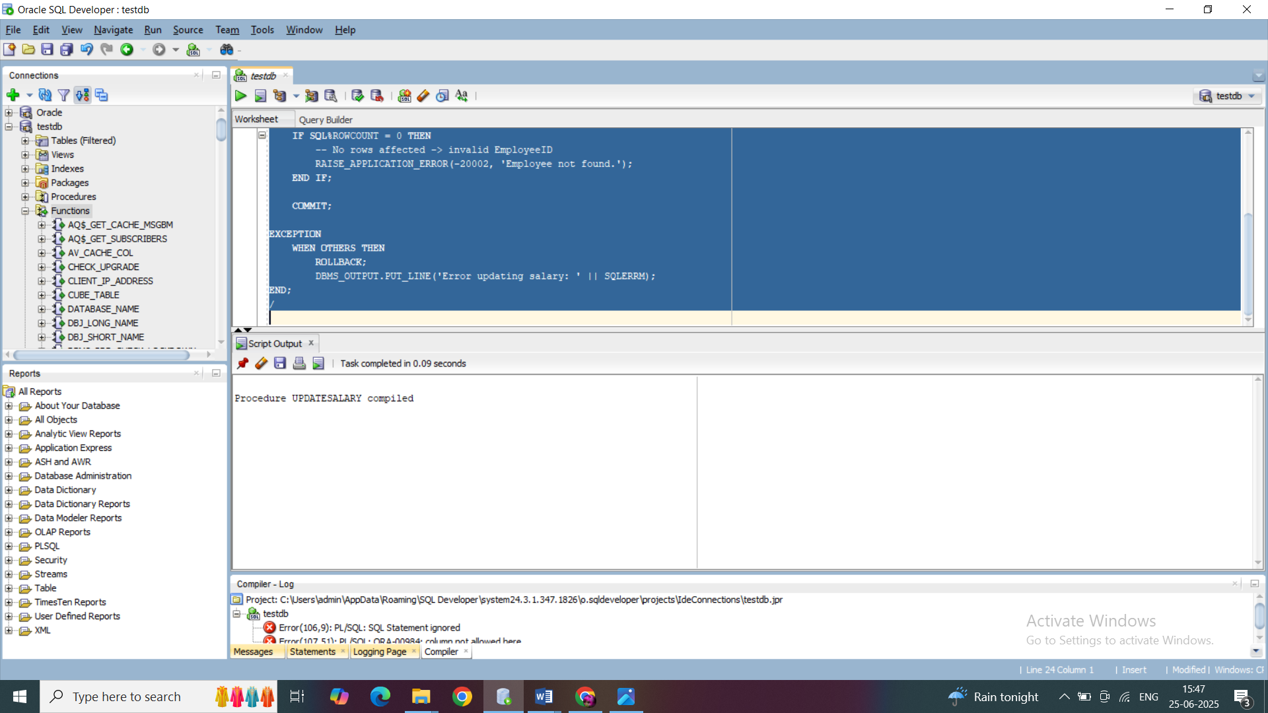

**Scenario 3:** Ensure data integrity when adding a new customer.

**Question:** Write a stored procedure **AddNewCustomer** that inserts a new customer into the Customers table. If a customer with the same ID already exists, handle the exception by logging an error and preventing the insertion.

CREATE OR REPLACE PROCEDURE AddNewCustomer(

p_CustomerID IN NUMBER,

p_Name IN VARCHAR2,

p_DOB IN DATE,

p_Balance IN NUMBER

) AS

BEGIN

INSERT INTO Customers (CustomerID, Name, DOB, Balance, LastModified)

VALUES (p_CustomerID, p_Name, p_DOB, p_Balance, SYSDATE);

COMMIT;

EXCEPTION

WHEN DUP_VAL_ON_INDEX THEN

ROLLBACK;

DBMS_OUTPUT.PUT_LINE('Customer with this ID already exists.');

WHEN OTHERS THEN

ROLLBACK;

DBMS_OUTPUT.PUT_LINE('Error adding customer: ' || SQLERRM);

END;

/

-- Test Fund Transfer (should fail if balance insufficient)

EXEC SafeTransferFunds(1, 2, 500);

-- Test Salary Update (invalid ID)

EXEC UpdateSalary(99, 10); -- Assuming ID 99 does not exist

-- Test Add Customer (duplicate ID)

EXEC AddNewCustomer(1, 'Duplicate John', TO_DATE('1992-08-15', 'YYYY-MM-DD'), 1000);

OUTPUT:

