**Exercise 3: Stored Procedures**

**Scenario 1:** The bank needs to process monthly interest for all savings accounts.

**Question:** Write a stored procedure **ProcessMonthlyInterest** that calculates and updates the balance of all savings accounts by applying an interest rate of 1% to the current balance.

CREATE OR REPLACE PROCEDURE ProcessMonthlyInterest IS

CURSOR savings_accounts IS

SELECT AccountID, Balance FROM Accounts WHERE AccountType = 'Savings' FOR UPDATE;

v_new_balance NUMBER;

BEGIN

FOR acc IN savings_accounts LOOP

v_new_balance := acc.Balance + (acc.Balance * 0.01);

UPDATE Accounts

SET Balance = v_new_balance,

LastModified = SYSDATE

WHERE AccountID = acc.AccountID;

DBMS_OUTPUT.PUT_LINE('Interest applied: AccountID=' || acc.AccountID ||

', Old Balance=' || acc.Balance ||

', New Balance=' || v_new_balance);

END LOOP;

COMMIT;

EXCEPTION

WHEN OTHERS THEN

ROLLBACK;

DBMS_OUTPUT.PUT_LINE('Error processing interest: ' || SQLERRM);

END;

/  
  
OUTPUT:

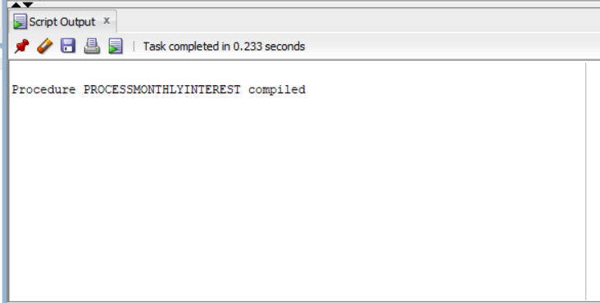

**Scenario 2:** The bank wants to implement a bonus scheme for employees based on their performance.

**Question:** Write a stored procedure **UpdateEmployeeBonus** that updates the salary of employees in a given department by adding a bonus percentage passed as a parameter.

CREATE OR REPLACE PROCEDURE UpdateEmployeeBonus(

p_Department IN VARCHAR2,

p_BonusPercent IN NUMBER

) AS

CURSOR emp_cursor IS

SELECT EmployeeID, Name, Salary FROM Employees WHERE Department = p_Department FOR UPDATE;

v_new_salary NUMBER;

BEGIN

FOR emp IN emp_cursor LOOP

v_new_salary := emp.Salary + (emp.Salary * p_BonusPercent / 100);

UPDATE Employees

SET Salary = v_new_salary

WHERE EmployeeID = emp.EmployeeID;

DBMS_OUTPUT.PUT_LINE('Bonus applied: EmployeeID=' || emp.EmployeeID ||

', Name=' || emp.Name ||

', Old Salary=' || emp.Salary ||

', New Salary=' || v_new_salary);

END LOOP;

IF emp_cursor%ROWCOUNT = 0 THEN

DBMS_OUTPUT.PUT_LINE('No employees found in department: ' || p_Department);

END IF;

COMMIT;

EXCEPTION

WHEN OTHERS THEN

ROLLBACK;

DBMS_OUTPUT.PUT_LINE('Error updating bonuses: ' || SQLERRM);

END;

/

OUTPUT:

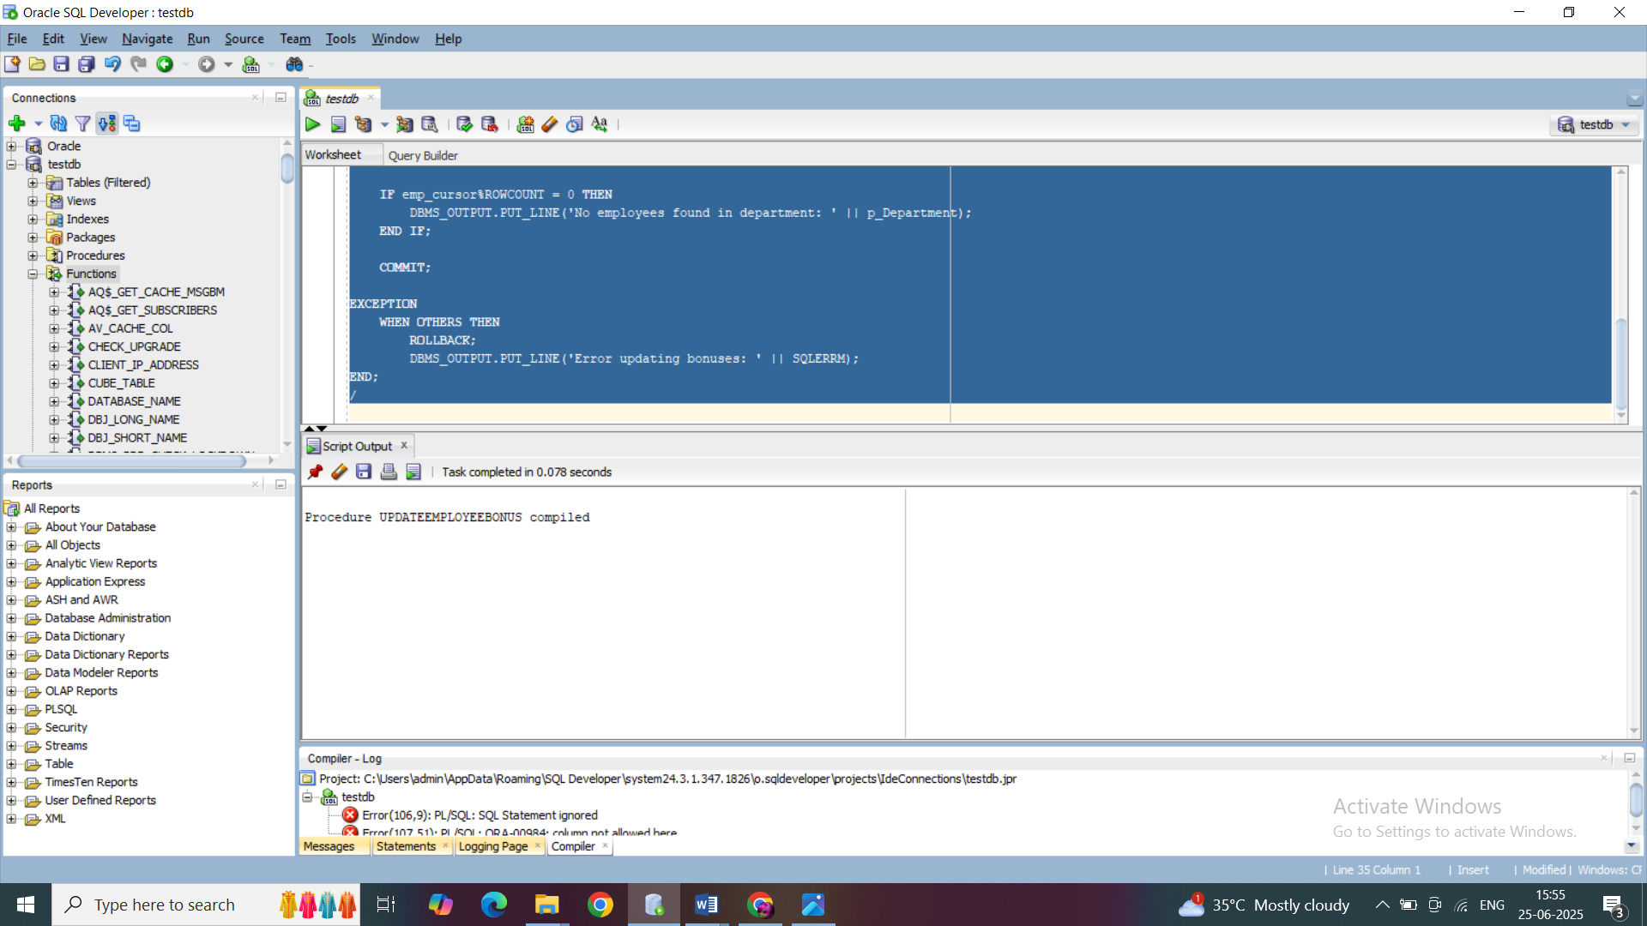

**Scenario 3:** Customers should be able to transfer funds between their accounts.

**Question:** Write a stored procedure **TransferFunds** that transfers a specified amount from one account to another, checking that the source account has sufficient balance before making the transfer.

CREATE OR REPLACE PROCEDURE TransferFunds(

p_SourceAccountID IN NUMBER,

p_TargetAccountID IN NUMBER,

p_Amount IN NUMBER

) AS

v_SourceBalance NUMBER;

v_TargetBalance NUMBER;

BEGIN

-- Lock and get source balance

SELECT Balance INTO v_SourceBalance FROM Accounts

WHERE AccountID = p_SourceAccountID FOR UPDATE;

IF v_SourceBalance < p_Amount THEN

RAISE_APPLICATION_ERROR(-20001, 'Insufficient balance in source account.');

END IF;

-- Lock and get target balance

SELECT Balance INTO v_TargetBalance FROM Accounts

WHERE AccountID = p_TargetAccountID FOR UPDATE;

-- Update source

UPDATE Accounts

SET Balance = v_SourceBalance - p_Amount,

LastModified = SYSDATE

WHERE AccountID = p_SourceAccountID;

-- Update target

UPDATE Accounts

SET Balance = v_TargetBalance + p_Amount,

LastModified = SYSDATE

WHERE AccountID = p_TargetAccountID;

-- Transactions

INSERT INTO Transactions (TransactionID, AccountID, TransactionDate, Amount, TransactionType)

VALUES (Transactions_SEQ.NEXTVAL, p_SourceAccountID, SYSDATE, p_Amount, 'TransferOut');

INSERT INTO Transactions (TransactionID, AccountID, TransactionDate, Amount, TransactionType)

VALUES (Transactions_SEQ.NEXTVAL, p_TargetAccountID, SYSDATE, p_Amount, 'TransferIn');

DBMS_OUTPUT.PUT_LINE('Transfer Successful!');

DBMS_OUTPUT.PUT_LINE('From Account: ' || p_SourceAccountID || ', Deducted: ' || p_Amount ||

', New Balance: ' || (v_SourceBalance - p_Amount));

DBMS_OUTPUT.PUT_LINE('To Account: ' || p_TargetAccountID || ', Added: ' || p_Amount ||

', New Balance: ' || (v_TargetBalance + p_Amount));

COMMIT;

EXCEPTION

WHEN NO_DATA_FOUND THEN

ROLLBACK;

DBMS_OUTPUT.PUT_LINE('Invalid source or target account ID.');

WHEN OTHERS THEN

ROLLBACK;

DBMS_OUTPUT.PUT_LINE('Error during fund transfer: ' || SQLERRM);

END;

/

OUTPUT:

