**Scenario 1:** Calculate the age of customers for eligibility checks.

* + **Question:** Write a function CalculateAge that takes a customer's date of birth as input and returns their age in years.

CREATE OR REPLACE FUNCTION CalculateAge(

p_DOB IN DATE

) RETURN NUMBER IS

v_age NUMBER;

BEGIN

v_age := FLOOR(MONTHS_BETWEEN(SYSDATE, p_DOB) / 12);

RETURN v_age;

END;

/

SELECT CalculateAge(DOB) AS Age FROM Customers WHERE CustomerID = 1;

OUTPUT:

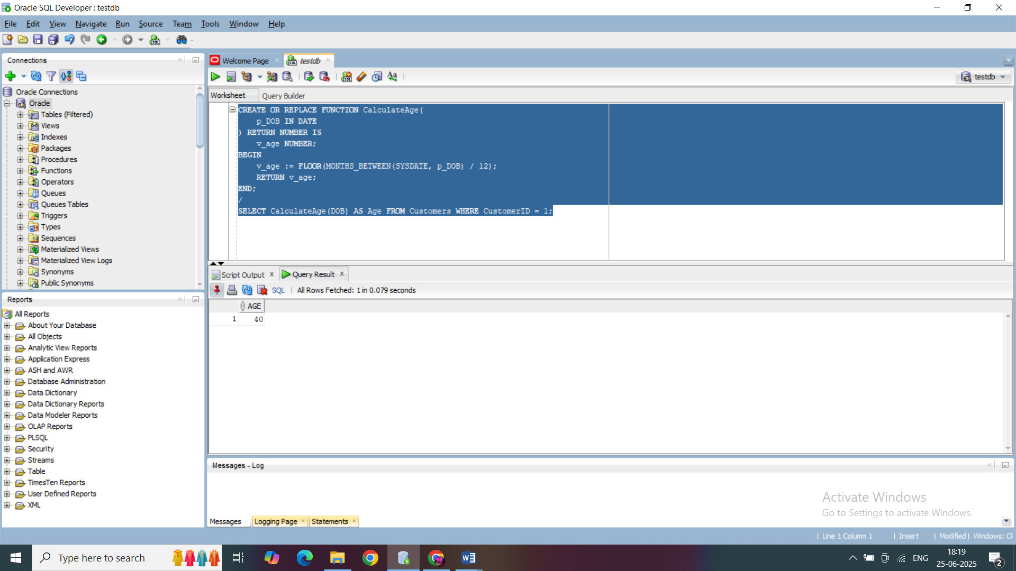

**Scenario 2:** The bank needs to compute the monthly installment for a loan.

**Question:** Write a function **CalculateMonthlyInstallment** that takes the loan amount, interest rate, and loan duration in years as input and returns the monthly installment amount.

CREATE OR REPLACE FUNCTION CalculateMonthlyInstallment(

p_LoanAmount IN NUMBER,

p_InterestRate IN NUMBER, -- annual rate in %

p_Years IN NUMBER

) RETURN NUMBER IS

v_monthlyRate NUMBER := p_InterestRate / 12 / 100;

v_months NUMBER := p_Years * 12;

v_emi NUMBER;

BEGIN

IF v_monthlyRate = 0 THEN

v_emi := p_LoanAmount / v_months;

ELSE

v_emi := (p_LoanAmount * v_monthlyRate * POWER(1 + v_monthlyRate, v_months)) /

(POWER(1 + v_monthlyRate, v_months) - 1);

END IF;

RETURN ROUND(v_emi, 2);

END;

/

SELECT CalculateMonthlyInstallment(50000, 6.5, 5) AS EMI FROM DUAL;

OUTPUT:

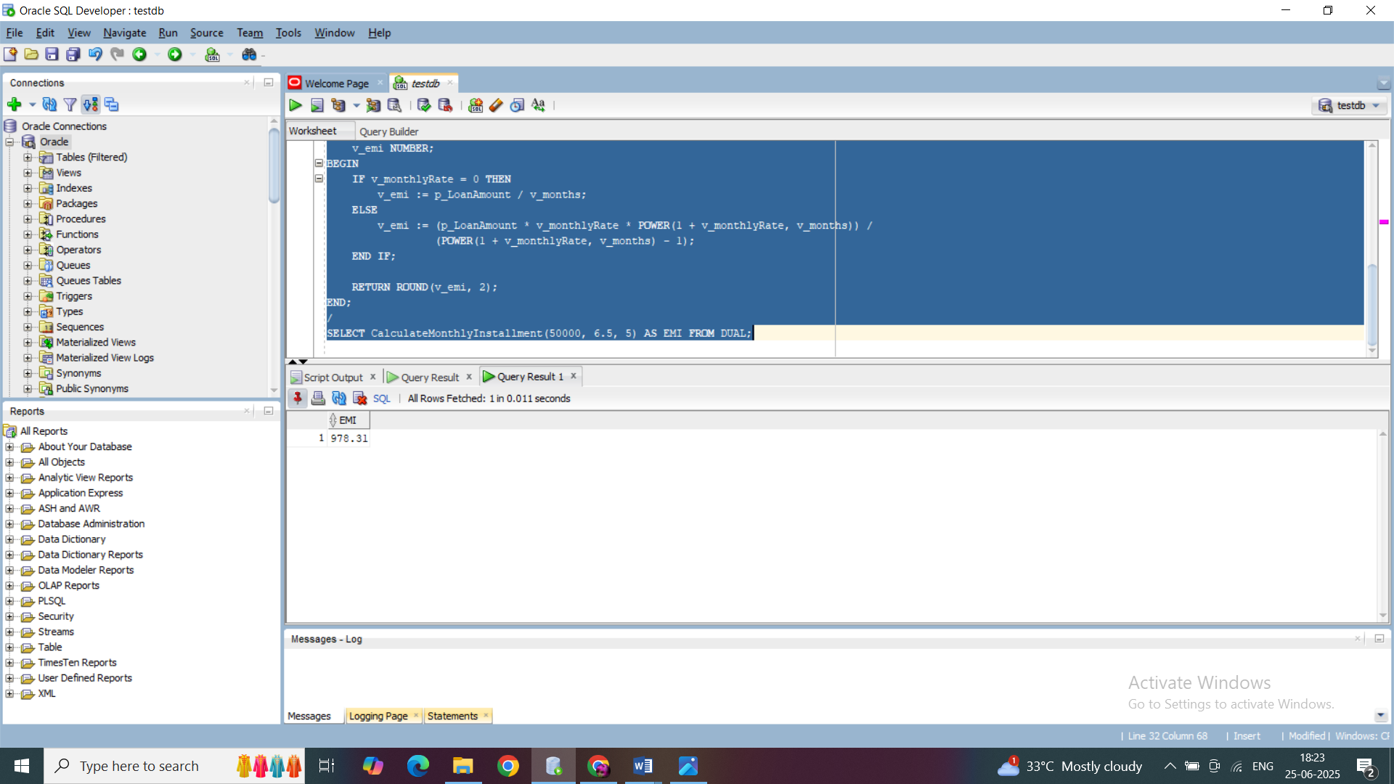

**Scenario 3:** Check if a customer has sufficient balance before making a transaction.

**Question:** Write a function **HasSufficientBalance** that takes an account ID and an amount as input and returns a boolean indicating whether the account has at least the specified amount.

CREATE OR REPLACE FUNCTION HasSufficientBalance(

p_AccountID IN NUMBER,

p_Amount IN NUMBER

) RETURN BOOLEAN IS

v_balance NUMBER;

BEGIN

SELECT Balance INTO v_balance

FROM Accounts

WHERE AccountID = p_AccountID;

RETURN v_balance >= p_Amount;

EXCEPTION

WHEN NO_DATA_FOUND THEN

RETURN FALSE;

WHEN OTHERS THEN

RETURN FALSE;

END;

/

DECLARE

v_result BOOLEAN;

BEGIN

v_result := HasSufficientBalance(1, 300);

IF v_result THEN

DBMS_OUTPUT.PUT_LINE('Sufficient balance.');

ELSE

DBMS_OUTPUT.PUT_LINE('Insufficient balance.');

END IF;

END;

/

OUTPUT:

