**Exercise 5: Triggers**

**Scenario 1:** Automatically update the last modified date when a customer's record is updated.

**Question:** Write a trigger **UpdateCustomerLastModified** that updates the LastModified column of the Customers table to the current date whenever a customer's record is updated.

**Solution:**

CREATE OR REPLACE TRIGGER UpdateCustomerLastModified

BEFORE UPDATE ON Customers

FOR EACH ROW

BEGIN

:NEW.LastModified := SYSDATE;

END;

/

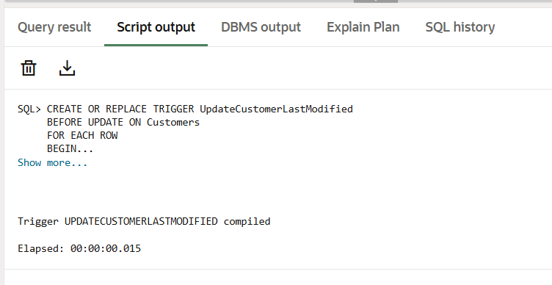

**Scenario 2:** Maintain an audit log for all transactions.

**Question:** Write a trigger **LogTransaction** that inserts a record into an AuditLog table whenever a transaction is inserted into the Transactions table.

**Solution:**

CREATE TABLE AuditLog (

LogID NUMBER GENERATED ALWAYS AS IDENTITY PRIMARY KEY,

TransactionID NUMBER,

AccountID NUMBER,

TransactionDate DATE,

Amount NUMBER,

TransactionType VARCHAR2(10),

LoggedAt DATE DEFAULT SYSDATE

);

CREATE OR REPLACE TRIGGER LogTransaction

AFTER INSERT ON Transactions

FOR EACH ROW

BEGIN

INSERT INTO AuditLog (TransactionID, AccountID, TransactionDate, Amount, TransactionType)

VALUES (:NEW.TransactionID, :NEW.AccountID, :NEW.TransactionDate, :NEW.Amount, :NEW.TransactionType);

INSERT INTO TriggerLog (LogMessage)

VALUES ('Audit log created for Transaction ID: ' || :NEW.TransactionID);

END;

/

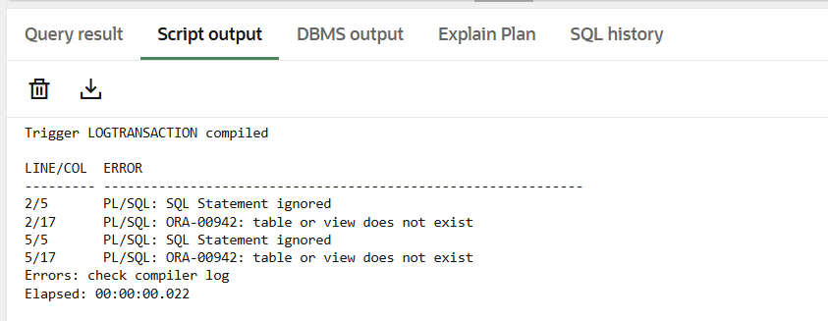

**Scenario 3:** Enforce business rules on deposits and withdrawals.

**Question:** Write a trigger **CheckTransactionRules** that ensures withdrawals do not exceed the balance and deposits are positive before inserting a record into the Transactions table.

**Solution:**

CREATE OR REPLACE TRIGGER CheckTransactionRules

BEFORE INSERT ON Transactions

FOR EACH ROW

DECLARE

current_balance NUMBER;

BEGIN

-- Get the current balance of the account

SELECT Balance INTO current_balance

FROM Accounts

WHERE AccountID = :NEW.AccountID;

-- Validate deposit

IF :NEW.TransactionType = 'Deposit' THEN

IF :NEW.Amount <= 0 THEN

RAISE_APPLICATION_ERROR(-20001, 'Deposit amount must be positive');

END IF;

-- Validate withdrawal

ELSIF :NEW.TransactionType = 'Withdrawal' THEN

IF :NEW.Amount > current_balance THEN

RAISE_APPLICATION_ERROR(-20002, 'Insufficient funds for withdrawal');

END IF;

END IF;

END;

/

