**Exercise 6: Cursors**

**Scenario 1:** Generate monthly statements for all customers.

**Question:** Write a PL/SQL block using an explicit cursor **GenerateMonthlyStatements** that retrieves all transactions for the current month and prints a statement for each customer.

DECLARE

CURSOR txn_cursor IS

SELECT c.CustomerID, c.Name, a.AccountID, t.TransactionDate, t.Amount, t.TransactionType

FROM Customers c

JOIN Accounts a ON c.CustomerID = a.CustomerID

JOIN Transactions t ON a.AccountID = t.AccountID

WHERE TRUNC(t.TransactionDate, 'MM') = TRUNC(SYSDATE, 'MM')

ORDER BY c.CustomerID, t.TransactionDate;

v_customer_id Customers.CustomerID%TYPE;

v_name Customers.Name%TYPE;

v_account_id Accounts.AccountID%TYPE;

v_txn_date Transactions.TransactionDate%TYPE;

v_amount Transactions.Amount%TYPE;

v_type Transactions.TransactionType%TYPE;

BEGIN

DBMS_OUTPUT.PUT_LINE('Monthly Statement for Transactions in ' || TO_CHAR(SYSDATE, 'Month YYYY'));

DBMS_OUTPUT.PUT_LINE('-------------------------------------------------------------');

OPEN txn_cursor;

LOOP

FETCH txn_cursor INTO v_customer_id, v_name, v_account_id, v_txn_date, v_amount, v_type;

EXIT WHEN txn_cursor%NOTFOUND;

DBMS_OUTPUT.PUT_LINE('Customer: ' || v_name || ' (ID: ' || v_customer_id || ')');

DBMS_OUTPUT.PUT_LINE(' Account ID: ' || v_account_id);

DBMS_OUTPUT.PUT_LINE(' Date: ' || TO_CHAR(v_txn_date, 'DD-MON-YYYY') ||

', Type: ' || v_type || ', Amount: ' || v_amount);

DBMS_OUTPUT.PUT_LINE('-------------------------------------------------------------');

END LOOP;

CLOSE txn_cursor;

END;

/

OUTPUT:

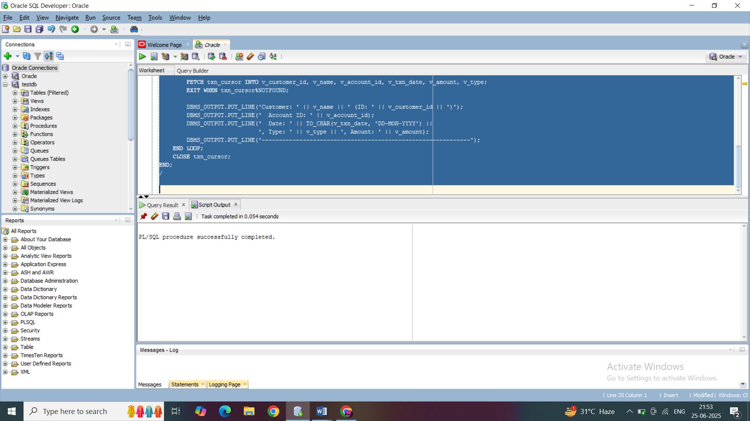

**Scenario 2:** Apply annual fee to all accounts.

**Question:** Write a PL/SQL block using an explicit cursor **ApplyAnnualFee** that deducts an annual maintenance fee from the balance of all accounts.

DECLARE

CURSOR acc_cursor IS

SELECT AccountID, Balance FROM Accounts FOR UPDATE;

v_account_id Accounts.AccountID%TYPE;

v_balance Accounts.Balance%TYPE;

annual_fee CONSTANT NUMBER := 100;

BEGIN

OPEN acc_cursor;

LOOP

FETCH acc_cursor INTO v_account_id, v_balance;

EXIT WHEN acc_cursor%NOTFOUND;

IF v_balance >= annual_fee THEN

UPDATE Accounts

SET Balance = Balance - annual_fee,

LastModified = SYSDATE

WHERE CURRENT OF acc_cursor;

DBMS_OUTPUT.PUT_LINE('Fee applied to Account ID ' || v_account_id ||

', New Balance: ' || (v_balance - annual_fee));

ELSE

DBMS_OUTPUT.PUT_LINE('Insufficient balance in Account ID ' || v_account_id ||

', Fee not applied.');

END IF;

END LOOP;

CLOSE acc_cursor;

END;

/

OUTPUT:

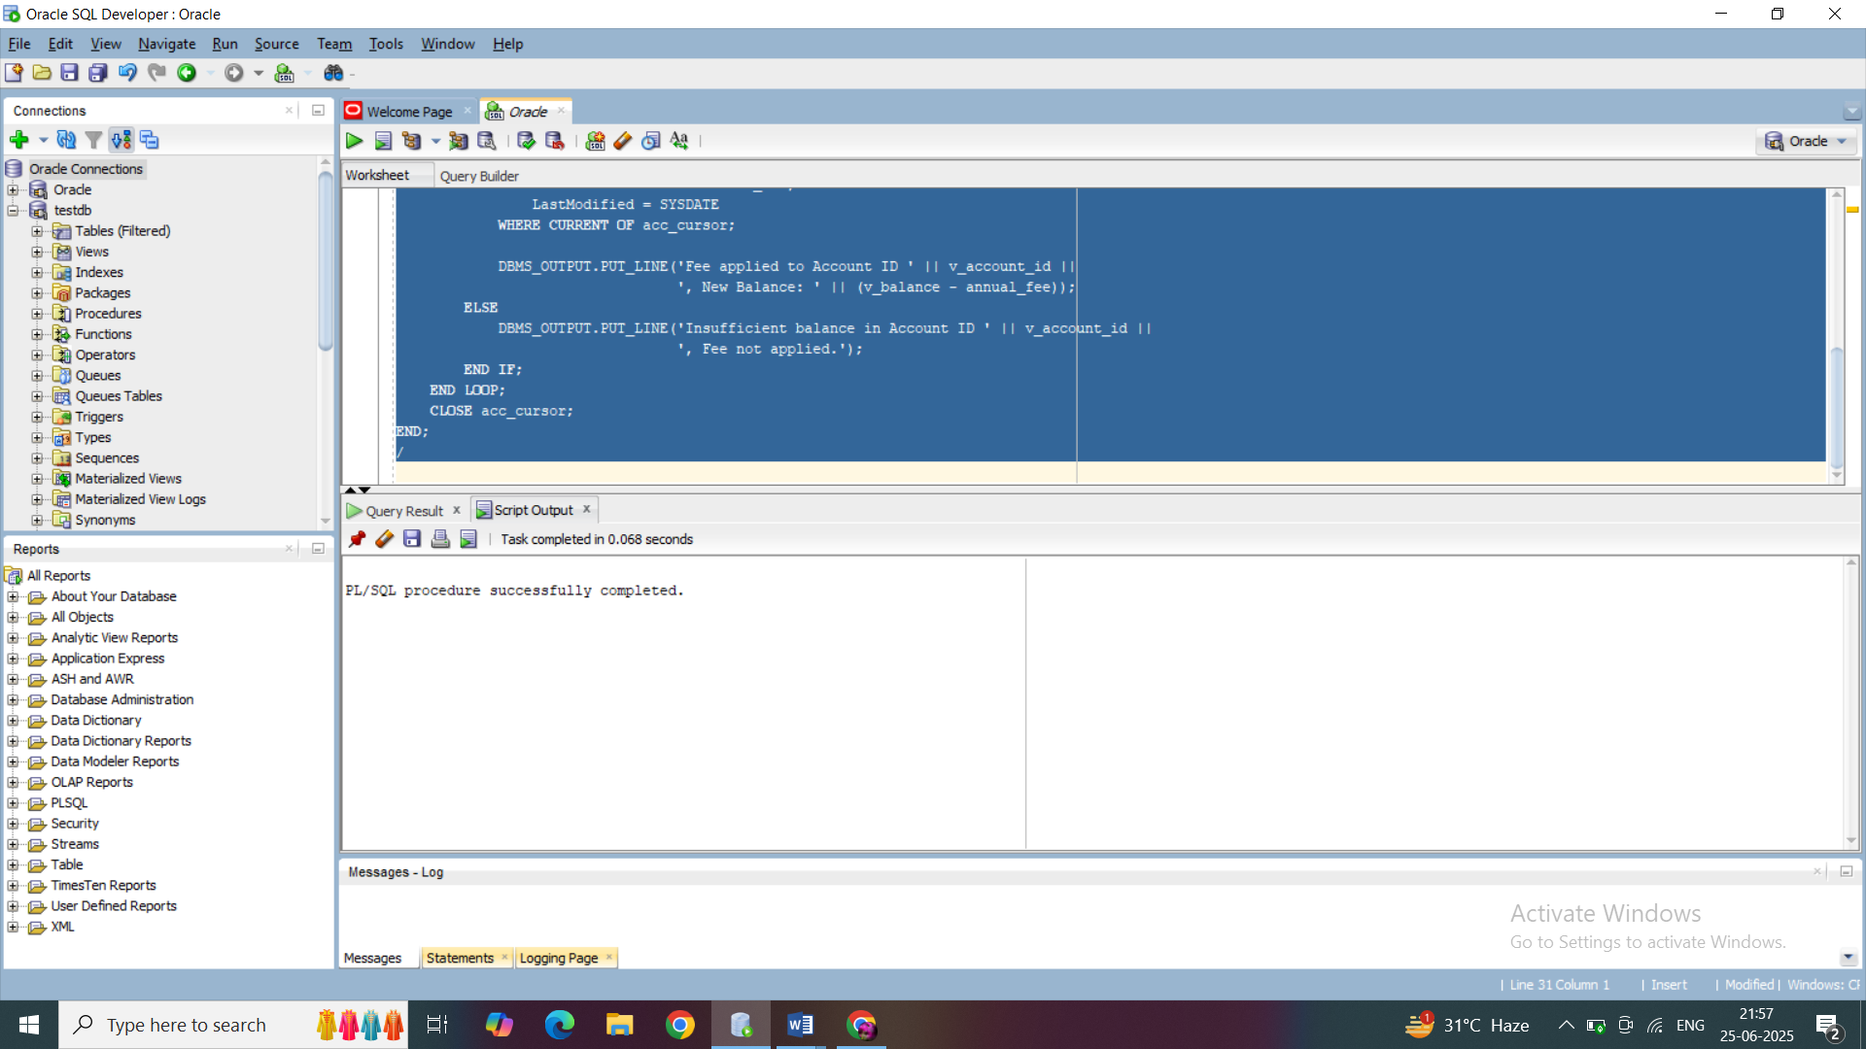

**Scenario 3:** Update the interest rate for all loans based on a new policy.

**Question:** Write a PL/SQL block using an explicit cursor **UpdateLoanInterestRates** that fetches all loans and updates their interest rates based on the new policy.

DECLARE

CURSOR loan_cursor IS

SELECT LoanID, InterestRate FROM Loans FOR UPDATE;

v_loan_id Loans.LoanID%TYPE;

v_interest Loans.InterestRate%TYPE;

increment_rate CONSTANT NUMBER := 0.5; -- Example new policy

BEGIN

OPEN loan_cursor;

LOOP

FETCH loan_cursor INTO v_loan_id, v_interest;

EXIT WHEN loan_cursor%NOTFOUND;

UPDATE Loans

SET InterestRate = v_interest + increment_rate

WHERE CURRENT OF loan_cursor;

DBMS_OUTPUT.PUT_LINE('Updated Loan ID ' || v_loan_id ||

', Old Rate: ' || v_interest ||

', New Rate: ' || (v_interest + increment_rate));

END LOOP;

CLOSE loan_cursor;

END;

/  
  
OUTPUT:

