**Exercise 7: Packages**

**Scenario 1:** Group all customer-related procedures and functions into a package.

**Question:** Create a package **CustomerManagement** with procedures for adding a new customer, updating customer details, and a function to get customer balance.

-- Package Specification

CREATE OR REPLACE PACKAGE CustomerManagement IS

PROCEDURE AddCustomer(p_ID NUMBER, p_Name VARCHAR2, p_DOB DATE, p_Balance NUMBER);

PROCEDURE UpdateCustomer(p_ID NUMBER, p_Name VARCHAR2, p_DOB DATE, p_Balance NUMBER);

FUNCTION GetCustomerBalance(p_ID NUMBER) RETURN NUMBER;

END CustomerManagement;

/

-- Package Body

CREATE OR REPLACE PACKAGE BODY CustomerManagement IS

PROCEDURE AddCustomer(p_ID NUMBER, p_Name VARCHAR2, p_DOB DATE, p_Balance NUMBER) IS

BEGIN

INSERT INTO Customers (CustomerID, Name, DOB, Balance, LastModified)

VALUES (p_ID, p_Name, p_DOB, p_Balance, SYSDATE);

END;

PROCEDURE UpdateCustomer(p_ID NUMBER, p_Name VARCHAR2, p_DOB DATE, p_Balance NUMBER) IS

BEGIN

UPDATE Customers

SET Name = p_Name, DOB = p_DOB, Balance = p_Balance, LastModified = SYSDATE

WHERE CustomerID = p_ID;

END;

FUNCTION GetCustomerBalance(p_ID NUMBER) RETURN NUMBER IS

v_balance NUMBER;

BEGIN

SELECT Balance INTO v_balance FROM Customers WHERE CustomerID = p_ID;

RETURN v_balance;

EXCEPTION

WHEN NO_DATA_FOUND THEN

RETURN NULL;

END;

END CustomerManagement;

/

OUTPUT:

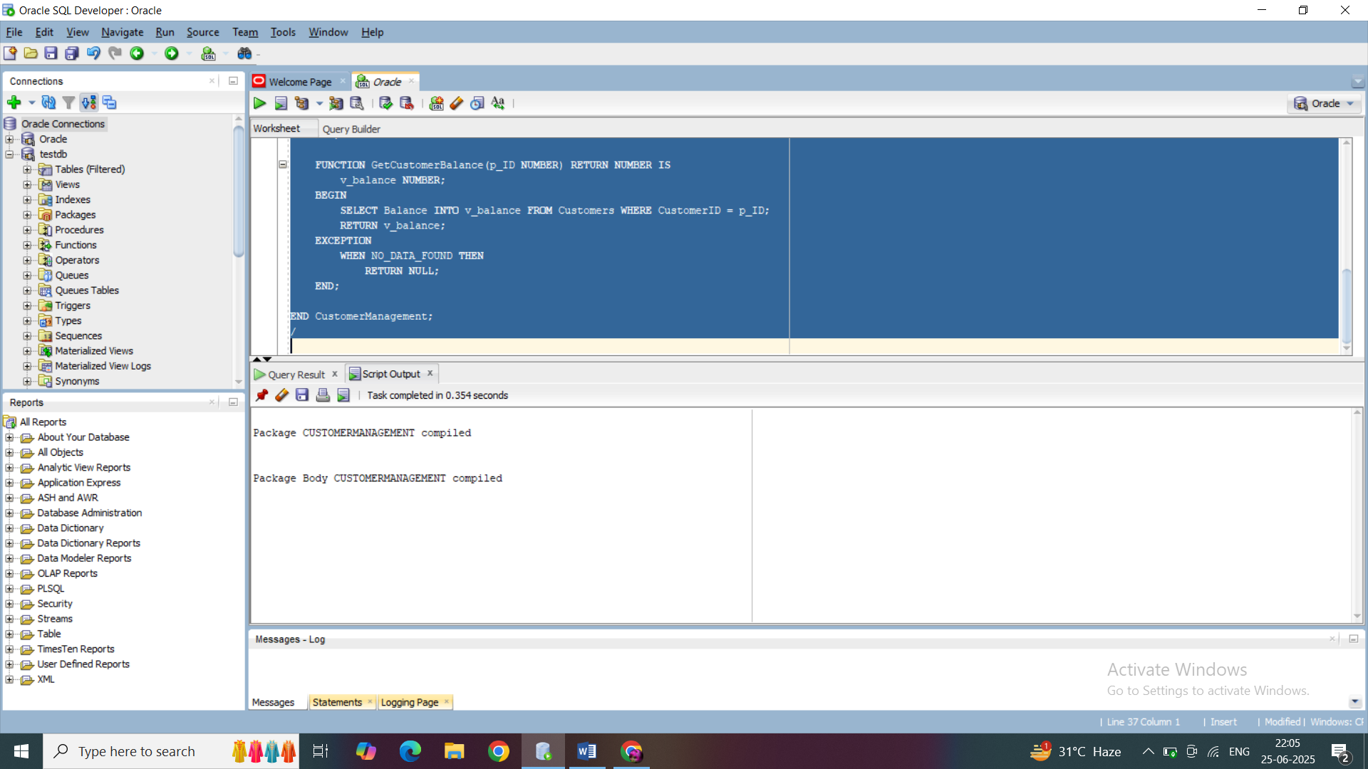

**Scenario 2:** Create a package to manage employee data.

**Question:** Write a package **EmployeeManagement** with procedures to hire new employees, update employee details, and a function to calculate annual salary.

-- Package Specification

CREATE OR REPLACE PACKAGE EmployeeManagement IS

PROCEDURE HireEmployee(p_ID NUMBER, p_Name VARCHAR2, p_Position VARCHAR2, p_Salary NUMBER, p_Dept VARCHAR2, p_HireDate DATE);

PROCEDURE UpdateEmployee(p_ID NUMBER, p_Name VARCHAR2, p_Position VARCHAR2, p_Salary NUMBER, p_Dept VARCHAR2);

FUNCTION CalcAnnualSalary(p_ID NUMBER) RETURN NUMBER;

END EmployeeManagement;

/

-- Package Body

CREATE OR REPLACE PACKAGE BODY EmployeeManagement IS

PROCEDURE HireEmployee(p_ID NUMBER, p_Name VARCHAR2, p_Position VARCHAR2, p_Salary NUMBER, p_Dept VARCHAR2, p_HireDate DATE) IS

BEGIN

INSERT INTO Employees (EmployeeID, Name, Position, Salary, Department, HireDate)

VALUES (p_ID, p_Name, p_Position, p_Salary, p_Dept, p_HireDate);

END;

PROCEDURE UpdateEmployee(p_ID NUMBER, p_Name VARCHAR2, p_Position VARCHAR2, p_Salary NUMBER, p_Dept VARCHAR2) IS

BEGIN

UPDATE Employees

SET Name = p_Name, Position = p_Position, Salary = p_Salary, Department = p_Dept

WHERE EmployeeID = p_ID;

END;

FUNCTION CalcAnnualSalary(p_ID NUMBER) RETURN NUMBER IS

v_salary NUMBER;

BEGIN

SELECT Salary INTO v_salary FROM Employees WHERE EmployeeID = p_ID;

RETURN v_salary * 12;

EXCEPTION

WHEN NO_DATA_FOUND THEN

RETURN NULL;

END;

END EmployeeManagement;

/

OUTPUT:

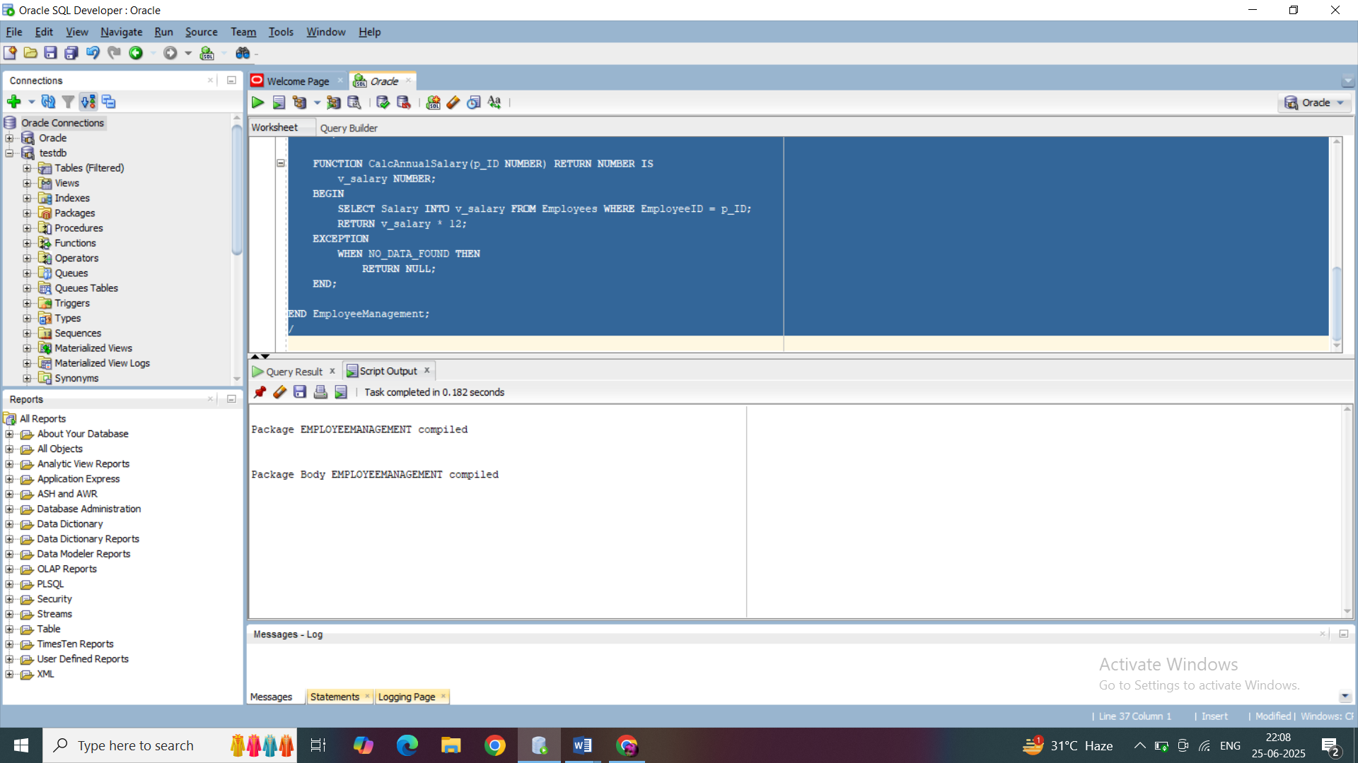

**Scenario 3:** Group all account-related operations into a package.

**Question:** Create a package **AccountOperations** with procedures for opening a new account, closing an account, and a function to get the total balance of a customer across all accounts.

-- Package Specification

CREATE OR REPLACE PACKAGE AccountOperations IS

PROCEDURE OpenAccount(p_AccID NUMBER, p_CustID NUMBER, p_AccType VARCHAR2, p_Balance NUMBER);

PROCEDURE CloseAccount(p_AccID NUMBER);

FUNCTION GetTotalBalance(p_CustID NUMBER) RETURN NUMBER;

END AccountOperations;

/

-- Package Body

CREATE OR REPLACE PACKAGE BODY AccountOperations IS

PROCEDURE OpenAccount(p_AccID NUMBER, p_CustID NUMBER, p_AccType VARCHAR2, p_Balance NUMBER) IS

BEGIN

INSERT INTO Accounts (AccountID, CustomerID, AccountType, Balance, LastModified)

VALUES (p_AccID, p_CustID, p_AccType, p_Balance, SYSDATE);

END;

PROCEDURE CloseAccount(p_AccID NUMBER) IS

BEGIN

DELETE FROM Accounts WHERE AccountID = p_AccID;

END;

FUNCTION GetTotalBalance(p_CustID NUMBER) RETURN NUMBER IS

v_total NUMBER;

BEGIN

SELECT SUM(Balance) INTO v_total

FROM Accounts

WHERE CustomerID = p_CustID;

RETURN NVL(v_total, 0);

EXCEPTION

WHEN NO_DATA_FOUND THEN

RETURN 0;

END;

END AccountOperations;

/

OUTPUT:

