REACT_1_HOL

import './App.css';

function App() {

  return (

    <h1>Welcome to the first session of React</h1>

  );

}

export default App;

OUTPUT  
  
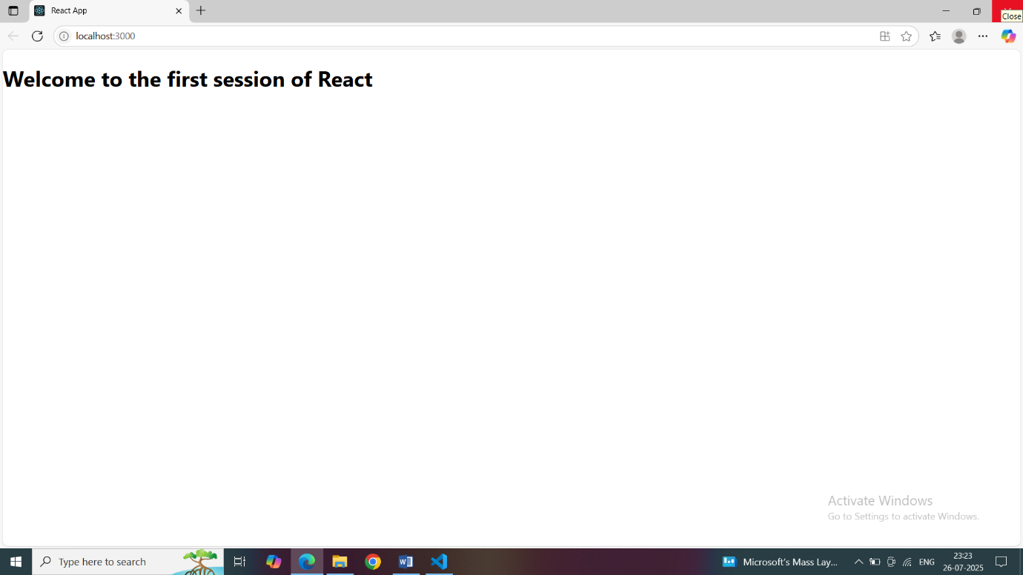

REACT_2_HOL

About.js

import React,{ Component } from "react";

class About extends Component{

    render()

    {

        return(

        <div>

        <h3>

        Welcome to the About Page of Student Management Portal</h3></div>

        );

    }

}

export default About;

Contact.js

import React,{ Component } from "react";

class Contact extends Component{

    render()

    {

        return(

        <div>

        <h3>

        Welcome to the Contact Page of Student Management App</h3></div>

        );

    }

}

export default Contact;

Home.js

import React,{ Component } from "react";

class Home extends Component{

    render()

    {

        return(

        <div>

        <h3>Welcome to the Home Page of Student Management Portal</h3></div>

        );

    }

}

export default Home;

OUTPUT:

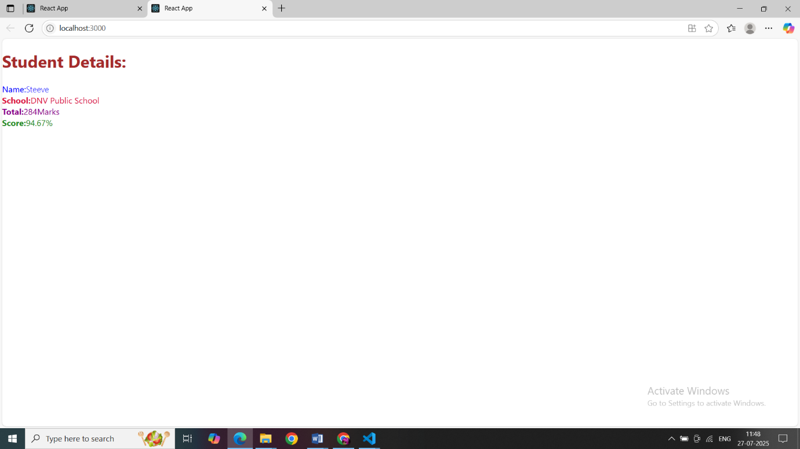

REACT_3_HOL  
  
Stylesheets

mystyle.css

.Name

{

    font-weight:300;

    color:blue;

}

.School

{

    color:crimson;

}

.Total

{

    color:darkmagenta;

}

.formatstyle

{

    text-align:center;

    font-size:large;;

}

.Score

{

    color:forestgreen

}

Components  
  
CalculateScore  
import '../Stylesheets/mystyle.css'

const percentToDecimal=(decimal)=>{

    return (decimal.toFixed(2)+'%')

}

const calscore=(total,goal)=>{

    return percentToDecimal(total/goal)

}

export const CalculateScore =({Name,School,total,goal})=>(

    <div className="formstyle">

        <h1><font color="Brown">Student Details:</font></h1>

        <div className="Name">

            <b><span>Name:</span></b>

            <span>{Name}</span>

        </div>

        <div className="School">

            <b><span>School:</span></b>

            <span>{School}</span>

        </div>

        <div className="Total">

            <b><span>Total:</span></b>

            <span>{total}</span>

            <span>Marks</span>

        </div>

        <div className="Score">

            <b>Score:</b>

            <span>

                {calscore(

                    total,

                    goal

                )}

            </span>

        </div>

    </div>

)

Output:

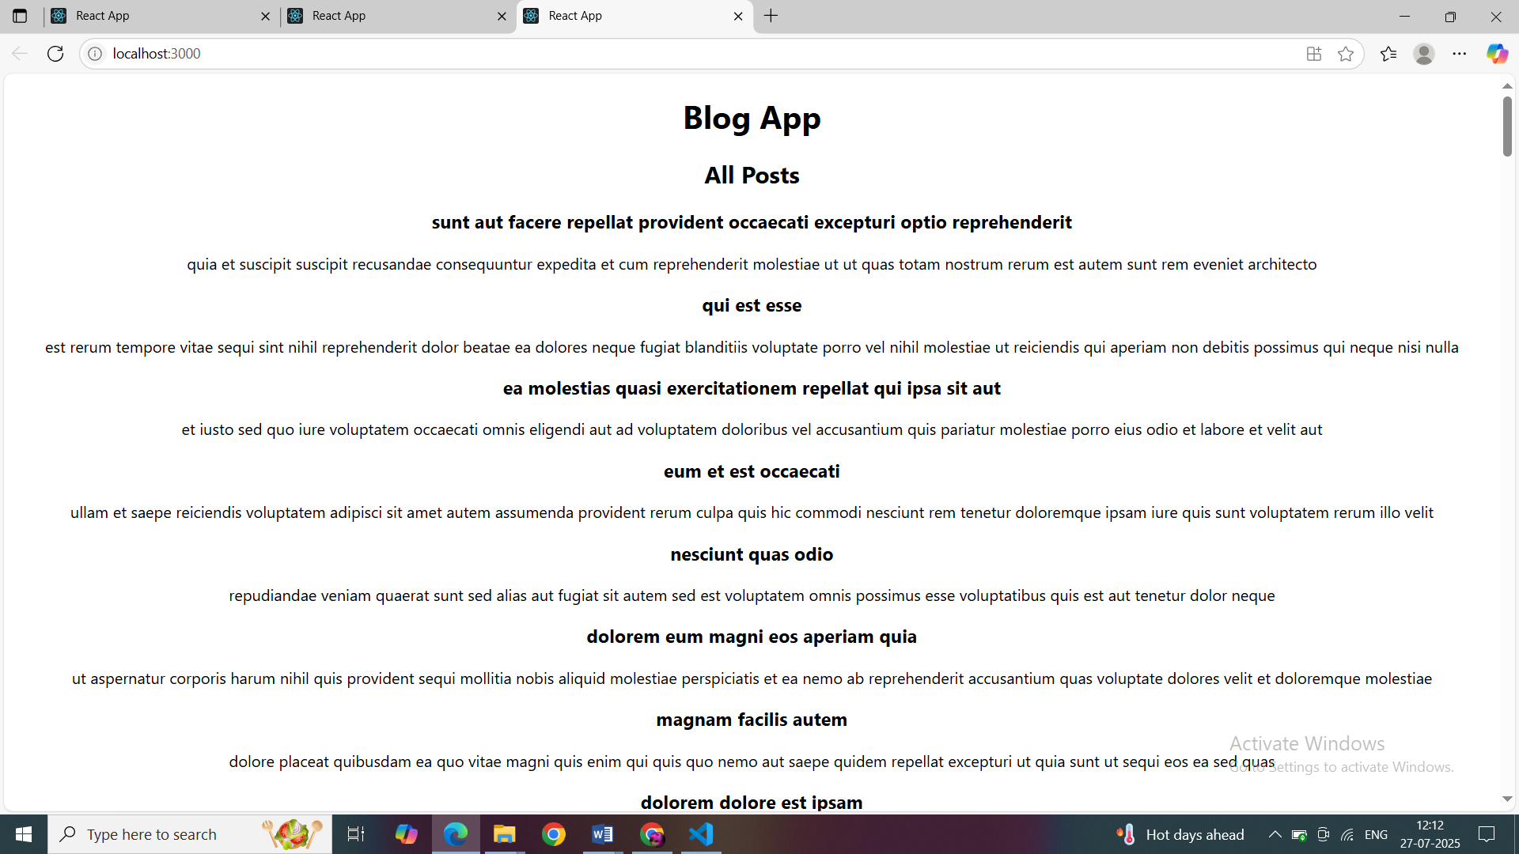  
  
REACT_4_HOL  
  
Posts.js

import React from 'react';

import Post from './Post';

class Posts extends React.Component{

    constructor(props)

    {

        super(props);

         this.state = {

      posts: [],

      hasError: false

    };

    }

    loadPosts()

    {

       fetch('https://jsonplaceholder.typicode.com/posts')

      .then(response => {

        if (!response.ok) throw new Error("Network response was not ok");

        return response.json();

      })

      .then(data => {

        // Convert each post to Post class object

        const postList = data.map(p => new Post(p.id, p.title, p.body));

        this.setState({ posts: postList });

      })

      .catch(error => {

        console.error('Error fetching posts:', error);

        this.setState({ hasError: true });

      });

    }

    componentDidMount()

    {

        this.loadPosts();

    }

    render()

    {

         return (

      <div>

        <h2>All Posts</h2>

        {this.state.posts.map(post => (

          <div key={post.id}>

            <h3>{post.title}</h3>

            <p>{post.body}</p>

          </div>

        ))}

      </div>

    );

    }

    componentDidCatch(error,info)

    {

         alert('An error occurred: ' + error.message);

    }

}

export default Posts;

Post.js  
  
  
class Post

{

    constructor(id,title,body)

    {

        this.id=id;

        this.title=title;

        this.body=body;

    }

}

export default Post;

OUTPUT:

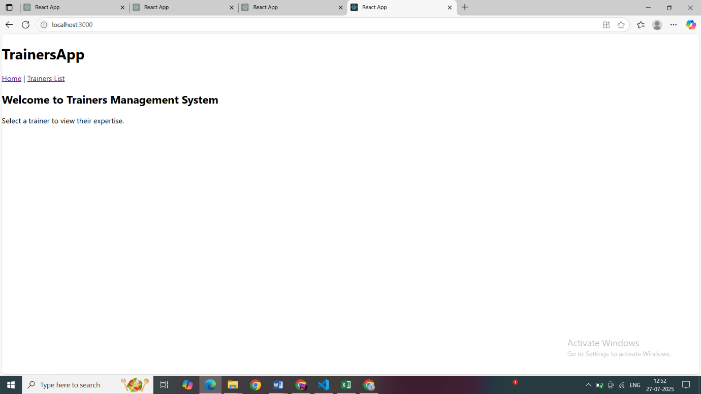

REACT_5_HOL

CohortDeatsils.modules.css

.box {

  width: 300px;

  display: inline-block;

  margin: 10px;

  padding: 10px 20px;

  border: 1px solid black;

  border-radius: 10px;

}

dt {

  font-weight: 500;

}

.ongoing {

  color: green;

}

.completed {

  color: blue;

}

CohortDetails.js

import React from 'react';

import styles from './CohortDetails.module.css';

function CohortDetails(props) {

    const { cohort } = props;

    const statusClass =

        cohort.currentStatus.toLowerCase() === 'ongoing'

            ? styles.ongoing

            : styles.completed;

    return (

        <div className={styles.box}>

            <h3 className={statusClass}>

                {cohort.cohortCode} -

                <span> {cohort.technology}</span>

            </h3>

            <dl>

                <dt>Started On</dt>

                <dd>{cohort.startDate}</dd>

                <dt>Current Status</dt>

                <dd>{cohort.currentStatus}</dd>

                <dt>Coach</dt>

                <dd>{cohort.coachName}</dd>

                <dt>Trainer</dt>

                <dd>{cohort.trainerName}</dd>

            </dl>

        </div>

    );

}

export default CohortDetails;

Cohort.js

class Cohort {

    constructor(cohortCode,

        startDate,

        technology,

        trainerName,

        coachName,

        currentStatus) {

        this.cohortCode = cohortCode;

        this.coachName = coachName;

        this.trainerName = trainerName;

        this.technology = technology;

        this.startDate = startDate;

        this.currentStatus = currentStatus;

    }

}

const CohortsData =[

    new Cohort('INTADMDF10','22-Feb-2022', '.NET FSD', 'Jojo Jose','Aathma', 'Scheduled'),

    new Cohort('ADM21JF014','10-Sep-2021', 'Java FSD', 'Elisa Smith','Apoorv', 'Ongoing'),

    new Cohort('CDBJF21025','24-Dec-2021', 'Java FSD', 'John Doe','Aathma', 'Ongoing'),

    new Cohort('INTADMJF12','22-Feb-2022', 'Java FSD', 'To Be Assigned','Ibrahim', 'Scheduled'),

    new Cohort('CDE22JF011','24-Dec-2021', 'Java FSD', 'Emma Swan','Apoorv', 'Ongoing'),

    new Cohort('INTADMDF09','22-Feb-2022', 'Dataware Housing', 'Babjee Rao','Aathma', 'Scheduled'),

    new Cohort('ADM22DF001','10-Sep-2021', '.NET FSD', 'Marie Curie','Ibrahim', 'Ongoing'),

];

export {Cohort, CohortsData};

OUTPUT: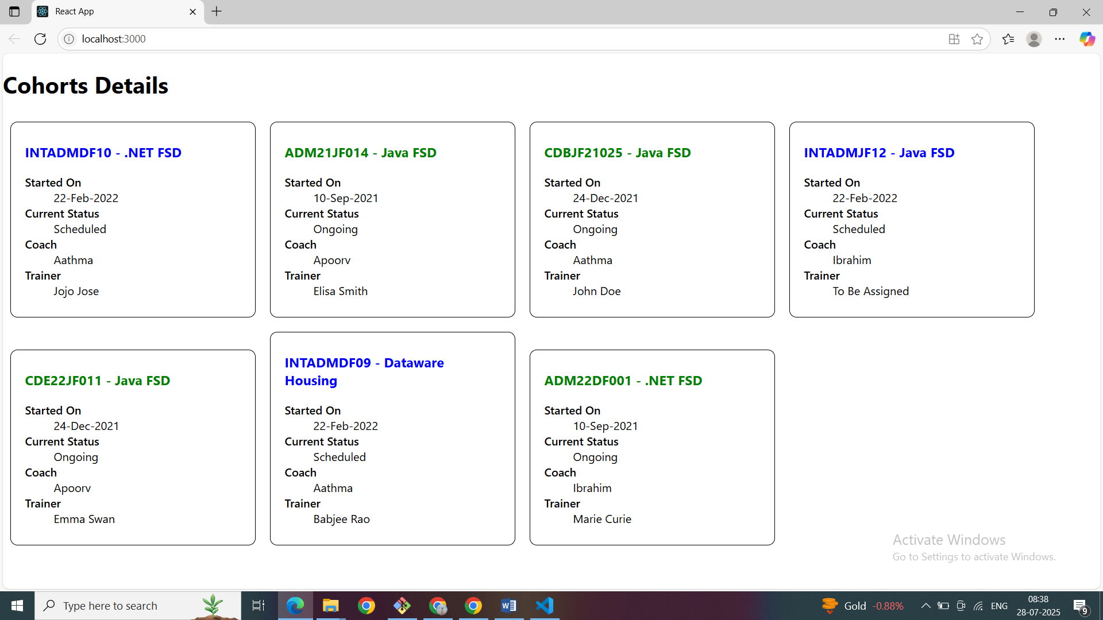  
  
REACT_6_HOL  
  
Home.js

import React from 'react';

function Home() {

  return (

    <div>

      <h2>Welcome to Trainers Management System</h2>

      <p>Select a trainer to view their expertise.</p>

    </div>

  );

}

export default Home;

trainer.js

class Trainer{

    constructor(trainerId,name,email,phone,technology,skills){

        this.trainerId = trainerId;

        this.name = name;

        this.email = email;

        this.phone = phone;

        this.technology = technology;

        this.skills = skills;

    }

}

export default Trainer;

TrainerDetails.js  
class Trainer{

    constructor(trainerId,name,email,phone,technology,skills){

        this.trainerId = trainerId;

        this.name = name;

        this.email = email;

        this.phone = phone;

        this.technology = technology;

        this.skills = skills;

    }

}

export default Trainer;

TrainerList.js  
  
import React from 'react';

import { Link } from 'react-router-dom';

function TrainersList({ trainers }) {

  return (

    <div>

      <h2>Trainers List</h2>

      <ul>

        {trainers.map((trainer) => (

          <li key={trainer.trainerId}>

            <Link to={`/trainer/${trainer.trainerId}`}>{trainer.name}</Link>

          </li>

        ))}

      </ul>

    </div>

  );

}

export default TrainersList;

TainerMock.js

import Trainer from './trainer.js';

const trainesrMock=[

    new Trainer(

    't-syed8',

    'Syed Khaleelullah',

    'khaleelullah@cognizant.com',

    '97676516962',

    '.NET',

    ['C#', 'SQL Server', 'React', '.NET Core']

  ),

  new Trainer(

    't-jojo',

    'Jojo Jose',

    'jojo@cognizant.com',

    '9897199231',

    'Java',

    ['Java', 'JSP', 'Angular', 'Spring']

  ),

  new Trainer(

    't-elisa',

    'Elisa Jones',

    'elisa@cognizant.com',

    '9871212235',

    'Python',

    ['Python', 'Django', 'Angular']

  )

];

export default trainesrMock;

OUTPUT:

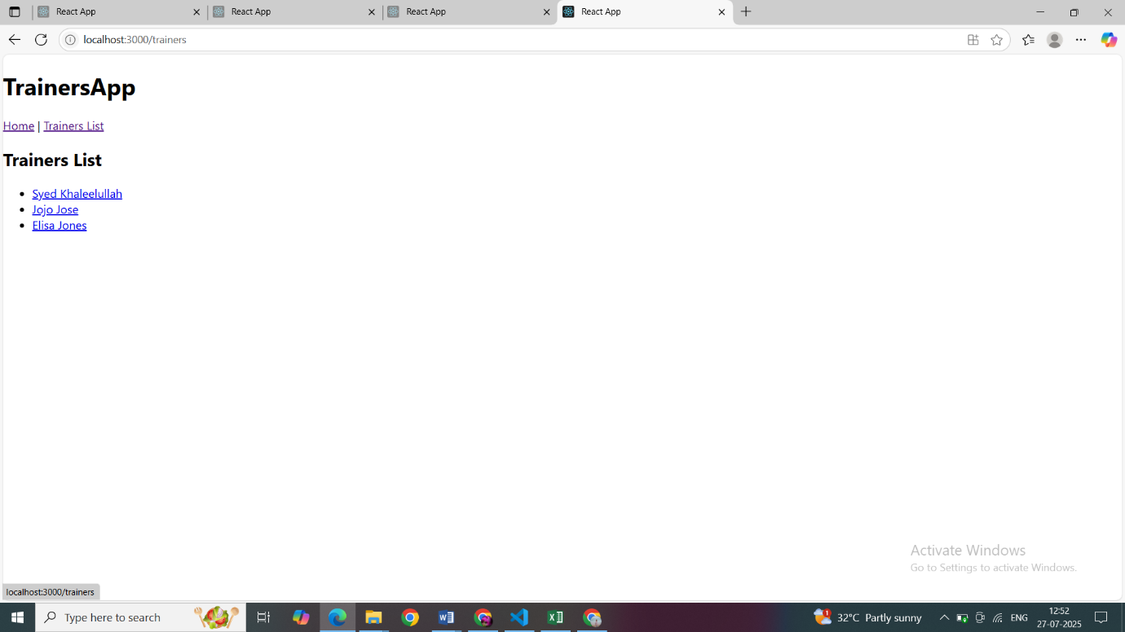  
  
REACT_7_HOL  
  
Cart.js

import React, { Component } from 'react';

class Cart extends Component {

  render() {

    const { itemname, price } = this.props;

    return (

      <div style={{ marginBottom: "10px" }}>

        <h4>Item: {itemname}</h4>

        <p>Price: ₹{price}</p>

      </div>

    );

  }

}

export default Cart;

OnlineShopping.js  
  
  
  
import React, { Component } from 'react';

class OnlineShopping extends Component {

  constructor(props) {

    super(props);

    this.state = {

      items: [

        { itemname: 'Laptop', price: 80000 },

        { itemname: 'TV', price: 120000 },

        { itemname: 'Washing Machine', price: 50000 },

        { itemname: 'Mobile', price: 30000 },

        { itemname: 'Fridge', price: 70000 }

      ]

    };

  }

  render() {

    return (

      <div style={{ textAlign: 'center', marginTop: '30px' }}>

        <h2 style={{ color: 'green' }}>Items Ordered :</h2>

        <table

          style={{

            margin: '0 auto',

            borderCollapse: 'collapse',

            border: '2px solid green'

          }}

        >

          <thead>

            <tr style={{ backgroundColor: '#e0f5e0' }}>

              <th style={{ border: '1px solid green', padding: '10px' }}>Name</th>

              <th style={{ border: '1px solid green', padding: '10px' }}>Price</th>

            </tr>

          </thead>

          <tbody>

            {this.state.items.map((item, index) => (

              <tr key={index}>

                <td style={{ border: '1px solid green', padding: '10px' }}>

                  {item.itemname}

                </td>

                <td style={{ border: '1px solid green', padding: '10px' }}>

                  {item.price}

                </td>

              </tr>

            ))}

          </tbody>

        </table>

      </div>

    );

  }

}

export default OnlineShopping;

OUTPUT:

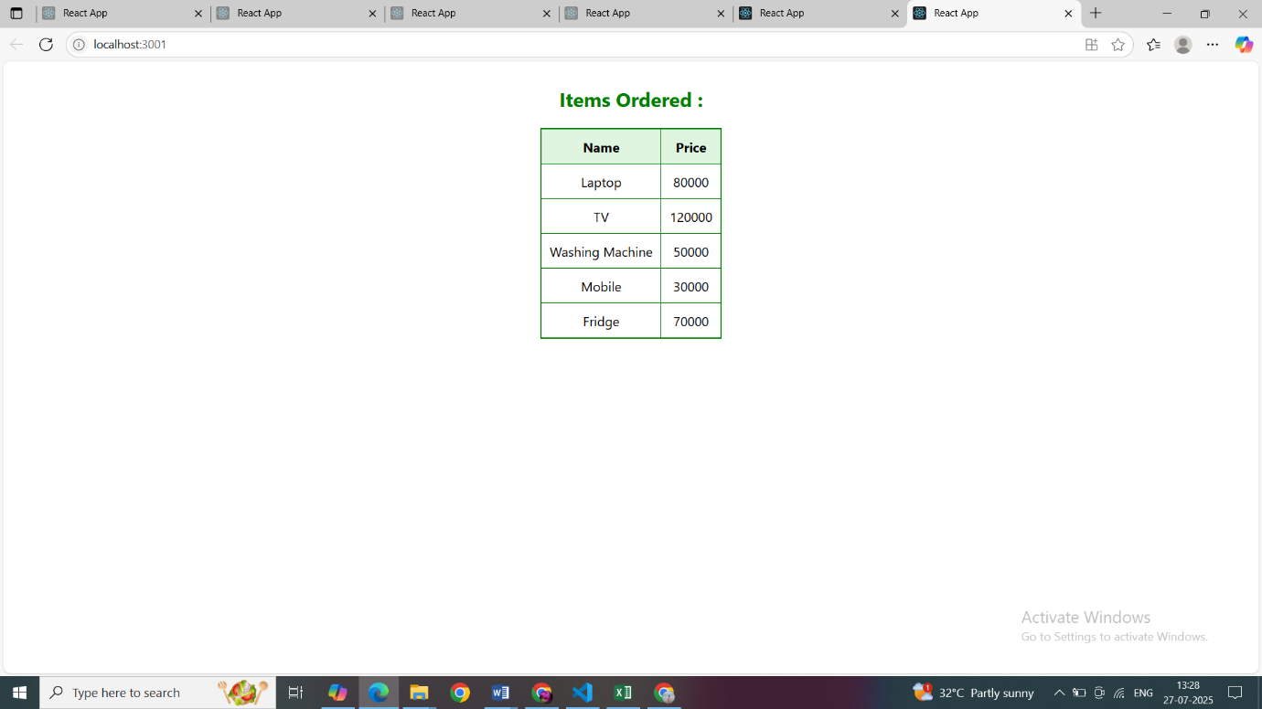  
  
REACT_8_HOL  
  
CountPeople.js

// src/components/CountPeople.js

import React, { Component } from 'react';

class CountPeople extends Component {

  constructor(props) {

    super(props);

    this.state = {

      entryCount: 0,

      exitCount: 0

    };

  }

  updateEntry = () => {

    this.setState((prevState) => ({

      entryCount: prevState.entryCount + 1

    }));

  };

  updateExit = () => {

    this.setState((prevState) => ({

      exitCount: prevState.exitCount + 1

    }));

  };

  render() {

    return (

      <div style={{ textAlign: 'center', marginTop: '50px' }}>

        <h2 style={{ color: '#2c3e50' }}>Welcome to Express Mall</h2>

        <h3 style={{ color: 'green' }}>Entry Count: {this.state.entryCount}</h3>

        <h3 style={{ color: 'red' }}>Exit Count: {this.state.exitCount}</h3>

        <div style={{ marginTop: '20px' }}>

          <button

            onClick={this.updateEntry}

            style={{

              padding: '10px 20px',

              margin: '10px',

              backgroundColor: 'green',

              color: 'white',

              border: 'none',

              borderRadius: '5px'

            }}

          >

            Login

          </button>

          <button

            onClick={this.updateExit}

            style={{

              padding: '10px 20px',

              margin: '10px',

              backgroundColor: 'red',

              color: 'white',

              border: 'none',

              borderRadius: '5px'

            }}

          >

            Exit

          </button>

        </div>

      </div>

    );

  }

}

export default CountPeople;

OUTPUT:

