Using libxbee, an XBee Open Source library (A test run tutorial).

Test Tutorial Author: Adolph Seema
Date Last Edited: 2013/11/21
Source Code used: latest commit 1208e5ccae  attie

Introduction

Apart from the official Digi Open source XBee library here: https://github.com/tomlogic/xbee_ansic_library.

There is another even more useful and well polished library hosted on Google Code (here). It also has a Google Group (here). We are grateful to Attie Grande for the great library and continuous support.

I got the source code using git by following the instructions here:
http://attie.co.uk/libxbee/getting_started/get_it#s1
Before you do anything, read the Getting Started Guide on the website thoroughly and browse the documentation/man pages.

The exercises I performed below were compiled and executed on Ubuntu 13.10 Core i7 Quad Core Dell Inspiron for what it is worth. Normal local gcc toolchain for the Ubuntu host OS used. The git source code used, was last committed on: 2013/11/09 as:

Key

Green ⇒ Good output,
Red ⇒ Bad output,
Blue ⇒ Actual command ran,
Black ⇒ Comment.
Purple ⇒ Warning.

Table of Contents

Introduction
Key
Table of Contents
Getting and compiling the source code.
Getting source code from GitHub with git.
Modifying config.mk
Save config.mk above and build the library.
Install the library in your Ubuntu wide accessible binary directories:
Note where the library header include files are installed.
Now it is a good time to test the XBee modules I have.
Testing XBee1 Examples
We will start with the first example “0.simple_at”:
Let’s compile the example.
How the two module network is configured.
Let us run the next XBee1 “1.simple_at” example then.
Let us run the next XBee1 “2.remote_at” example:
Let us run the next XBee1 “3.simple_data” example:
Let us run the next XBee1 “4.simple_io” example:
Let us run the next XBee1 “5.get_conTypes” example:
Let us run the next XBee1 “6.log_config” example:
Let us run the next XBee1 “7.broadcast” example:
Let us run the next XBee1 “8.catch-all” example:
Let us run the next XBee1 “9.node_detect” example:
Let us run the next XBee1 “10.c++” example:
Let us run the next XBee1 “11.uart_test” example:
Let us run the next XBee1 “12.timestamp” example:
Let us run the next XBee1 “13.lxb2lxb_client” and “13.lxb2lxb_server” example:
Let us run the next XBee1 “14.request_io” example:
Let us run the next XBee1 “15.qt” example:
Updating the source code from previous to the latest?
Going back to re-build examples.
Testing XBeeZB (i.e. S2 Zigbee) Examples
Running XBeeZB “1.simple_at” example then.
Running XBeeZB “2.remote_at” example then.
Running XBeeZB “9.node_detect” example then.
Running XBeeZB “13.lxb2lxb_server” and “13.lxb2lxb_client” example.

Getting and compiling the source code.

Getting source code from GitHub with git.

$ cd $HOME/mygits
$ mkdir my_libxbee
$ cd my_libxbee/
$ git clone https://github.com/attie/libxbee3.git

++++++++++++++++++++++++GOOD OUTPUT+++++++++++++++++++++++++
Cloning into 'libxbee3'...
remote: Counting objects: 5514, done.
remote: Compressing objects: 100% (2255/2255), done.
remote: Total 5514 (delta 3544), reused 5138 (delta 3171)
Receiving objects: 100% (5514/5514), 14.40 MiB | 1.70 MiB/s, done.
Resolving deltas: 100% (3544/3544), done.
Checking connectivity... done
++++++++++++++++++++++++++++++++++++++++++++++++++++++++++++++

$ ls -l
++++++++++++++++++++++++GOOD OUTPUT+++++++++++++++++++++++++
total 4
drwxr-xr-x 13 aseema aseema 4096 Nov 9 15:33 libxbee3
++++++++++++++++++++++++++++++++++++++++++++++++++++++++++++++

$ cd libxbee3/
$ ls

++++++++++++++++++++++++GOOD OUTPUT+++++++++++++++++++++++++
:~/mygits/my_libxbee/libxbee3$ ls
apps frame.c ll.h mode.c net_callbacks.h pkt.c sample xbee.h xsys_darwin.h
conn.c frame.h log.c mode.h net.h pkt.h thread.c xbee_int.h xsys.h
conn.h HISTORY log.h modes net_handlers.c prepare.c thread.h xbeep.cpp xsys_linux.c
COPYING html make mutex.c net_handlers.h prepare.h tx.c xbeep.h xsys_linux.h
COPYING.header interface makefile mutex.h net_io.c README tx.h xsys.c
COPYING.LESSER internal.h man net.c net_io.h rx.c ver.c xsys_darwin
error.c ll.c manuals net_callbacks.c package rx.h xbee.c xsys_darwin.c
++++++++++++++++++++++++++++++++++++++++++++++++++++++++++++++

$ emacs README

++++++++++++++++++++++++GOOD OUTPUT+++++++++++++++++++++++++
… snip …
19
20 'xbee1' => XBee Series 1 (802.15.4 / no meshing)
21 http://goo.gl/10a45
22 http://sprkfn.com/p8665
23 http://doc.libxbee.attie.co.uk/images/xbee1.jpg
24 'xbee2' => XBee Series 2.5 (ZNet / DigiMesh) - formerly 'Series 2'
25 http://goo.gl/fQbkt
26 http://sprkfn.com/p8876
27 http://doc.libxbee.attie.co.uk/images/xbee2.jpg
28 'xbeeZB' => XBee Series 2 (ZigBee)
29 http://goo.gl/TJmeQ
30 http://sprkfn.com/p10414
31 http://doc.libxbee.attie.co.uk/images/xbeeZB.jpg
32 'xbee3' => XBee Series 3 (900 MHz)
33 http://goo.gl/Wdghyq
34 'xbee5' => XBee Series 5 (868 MHz)
35 http://goo.gl/66FZIenv UBUNTU_MENUPROXY=0 GTK2_RC_FILES=$GTK2_RC_FILES:/opt/Digi/XCTU-NG/.gtkrc-eclipse sudo /opt/Digi/XCTU-NG/app
36 'xbee6b' => XBee Series 6B (WiFi)
37 http://goo.gl/gV9XwN
38
… snip ...
++++++++++++++++++++++++++++++++++++++++++++++++++++++++++++++
It is just 95 lines long, please read it.

The README shows the modules above are supported. See config.mk generated below for confirmation.
i.e. see the “commented line #12

++++++++++++++++++++++++GOOD OUTPUT+++++++++++++++++++++++++
… snip …
12#MODELIST:= xbee1 xbee2 xbee3 xbee5 xbee6b xbeeZB net debug
… snip ...
++++++++++++++++++++++++++++++++++++++++++++++++++++++++++++++

$ make configure

++++++++++++++++++++++++GOOD OUTPUT+++++++++++++++++++++++++
… snip …
:~/mygits/my_libxbee/libxbee3$ ls -l c*
-rw-r--r-- 1 aseema aseema 1737 Nov 9 16:01 config.mk
-rw-r--r-- 1 aseema aseema 31277 Nov 9 15:33 conn.c
-rw-r--r-- 1 aseema aseema 2619 Nov 9 15:33 conn.h
… snip ...
++++++++++++++++++++++++++++++++++++++++++++++++++++++++++++++

Modifying config.mk

I opened up the config.mk above and uncommented XBEE_LOG_RX and XBEE_LOG_TX in order to get debug info.

See lines 28 and 29. Note that I left HARDWARE flow control enabled.

$ emacs config.mk

++++++++++++++++++++++++GOOD OUTPUT+++++++++++++++++++++++++
1### Libxbee configuration options:
2
3### system install directories
4SYS_ROOT?=
5SYS_LIBDIR:= $(SYS_ROOT)/usr/lib
6SYS_INCDIR:= $(SYS_ROOT)/usr/include
7SYS_MANDIR:= $(SYS_ROOT)/usr/share/man
8SYS_GROUP:= root
9SYS_USER:= root
10
11### using this can create a smaller binary, by removing modes you won't use
12#MODELIST:= xbee1 xbee2 xbee3 xbee5 xbee6b xbeeZB net debug
13
14### to use the 'install_html' rule, you must specify where to install the files to
15#SYS_HTMLDIR:= /var/www/libxbee.doc
16
17### setup a cross-compile toolchain (either here, or in the environment)
18#CROSS_COMPILE?=
19#CFLAGS+=
20#CLINKS+=
21
22### un-comment to remove ALL logging (smaller & faster binary)
23#OPTIONS+= XBEE_DISABLE_LOGGING
24
25### use for more precise logging options
26#OPTIONS+= XBEE_LOG_NO_COLOR
27#OPTIONS+= XBEE_LOG_LEVEL=100
28OPTIONS+= XBEE_LOG_RX
29OPTIONS+= XBEE_LOG_TX
30
31### un-comment to disable strict objects (xbee/con/pkt pointers are usually checked inside functions)
32### this may give increased execution speed, but will be more suseptible to incorrect parameters
33#OPTIONS+= XBEE_DISABLE_STRICT_OBJECTS
34
35### un-comment to remove network server functionality
36#OPTIONS+= XBEE_NO_NET_SERVER
37#OPTIONS+= XBEE_NO_NET_STRICT_VERSIONS
38
39### un-comment to turn off hardware flow control
40#OPTIONS+= XBEE_NO_RTSCTS
41
… snip ...
++++++++++++++++++++++++++++++++++++++++++++++++++++++++++++++

Save config.mk above and build the library.

$ make

++++++++++++++++++++++++GOOD OUTPUT+++++++++++++++++++++++++
mkdir -p lib
mkdir -p .build
gcc -Wall -c -fPIC -g -DXBEE_LOG_RX -DXBEE_LOG_TX -DLIBXBEE_BUILD -fvisibility=hidden -Wno-variadic-macros -Wstrict-prototypes -MMD conn.c -c -o .build/conn.o
conn.c: In function ‘xbee_conAddressCmpDefault’:
conn.c:241:2: warning: #warning TODO - handle broadcast endpoint, but probably not here... [-Wcpp]
#warning TODO - handle broadcast endpoint, but probably not here...
^
conn.c: In function ‘xbee_conCallbackProd’:
conn.c:926:2: warning: #warning TODO - there is a gap here, needs a mutex [-Wcpp]
#warning TODO - there is a gap here, needs a mutex
^
gcc -Wall -c -fPIC -g -DXBEE_LOG_RX -DXBEE_LOG_TX -DLIBXBEE_BUILD -fvisibility=hidden -Wno-variadic-macros -Wstrict-prototypes -MMD error.c -c -o .build/error.o

… snip …

modes/xbee2/mode.c: In function ‘xbee_s2_transmitStatus_rx_func’:
modes/xbee2/mode.c:107:2: warning: #warning TODO - currently missing out on the resolved network address, retry count, and discovery status [-Wcpp]
#warning TODO - currently missing out on the resolved network address, retry count, and discovery status
^
gcc -Wall -c -fPIC -g -DXBEE_LOG_RX -DXBEE_LOG_TX -DLIBXBEE_BUILD -fvisibility=hidden -Wno-variadic-macros -Wstrict-prototypes -MMD modes/xbee2/sensor.c -c -o .build/modes_x005F_xbee2_sensor.o
ld -r -o .build/__mode_xbee2.o .build/modes_x005F_xbee2_at.o .build/modes_x005F_xbee2_data.o .build/modes_x005F_xbee2_dataExp.o .build/modes_x005F_xbee2_identify.o .build/modes_x005F_xbee2_io.o .build/modes_x005F_xbee2_mode.o .build/modes_x005F_xbee2_sensor.o
gcc -Wall -c -fPIC -g -DXBEE_LOG_RX -DXBEE_LOG_TX -DLIBXBEE_BUILD -fvisibility=hidden -Wno-variadic-macros -Wstrict-prototypes -MMD modes/xbee3/at.c -c -o .build/modes_x005F_xbee3_at.o
gcc -Wall -c -fPIC -g -DXBEE_LOG_RX -DXBEE_LOG_TX -DLIBXBEE_BUILD -fvisibility=hidden -Wno-variadic-macros -Wstrict-prototypes -MMD modes/xbee3/data.c -c -o .build/modes_x005F_xbee3_data.o
modes/xbee3/data.c: In function ‘xbee_s3_data_tx_func’:
modes/xbee3/data.c:101:2: warning: #warning TODO - currently missing support for NAK and Trace Route messages [-Wcpp]
#warning TODO - currently missing support for NAK and Trace Route messages
^
gcc -Wall -c -fPIC -g -DXBEE_LOG_RX -DXBEE_LOG_TX -DLIBXBEE_BUILD -fvisibility=hidden -Wno-variadic-macros -Wstrict-prototypes -MMD modes/xbee3/dataExp.c -c -o .build/modes_x005F_xbee3_dataExp.o
modes/xbee3/dataExp.c: In function ‘xbee_s3_dataExp_tx_func’:
modes/xbee3/dataExp.c:129:2: warning: #warning TODO - currently missing support for NAK and Trace Route messages [-Wcpp]
#warning TODO - currently missing support for NAK and Trace Route messages
^
gcc -Wall -c -fPIC -g -DXBEE_LOG_RX -DXBEE_LOG_TX -DLIBXBEE_BUILD -fvisibility=hidden -Wno-variadic-macros -Wstrict-prototypes -MMD modes/xbee3/identify.c -c -o .build/modes_x005F_xbee3_identify.o

… snip …

gcc -Wall -c -fPIC -g -DXBEE_LOG_RX -DXBEE_LOG_TX -DLIBXBEE_BUILD -fvisibility=hidden -Wno-variadic-macros -Wstrict-prototypes -MMD modes/xbee6b/mode.c -c -o .build/modes_xbee6b_mode.o
modes/xbee6b/mode.c: In function ‘xbee_s6b_frameError_rx_func’:
modes/xbee6b/mode.c:186:2: warning: #warning TODO - figure out how to use this feedback... [-Wcpp]
#warning TODO - figure out how to use this feedback...
^
ld -r -o .build/__mode_xbee6b.o .build/modes_xbee6b_at.o .build/modes_xbee6b_data.o .build/modes_xbee6b_io.o .build/modes_xbee6b_mode.o

… snip …

gcc -Wall -c -fPIC -g -DXBEE_LOG_RX -DXBEE_LOG_TX -DLIBXBEE_BUILD -fvisibility=hidden -Wno-variadic-macros -Wstrict-prototypes -MMD modes/xbeeZB/mode.c -c -o .build/modes_xbeeZB_mode.o
modes/xbeeZB/mode.c: In function ‘xbee_sZB_transmitStatus_rx_func’:
modes/xbeeZB/mode.c:108:2: warning: #warning TODO - currently missing out on the resolved network address, retry count, and discovery status [-Wcpp]
#warning TODO - currently missing out on the resolved network address, retry count, and discovery status
^
gcc -Wall -c -fPIC -g -DXBEE_LOG_RX -DXBEE_LOG_TX -DLIBXBEE_BUILD -fvisibility=hidden -Wno-variadic-macros -Wstrict-prototypes -MMD modes/xbeeZB/ota.c -c -o .build/modes_xbeeZB_ota.o
modes/xbeeZB/ota.c: In function ‘xbee_sZB_ota_rx_func’:
modes/xbeeZB/ota.c:43:2: warning: #warning TODO - check that these are the correct addresses to be using [-Wcpp]
#warning TODO - check that these are the correct addresses to be using
^
gcc -Wall -c -fPIC -g -DXBEE_LOG_RX -DXBEE_LOG_TX -DLIBXBEE_BUILD -fvisibility=hidden -Wno-variadic-macros -Wstrict-prototypes -MMD modes/xbeeZB/sensor.c -c -o .build/modes_xbeeZB_sensor.o

… snip …

ln -fs `basename lib/libxbeep.so.3.0.10` lib/libxbeep.so
objcopy --only-keep-debug lib/libxbeep.so.3.0.10 lib/libxbeep.so.3.0.10.dbg
objcopy --add-gnu-debuglink=lib/libxbeep.so.3.0.10.dbg lib/libxbeep.so.3.0.10
objcopy --strip-debug lib/libxbeep.so.3.0.10
touch lib/libxbeep.so.3.0.10.dbg
ar rcs lib/libxbeep.a.3.0.10 lib/libxbeep.o
ln -fs `basename lib/libxbeep.a.3.0.10` lib/libxbeep.a
:~/mygits/my_libxbee/libxbee3$
++++++++++++++++++++++++++++++++++++++++++++++++++++++++++++++

Install the library in your Ubuntu wide accessible binary directories:

$ sudo make install

++++++++++++++++++++++++GOOD OUTPUT+++++++++++++++++++++++++
:~/mygits/my_libxbee/libxbee3$ sudo make install
[sudo] password for aseema:
install -g root -o root -DT -m 755 lib/libxbee.so.3.0.10 /usr/lib/libxbee.so.3.0.10
install -g root -o root -DT -m 755 lib/libxbee.so.3.0.10.dbg /usr/lib/libxbee.so.3.0.10.dbg
ln -fs libxbee.so.3.0.10 /usr/lib/libxbee.so
install -g root -o root -DT -m 755 lib/libxbee.a.3.0.10 /usr/lib/libxbee.a.3.0.10
ln -fs libxbee.a.3.0.10 /usr/lib/libxbee.a
install -g root -o root -DT -m 755 lib/libxbeep.so.3.0.10 /usr/lib/libxbeep.so.3.0.10
install -g root -o root -DT -m 755 lib/libxbeep.so.3.0.10.dbg /usr/lib/libxbeep.so.3.0.10.dbg
ln -fs libxbeep.so.3.0.10 /usr/lib/libxbeep.so
install -g root -o root -DT -m 755 lib/libxbeep.a.3.0.10 /usr/lib/libxbeep.a.3.0.10
ln -fs libxbeep.a.3.0.10 /usr/lib/libxbeep.a
install -g root -o root -DT -m 644 man/man3/libxbee.3 /usr/share/man/man3/libxbee.3.gz
chown -h root:root /usr/share/man/man3/libxbee.3.gz

… snip ...

install -g root -o root -DT -m 644 man/man3/xbee_vsetup.3 /usr/share/man/man3/xbee_vsetup.3.gz
chown -h root:root /usr/share/man/man3/xbee_vsetup.3.gz
install -g root -o root -DT -m 644 xbee.h /usr/include/xbee.h
install -g root -o root -DT -m 644 xbeep.h /usr/include/xbeep.h
:~/mygits/my_libxbee/libxbee3$
++++++++++++++++++++++++++++++++++++++++++++++++++++++++++++++

Note where the library header include files are installed.

$ ls
++++++++++++++++++++++++GOOD OUTPUT+++++++++++++++++++++++++
:~/mygits/my_libxbee/libxbee3$ ls
apps COPYING.LESSER internal.h makefile mutex.h net_io.c README tx.h xsys.c
config.mk error.c lib man net.c net_io.h rx.c ver.c xsys_darwin
config.mk~ frame.c ll.c manuals net_callbacks.c package rx.h xbee.c xsys_darwin.c
conn.c frame.h ll.h mode.c net_callbacks.h pkt.c sample xbee.h xsys_darwin.h
conn.h HISTORY log.c mode.h net.h pkt.h thread.c xbee_int.h xsys.h
COPYING html log.h modes net_handlers.c prepare.c thread.h xbeep.cpp xsys_linux.c
COPYING.header interface make mutex.c net_handlers.h prepare.h tx.c xbeep.h xsys_linux.h
++++++++++++++++++++++++++++++++++++++++++++++++++++++++++++++

$ ls lib/
++++++++++++++++++++++++GOOD OUTPUT+++++++++++++++++++++++++
:~/mygits/my_libxbee/libxbee3$ ls lib/
libxbee.a libxbee.o libxbeep.a.3.0.10 libxbeep.so libxbeep.so.3.0.10.dbg libxbee.so.3.0.10
libxbee.a.3.0.10 libxbeep.a libxbeep.o libxbeep.so.3.0.10 libxbee.so libxbee.so.3.0.10.dbg
++++++++++++++++++++++++++++++++++++++++++++++++++++++++++++++

$ ls apps/
++++++++++++++++++++++++GOOD OUTPUT+++++++++++++++++++++++++
:~/mygits/my_libxbee/libxbee3$ ls apps/
config connection_test makefile net_term pseudo_term README stress_test
++++++++++++++++++++++++++++++++++++++++++++++++++++++++++++++

$ ls sample/
++++++++++++++++++++++++GOOD OUTPUT+++++++++++++++++++++++++
:~/mygits/my_libxbee/libxbee3$ ls sample/
buildall debug generic makefile makefile.cpp net xbee1 xbee2 xbee5 xbee6b xbeeZB
++++++++++++++++++++++++++++++++++++++++++++++++++++++++++++++

Now it is a good time to test the XBee modules I have.
I am lucky to have XBee S1, XBee S2 (XB24-ZB) and XBee 6.
See: “Which modules should I use?

Testing XBee1 Examples

Below are the available XBee1 examples that come with the library.

$ ls -l sample/xbee1/
++++++++++++++++++++++++GOOD OUTPUT+++++++++++++++++++++++++
:~/mygits/my_libxbee/libxbee3/sample/xbee1$ ls -l
total 68
drwxr-xr-x 2 aseema aseema 4096 Nov 13 22:42 0.simple_at
drwxr-xr-x 2 aseema aseema 4096 Nov 13 21:14 10.c++
drwxr-xr-x 2 aseema aseema 4096 Nov 11 21:40 11.uart_test
drwxr-xr-x 2 aseema aseema 4096 Nov 11 21:53 12.timestamp
drwxr-xr-x 2 aseema aseema 4096 Nov 14 12:15 13.lxb2lxb_client
drwxr-xr-x 2 aseema aseema 4096 Nov 14 12:16 13.lxb2lxb_server
drwxr-xr-x 2 aseema aseema 4096 Nov 11 21:40 14.request_io
drwxr-xr-x 2 aseema aseema 4096 Nov 9 15:33 15.qt
drwxr-xr-x 2 aseema aseema 4096 Nov 13 22:35 1.simple_at
drwxr-xr-x 2 aseema aseema 4096 Nov 14 10:11 2.remote_at
drwxr-xr-x 2 aseema aseema 4096 Nov 13 23:27 3.simple_data
drwxr-xr-x 2 aseema aseema 4096 Nov 11 21:53 4.simple_io
drwxr-xr-x 2 aseema aseema 4096 Nov 11 21:40 5.get_conTypes
drwxr-xr-x 2 aseema aseema 4096 Nov 11 21:53 6.log_config
drwxr-xr-x 2 aseema aseema 4096 Nov 14 11:53 7.broadcast
drwxr-xr-x 2 aseema aseema 4096 Nov 14 12:02 8.catch-all
drwxr-xr-x 2 aseema aseema 4096 Nov 13 21:24 9.node_detect
++++++++++++++++++++++++++++++++++++++++++++++++++++++++++++++

We will start with the first example “0.simple_at”:

Before you start make sure you understand, XBee addressing and API basics:

How to setup the HW and to test it, this tutorial is great. Skip Chapter 4 and read only the first 4 pages of Cpater 5 if you are not using parallax MCU. The other Chapters apart from the sample programs they show, are relevant to all XBee modules and network notions.

XBee addressing:
http://www.digi.com/support/kbase/kbaseresultdetl?id=2187

XBee API mode:
http://www.digi.com/support/kbase/kbaseresultdetl?id=2184

For details, check the XBee protocol and meaning everything from official Digi here.
See page 61 for TX (Transmit) Request: 64-bit address. OR begin at page 57 for API Operation in depth.

$ cd sample/xbee1/0.simple_at/

++++++++++++++++++++++++GOOD OUTPUT+++++++++++++++++++++++++
:~/mygits/my_libxbee/libxbee3/sample/xbee1/0.simple_at$ ls -l
total 16
-rwxr-xr-x 1 aseema aseema 12030 Nov 13 22:16 main
-rw-r--r-- 1 aseema aseema 3102 Nov 13 22:31 main.c
lrwxrwxrwx 1 aseema aseema 14 Nov 9 15:33 makefile -> ../../makefile
++++++++++++++++++++++++++++++++++++++++++++++++++++++++++++++

Let’s compile the example.

$ make; ./main

++++++++++++++++++++++++GOOD OUTPUT+++++++++++++++++++++++++
:~/mygits/my_libxbee/libxbee3/sample/xbee1/0.simple_at$ make
gcc main.c -g -o main -I ../../.. -L ../../../lib -lxbee

:~/mygits/my_libxbee/libxbee3/sample/xbee1/0.simple_at$ ./main
tx: 0
Response is 12 bytes long:
0: 0x78 - x
1: 0x62 - b
2: 0x65 - e
3: 0x65 - e
4: 0x31 - 1
5: 0x5F - _
6: 0x77 - w
7: 0x76 - v
8: 0x73 - s
9: 0x6E - n
10: 0x70 - p
11: 0x30 - 0
:~/mygits/my_libxbee/libxbee3/sample/xbee1/0.simple_at$
++++++++++++++++++++++++++++++++++++++++++++++++++++++++++++++

This means that the library correctly read my modules’ Node Identifier (NI=xbee1_wvsnp0) which I set as in this image below:
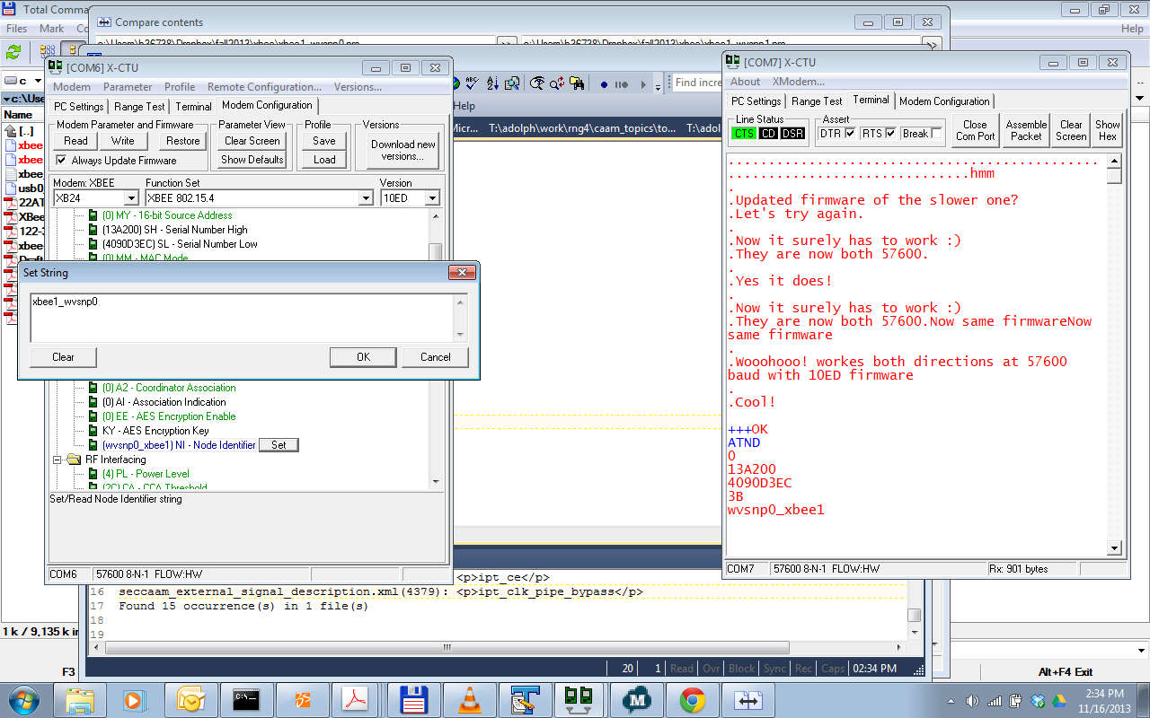

How the two module network is configured.

It is probably a good idea at this point to tell you that, I configure two XBee1 modules using X-CTU and plugged them both to my Windoze to configure them fully before i ran these tests on the library.

-----------------Module 1 showed up as COM6 and on Linux it is /dev/ttyUSB0-----------------
I upgraded each’s firmware to the latest and each’s baud rate to 57600.

---------------USB0---------------

XB24
Firmware=10ED
SH=13A200 SL=4090D3EC
DH=13A200 DL=4090D3DF
FLOW=HARDWARE
BITS=8-N-1
BAUD=57600
16-bit Source Address=FFFF

Detailed Profile saved as: xbee1_wvsnp0.pro

--------------USB1---------------

XB24
Firmware=10ED
SH=13A200 SL=4090D3DF
DH=13A200 DL=4090D3EC
FLOW=HARDWARE
BITS=8-N-1
BAUD=57600
16-bit Source Address=FFFF

Detailed Profile saved as: xbee1_wvsnp1.pro

So, as the profiles show, at this point I disabled 16-bit addressing for each (MY=FFFF) and set USB0 to API mode (AP=1) then connected it to the linux USB as “/dev/ttyUSB0” baud 57600 (BD=6) to match the library examples. Also note that the network is setup as peer to peer duplex between these modules pointing to each other. That is DL of USB0 is set of SL of USB1 module and vice versa.

USB1 is still connected to X-CTU on a windows machine in AT-Mode at this point. The image below shows how I tested both on Windows to make sure they can send to each other even though the other one was in API mode 1 and the other one under AT mode.
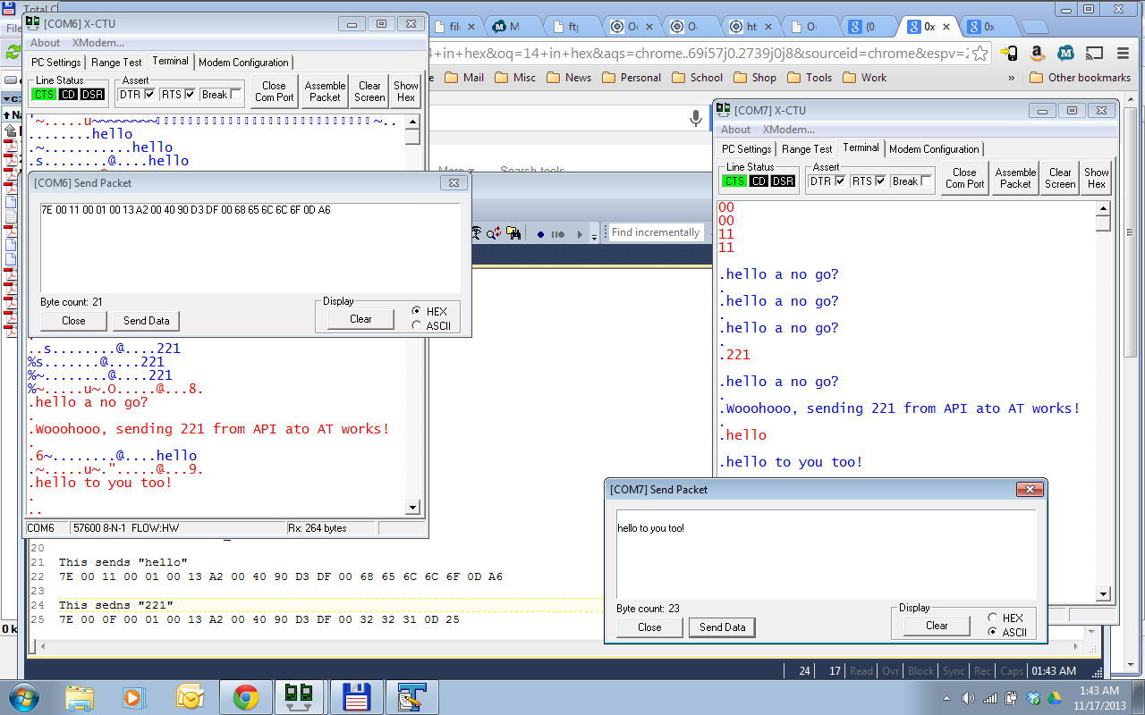
Also note the example on the bottom left showing how to send “hello” and “221” in API mode frame. You read the above linked documents right?
Ok let’s move on then.

Building all samples at once works as well, so lets go to the top of all examples and run the buildall script.

$ cd ../../
$ ls -l

++++++++++++++++++++++++GOOD OUTPUT+++++++++++++++++++++++++
:~/mygits/my_libxbee/libxbee3/sample$ ls -l
total 44
-rwxr-xr-x 1 aseema aseema 176 Nov 9 15:33 buildall
drwxr-xr-x 3 aseema aseema 4096 Nov 9 15:33 debug
drwxr-xr-x 5 aseema aseema 4096 Nov 9 15:33 generic
-rw-r--r-- 1 aseema aseema 212 Nov 9 15:33 makefile
-rw-r--r-- 1 aseema aseema 242 Nov 9 15:33 makefile.cpp
drwxr-xr-x 5 aseema aseema 4096 Nov 9 15:33 net
drwxr-xr-x 19 aseema aseema 4096 Nov 9 15:33 xbee1
drwxr-xr-x 11 aseema aseema 4096 Nov 9 15:33 xbee2
drwxr-xr-x 3 aseema aseema 4096 Nov 9 15:33 xbee5
drwxr-xr-x 5 aseema aseema 4096 Nov 9 15:33 xbee6b
drwxr-xr-x 5 aseema aseema 4096 Nov 9 15:33 xbeeZB
++++++++++++++++++++++++++++++++++++++++++++++++++++++++++++++

$ ./buildall

++++++++++++++++++++++++GOOD OUTPUT+++++++++++++++++++++++++
:~/mygits/my_libxbee/libxbee3/sample$ ./buildall
make: Entering directory `/home/aseema/mygits/my_libxbee/libxbee3/sample/xbee6b/1.simple_at'
gcc main.c -g -o main -I ../../.. -L ../../../lib -lxbee

… snip …

make: Leaving directory `/home/aseema/mygits/my_libxbee/libxbee3/sample/net/3.simple_at'
make: Entering directory `/home/aseema/mygits/my_libxbee/libxbee3/sample/xbee5/1.simple_at'
gcc main.c -g -o main -I ../../.. -L ../../../lib -lxbee
make: Leaving directory `/home/aseema/mygits/my_libxbee/libxbee3/sample/xbee5/1.simple_at'
:~/mygits/my_libxbee/libxbee3/sample$
++++++++++++++++++++++++++++++++++++++++++++++++++++++++++++++

So it looks like all the samples built successfully!

Let us run the next XBee1 “1.simple_at” example then.
This example proved that the callback functions are firing as expected. Note that this time
the NI I set earlier is now printed from the callback function.
$ cd ../1.simple_at/; ls -l; make; ./main

++++++++++++++++++++++++GOOD OUTPUT+++++++++++++++++++++++++
:~/mygits/my_libxbee/libxbee3/sample/xbee1/1.simple_at$ ls -l
total 24
-rwxr-xr-x 1 aseema aseema 16394 Nov 13 22:35 main
-rw-r--r-- 1 aseema aseema 3213 Nov 17 03:05 main.c
lrwxrwxrwx 1 aseema aseema 14 Nov 9 15:33 makefile -> ../../makefile
:~/mygits/my_libxbee/libxbee3/sample/xbee1/1.simple_at$ make
gcc main.c -g -o main -I ../../.. -L ../../../lib -lxbee
LD_LIBRARY_PATH=../../../lib ./main
rx: [xbee1_wvsnp0]
tx: 0
:~/mygits/my_libxbee/libxbee3/sample/xbee1/1.simple_at$ ./main
tx: 0
rx: [xbee1_wvsnp0]
:~/mygits/my_libxbee/libxbee3/sample/xbee1/1.simple_at$
++++++++++++++++++++++++++++++++++++++++++++++++++++++++++++++

Attie sya: “This is only working because you have installed libxbee... otherwise you'd need the LD_LIBRARY_PATH environment variable set (as above).”

Let us run the next XBee1 “2.remote_at” example:
This example proves that the callback functions are firing as expected and that 64-bit
addressing & communication with a remote node works. For this test the remote node is
connected COM7 of a Windoze machine in AT mode. It is configured as:
--------------USB1---------------

XB24
Firmware=10ED
SH=13A200 SL=4090D3DF
DH=13A200 DL=4090D3EC
FLOW=HARDWARE
BITS=8-N-1
BAUD=57600
16-bit Source Address=FFFF

Detailed Profile saved as: xbee1_wvsnp1.pro

$ cd ../2.remote_at/; ls -l; make; ./main

++++++++++++++++++++++++GOOD OUTPUT+++++++++++++++++++++++++
:~/mygits/my_libxbee/libxbee3/sample/xbee1/2.remote_at$ make
gcc main.c -g -o main -I ../../.. -L ../../../lib -lxbee
LD_LIBRARY_PATH=../../../lib ./main
tx: 0
rx: [xbee1_wvsnp1]
:~/mygits/my_libxbee/libxbee3/sample/xbee1/2.remote_at$
++++++++++++++++++++++++++++++++++++++++++++++++++++++++++++++
Note that it was able to query the NI of the remote module which I previously named: “xbee1_wvsnp1”. when I configured the 2 modules prior to this test.

Let us run the next XBee1 “3.simple_data” example:

This example proves that you can receive real text (i.e. data) from a remote module.
The program runs in a loop forever waiting for input from a remote module at the address
set in this programs main.c i.e. for this test the address was hard coded to:
<code>
54
55 //---This is the 64-bit address of the module that this module
56 //is hard coded to send to.
57 //DH
58 address.addr64[0] = 0x00;
59 address.addr64[1] = 0x13;
60 address.addr64[2] = 0xA2;
61 address.addr64[3] = 0x00;
62 //DL
63 address.addr64[4] = 0x40;
64 address.addr64[5] = 0x90;
65 address.addr64[6] = 0xD3;
66 address.addr64[7] = 0xDF;
67
</code>
Again, for this test, the remote node is connected to COM7 of a Windoze machine in AT
mode. It is configured as:
--------------USB1---------------

XB24
Firmware=10ED
SH=13A200 SL=4090D3DF
DH=13A200 DL=4090D3EC
FLOW=HARDWARE
BITS=8-N-1
BAUD=57600
16-bit Source Address=FFFF (i.e. 16-bit addressing disabled).

Detailed Profile saved as: xbee1_wvsnp1.pro

$ cd ../3.simple_data/; ls -l; make; ./main

++++++++++++++++++++++++GOOD OUTPUT+++++++++++++++++++++++++
:~/mygits/my_libxbee/libxbee3/sample/xbee1/2.remote_at$ cd ../3.simple_data/; ls -l
total 24
-rwxr-xr-x 1 aseema aseema 16894 Nov 13 23:27 main
-rw-r--r-- 1 aseema aseema 3218 Nov 13 23:26 main.c
lrwxrwxrwx 1 aseema aseema 14 Nov 9 15:33 makefile -> ../../makefile
:~/mygits/my_libxbee/libxbee3/sample/xbee1/3.simple_data$ make
gcc main.c -g -o main -I ../../.. -L ../../../lib -lxbee
LD_LIBRARY_PATH=../../../lib ./main
rx: [testing from windows.]
tx: 0
rx: [

yep, it looks like it works as designed :)]
tx: 0
++++++++++++++++++++++++++++++++++++++++++++++++++++++++++++++
Note above that I was able to send text/data from a remote module which I previously named: “xbee1_wvsnp1”. when I configured the 2 modules prior to this test. The screenshot below shows the action of duplex communication from the Windows modules point of view of this data exchange. Note that the Linux module sent back a “Hello” every time the Windows module sent it text. You can do something more useful than “Hello” of course :) This is where your own project and incoming data parsing begins.
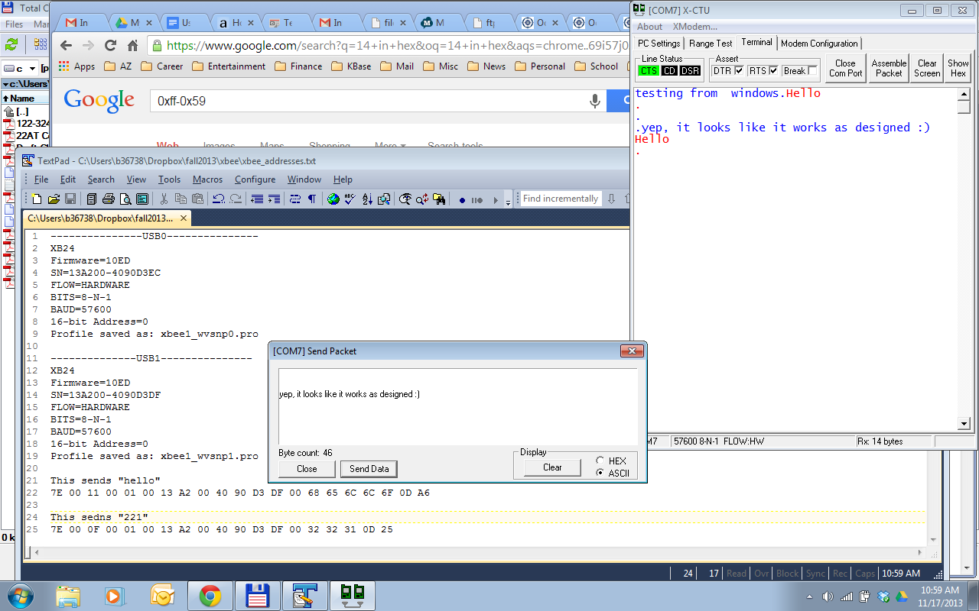

Let us run the next XBee1 “4.simple_io” example:

This example proves that you can receive real IO data (i.e. pin status) from a remote
module’s digital/analog inputs or outputs. To do so, I configured the remote module on Windows via X-CTU Modem Configuration tab, to the following:

o As usual I changed the hard coded the address of the remote IO module
xbee1_wvsnp1’s one.
o I/O Setting D0 to ADC (2) (to read analog input)
o I/O Setting D1 to ADC (2) (to read analog input)
o I/O Setting D3 to DI (3) (to read digital input), pin #17 of the XBee1 module.
o I/O Setting D4 to DI (3) (to read digital input)
o IR Setting to $7D0 (2000 decimal to sample once every two seconds)

Then write the parameters to the module. See screenshot of the saved profile and the “read back” parameters showing. Note this example only cares about D3 Digital Input.
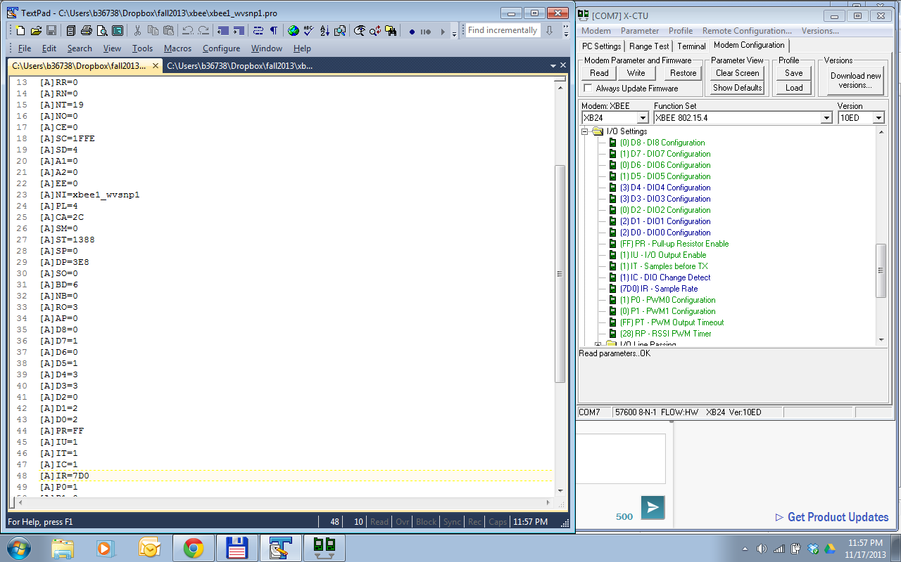

Then run the simple_io example.
$ cd ../4.simple_io/; ls -l; make; ./main

++++++++++++++++++++++++GOOD OUTPUT+++++++++++++++++++++++++
:~/mygits/my_libxbee/libxbee3/saFLOW=HARDWAREmple/xbee1/3.simple_data$ cd ../4.simple_io/; ls -l
total 24
-rwxr-xr-x 1 aseema aseema 16562 Nov 11 21:53 main
-rw-r--r-- 1 aseema aseema 2332 Nov 9 15:33 main.c
lrwxrwxrwx 1 aseema aseema 14 Nov 9 15:33 makefile -> ../../makefile
:~/mygits/my_libxbee/libxbee3/sample/xbee1/4.simple_io$ make
gcc main.c -g -o main -I ../../.. -L ../../../lib -lxbee
LD_LIBRARY_PATH=../../../lib ./main

:~/mygits/my_libxbee/libxbee3/sample/xbee1/4.simple_io$ ./main
D3: 1
D3: 1
D3: 1
D3: 0
D3: 0
D3: 1
D3: 0
D3: 1
D3: 1
D3: 0
D3: 0
D3: 0
D3: 1
D3: 0
D3: 1
^C
:~/mygits/my_libxbee/libxbee3/sample/xbee1/4.simple_io$
++++++++++++++++++++++++++++++++++++++++++++++++++++++++++++++
Note that since XBee has internal pull-up resistors on it spins the default value of the DIO3, (D3 value) is 1 (HIGH). To see it change value and see 0 (LOW) value, I took a wire and connected between GND and pin #17 of the xbee1_wvsnp1 module. This pull it to GND and hence an input value of as shown in the output above.

Let us run the next XBee1 “5.get_conTypes” example:

This example helps you figure out the type of connections your attached module supports. Attie has more detail here:
- Creating connections
- Using connections
Run the example:

$ cd ../5.get_conTypes/; ls -l; make; ./main

++++++++++++++++++++++++GOOD OUTPUT+++++++++++++++++++++++++
:~/mygits/my_libxbee/libxbee3/sample/xbee1/4.simple_io$ cd ../5.get_conTypes/; ls -l;
total 16
-rwxr-xr-x 1 aseema aseema 10740 Nov 11 21:40 main
-rw-r--r-- 1 aseema aseema 1399 Nov 9 15:33 main.c
lrwxrwxrwx 1 aseema aseema 14 Nov 9 15:33 makefile -> ../../makefile
:~/mygits/my_libxbee/libxbee3/sample/xbee1/5.get_conTypes$ ./main
connection type 0 - Modem Status
connection type 1 - Transmit Status
connection type 2 - Local AT
connection type 3 - Remote AT
connection type 4 - 16-bit Data
connection type 5 - 64-bit Data
connection type 6 - 16-bit I/O
connection type 7 - 64-bit I/O
:~/mygits/my_libxbee/libxbee3/sample/xbee1/5.get_conTypes$
++++++++++++++++++++++++++++++++++++++++++++++++++++++++++++++

Above are what my xbee1_wvsnp0 supports. this is the coordinator module attached to my Ubuntu 13.10 Linux machine.

Let us run the next XBee1 “6.log_config” example:

This example helps you figure out what log level is set to. This is helpful for debugging if you want the internals of the library print out details of what it is doing or where it gets stuck.

Run the example:

$ cd ../6.log_config/; ls -l; make; ./main

++++++++++++++++++++++++GOOD OUTPUT+++++++++++++++++++++++++
:~/mygits/my_libxbee/libxbee3/sample/xbee1/5.get_conTypes$ cd ../6.log_config/; ls -l;
total 16
-rwxr-xr-x 1 aseema aseema 11012 Nov 11 21:53 main
-rw-r--r-- 1 aseema aseema 1728 Nov 9 15:33 main.c
lrwxrwxrwx 1 aseema aseema 14 Nov 9 15:33 makefile -> ../../makefile
:~/mygits/my_libxbee/libxbee3/sample/xbee1/6.log_config$ ./main
libxbee log level is currently: 0

Don't forget you can set the log level via the environment, for example:
XBEE_LOG_LEVEL=100 ./main

setting libxbee log level to: 100
DEV: 50#[main.c:52] main() 0xcd41f0: Test Message 2...
++++++++++++++++++++++++++++++++++++++++++++++++++++++++++++++

Obviously from my example above it is not set to print out details of what it is doing. Now see what happens when I set it to 100 on the fly :)

$ XBEE_LOG_LEVEL=100 ./main

++++++++++++++++++++++++GOOD OUTPUT+++++++++++++++++++++++++
:~/mygits/my_libxbee/libxbee3/sample/xbee1/6.log_config$ XBEE_LOG_LEVEL=100 ./main
libxbee log level is currently: 100

Don't forget you can set the log level via the environment, for example:
XBEE_LOG_LEVEL=100 ./main

15#[thread.c:68] threadFunc() 0xcaa1f0: starting thread 0xcade60, function xbee_rxHandler()...
15#[thread.c:68] threadFunc() 0xcaa1f0: starting thread 0xcadca0, function xbee_rx()...
DEV: 50#[main.c:44] main() 0xcaa1f0: Test Message 1...
setting libxbee log level to: 100
15#[thread.c:68] threadFunc() 0xcaa1f0: starting thread 0xcae020, function xbee_tx()...
DEV: 50#[main.c:52] main() 0xcaa1f0: Test Message 2...
:~/mygits/my_libxbee/libxbee3/sample/xbee1/6.log_config$
++++++++++++++++++++++++++++++++++++++++++++++++++++++++++++++

So this would be a good way to analyse what the library is doing as it moves data around.

Let us run the next XBee1 “7.broadcast” example:

This will broadcast numbers 0 to 1000 to any module within xbee1_wvsnp0’s network.
I changed the example a bit so it accepts “/dev/ttyUSB0” and to print out what it is broadcasting. Leave the address given in example unchanged. It is the default broadcast address.

Run the example:

$ cd ../7.broadcast/; ls -l; make; ./main

++++++++++++++++++++++++GOOD OUTPUT+++++++++++++++++++++++++
:~/mygits/my_libxbee/libxbee3/sample/xbee1/6.log_config$ cd ../7.broadcast/; ls -l;
total 20
-rwxr-xr-x 1 aseema aseema 16314 Nov 14 11:53 main
-rw-r--r-- 1 aseema aseema 2478 Nov 18 01:03 main.c
lrwxrwxrwx 1 aseema aseema 14 Nov 9 15:33 makefile -> ../../makefile
:~/mygits/my_libxbee/libxbee3/sample/xbee1/7.broadcast$ make
gcc main.c -g -o main -I ../../.. -L ../../../lib -lxbee
LD_LIBRARY_PATH=../../../lib ./main
Missing tty port: USAGE: main '/dev/ttyUSB#'
make: *** [all] Error 255
:~/mygits/my_libxbee/libxbee3/sample/xbee1/7.broadcast$ ./main "/dev/ttyUSB0"
Successfully opened[/dev/ttyUSB0], ret[0]
Broadcasting[0].
Broadcasting[1].
Broadcasting[2].
Broadcasting[3].
Broadcasting[4].
Broadcasting[5].
Broadcasting[6].
Broadcasting[7].
Broadcasting[8].
Broadcasting[9].
Broadcasting[10].
Broadcasting[11].
Broadcasting[12].
...
++++++++++++++++++++++++++++++++++++++++++++++++++++++++++++++

See the xbee1_wvsnp1 module on the windows machine receiving the broadcast message.
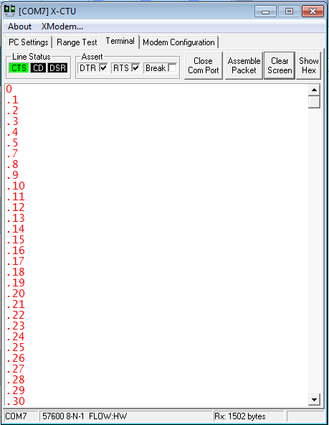

Let us run the next XBee1 “8.catch-all” example:

This example is the reverse of a broadcast. So it will accept anything that is sent by other XBee modules in its network. Leave the address given in example unchanged. It is the default catchall address.

Run the example:

$ cd ../8.catch-all/; ls -l; make; ./main

++++++++++++++++++++++++GOOD OUTPUT+++++++++++++++++++++++++
:~/mygits/my_libxbee/libxbee3/sample/xbee1/7.broadcast$ cd ../8.catch-all/; ls -l;
total 48
-rwxr-xr-x 1 aseema aseema 17302 Nov 14 10:51 main
-rwxr-xr-x 1 aseema aseema 17246 Nov 13 23:10 main1
-rw-r--r-- 1 aseema aseema 4481 Nov 18 01:35 main.c
lrwxrwxrwx 1 aseema aseema 14 Nov 9 15:33 makefile -> ../../makefile
:~/mygits/my_libxbee/libxbee3/sample/xbee1/8.catch-all$ rm main1
:~/mygits/my_libxbee/libxbee3/sample/xbee1/8.catch-all$ make
gcc main.c -g -o main -I ../../.. -L ../../../lib -lxbee
LD_LIBRARY_PATH=../../../lib ./main
Ready!... waiting for 30 secs
Got packet from new node!
64-bit (0x0013A200 0x4090D3DF)
rx: [testing catchall
]
tx: 0
:~/mygits/my_libxbee/libxbee3/sample/xbee1/8.catch-all$ ./main
Ready!... waiting for 30 secs
Got packet from new node!
64-bit (0x0013A200 0x4090D3DF)
rx: [
OK it was really caught.
Bien!

]
tx: 0
:~/mygits/my_libxbee/libxbee3/sample/xbee1/8.catch-all$
++++++++++++++++++++++++++++++++++++++++++++++++++++++++++++++

Above was sent from xbee1_wvsnp1 on windows. Note that xbee1_wvsnp0 sends back “Hello” to the correct source of the data using specificCB function.
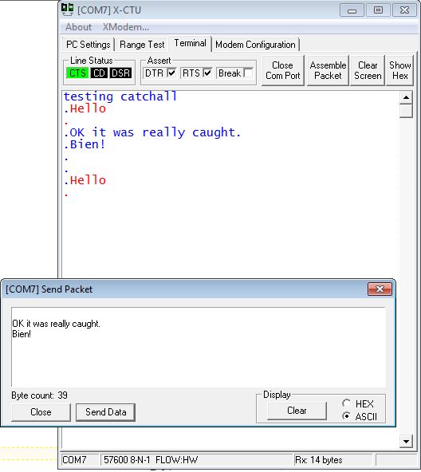

Let us run the next XBee1 “9.node_detect” example:

This is supposed to work just like the ATND command where it lists all the nodes it can find within the network. The sem* seems to be broken for now.
So will wait for Attie to fix it. Surprising that this sem* to work for the “11.uart_test” example.

Run the example:

$ cd ../9.node_detect/; ls -l; make; ./main

This time I have only one module so I am not expecting it to detect nodes in the network. Will test it again soon, but it works as designed.FLOW=HARDWARE

++++++++++++++++++++++++GOOD OUTPUT+++++++++++++++++++++++++
:~/mygits/my_libxbee/libxbee3/sample/xbee1/9.node_detect$ make
gcc main.c -g -o main -I ../../.. -L ../../../lib -lxbee -lpthread
:~/mygits/my_libxbee/libxbee3/sample/xbee1/9.node_detect$ ls -l
total 24
-rwxr-xr-x 1 aseema aseema 17117 Nov 19 22:25 main
-rw-r--r-- 1 aseema aseema 3213 Nov 13 21:14 main.c
lrwxrwxrwx 1 aseema aseema 22 Nov 19 19:57 makefile -> ../../makefile.pthread
:~/mygits/my_libxbee/libxbee3/sample/xbee1/9.node_detect$ ./main
ND Sent!... waiting for completion
Scan complete!
:~/mygits/my_libxbee/libxbee3/sample/xbee1/9.node_detect$
++++++++++++++++++++++++++++++++++++++++++++++++++++++++++++++
TODO: Output when there is a network.

Let us run the next XBee1 “10.c++” example:

This is supposed to showcase C++ interface to the library. I guess not susseful at this point will wait for fix.

$ cd ../10.c++/; ls -l; make; ./main

----------------------------------------------BAD OUTPUT-----------------------------------------------
:~/mygits/my_libxbee/libxbee3/sample/xbee1/10.c++$ make
g++ main.cpp -g -o main -I ../../.. -L ../../../lib -lxbeep
main.cpp: In function ‘int main(int, char**)’:
main.cpp:114:10: error: ‘sleep’ was not declared in this scope
sleep(1);
^
make: *** [main] Error 1

--------------------------------------------STILL HERE---------------------------------------------------
g++ main.cpp -g -o main -I ../../.. -L ../../../lib -lxbeep
main.cpp: In function ‘int main(int, char**)’:
main.cpp:114:17: error: ‘usleep’ was not declared in this scope
usleep(1000000);
^
make: *** [main] Error 1
---------------------------------------------------------------------------------------------------------------

Will re-visit above later.

Let us run the next XBee1 “11.uart_test” example:

This example helps you figure out the reliability of your UART. It sends NI query to the remote module and and checks is its request times out. Repeats this 100o times. Then it output the percentage success.

Run the example:

$ cd ../11.uart_test/; ls -l; make; ./main

++++++++++++++++++++++++GOOD OUTPUT+++++++++++++++++++++++++
:~/mygits/my_libxbee/libxbee3/sample/xbee1/10.c++$ cd ../11.uart_test/; ls -l;
total 28
-rwxr-xr-x 1 aseema aseema 16991 Nov 11 21:40 main
-rw-r--r-- 1 aseema aseema 2551 Nov 9 15:33 main.c
-rw-r--r-- 1 aseema aseema 222 Nov 9 15:33 makefile
:~/mygits/my_libxbee/libxbee3/sample/xbee1/11.uart_test$ ./main
rx: [xbee1_wvsnp0]
tx: 0
tx: 0
rx: [xbee1_wvsnp0]
tx: 0
rx: [xbee1_wvsnp0]

… snip ...

tx: 0
rx: [xbee1_wvsnp0]
tx: 0
rx: [xbee1_wvsnp0]
1000 / 0 / 1000 - success/timeout/total - success rate (100.0%) / timeout rate (0.0%)
:~/mygits/my_libxbee/libxbee3/sample/xbee1/11.uart_test$
++++++++++++++++++++++++++++++++++++++++++++++++++++++++++++++

Apparently mine passes 100 percent!

Let us run the next XBee1 “12.timestamp” example:

This example helps you learn how to do time stamping of the the packet.
It sends an NI query to a remote node and then timestamps the incoming RX data.

Run the example:

$ cd ../12.timestamp/; ls -l; make; ./main

++++++++++++++++++++++++GOOD OUTPUT+++++++++++++++++++++++++
:~/mygits/my_libxbee/libxbee3/sample/xbee1/11.uart_test$ cd ../12.timestamp/; ls -l;
total 24
-rwxr-xr-x 1 aseema aseema 16437 Nov 11 21:53 main
-rw-r--r-- 1 aseema aseema 2091 Nov 9 15:33 main.c
lrwxrwxrwx 1 aseema aseema 14 Nov 9 15:33 makefile -> ../../makefile
:~/mygits/my_libxbee/libxbee3/sample/xbee1/12.timestamp$ ./main
tx: 0
rx: [xbee1_wvsnp0] @ 1384767118.768480872 - Mon Nov 18 02:31:58 2013

:~/mygits/my_libxbee/libxbee3/sample/xbee1/12.timestamp$ make
gcc main.c -g -o main -I ../../.. -L ../../../lib -lxbee
LD_LIBRARY_PATH=../../../lib ./main
tx: 0
rx: [xbee1_wvsnp0] @ 1384767160.724053046 - Mon Nov 18 02:32:40 2013

:~/mygits/my_libxbee/libxbee3/sample/xbee1/12.timestamp$ make
gcc main.c -g -o main -I ../../.. -L ../../../lib -lxbee
LD_LIBRARY_PATH=../../../lib ./main
tx: 0
rx: [xbee1_wvsnp0] @ 1384767193.495388846 - Mon Nov 18 02:33:13 2013

:~/mygits/my_libxbee/libxbee3/sample/xbee1/12.timestamp$
++++++++++++++++++++++++++++++++++++++++++++++++++++++++++++++

Cool.

Let us run the next XBee1 “13.lxb2lxb_client” and “13.lxb2lxb_server” example:

This example sets up one XBee module as a client and the other as server. In this test, the modules are setup in API mode and both plugged into the Ubuntu Linux laptop’s USB ports as:

Client:---------------/dev/ttyUSB0---------------

XB24
Firmware=10ED
SH=13A200 SL=4090D3EC
DH=13A200 DL=4090D3DF
FLOW=HARDWARE
BITS=8-N-1
BAUD=57600
16-bit Source Address=FFFF
NI=xbee1_wvsnp0

Server:--------------/dev/ttyUSB1---------------

XB24
Firmware=10ED
SH=13A200 SL=4090D3DF
DH=13A200 DL=4090D3EC
FLOW=HARDWARE
BITS=8-N-1
BAUD=57600
16-bit Source Address=FFFF
NI=xbee1_wvsnp1

Start the server first as below. It will wait until it receives a “Hello?” from the client.
Once it receives a “Hello?”, it will respond with a “Hi!” which you will see immediately after invoking the client.

Run each example in a separate terminal:

$ cd ../13.lxb2lxb_server/; ls -l; make; ./main

++++++++++++++++++++++++GOOD OUTPUT+++++++++++++++++++++++++
:~/mygits/my_libxbee/libxbee3/sample/xbee1/13.lxb2lxb_server$ make
gcc main.c -g -o main -I ../../.. -L ../../../lib -lxbee
LD_LIBRARY_PATH=../../../lib ./main
Missing tty port: USAGE: main '/dev/ttyUSB#'
make: *** [all] Error 255
:~/mygits/my_libxbee/libxbee3/sample/xbee1/13.lxb2lxb_server$ ./main /dev/ttyUSB1
Successfully opened[/dev/ttyUSB1], ret[0]
rx: [Hi!]
rx: [Hi!]
rx: [Hi!]
rx: [Hi!]
rx: [Hi!]
rx: [Hi!]
rx: [Hi!]
rx: [Hi!]
rx: [Hi!]
rx: [Hi!]
rx: [Hi!]
rx: [Hi!]
rx: [Hi!]
rx: [Hi!]
^C
:~/mygits/my_libxbee/libxbee3/sample/xbee1/13.lxb2lxb_server$
++++++++++++++++++++++++++++++++++++++++++++++++++++++++++++++

$ cd ../13.lxb2lxb_client/; ls -l; make; ./main

++++++++++++++++++++++++GOOD OUTPUT+++++++++++++++++++++++++
:~/mygits/my_libxbee/libxbee3/sample/xbee1/13.lxb2lxb_client$ make
gcc main.c -g -o main -I ../../.. -L ../../../lib -lxbee
LD_LIBRARY_PATH=../../../lib ./main
Missing tty port: USAGE: main '/dev/ttyUSB#'
make: *** [all] Error 255
:~/mygits/my_libxbee/libxbee3/sample/xbee1/13.lxb2lxb_client$ ./main /dev/ttyUSB0
Successfully opened[/dev/ttyUSB0], ret[0]
rx: [Hello?]
rx: [Hello?]
rx: [Hello?]
rx: [Hello?]
rx: [Hello?]
rx: [Hello?]
rx: [Hello?]
rx: [Hello?]
rx: [Hello?]
rx: [Hello?]
rx: [Hello?]
rx: [Hello?]
rx: [Hello?]
rx: [Hello?]
^C
:~/mygits/my_libxbee/libxbee3/sample/xbee1/13.lxb2lxb_client$
++++++++++++++++++++++++++++++++++++++++++++++++++++++++++++++

Works!

Let us run the next XBee1 “14.request_io” example:

This example differs from “4.simple_io” example because this one polls for pin values on the remote module. Remember in that example I activated 2 pins for Analog IO (A0 and A1) and 2 pins for digital IO (D3 and D4). In “4.simple_io” example, xbee1_wvsnp1 was configured to periodically send its IO values to xbee1_wvsnp0. xbee1_wvsnp0 only printed out the remote pin’s (D3) value when it receives it (interrupt driven). In this example it is polling the remote module for values of all activated IO pins in the remote module. Since I activated 4 of them it prints only 4 values.

Run the example:

$ cd ../14.request_io/; ls -l; make; ./main

++++++++++++++++++++++++GOOD OUTPUT+++++++++++++++++++++++++
:~/mygits/my_libxbee/libxbee3/sample/xbee1$ cd 14.request_io/
:~/mygits/my_libxbee/libxbee3/sample/xbee1/14.request_io$ ls -l
total 24
-rwxr-xr-x 1 aseema aseema 16661 Nov 11 21:40 main
-rw-r--r-- 1 aseema aseema 2844 Nov 18 21:50 main.c
lrwxrwxrwx 1 aseema aseema 14 Nov 9 15:33 makefile -> ../../makefile
:~/mygits/my_libxbee/libxbee3/sample/xbee1/14.request_io$ make
gcc main.c -g -o main -I ../../.. -L ../../../lib -lxbee
LD_LIBRARY_PATH=../../../lib ./main
D3: 1
D4: 1
A0: 1023
A1: 1023
:~/mygits/my_libxbee/libxbee3/sample/xbee1/14.request_io$
:~/mygits/my_libxbee/libxbee3/sample/xbee1/14.request_io$ ./main
D3: 1
D4: 0
A0: 1023
A1: 1023
:~/mygits/my_libxbee/libxbee3/sample/xbee1/14.request_io$ ./main
D3: 0
D4: 1
A0: 1023
A1: 1023
:~/mygits/my_libxbee/libxbee3/sample/xbee1/14.request_io$
++++++++++++++++++++++++++++++++++++++++++++++++++++++++++++++

Again, to read zero values on D3 and D4 above, I connected each the respective pin to GND before running the program to get the values above. D4 only for the 2nd run and D3 only for the third run.

Let us run the next XBee1 “15.qt” example:

This example seems to show a Qt GUI framework using XBee. The README says you can compile it via qmake but it is not saying much about all the Qt dependency setup, etc.

$ cd ../15.qt/; ls -l;

++++++++++++++++++++++++GOOD OUTPUT+++++++++++++++++++++++++
total 32
-rw-r--r-- 1 aseema aseema 357 Nov 9 15:33 15qt.pro
-rw-r--r-- 1 aseema aseema 1001 Nov 9 15:33 main.cpp
-rw-r--r-- 1 aseema aseema 95 Nov 9 15:33 README
-rw-r--r-- 1 aseema aseema 2789 Nov 9 15:33 window.cpp
-rw-r--r-- 1 aseema aseema 1569 Nov 9 15:33 window.h
-rw-r--r-- 1 aseema aseema 3637 Nov 9 15:33 window.ui
-rw-r--r-- 1 aseema aseema 1116 Nov 9 15:33 xbeeqt.cpp
-rw-r--r-- 1 aseema aseema 1358 Nov 9 15:33 xbeeqt.h
++++++++++++++++++++++++++++++++++++++++++++++++++++++++++++++

$ qmake

----------------------------------------------BAD OUTPUT-----------------------------------------------
:~/mygits/my_libxbee/libxbee3/sample/xbee1/15.qt$ qmake
qmake: could not find a Qt installation of ''
:~/mygits/my_libxbee/libxbee3/sample/xbee1/15.qt$
---------------------------------------------------------------------------------------------------------------

Technically this not a bad output. I just have not bothered to install QT.

So, the libxbee XBee1 tutorial is a success.
Let’s all thank Attie Grande for the great work and service!

I will test XBee Zigbee and XBee WiFi next.
---------------------------------------------------------------------------------------------------------

Updating the source code from previous to the latest?

Do this:

$ cd ~/mygits/my_libxbee/libxbee3
$ git reset --hard HEAD

++++++++++++++++++++++++GOOD OUTPUT+++++++++++++++++++++++++
:~/mygits/my_libxbee/libxbee3$ git reset --hard HEAD
HEAD is now at ec3bb90 implemented file locking on Linux, to prevent multiple applications accessing the same XBee
:~/mygits/my_libxbee/libxbee3$
++++++++++++++++++++++++++++++++++++++++++++++++++++++++++++++

$ git pull

++++++++++++++++++++++++GOOD OUTPUT+++++++++++++++++++++++++
:~/mygits/my_libxbee/libxbee3$ git pull
remote: Counting objects: 35, done.
remote: Compressing objects: 100% (11/11), done.
remote: Total 19 (delta 11), reused 16 (delta 8)
Unpacking objects: 100% (19/19), done.
From https://github.com/attie/libxbee3
aad1fce..1208e5c master -> origin/master
90163ba..ef2fa04 mingw32 -> origin/mingw32
Updating aad1fce..1208e5c
Fast-forward
README | 6 +++++-
sample/xbee1/10.c++/main.cpp | 1 +
sample/xbee1/14.request_io/main.c | 1 +
sample/xbee2/9.node_detect/makefile | 2 +-
4 files changed, 8 insertions(+), 2 deletions(-)
:~/mygits/my_libxbee/libxbee3$
++++++++++++++++++++++++++++++++++++++++++++++++++++++++++++++

Note that we updated this now from version: [aad1fce] to version [1208e5c], lets rebuild the code. See the files that were updated above.

$ make clean

++++++++++++++++++++++++GOOD OUTPUT+++++++++++++++++++++++++
:~/mygits/my_libxbee/libxbee3$ make clean
rm -f .build/*.o .build/*.d
:~/mygits/my_libxbee/libxbee3$
++++++++++++++++++++++++++++++++++++++++++++++++++++++++++++++

$ make all

I am just highlighting the warnings that still exist for future reference.

++++++++++++++++++++++++GOOD OUTPUT+++++++++++++++++++++++++
:~/mygits/my_libxbee/libxbee3$ make all
gcc -Wall -c -fPIC -g -DXBEE_LOG_RX -DXBEE_LOG_TX -DLIBXBEE_BUILD -fvisibility=hidden -Wno-variadic-macros -Wstrict-prototypes -MMD conn.c -c -o .build/conn.o
conn.c: In function ‘xbee_conAddressCmpDefault’:
conn.c:241:2: warning: #warning TODO - handle broadcast endpoint, but probably not here... [-Wcpp]
#warning TODO - handle broadcast endpoint, but probably not here...
^
conn.c: In function ‘xbee_conCallbackProd’:
… snip …
conn.c:926:2: warning: #warning TODO - there is a gap here, needs a mutex [-Wcpp]
#warning TODO - there is a gap here, needs a mutex
^
… snip …
xsys_linux.c:97:2: warning: implicit declaration of function ‘flock’ [-Wimplicit-function-declaration]
if (flock(info->dev.fd, LOCK_EX | LOCK_NB) == -1) {
^
… snip …
modes/xbee2/mode.c:107:2: warning: #warning TODO - currently missing out on the resolved network address, retry count, and discovery status [-Wcpp]
#warning TODO - currently missing out on the resolved network address, retry count, and discovery status
^
… snip …
modes/xbee3/data.c:101:2: warning: #warning TODO - currently missing support for NAK and Trace Route messages [-Wcpp]
#warning TODO - currently missing support for NAK and Trace Route messages
^
gcc -Wall -c -fPIC -g -DXBEE_LOG_RX -DXBEE_LOG_TX -DLIBXBEE_BUILD -fvisibility=hidden -Wno-variadic-macros -Wstrict-prototypes -MMD modes/xbee3/dataExp.c -c -o .build/modes_x005F_xbee3_dataExp.o
modes/xbee3/dataExp.c: In function ‘xbee_s3_dataExp_tx_func’:
modes/xbee3/dataExp.c:129:2: warning: #warning TODO - currently missing support for NAK and Trace Route messages [-Wcpp]
#warning TODO - currently missing support for NAK and Trace Route messages
^
… snip …
modes/xbee6b/mode.c:186:2: warning: #warning TODO - figure out how to use this feedback... [-Wcpp]
#warning TODO - figure out how to use this feedback...
^
… snip …
modes/xbeeZB/mode.c:108:2: warning: #warning TODO - currently missing out on the resolved network address, retry count, and discovery status [-Wcpp]
#warning TODO - currently missing out on the resolved network address, retry count, and discovery status
^
gcc -Wall -c -fPIC -g -DXBEE_LOG_RX -DXBEE_LOG_TX -DLIBXBEE_BUILD -fvisibility=hidden -Wno-variadic-macros -Wstrict-prototypes -MMD modes/xbeeZB/ota.c -c -o .build/modes_xbeeZB_ota.o
modes/xbeeZB/ota.c: In function ‘xbee_sZB_ota_rx_func’:
modes/xbeeZB/ota.c:43:2: warning: #warning TODO - check that these are the correct addresses to be using [-Wcpp]
#warning TODO - check that these are the correct addresses to be using
^
… snip …
ln -fs `basename lib/libxbee.so.3.0.10` lib/libxbee.so
objcopy --only-keep-debug lib/libxbee.so.3.0.10 lib/libxbee.so.3.0.10.dbg
objcopy --add-gnu-debuglink=lib/libxbee.so.3.0.10.dbg lib/libxbee.so.3.0.10
objcopy --strip-debug lib/libxbee.so.3.0.10
touch lib/libxbee.so.3.0.10.dbg
ar rcs lib/libxbee.a.3.0.10 lib/libxbee.o
ln -fs `basename lib/libxbee.a.3.0.10` lib/libxbee.a
g++ -Wall -c -fPIC -g -DLIBXBEE_BUILD -fvisibility=hidden -Wno-variadic-macros -MMD xbeep.cpp -c -o .build/xbeep.o
ld -r -o .build/__corep.o .build/xbeep.o
ld -r -o lib/libxbeep.o .build/__corep.o
g++ -shared -Wl,--no-undefined -Wl,-soname,libxbeep.so.3.0.10 lib/libxbeep.o -fPIC -lpthread -lrt -g -Llib -lxbee -o lib/libxbeep.so.3.0.10
ln -fs `basename lib/libxbeep.so.3.0.10` lib/libxbeep.so
objcopy --only-keep-debug lib/libxbeep.so.3.0.10 lib/libxbeep.so.3.0.10.dbg
objcopy --add-gnu-debuglink=lib/libxbeep.so.3.0.10.dbg lib/libxbeep.so.3.0.10
objcopy --strip-debug lib/libxbeep.so.3.0.10
touch lib/libxbeep.so.3.0.10.dbg
ar rcs lib/libxbeep.a.3.0.10 lib/libxbeep.o
ln -fs `basename lib/libxbeep.a.3.0.10` lib/libxbeep.a
:~/mygits/my_libxbee/libxbee3$
++++++++++++++++++++++++++++++++++++++++++++++++++++++++++++++

So far so good. Still 9 warnings as before. Lets re-install it.

$ sudo make install

++++++++++++++++++++++++GOOD OUTPUT+++++++++++++++++++++++++
:~/mygits/my_libxbee/libxbee3$ sudo make install
[sudo] password for aseema:
install -g root -o root -DT -m 755 lib/libxbee.so.3.0.10 /usr/lib/libxbee.so.3.0.10
install -g root -o root -DT -m 755 lib/libxbee.so.3.0.10.dbg /usr/lib/libxbee.so.3.0.10.dbg
install -g root -o root -DT -m 755 lib/libxbee.a.3.0.10 /usr/lib/libxbee.a.3.0.10
install -g root -o root -DT -m 755 lib/libxbeep.so.3.0.10 /usr/lib/libxbeep.so.3.0.10
install -g root -o root -DT -m 755 lib/libxbeep.so.3.0.10.dbg /usr/lib/libxbeep.so.3.0.10.dbg
install -g root -o root -DT -m 755 lib/libxbeep.a.3.0.10 /usr/lib/libxbeep.a.3.0.10
:~/mygits/my_libxbee/libxbee3$
++++++++++++++++++++++++++++++++++++++++++++++++++++++++++++++

Going back to re-build examples.

Testing XBeeZB (i.e. S2 Zigbee) Examples

Below are the available XBeeZB examples that come with the library.

$ ls -l sample/xbeeZB/
++++++++++++++++++++++++GOOD OUTPUT+++++++++++++++++++++++++
:~/mygits/my_libxbee/libxbee3/sample/xbeeZB$ ls -l
drwxr-xr-x 2 aseema aseema 4096 Nov 21 10:42 1.simple_at
drwxr-xr-x 2 aseema aseema 4096 Nov 21 10:42 2.remote_at
drwxr-xr-x 2 aseema aseema 4096 Nov 21 10:42 3.simple_data
:~/mygits/my_libxbee/libxbee3/sample/xbeeZB$
++++++++++++++++++++++++++++++++++++++++++++++++++++++++++++++

Module 1 showed up as COM4 on Windows7 and on Ubuntu it is /dev/ttyUSB0
Module 2 showed up as COM8 on Windows7 and on Ubuntu it is /dev/ttyUSB1
I upgraded each’s firmware to the latest and each’s baud rate to 57600.

All xbeeZB examples below were only on Ubuntu 13.10 with two XBee Zigbee modules configured as:

--------------- /dev/ttyUSB0---------------

XB24-ZB --- Coordinator API
PAN-ID=3
Firmware=21A7
SH=13A200 SL=408BAD2D
DH=13A200 DL=408BAE32
FLOW=HARDWARE
BITS=8-N-1
BAUD=57600

Detailed Profile saved as: zigbee_wvsnp0.pro

N.B. If you leave the coordinator’s PAN-ID as ZERO(0) the Coordinator will create a random one and your network will likely not work.

-------------- /dev/ttyUSB1---------------

XB24-ZB --- Router API
PAN-ID=3
Firmware=23A7
SH=13A200 SL=408BAE32
DH=13A200 DL=408BAD2D
FLOW=HARDWARE
BITS=8-N-1
BAUD=57600

Detailed Profile saved as: zigbee_wvsnp1.pro

Running XBeeZB “1.simple_at” example then.
This example proved that the callback functions are firing as expected. Note that
the NI I set earlier is printed from the callback function. For simplicity, I compiled code with “/dev/ttyUSB1” and then renamed the binary “main_usb1”. Then recompiled it again “/dev/ttyUSB0” and left as “main”.
$ cd ../1.simple_at/; ls -l; make; ./main

++++++++++++++++++++++++GOOD OUTPUT+++++++++++++++++++++++++
:~/mygits/my_libxbee/libxbee3/sample/xbeeZB/1.simple_at$ make
gcc main.c -g -o main -I ../../.. -L ../../../lib -lxbee
:~/mygits/my_libxbee/libxbee3/sample/xbeeZB/1.simple_at$ ls -l
total 44
-rwxr-xr-x 1 aseema aseema 16402 Nov 21 11:17 main
-rw-r--r-- 1 aseema aseema 3270 Nov 21 11:17 main.c
-rwxr-xr-x 1 aseema aseema 16402 Nov 21 10:42 main_usb1
lrwxrwxrwx 1 aseema aseema 14 Nov 21 10:38 makefile -> ../../makefile
:~/mygits/my_libxbee/libxbee3/sample/xbeeZB/1.simple_at$ ./main
rx: [zigbee_wvsnp0]
tx: 0
:~/mygits/my_libxbee/libxbee3/sample/xbeeZB/1.simple_at$ ./main_usb1
tx: 0
rx: [zigbee_wvsnp1]
:~/mygits/my_libxbee/libxbee3/sample/xbeeZB/1.simple_at$
++++++++++++++++++++++++++++++++++++++++++++++++++++++++++++++

As the output shows, they work! Moving on …

Running XBeeZB “2.remote_at” example then.

For simplicity, I compiled code with “/dev/ttyUSB1” and then renamed the binary “main_usb1”. Then recompiled it again “/dev/ttyUSB0” and left as “main”.
Note that below I ran the “1.simple_at/main” and “1.simple_at/main_usb1”. first for coordinator and router respectively to verify that they know themselves. The next, I ran the “2.remote_at/main” and “2.remote_at/main_usb1”. This proves that coordinator was able to ask the remote router its name and got a response. And vice versa for the router.

++++++++++++++++++++++++GOOD OUTPUT+++++++++++++++++++++++++
:~/mygits/my_libxbee/libxbee3/sample/xbeeZB/2.remote_at$ make
gcc main.c -g -o main -I ../../.. -L ../../../lib -lxbee
:~/mygits/my_libxbee/libxbee3/sample/xbeeZB/2.remote_at$ ls -l
total 48
-rwxr-xr-x 1 aseema aseema 16538 Nov 21 11:54 main
-rw-r--r-- 1 aseema aseema 2741 Nov 21 11:54 main.c
-rwxr-xr-x 1 aseema aseema 16538 Nov 21 11:49 main_usb1
-rw-r--r-- 1 aseema aseema 2751 Nov 21 11:52 main_usb1.c
lrwxrwxrwx 1 aseema aseema 14 Nov 21 10:38 makefile -> ../../makefile
:~/mygits/my_libxbee/libxbee3/sample/xbeeZB/2.remote_at$ ./main
tx: -25
txRet: 4
:~/mygits/my_libxbee/libxbee3/sample/xbeeZB/2.remote_at$ ../1.simple_at/main
tx: 0
rx: [zigbee_wvsnp0]
:~/mygits/my_libxbee/libxbee3/sample/xbeeZB/2.remote_at$ ../1.simple_at/main_usb1
tx: 0
rx: [zigbee_wvsnp1]
:~/mygits/my_libxbee/libxbee3/sample/xbeeZB/2.remote_at$ ./main
rx: [zigbee_wvsnp1]
tx: 0
:~/mygits/my_libxbee/libxbee3/sample/xbeeZB/2.remote_at$ ./main_usb1
tx: 0
rx: [zigbee_wvsnp0]
:~/mygits/my_libxbee/libxbee3/sample/xbeeZB/2.remote_at$
++++++++++++++++++++++++++++++++++++++++++++++++++++++++++++++

Note that the Coordinator “zigbee_wvsnp0” was able to query the NI of the remote router module “zigbee_wvsnp1” which are configured as above.

Running XBeeZB “9.node_detect” example then.

For this one I copied the “sample/xbee1/9.node_detect” example to “sample/xbeeZB/9.node_detect”. Then just changed the code below to xbeeZB.

… snip ...
78 if ((ret = xbee_setup(&xbee, "xbeeZB", "/dev/ttyUSB0", 57600)) != XBEE_ENONE) {
79 printf("ret: %d (%s)\n", ret, xbee_errorToStr(ret));
80 return ret;
81 }
… snip …

And wallah! It works!

++++++++++++++++++++++++GOOD OUTPUT+++++++++++++++++++++++++
:~/mygits/my_libxbee/libxbee3/sample/xbeeZB/9.node_detect$ make
gcc main.c -g -o main -I ../../.. -L ../../../lib -lxbee -lpthread
:~/mygits/my_libxbee/libxbee3/sample/xbeeZB/9.node_detect$ ls -l
total 28
-rwxr-xr-x 1 aseema aseema 17117 Nov 21 12:57 main
-rw-r--r-- 1 aseema aseema 3214 Nov 21 12:57 main.c
-rw-r--r-- 1 aseema aseema 3213 Nov 21 11:07 main.c~
lrwxrwxrwx 1 aseema aseema 22 Nov 21 11:07 makefile -> ../../makefile.pthread
:~/mygits/my_libxbee/libxbee3/sample/xbeeZB/9.node_detect$ ./main
ND Sent!... waiting for completion
Node: igbee_wvsnp1 0x7809 0x0013A200 0x408BAE32
Timeout while waiting for ND command to complete...
:~/mygits/my_libxbee/libxbee3/sample/xbeeZB/9.node_detect$
++++++++++++++++++++++++++++++++++++++++++++++++++++++++++++++

Running XBeeZB “13.lxb2lxb_server” and “13.lxb2lxb_client” example.

Well not so fast! I set the Coordinator as Server and Router as Client from the examples copied from xbee1 “13.lxb2lxb_server” and “13.lxb2lxb_client” examples above and compiled as example above. But trying to get them to talk had a glitch. Well, as the code from “sample/xbeeZB/3.simple_data/main.c” shows, you have to change the mode to Zigbee’s “Data”.

… snip …

62
63 if ((ret = xbee_conNew(xbee, &con, "64-bit Data", &address)) != XBEE_ENONE) {
64 xbee_log(xbee, -1, "xbee_conNew() returned: %d (%s)", ret, xbee_errorToStr(ret));
65 return ret;
66 }
67

...snip …

to

...snip …

61 if ((ret = xbee_conNew(xbee, &con, "Data", &address)) != XBEE_ENONE) {
62 xbee_log(xbee, -1, "xbee_conNew() returned: %d (%s)", ret, xbee_errorToStr(ret));
63 return ret;
64 }
65

...snip …

Run the server first in a separate window, then the client. And it works!

++++++++++++++++++++++++GOOD OUTPUT+++++++++++++++++++++++++
:~/mygits/my_libxbee/libxbee3/sample/xbeeZB/9.node_detect$ cd ../13.lxb2lxb_server/
:~/mygits/my_libxbee/libxbee3/sample/xbeeZB/13.lxb2lxb_server$ make
gcc main.c -g -o main -I ../../.. -L ../../../lib -lxbee
:~/mygits/my_libxbee/libxbee3/sample/xbeeZB/13.lxb2lxb_server$ ls -l
total 28
-rwxr-xr-x 1 aseema aseema 16630 Nov 21 13:17 main
-rw-r--r-- 1 aseema aseema 2476 Nov 21 13:14 main.c
-rw-r--r-- 1 aseema aseema 2423 Nov 21 11:08 main.c~
lrwxrwxrwx 1 aseema aseema 14 Nov 21 11:08 makefile -> ../../makefile
:~/mygits/my_libxbee/libxbee3/sample/xbeeZB/13.lxb2lxb_server$ cd ../13.lxb2lxb_client/
:~/mygits/my_libxbee/libxbee3/sample/xbeeZB/13.lxb2lxb_client$ make
gcc main.c -g -o main -I ../../.. -L ../../../lib -lxbee
:~/mygits/my_libxbee/libxbee3/sample/xbeeZB/13.lxb2lxb_client$ ls -l
total 28
-rwxr-xr-x 1 aseema aseema 16491 Nov 21 13:18 main
-rw-r--r-- 1 aseema aseema 2409 Nov 21 13:16 main.c
-rw-r--r-- 1 aseema aseema 2346 Nov 21 11:08 main.c~
lrwxrwxrwx 1 aseema aseema 14 Nov 21 11:08 makefile -> ../../makefile
:~/mygits/my_libxbee/libxbee3/sample/xbeeZB/13.lxb2lxb_client$ cd ..
:~/mygits/my_libxbee/libxbee3/sample/xbeeZB$ 13.lxb2lxb_server/main
DEV: -1#[main.c:61] main() 0x1db11f0: xbee_conNew() returned: -21 (The requested item does not exist)

FIX THE GLITCH! As discussed above. Both in ”sample/xbeeZB/13.lxb2lxb_server/main.c”
and
”sample/xbeeZB/13.lxb2lxb_client/main.c”.

:~/mygits/my_libxbee/libxbee3/sample/xbeeZB$ cd 13.lxb2lxb_server/
:~/mygits/my_libxbee/libxbee3/sample/xbeeZB/13.lxb2lxb_server$ ls -l
:~/mygits/my_libxbee/libxbee3/sample/xbeeZB/13.lxb2lxb_server$ e main.c
:~/mygits/my_libxbee/libxbee3/sample/xbeeZB/13.lxb2lxb_server$ make
gcc main.c -g -o main -I ../../.. -L ../../../lib -lxbee
:~/mygits/my_libxbee/libxbee3/sample/xbeeZB/13.lxb2lxb_server$ ./main
rx: [Hi!]
rx: [Hi!]
rx: [Hi!]
rx: [Hi!]
rx: [Hi!]
rx: [Hi!]
rx: [Hi!]
rx: [Hi!]
rx: [Hi!]
rx: [Hi!]
^C
:~/mygits/my_libxbee/libxbee3/sample/xbeeZB/13.lxb2lxb_server$
++++++++++++++++++++++++++++++++++++++++++++++++++++++++++++++

On the client side run:

++++++++++++++++++++++++GOOD OUTPUT+++++++++++++++++++++++++
:~/mygits/my_libxbee/libxbee3/sample/xbeeZB$ cd 13.lxb2lxb_client/
:~/mygits/my_libxbee/libxbee3/sample/xbeeZB/13.lxb2lxb_client$ ls -l
total 28
-rwxr-xr-x 1 aseema aseema 16491 Nov 21 13:18 main
-rw-r--r-- 1 aseema aseema 2402 Nov 21 13:39 main.c
-rw-r--r-- 1 aseema aseema 2409 Nov 21 13:16 main.c~
lrwxrwxrwx 1 aseema aseema 14 Nov 21 11:08 makefile -> ../../makefile
:~/mygits/my_libxbee/libxbee3/sample/xbeeZB/13.lxb2lxb_client$ make
gcc main.c -g -o main -I ../../.. -L ../../../lib -lxbee
:~/mygits/my_libxbee/libxbee3/sample/xbeeZB/13.lxb2lxb_client$ ./main
rx: [Hello?]
rx: [Hello?]
rx: [Hello?]
rx: [Hello?]
rx: [Hello?]
rx: [Hello?]
rx: [Hello?]
rx: [Hello?]
rx: [Hello?]
rx: [Hello?]
^C
:~/mygits/my_libxbee/libxbee3/sample/xbeeZB/13.lxb2lxb_client$
++++++++++++++++++++++++++++++++++++++++++++++++++++++++++++++

So, here is my xbeeZB sample list:

++++++++++++++++++++++++GOOD OUTPUT+++++++++++++++++++++++++
:~/mygits/my_libxbee/libxbee3/sample/xbeeZB/9.node_detect$ ls -l ../
total 24
drwxr-xr-x 2 aseema aseema 4096 Nov 21 11:08 13.lxb2lxb_client
drwxr-xr-x 2 aseema aseema 4096 Nov 21 11:08 13.lxb2lxb_server
drwxr-xr-x 2 aseema aseema 4096 Nov 21 11:17 1.simple_at
drwxr-xr-x 2 aseema aseema 4096 Nov 21 11:54 2.remote_at
drwxr-xr-x 2 aseema aseema 4096 Nov 21 10:42 3.simple_data
drwxr-xr-x 2 aseema aseema 4096 Nov 21 12:57 9.node_detect
:~/mygits/my_libxbee/libxbee3/sample/xbeeZB/9.node_detect$
++++++++++++++++++++++++++++++++++++++++++++++++++++++++++++++

Next WiFi!

-------------------------END OF DOCUMENT FOR NOW---------------------------------------

