create database employee_database;

use employee_database;

create table employee(

emp_no int primary key,

e_name varchar(40),

mgr_no int,

hire_date date,

sal int,

dept_no int,

foreign key (dept_no) references department(dept_no)

);

create table department(

dept_no int primary key,

d_name varchar(40),

d_loc varchar(40)

);

create table incentives(

emp_no int,

incentive_date date,

incentive_amt int,

primary key(emp_no,incentive_date),

foreign key(emp_no) references employee(emp_no)

);

create table project(

p_no int primary key,

p_loc varchar(40),

p_name varchar(40)

);

create table assigned_to(

emp_no int,

p_no int,

job_role varchar(40),

primary key(emp_no,p_no),

foreign key(emp_no) references employee(emp_no),

foreign key(p_no) references project(p_no)

);

desc department;

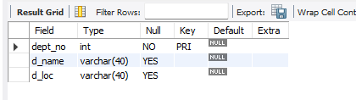

desc employee;

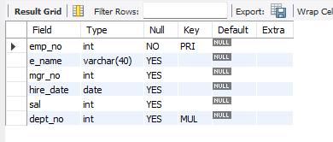

desc incentives;

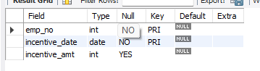

desc project;

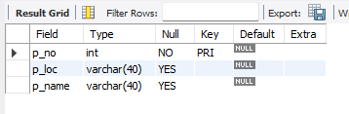

desc assigned_to;

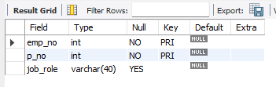

insert into department

values(1,'Logistics','bengaluru'),(2,'Statistics','mysuru'),(3,'Marketing','hyderabad'),(4,'Design','bengaluru'),(5,'Management','mysuru'),(6,'Finance','bombay');

select * from department;

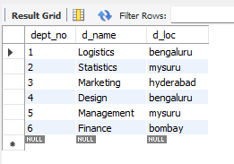

insert into employee

values(101,'Avinash',2310,'2021-09-12',56000,1),(102,'Dinesh',2317,'2021-07-05',96000,1),(103,'Balaji',2510,'2019-07-21',66000,1),(104,'Sovesh',9310,'2020-05-04',42000,2),(105,'Avinash',3310,'2021-04-24',76000,2),(106,'Hasbulla',5561,'2018-09-21',47900,3),(107,'Tacitus_Kilgore',7810,'2021-11-12',420000,4),(108,'Gowardana_Prasad',4231,'2019-02-12',327100,5),(109,'Champika',1324,'2021-12-23',87600,5),(110,'Robin',6780,'2022-01-01',123000,5);

select * from employee;

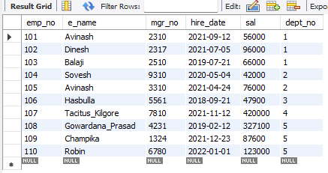

insert into incentives

values(101,'2020-09-02',5000),(106,'2020-08-12',7000),(102,'2021-11-21',5000),(105,'2022-04-17',5000),(110,'2022-03-18',9000);

select * from incentives;

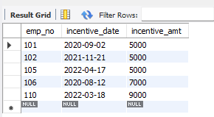

insert into project

values(01,'hyderabad','Project_Zero'),(02,'mysuru','Project_alpha'),(03,'hyderabad','Project_Bozo'),(04,'bengaluru','Project_Waaris'),(05,'bombay','Project_Onslaught'),(06,'mysuru','Project_DivideBY');

select * from project;

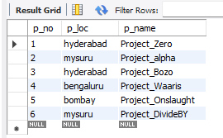

insert into assigned_to

values(101,01,'Candidate'),(103,04,'Candidate'),(102,05,'Manager'),(105,03,'Supervisor'),(107,02,'Candidate'),(106,06,'Candidate');

select * from assigned_to;

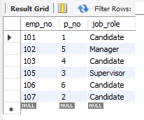

select E.emp_no from employee E,project P,assigned_to A where E.emp_no=A.emp_no and P.p_no=A.p_no and p_loc in ('bengaluru','mysuru','hyderabad');

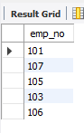

select emp_no from employee where emp_no not in (select emp_no from incentives);

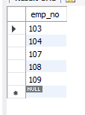

select E.e_name,E.emp_no,D.d_name,A.job_role,D.d_loc,P.p_loc from employee E,department D,Assigned_to A,project P where E.emp_no=A.emp_no and E.dept_no=D.dept_no and A.p_no=P.p_no and P.p_loc=D.d_loc;

