**Week-9**

**NOSQL**

**Perform the following DB operations using MongoDB.**

**1. Create a database “Student” with the following attributes Rollno, Age, ContactNo, Email-Id.**

**2. Insert appropriate values**

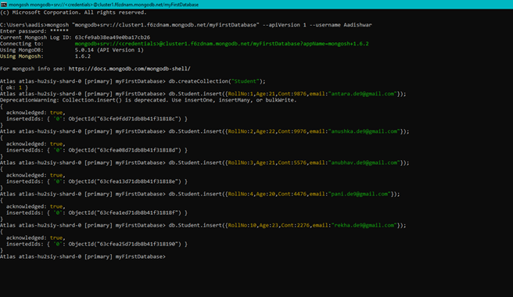

**3. Write query to update Email-Id of a student with roll no**

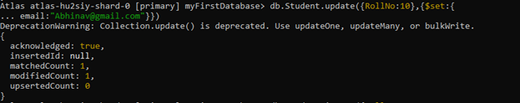

**4. Replace the student name from “ABC” to “FEM” of roll no**

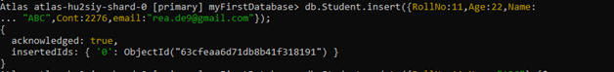

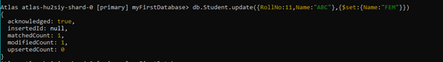

**5. Export the created table into local file system**

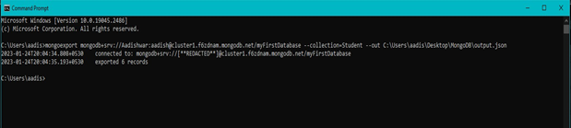

**6. Drop the table**

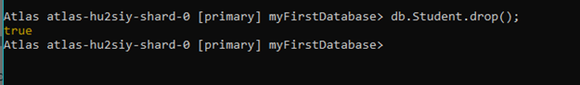

**7. Import a given csv dataset from local file system into mongodb collection.**

