**Q.Write a program that demonstrates handling of exceptions in inheritance tree.**

**Create a base class called “Father” and derived class called “Son” which**

**extends the base class. In Father class, implement a constructor which takes**

**the age and throws the exception WrongAge( ) when the input age<0. In Son**

**class, implement a constructor that cases both father and son’s age and**

**throws an exception if son’s age is >=father’s age.**

import java.util.*;

import java.lang.Exception;

class WrongAge extends Exception{

private int age;

WrongAge(int a){

age = a;

}

public String toString(){

return "Error! Wrong age has been entered:"+age;

}

}

class Father{

int father_age;

Father(int a){

father_age = a;

}

void check1() throws WrongAge{

if(father_age<18){

throw new WrongAge(father_age);

}

}

}

class Son extends Father{

int son_age;

Son(int a,int b){

super(a);

son_age=b;

}

void check2() throws WrongAge{

if((son_age >= father_age) || ((father_age-son_age)<21) ){

throw new WrongAge(son_age);

}

}

}

class Main{

public static void main(String args[]){

// Son s2 = new Son(18,16);

Son s2 = new Son(-14,18);

try{

s2.check1();

s2.check2();

System.out.print("The entered age for Father and Son are correct");

}

catch(WrongAge e){

System.out.print("Caught:"+e);

}

}

}

**Output:**

For father_age = -14 and Son_age = 18

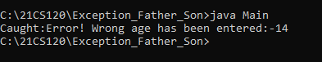

For father_age = 25 and Son_age = 2

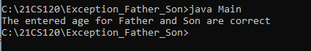

For father_age = 25 and Son_age = 35

