1. Write a python program to import and export data using Pandas library functions.

Importing data

Algorithm(Observation book)

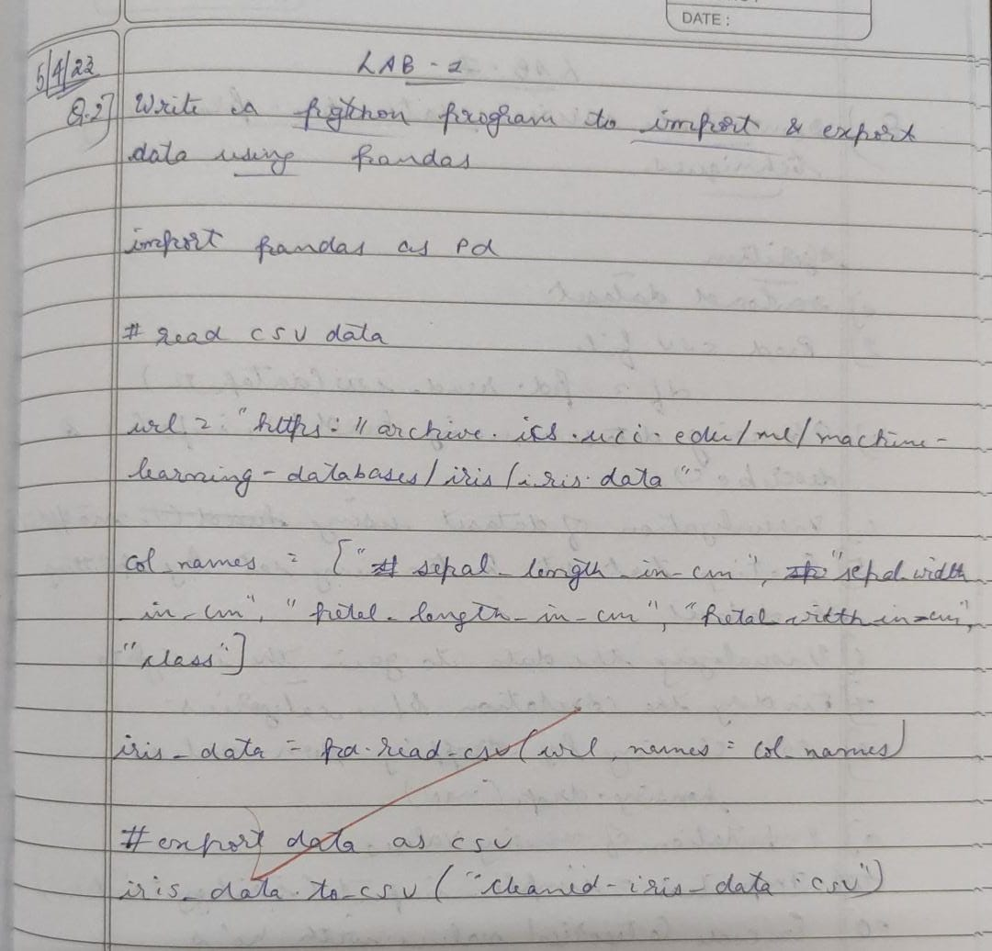

Code

import pandas as pd

df=pd.read_csv("/content/austinHousingData.csv")

df.head(5)

Output

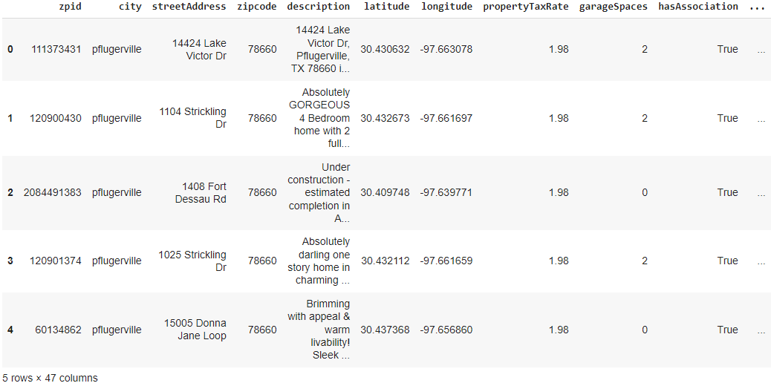

Exporting data

1. Demonstrate various data pre-processing techniques for a given dataset.

Algorithm(Observation book)

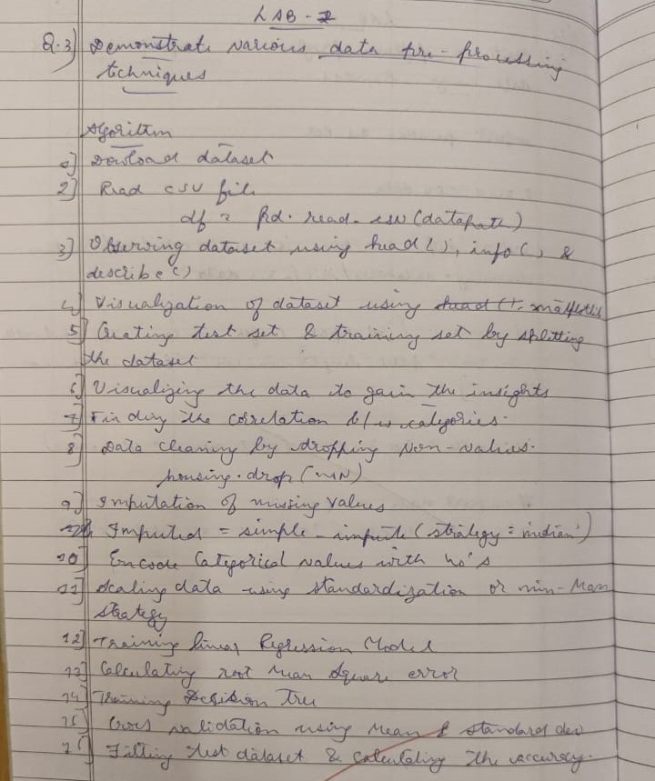

Code

url = “https://archive.ics.uci.edu/ml/machine-learning-databases/iris/iris.data”

# Define the column names

col_names = [“sepal_length_in_cm”,

            “sepal_width_in_cm”,

            “petal_length_in_cm”,

            “petal_width_in_cm”,

            “class”]

# Read data from URL

iris_data = pd.read_csv(url, names=col_names)

iris_data.head(5)

iris_data.to_csv(“/content/exported_irisData.csv”)

Output:

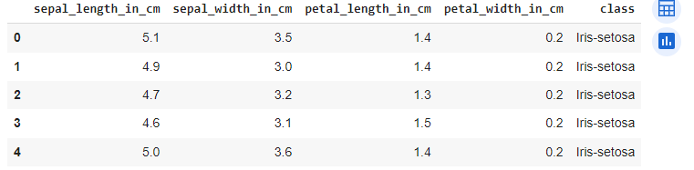

%matplotlib inline

import numpy as np

import pandas as pd

import matplotlib.pyplot as plt

import seaborn as sns

import sklearn

df1=pd.read_csv(“/content/Data.csv”)

df1.head(5)

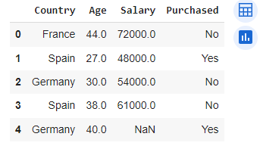

#Identifying and handling the missing values

df1.isnull().sum()

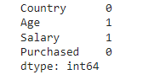

1. Use an appropriate dataset for building the decision tree(ID3) and apply this knowledge to classify a new sample.

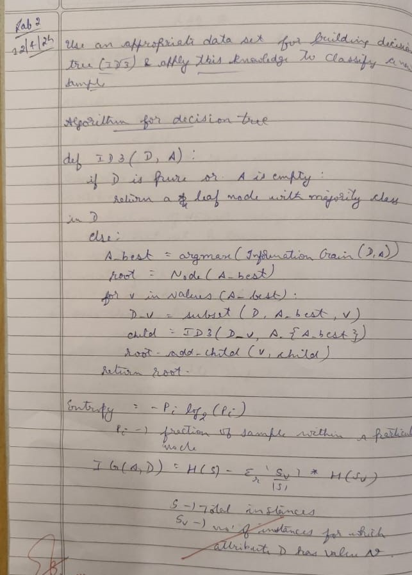Algorithm(Observation book)

Code

# Importing the required libraries

import pandas as pd

import numpy as np

import math

data = pd.read_csv('/content/PlayTennis.csv')

def highlight(cell_value):

    '''

    Highlight yes / no values in the dataframe

    '''

    color_1 = 'background-color: pink;'

    color_2 = 'background-color: lightgreen;'

    if cell_value == 'no':

        return color_1

    elif cell_value == 'yes':

        return color_2

data.style.applymap(highlight)\

    .set_properties(subset=data.columns, **{'width': '100px'})\

    .set_table_styles([{'selector': 'th', 'props': [('background-color', 'lightgray'), ('border', '1px solid gray'),

                                                    ('font-weight', 'bold')]},

     {'selector': 'tr:hover', 'props': [('background-color', 'white'), ('border', '1.5px solid black')]}])

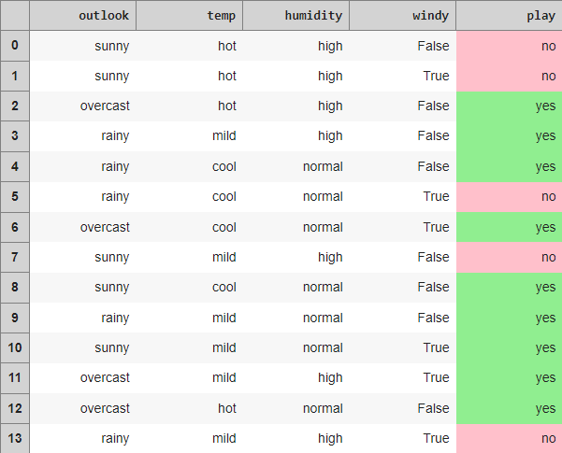

def find_entropy(data):

    """

    Returns the entropy of the class or features

    formula: - ∑ P(X)logP(X)

    """

    entropy = 0

    for i in range(data.nunique()):

        x = data.value_counts()[i]/data.shape[0]

        entropy += (- x * math.log(x,2))

    return round(entropy,3)

def information_gain(data, data_):

    """

    Returns the information gain of the features

    """

    info = 0

    for i in range(data_.nunique()):

        df = data[data_ == data_.unique()[i]]

        w_avg = df.shape[0]/data.shape[0]

        entropy = find_entropy(df.play)

        x = w_avg * entropy

        info += x

    ig = find_entropy(data.play) - info

    return round(ig, 3)

def entropy_and_infogain(datax, feature):

    """

    Grouping features with the same class and computing their

    entropy and information gain for splitting

    """

    for i in range(data[feature].nunique()):

        df = datax[datax[feature]==data[feature].unique()[i]]

        if df.shape[0] < 1:

            continue

        display(df[[feature, 'play']].style.applymap(highlight)\

                .set_properties(subset=[feature, 'play'], **{'width': '80px'})\

                .set_table_styles([{'selector': 'th', 'props': [('background-color', 'lightgray'),

                                                                ('border', '1px solid gray'),

                                                                ('font-weight', 'bold')]},

                                   {'selector': 'td', 'props': [('border', '1px solid gray')]},

                                   {'selector': 'tr:hover', 'props': [('background-color', 'white'),

                                                                      ('border', '1.5px solid black')]}]))

        print(f'Entropy of {feature} - {data[feature].unique()[i]} = {find_entropy(df.play)}')

    print(f'Information Gain for {feature} = {information_gain(datax, datax[feature])}')

#Computing entropy for the entire dataset

print(f'Entropy of the entire dataset: {find_entropy(data.play)}')



#Calculate the Information Gain for each feature.

#Outlook

entropy_and_infogain(data, 'outlook')

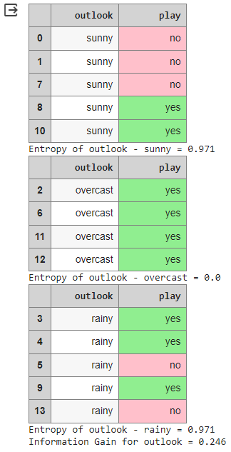

#Temp

entropy_and_infogain(data, 'temp')

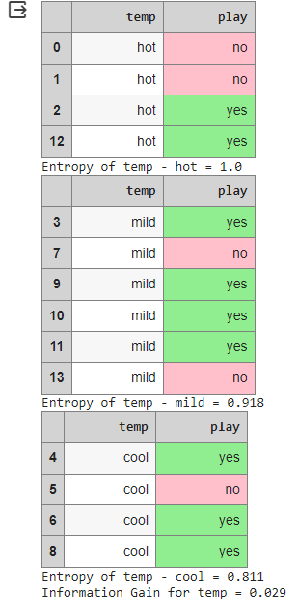

#Humidity

entropy_and_infogain(data, 'humidity')

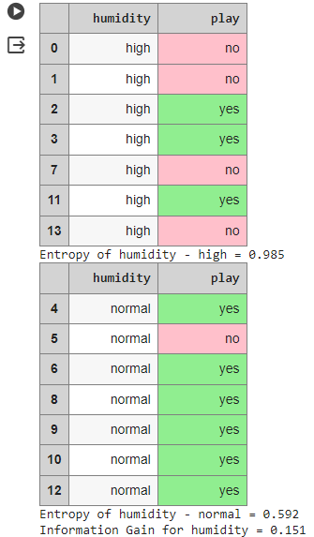

#Windy

entropy_and_infogain(data, 'windy')

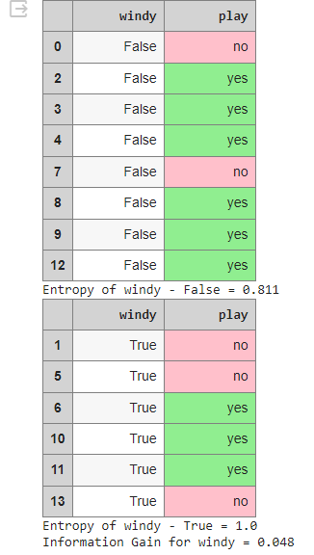

#Make a decision tree node using the feature with the maximum Information Gain.

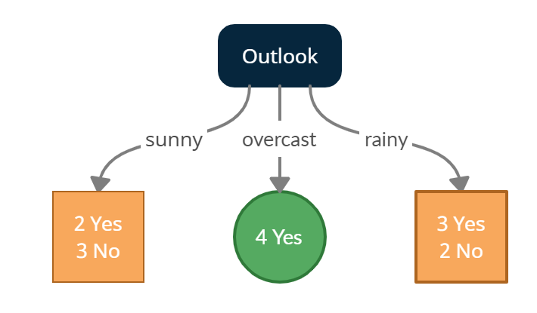

sunny = data[data['outlook'] == 'sunny']

sunny.style.applymap(highlight)\

    .set_properties(subset=data.columns, **{'width': '100px'})\

    .set_table_styles([{'selector': 'th', 'props': [('background-color', 'lightgray'), ('border', '1px solid gray'),

                                                    ('font-weight', 'bold')]},

     {'selector': 'tr:hover', 'props': [('background-color', 'white'), ('border', '1.5px solid black')]}])

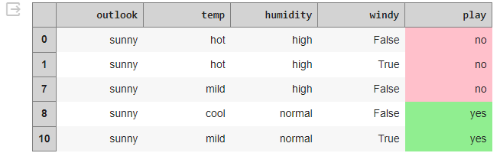

print(f'Entropy of the Sunny dataset: {find_entropy(sunny.play)}')



#temp

entropy_and_infogain(sunny, 'temp')

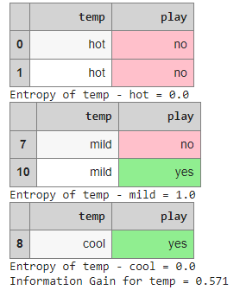

#Humidity

entropy_and_infogain(sunny, 'humidity')

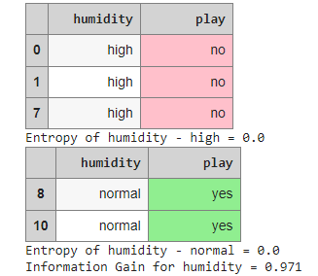

#Windy

entropy_and_infogain(sunny, 'windy')

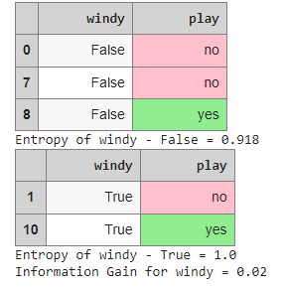

**#Making a decision tree node using the feature which has the maximum Information Gain**

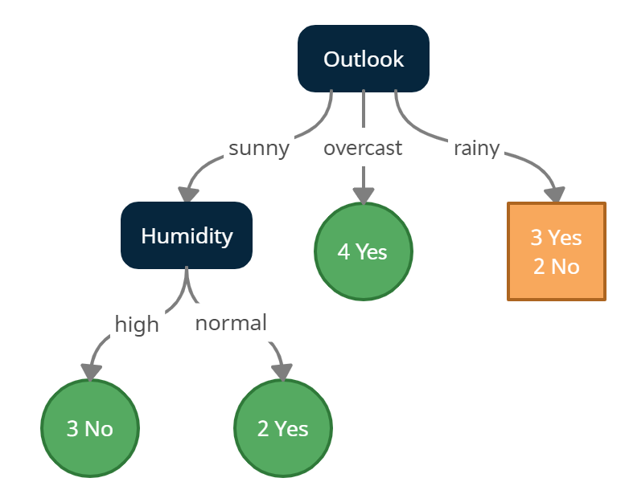

#Outlook - Rainy

rainy = data[data['outlook'] == 'rainy']

rainy.style.applymap(highlight)\

    .set_properties(subset=data.columns, **{'width': '100px'})\

    .set_table_styles([{'selector': 'th', 'props': [('background-color', 'lightgray'), ('border', '1px solid gray'),

                                                    ('font-weight', 'bold')]},

     {'selector': 'tr:hover', 'props': [('background-color', 'white'), ('border', '1.5px solid black')]}])

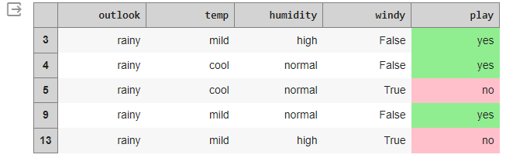

print(f'Entropy of the Rainy dataset: {find_entropy(rainy.play)}')



#temp

entropy_and_infogain(rainy, 'temp')

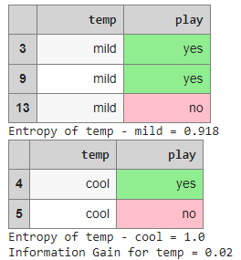

#Humidity

entropy_and_infogain(rainy, 'humidity')

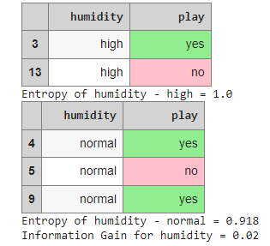

#Windy

entropy_and_infogain(rainy, 'windy')

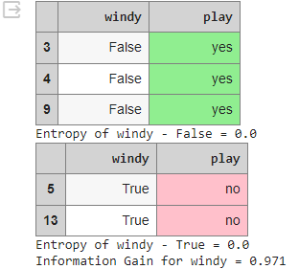

**#Making a decision tree node using the feature which has the maximum Information Gain.**

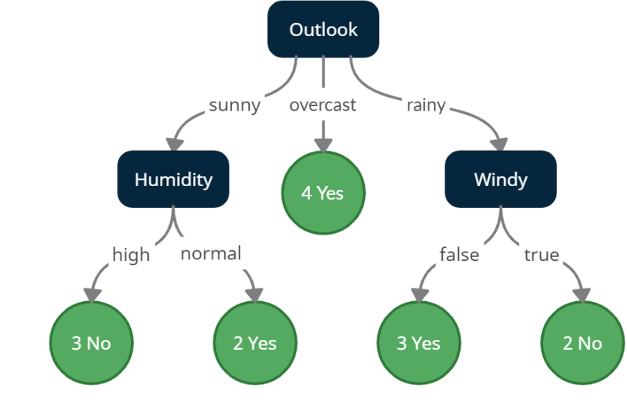

1. Implement Linear and Multi-Linear Regression algorithm using appropriate dataset

**Algorithm**

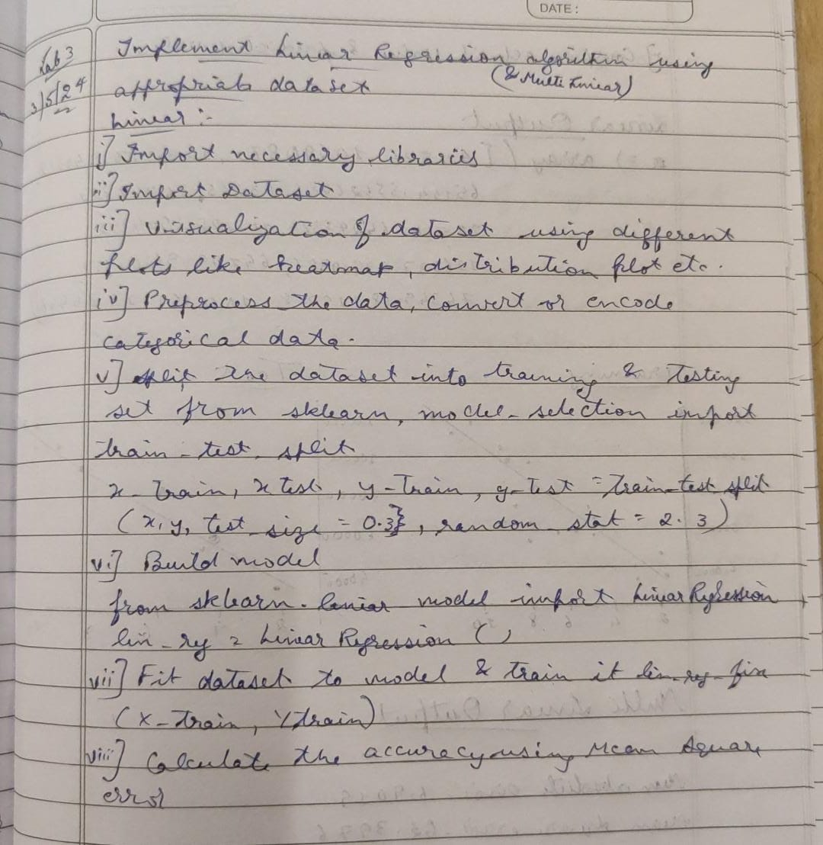

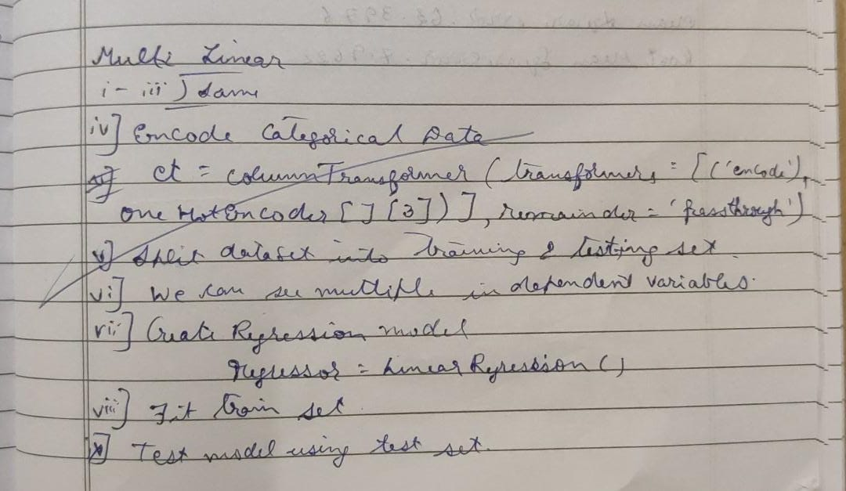

**Code:**

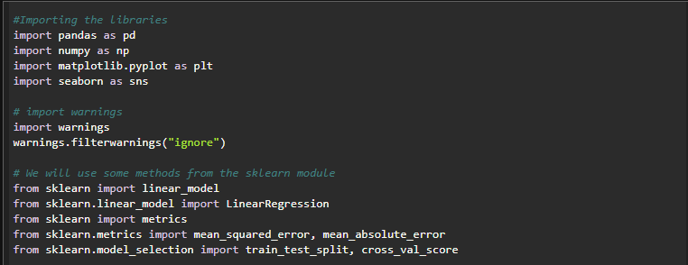

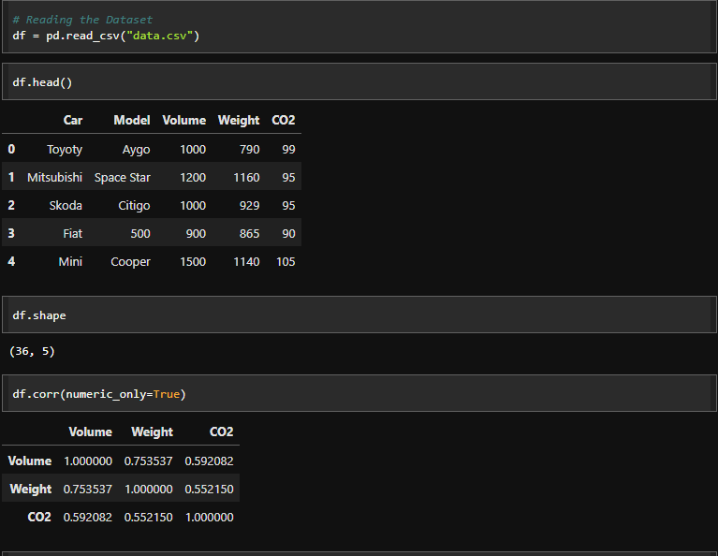

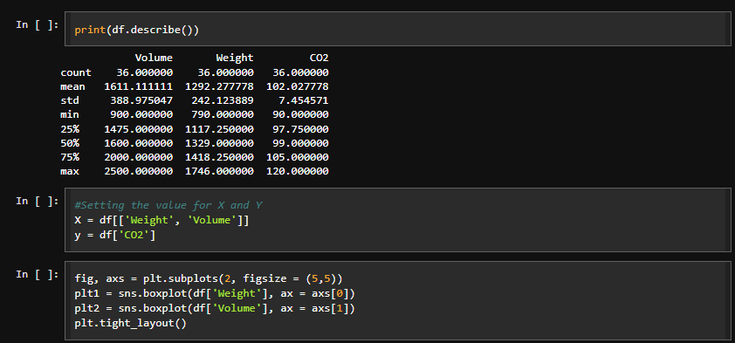

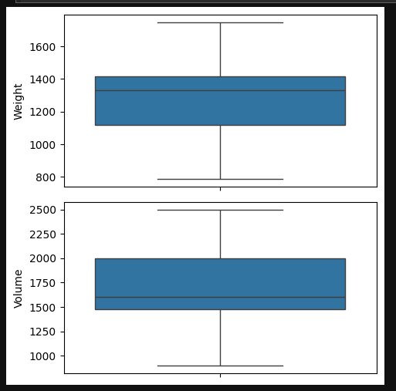

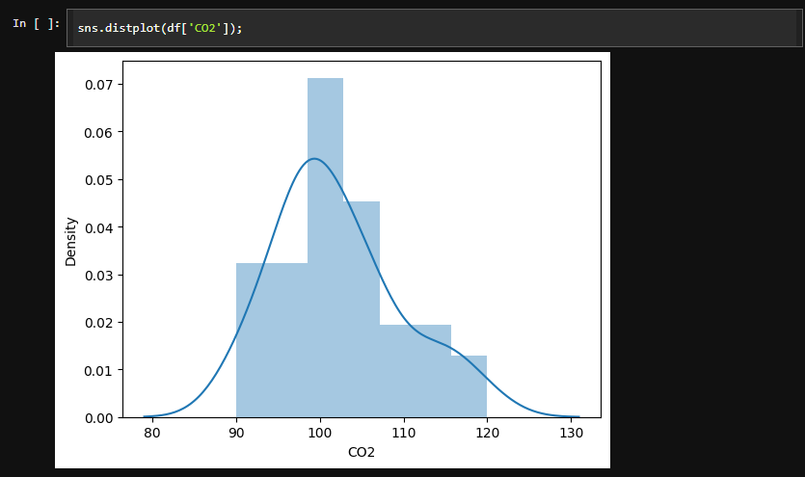

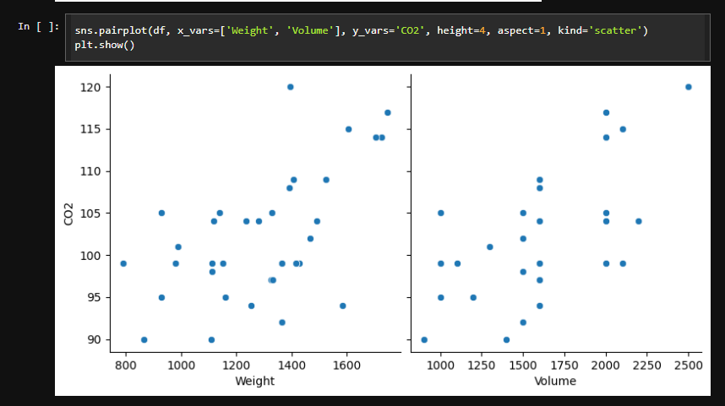 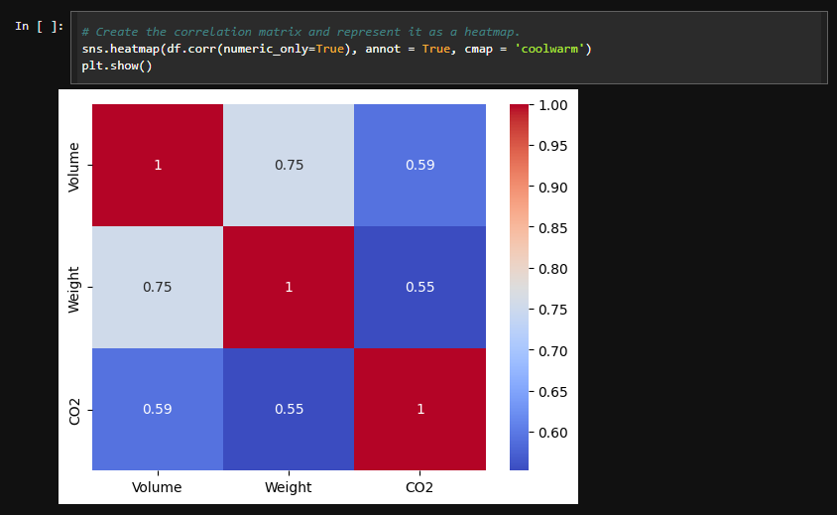

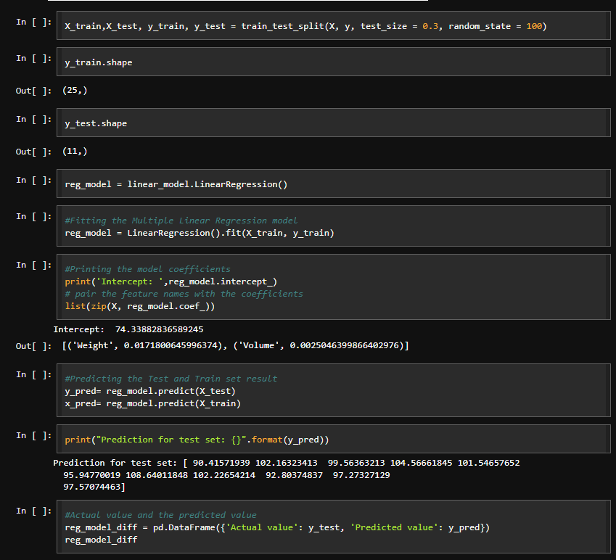

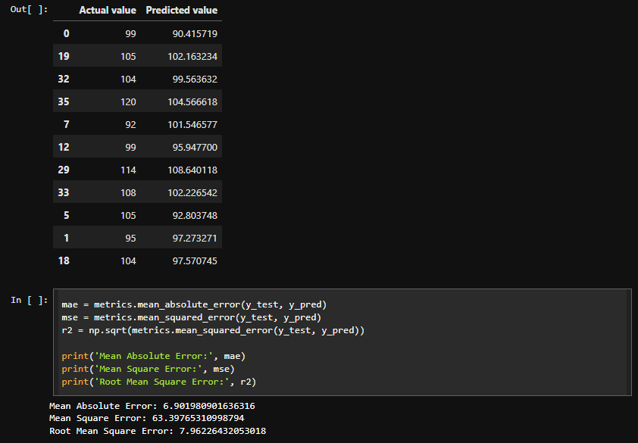

**Results**



1. Build KNN Classification model for a given dataset.

Algorithm

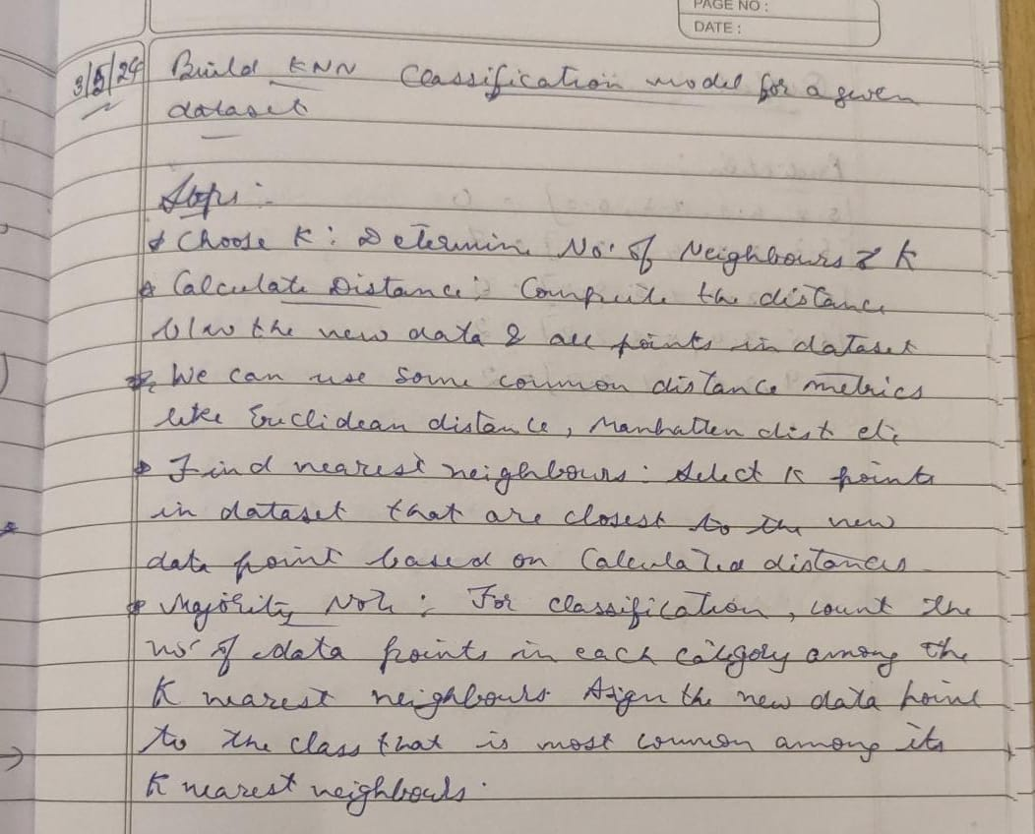

Code:

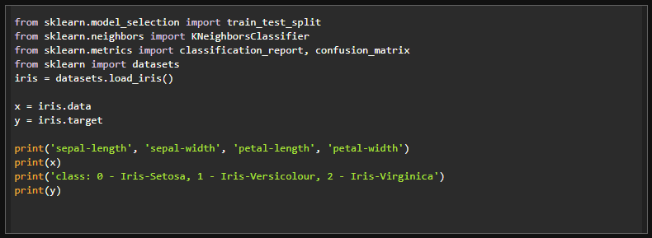

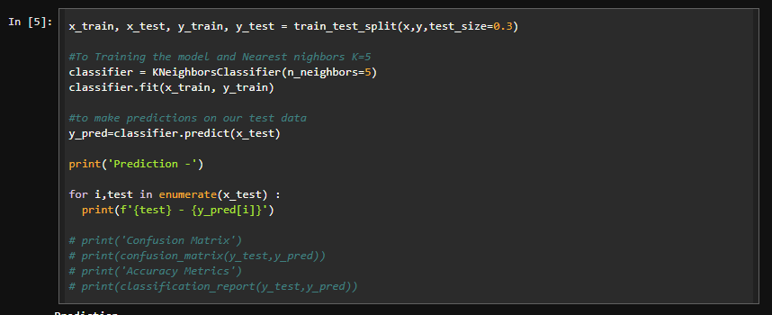

Results:

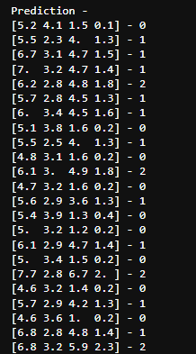

1. Build Logistic Regression Model for a given dataset

Algorithm:

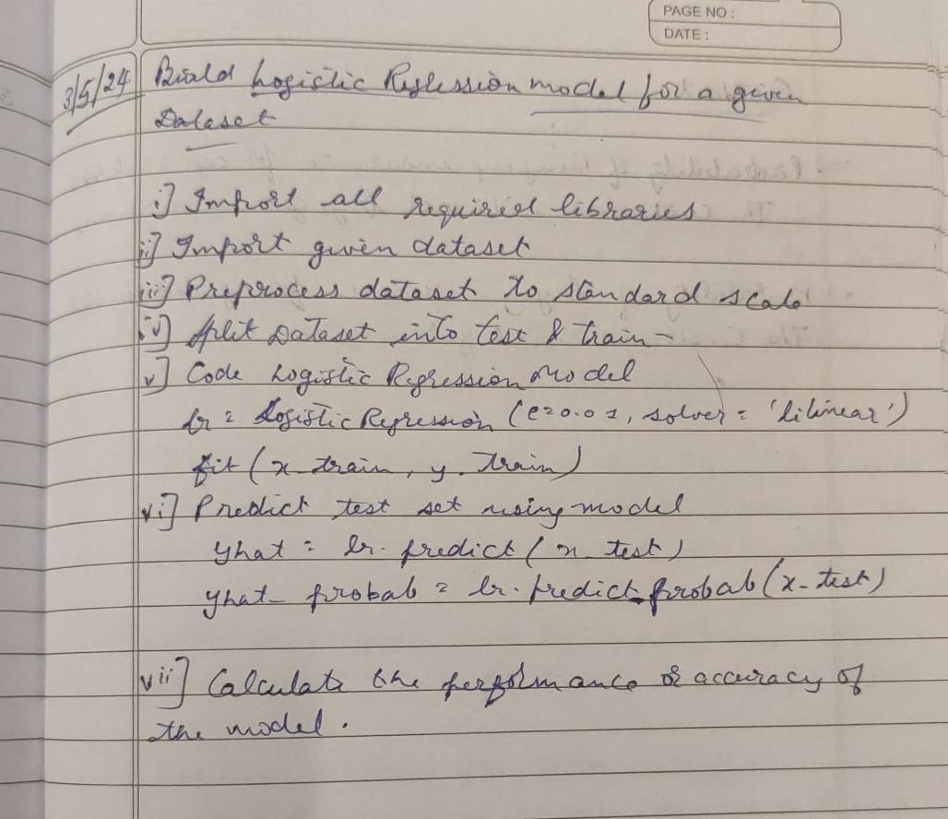

Code:

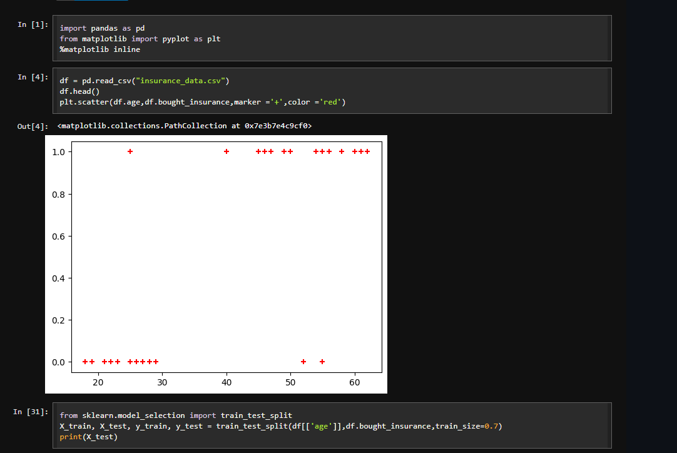

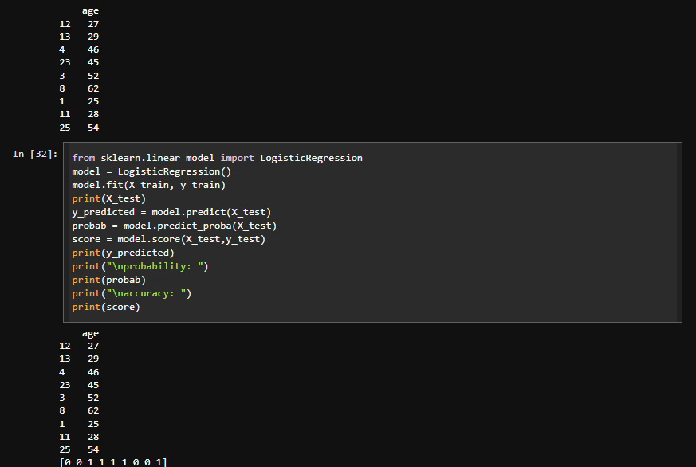

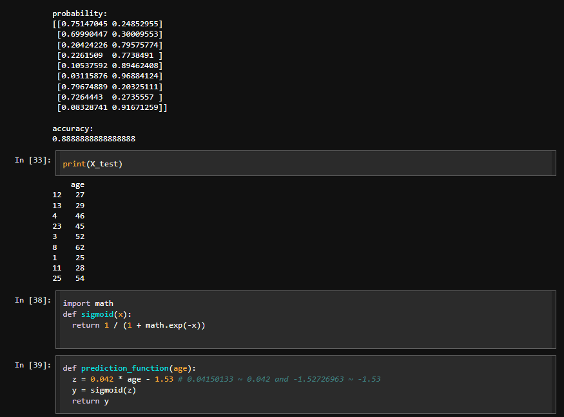

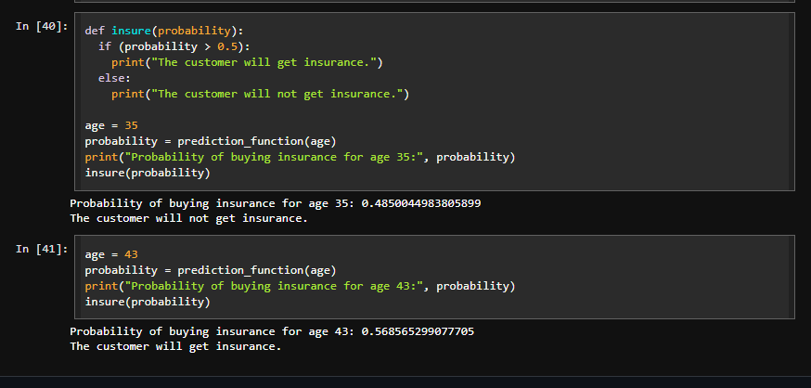

Results:

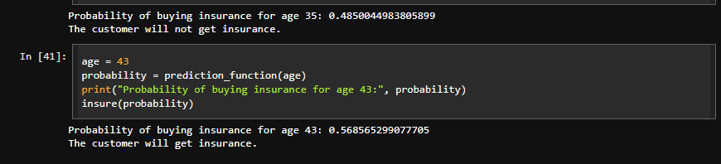

1. Build Support vector machine model for a given dataset

Algorithm:

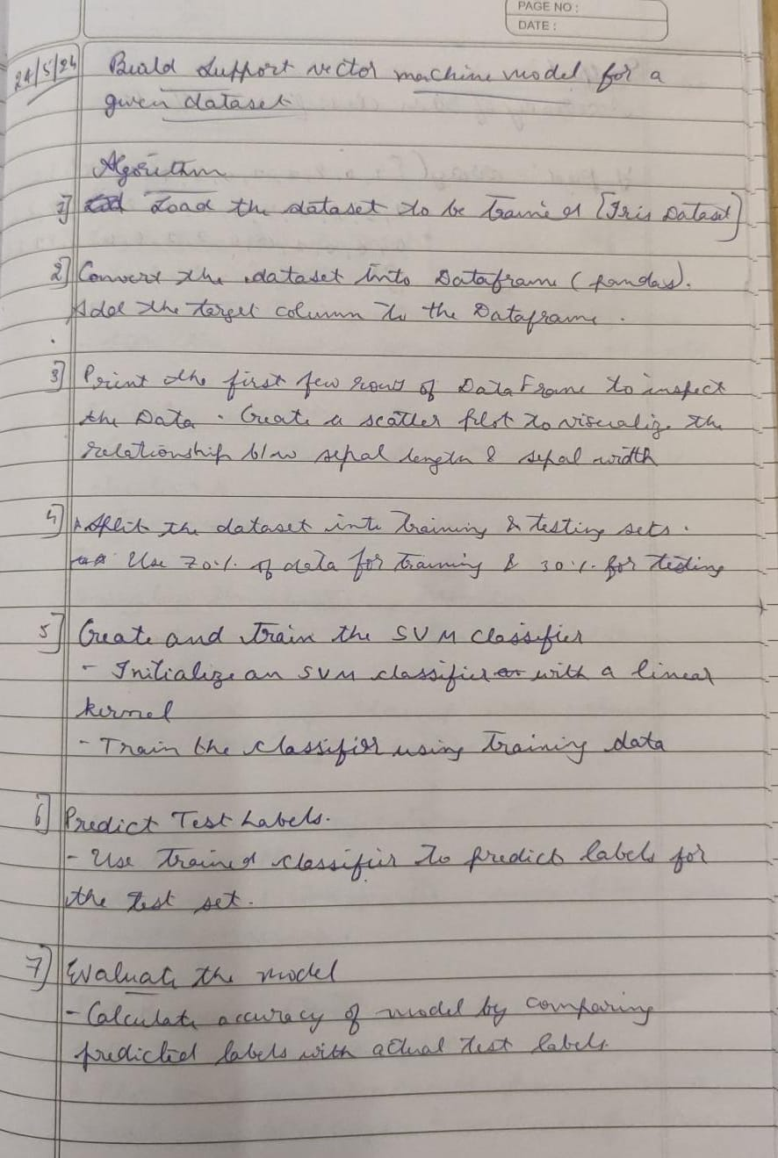

Code:

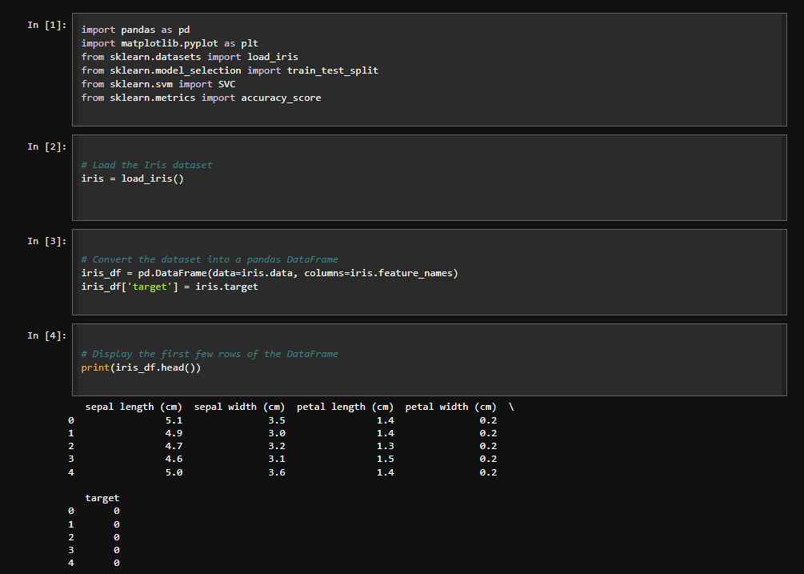

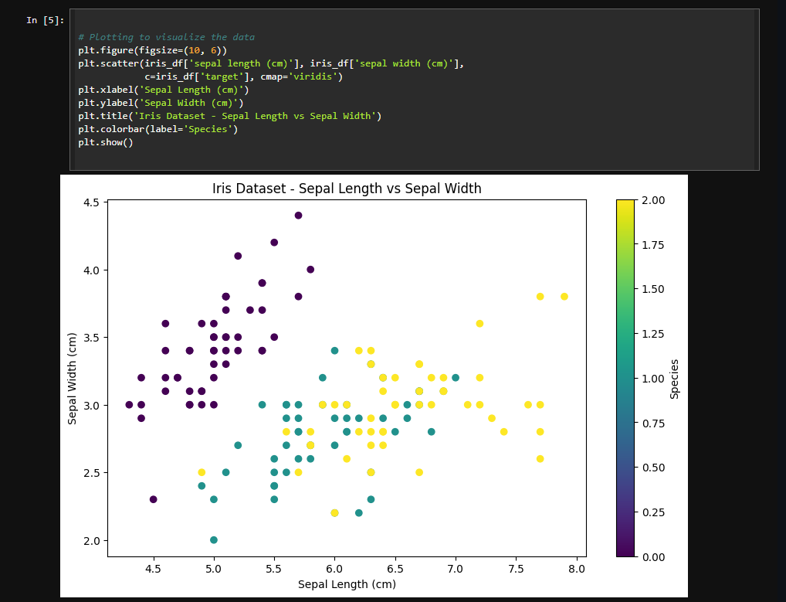

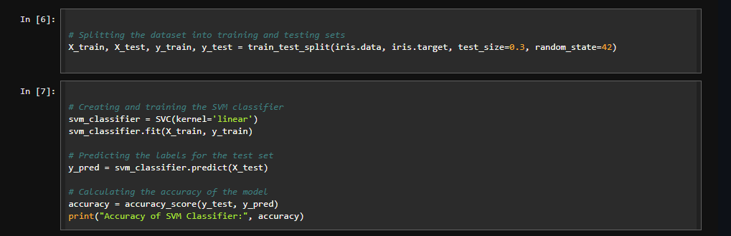

Results:

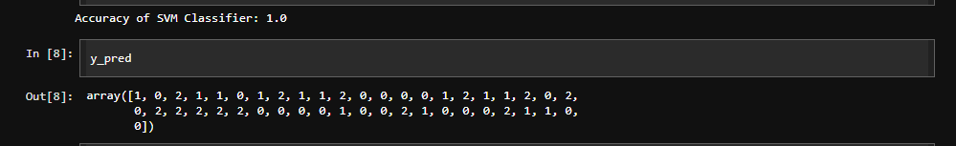

1. Build k-Means algorithm to cluster a set of data stored in a .CSV file.

Algorithm:

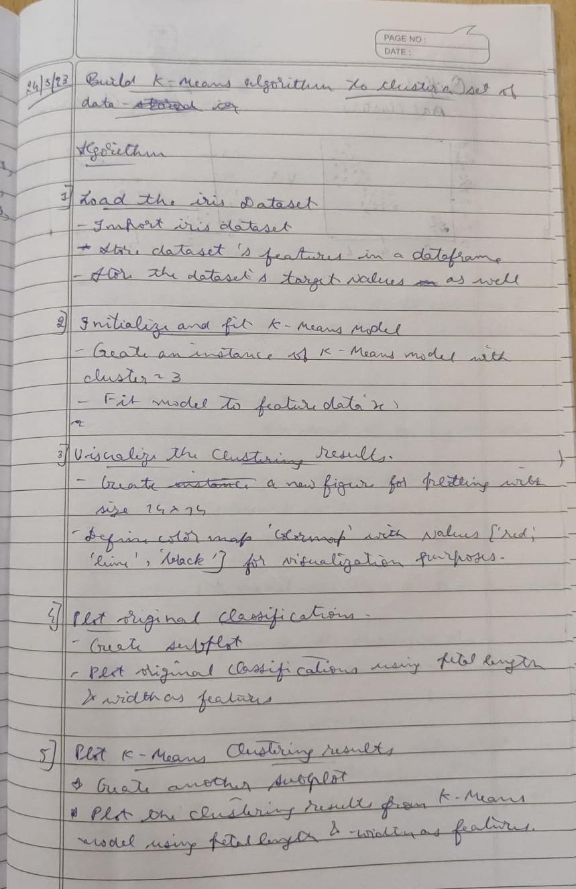

Code:

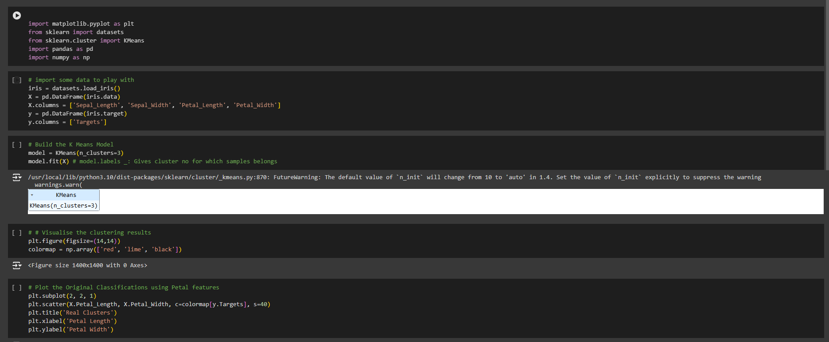

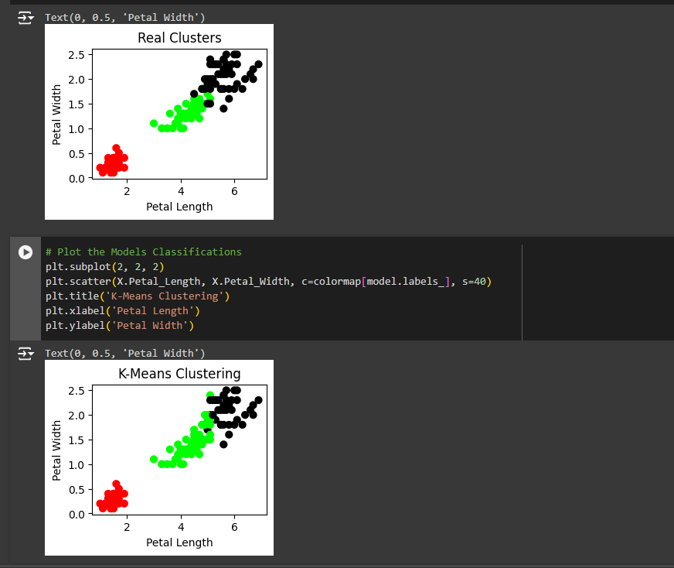

1. Implement Dimensionality reduction using Principle Component Analysis (PCA)  
   method.

Algorithm

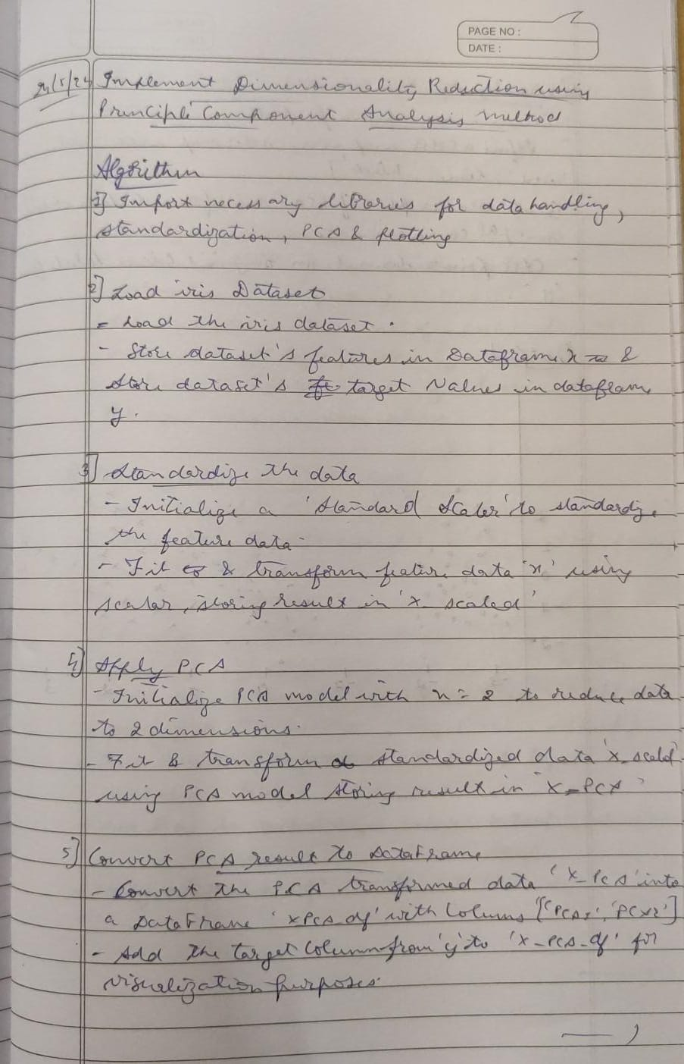

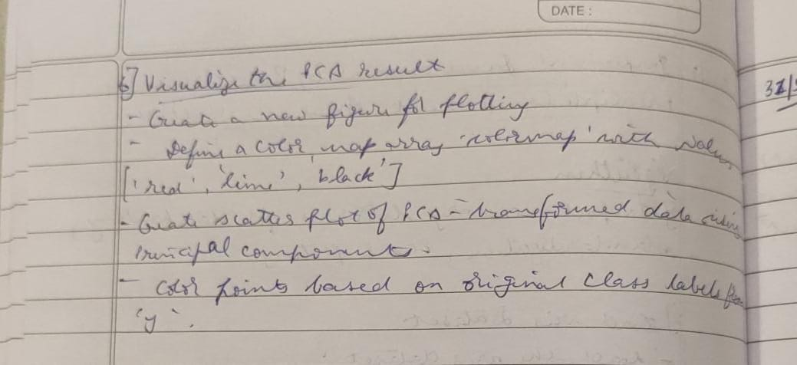

Code:

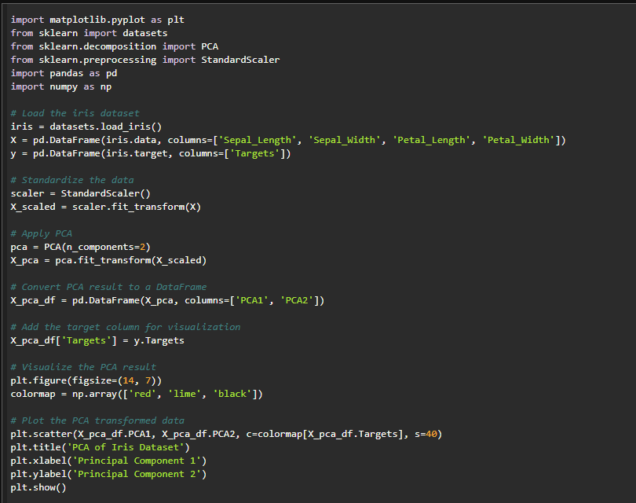

Results:

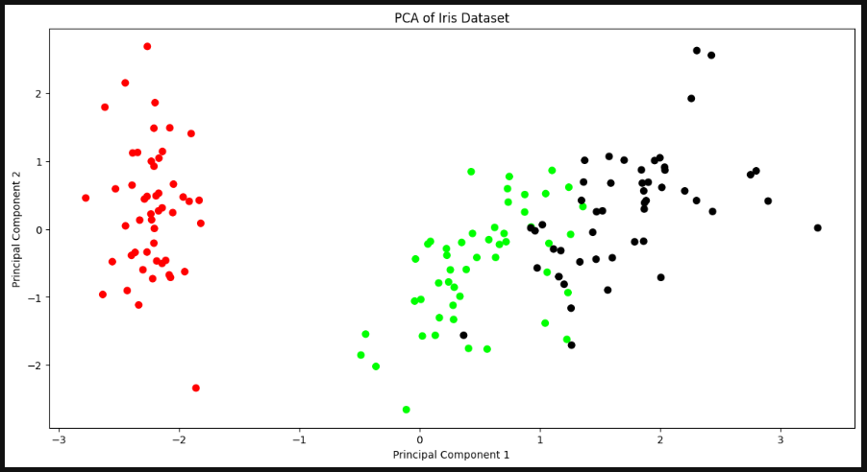

1. Build Artificial Neural Network model with back propagation on a given dataset

Algorithm

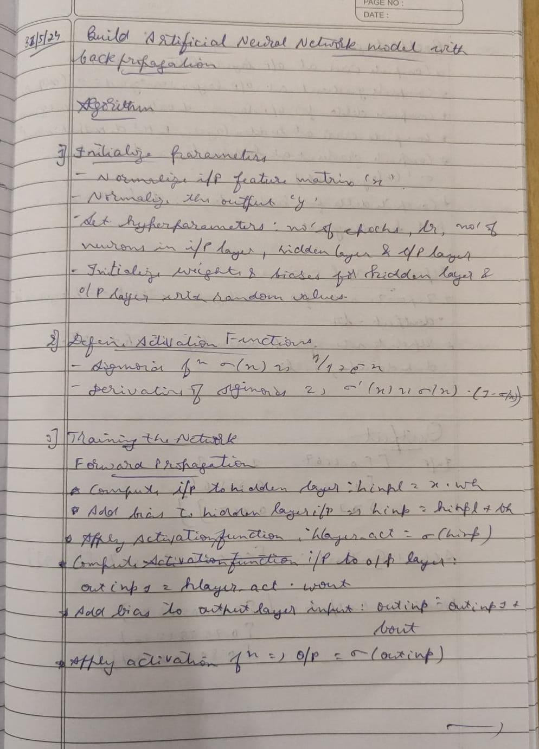

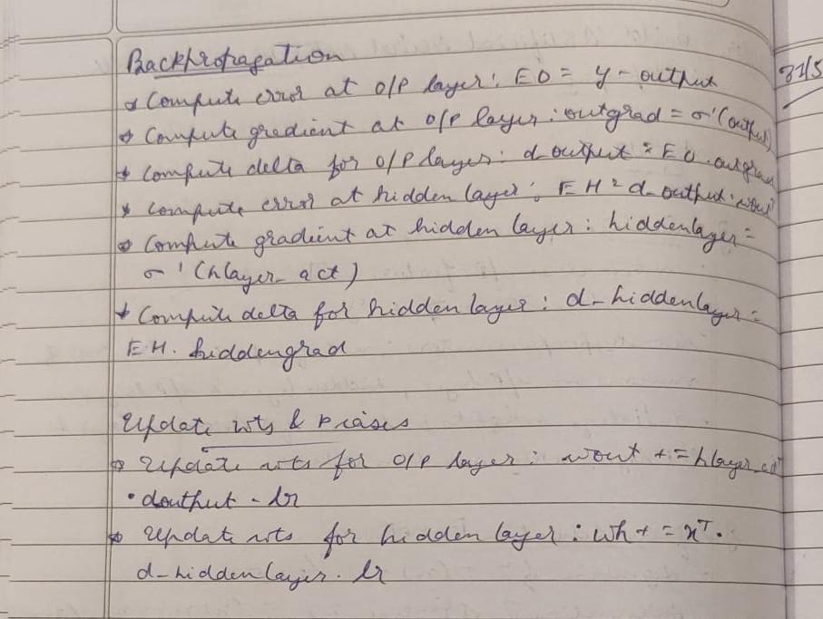

Code:

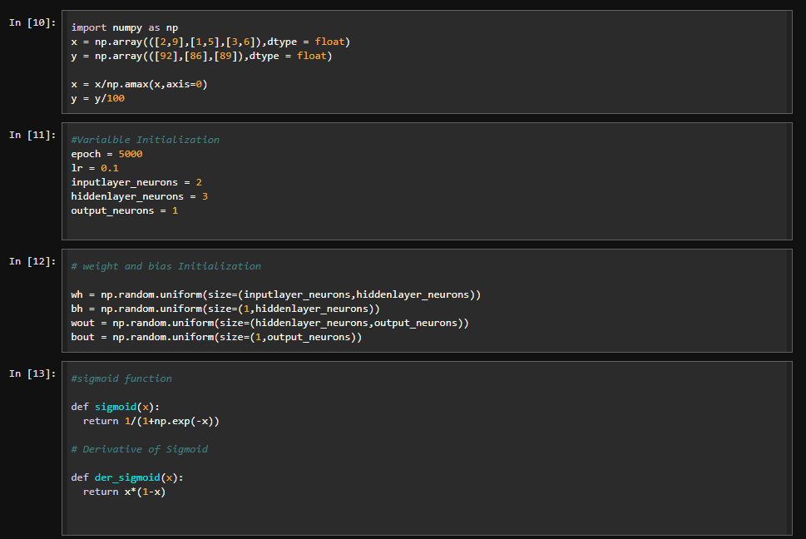

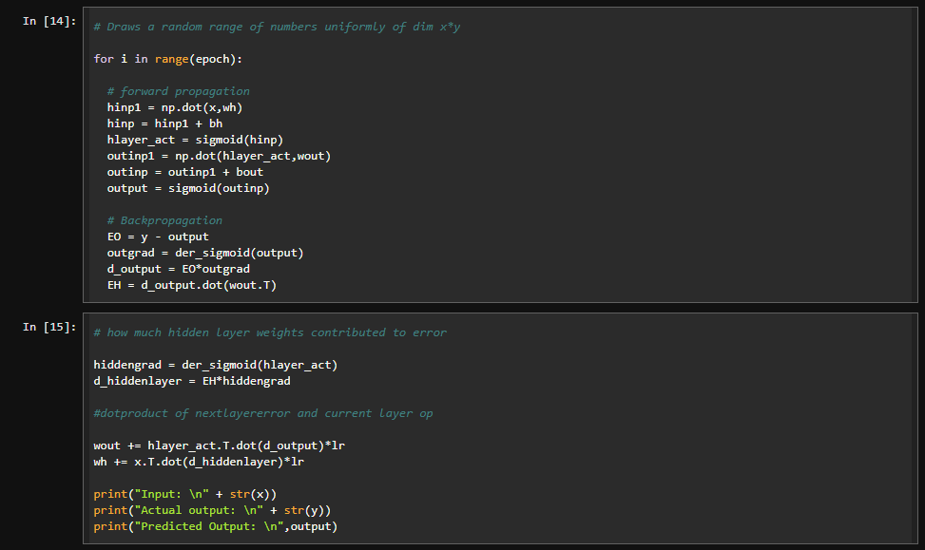

Results

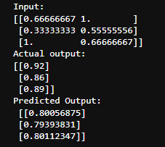

1. Implement Random forest ensemble method on a given dataset.

Algorithm

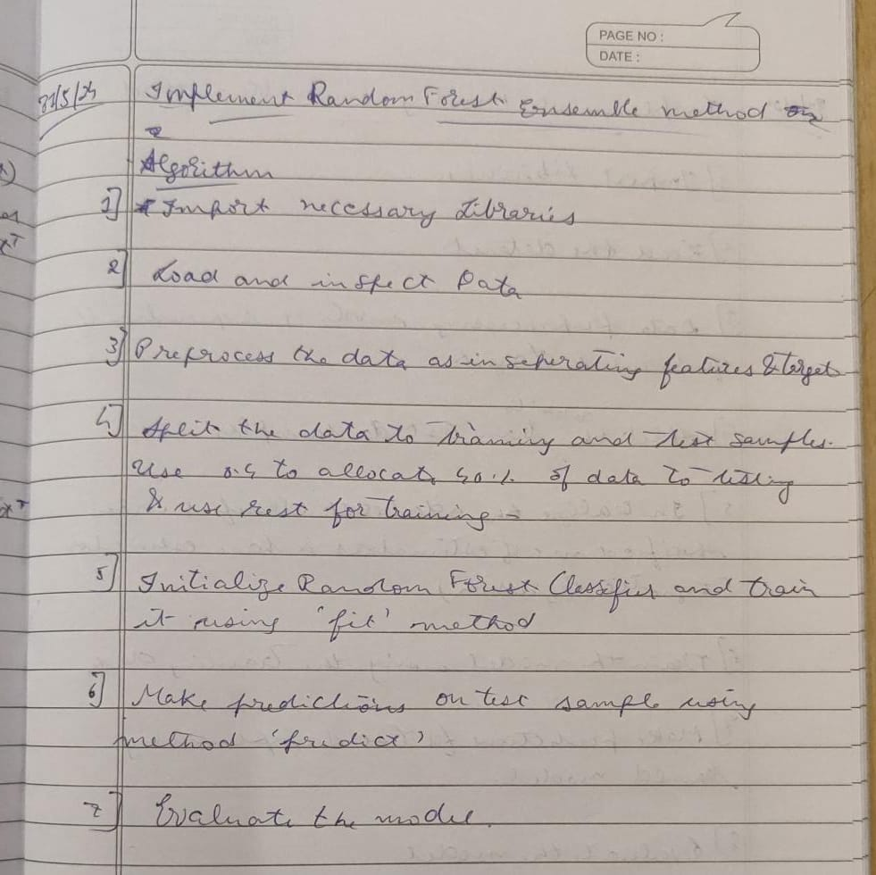

Code:

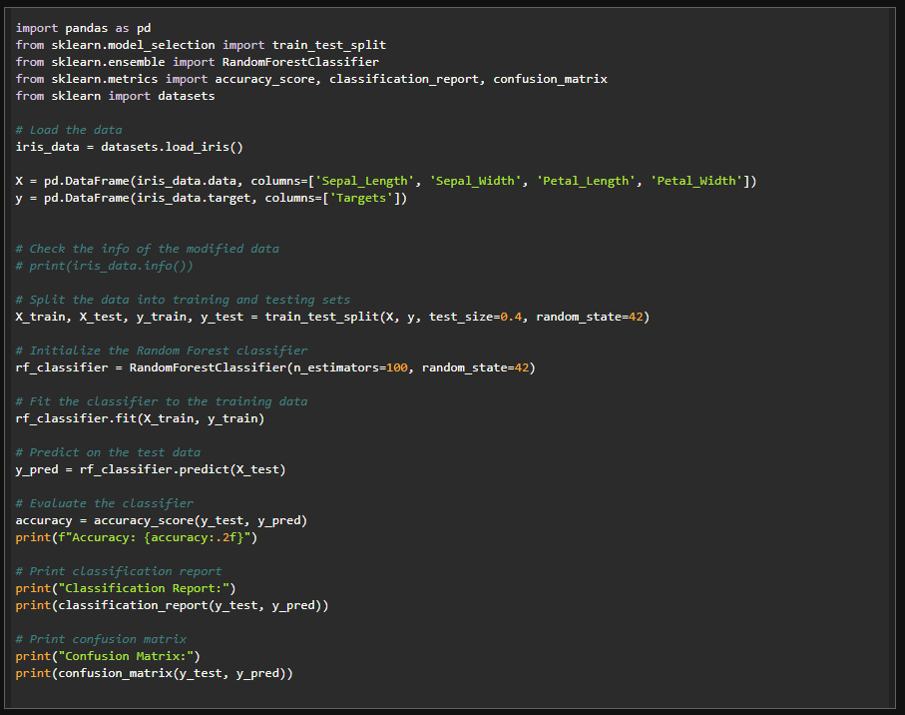

Results:

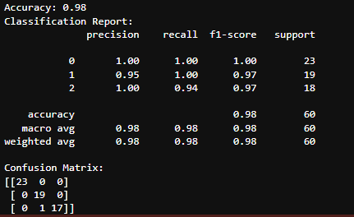

1. Implement Boosting ensemble method on a given dataset.

Algorithm

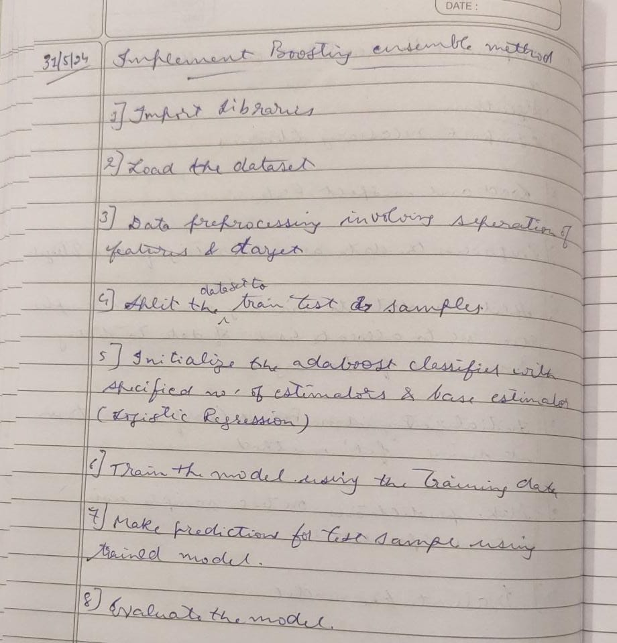

Code:

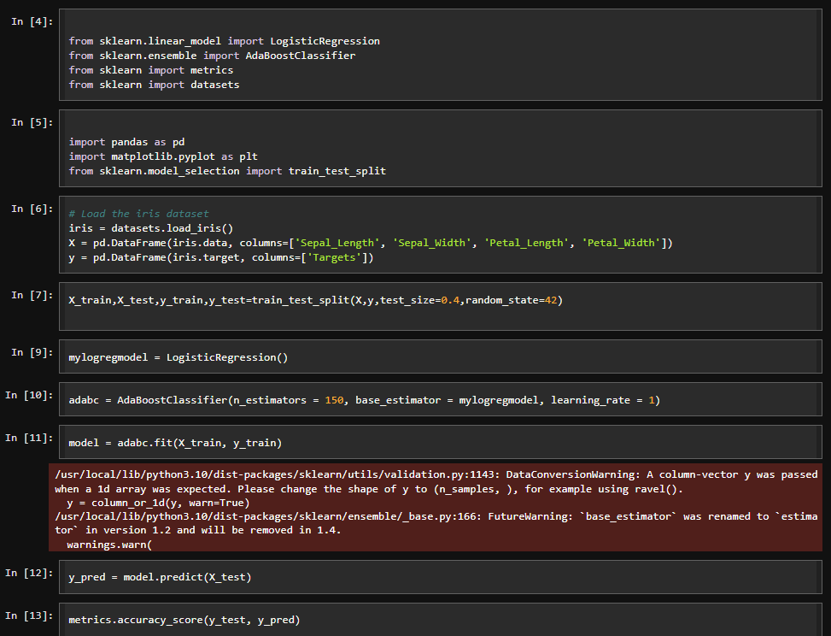

Results:

