SonicAtlas: An Interactive In-Browser Exploratory Data Analysis Platform for Multi-Dimensional Audio Features and Lyrics of Spotify Tracks Across Genres and Eras
Sharvesh Prabhu (25BDS0318)  School of Computer Science and Engineering  Vellore Institute of Technology  Vellore, India  <email> | Nithin S (25BDS0308)  School of Computer Science and Engineering  Vellore Institute of Technology  Vellore, India  nithin.s2025a@vitstudent.ac.in

Abstract—Archived Spotify audio descriptors are among the few open windows onto the acoustic character of recorded music, but most analyses of them are static and stop at a handful of charts. We describe SonicAtlas, a reproducible exploratory pipeline and a serverless web platform built on 1,204,025 tracks, 89,740 genre-labelled tracks in 114 genres and a 161,401-song English lyrics sample. Impossible values are repaired with chained-equation imputation that lowers masked-value error by up to 57.5% relative to mean filling, and outliers are flagged rather than removed. Across 1959-2020, average loudness climbs by 7.8 dB while acousticness falls from 0.86 to 0.31, with loudness change points at 1989, 1999. Genre accounts for 42.5% of the variance of danceability, yet genre labels overlap strongly in every two-dimensional embedding; t-SNE attains the highest trustworthiness (0.976) among PCA, LLE, UMAP and t-SNE. Lyric sentiment is almost unrelated to audio valence (r = 0.06). All results are explorable in the browser through SQL executed by DuckDB-WASM on Parquet files, with no server.
Index Terms—exploratory data analysis, music information retrieval, audio features, dimensionality reduction, time-series analysis, in-browser analytics
I. INTRODUCTION
Popular music has been studied quantitatively for more than a decade, from the long-run homogenisation of timbre and loudness [1] to revolutions in US chart music [2] and the predictability of commercial success [3], [4]. Streaming platforms made such work easier by publishing per-track descriptors such as energy, valence and danceability, and large crawls of these values still circulate on open-data portals even though the original API endpoint has been closed to new applications.
Two practical problems limit the value of these crawls. First, the raw tables contain impossible values, duplicated re-issues and sources that do not share keys, and published studies rarely say how such issues were treated. Second, results are usually frozen into figures, so a reader cannot ask a slightly different question without rebuilding the pipeline. This paper addresses both problems. Our contributions are: (i) a documented cleaning pipeline over 1.2 million tracks with validated imputation and explicit outlier and re-issue flags; (ii) a systematic exploration that combines course-standard descriptive statistics, multivariate views, four embedding methods, clustering, time-series decomposition, hypothesis tests and lyrics mining; and (iii) SonicAtlas, a static web application in which every table can be filtered, queried and compared in the reader's own browser.
II. RELATED WORK
Audio descriptors and genre. Large open collections such as the Million Song Dataset [5] and handcrafted features for genre recognition [6] established the use of numeric audio summaries, and deep models now learn such features directly from audio [7].
Trends and popularity. Studies of musical evolution [1], [2] and hit prediction [3], [4] report strong temporal signals but publish them as static results. Lyrics research shows rising negativity over time [8], usually without the matching audio view; sentiment is often scored with VADER [9]. Recommendation surveys [10] motivate similarity search over descriptors.
Embeddings and EDA tooling. PCA [11], LLE [12], t-SNE [13] and UMAP [14] are standard for maps of high-dimensional data. Automated EDA has been surveyed by Milo and Somech [15], and interactive charts are commonly specified with declarative grammars such as Vega-Lite [16]. On the systems side, embeddable analytical engines [17], their WebAssembly port [18] and scalable linked views [19] make serverless analysis feasible. The closest system in spirit is a Streamlit application for exploratory analysis of clinical data [20], which, unlike SonicAtlas, requires a Python server and is not domain-aware for music.
III. DATASETS AND PREPROCESSING
We combine three public Kaggle datasets: a crawl of 1,204,025 tracks with audio descriptors and release dates [21], a genre-balanced table of 114,000 rows covering 114 genres [22], and Genius lyrics with language tags [23]. Raw files are checksummed and never modified.
Repairs. 2,777 tracks report 0 BPM and 2,809 a time signature of 0. Both are treated as missing and imputed with chained equations (MICE) [24] using the remaining descriptors. Because the descriptors have no natural gaps, we hid 5% of known values: the imputer reduced RMSE versus mean filling by 57.5% for energy, 25.2% for valence and only 3.9% for tempo, which the other features predict poorly.
Duplicates and joins. The earliest release of each normalised title and lead artist is marked canonical; 90,457 re-issues are excluded from temporal statistics. De-duplicating multi-genre rows leaves 89,740 genre tracks, of which only 10.7% can be linked to the main table by track ID or title and artist, so genre analyses use the genre table on its own.
Transforms and outliers. Skewed fields are transformed (duration G1 8.04 to 0.23 after log1p), and Min-Max and z-score versions are stored. Tukey fences and an Isolation Forest [25] flag outliers; the forest marks 24,547 tracks (2.0%), dominated by spoken-word content (mean speechiness 0.48 vs 0.08).
IV. METHODOLOGY
Descriptive statistics follow the conventions of our course: sample variance with denominator n-1, Tukey hinges for quartiles, the adjusted Fisher-Pearson skewness G1 and the bias-corrected excess kurtosis G2. The implementation is unit-tested against SciPy and a textbook example. Table I lists the resulting summary for the main descriptors.
Multivariate analysis uses Pearson and Spearman matrices on a 300,000-track sample, and parallel coordinates, Andrews curves, radar and violin plots on a balanced sample of eight genres.
Embeddings and clusters. PCA is fitted on all tracks; t-SNE (perplexity 30), LLE (15 neighbours) and UMAP run on a 10,000-track sample stratified by genre. Methods are compared by runtime, trustworthiness at k = 10 and silhouette with genre labels. KMeans is run on the first 7 principal components for k = 2-10, and HDBSCAN checks for density structure.
Time series. Yearly means of canonical releases are smoothed with 5-year windows, decomposed with STL [26] at monthly resolution, segmented with PELT change-point detection [27], and forecast with ARIMA(1,1,1) evaluated on a ten-year hold-out against a naive baseline.
Tests and text. Genre differences are tested with one-way ANOVA and Tukey HSD, a Kruskal-Wallis check and a chi-square test with Cramer's V; features are ranked by filter criteria and by recursive feature elimination. Lyrics are cleaned and scored with VADER [9] and TextBlob [28]. Tooling is built on pandas [29] and scikit-learn [30].
TABLE I
DESCRIPTIVE STATISTICS OF SELECTED AUDIO FEATURES (N = 1,204,025)
Feature | Mean | Median | IQR | G1 | G2
danceability | 0.493 | 0.501 | 0.277 | -0.10 | -0.61
energy | 0.510 | 0.524 | 0.514 | -0.09 | -1.22
loudness | -11.809 | -9.791 | 8.537 | -1.28 | 1.78
speechiness | 0.084 | 0.045 | 0.037 | 4.24 | 22.35
acousticness | 0.447 | 0.389 | 0.823 | 0.16 | -1.64
instrumentalness | 0.283 | 0.008 | 0.719 | 0.80 | -1.18
valence | 0.428 | 0.403 | 0.453 | 0.25 | -1.05
tempo | 117.899 | 116.838 | 42.753 | 0.40 | -0.29
duration | 4.147 | 3.739 | 1.863 | 8.04 | 146.28
V. SYSTEM ARCHITECTURE OF SONICATLAS
Fig. 1 summarises the design. All expensive steps run once in Python and emit columnar Parquet files, precomputed embeddings and a single JSON file of results. The website is a static React bundle. On load, DuckDB-WASM [18] starts in a Web Worker and reads the Parquet files over HTTP, so filtering, aggregation and similarity search run as SQL on the user's machine. A rule-based parser turns short English requests into SQL that is shown to the user, and every view stores its state in the URL so that a result can be shared as a link. The site is deployed to GitHub Pages without any backend.
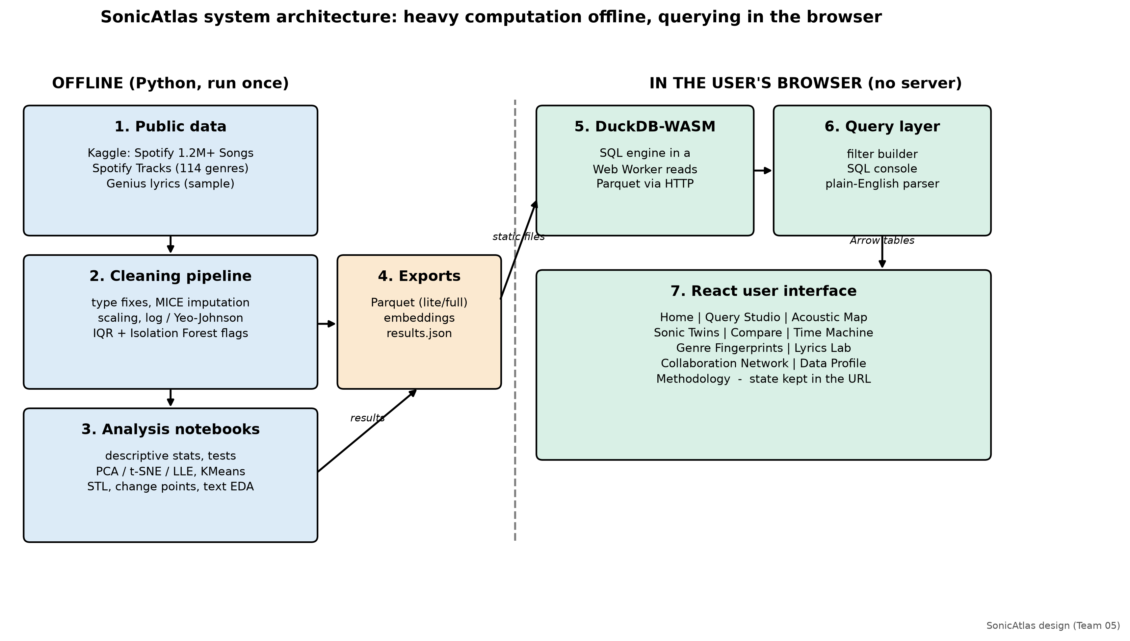
Fig. 1. SonicAtlas architecture: offline Python pipeline and in-browser query engine.
VI. RESULTS AND DISCUSSION
Structure of the feature space. Fig. 2 shows the correlation structure. Loudness and energy are tightly coupled (r = 0.82) and energy opposes acousticness (r = -0.80); Spearman coefficients agree, so the relations are monotonic. PCA concentrates 33.5% of the variance in an electric-versus-acoustic first component and needs 7 components for 90%.
Embeddings. Table II compares the four methods and Fig. 3 shows the maps. t-SNE keeps local neighbourhoods best (trustworthiness 0.976), UMAP is close (0.947) and LLE is weakest (0.671). Silhouette scores computed with genre labels are negative for every method and in the original space (-0.029), showing that genre is only partly encoded by the descriptors. KMeans with six clusters yields interpretable groups (Table III, Fig. 4), while HDBSCAN labels 65% of points as noise, consistent with a continuum.
Temporal dynamics. Fig. 5 shows the yearly trends and Fig. 6 the detected change points. Mean loudness rose from -17.4 dB in 1959 to -9.7 dB in 2020, with breaks in 1989, 1999 that coincide with the period of aggressive CD mastering; energy and acousticness break in 2004. The ARIMA forecast of loudness reaches an MAE of 0.58 dB, practically equal to the naive baseline (0.59 dB), because loudness plateaued after 2010. STL finds modest seasonality in valence (strength 0.40).
Genre tests. One-way ANOVA rejects equal mean danceability across eight genres (F(7, 4,855) = 512.1, p < 0.001, eta squared = 0.425), Tukey HSD separates 26 of 28 pairs, and Kruskal-Wallis agrees. Mode depends on genre (chi-square = 539.4, V = 0.333), with country the most major-key genre; Table IV collects the tests. With more than a million rows even tiny effects become significant, so we interpret effect sizes: the genre effect on danceability is large, while the drift of mode across decades (V = 0.054) is negligible. Acousticness and loudness lead the filter and wrapper rankings alike.
Lyrics. In 161,401 English songs the median lyric has 243 words and repeats 24% of its lines. VADER and TextBlob agree on polarity for 71.0% of songs (r = 0.48). Country lyrics are the most positive and rap the most negative. For the 1,202 songs linked to audio descriptors, lyric sentiment and valence correlate at only r = 0.06, so words and sound carry largely independent emotional information (Fig. 7).
Automated EDA tools. YData-Profiling, Sweetviz and D-Tale produced their outputs in 5, 6 and 4 s and caught skew and correlation, but none flagged the physically impossible tempo values or performed tests, embeddings or decomposition.
Website. The platform passes 65 unit and 8 end-to-end tests, answers a SQL console query in 4.7 ms on the lite data, and scores 98-99 (performance) and 100 (accessibility, best practice, SEO) in Lighthouse audits of four pages.
TABLE II
COMPARISON OF DIMENSIONALITY-REDUCTION METHODS
Method | Time (s) | Trust. | Silh.
PCA | 0.0 | 0.779 | -0.085
t-SNE | 49.8 | 0.976 | -0.061
LLE | 42.4 | 0.671 | -0.140
UMAP | 32.2 | 0.947 | -0.055
Original 10-D | 0.0 | 1.000 | -0.029
TABLE III
NAMED KMEANS CLUSTERS (K = 6)
Cluster | Share | Energy | Acoust. | Speech.
Live recordings | 6.2% | 0.67 | 0.33 | 0.09
Upbeat danceable pop | 28.5% | 0.68 | 0.23 | 0.08
Soft acoustic songs | 20.5% | 0.28 | 0.76 | 0.05
Loud & intense (rock/metal) | 21.9% | 0.76 | 0.09 | 0.07
Quiet acoustic instrumentals | 18.7% | 0.14 | 0.88 | 0.05
Spoken word & rap | 4.2% | 0.54 | 0.42 | 0.52
TABLE IV
SUMMARY OF HYPOTHESIS TESTS
Test | Statistic | p | Effect
ANOVA (danceability) | F = 512.1 | < 0.001 | eta2 = 0.425
Kruskal-Wallis | H = 2061 | < 0.001 | eps2 = 0.423
Chi-sq mode x genre | 539.4 | < 0.001 | V = 0.333
Chi-sq mode x decade | 3089 | < 0.001 | V = 0.054
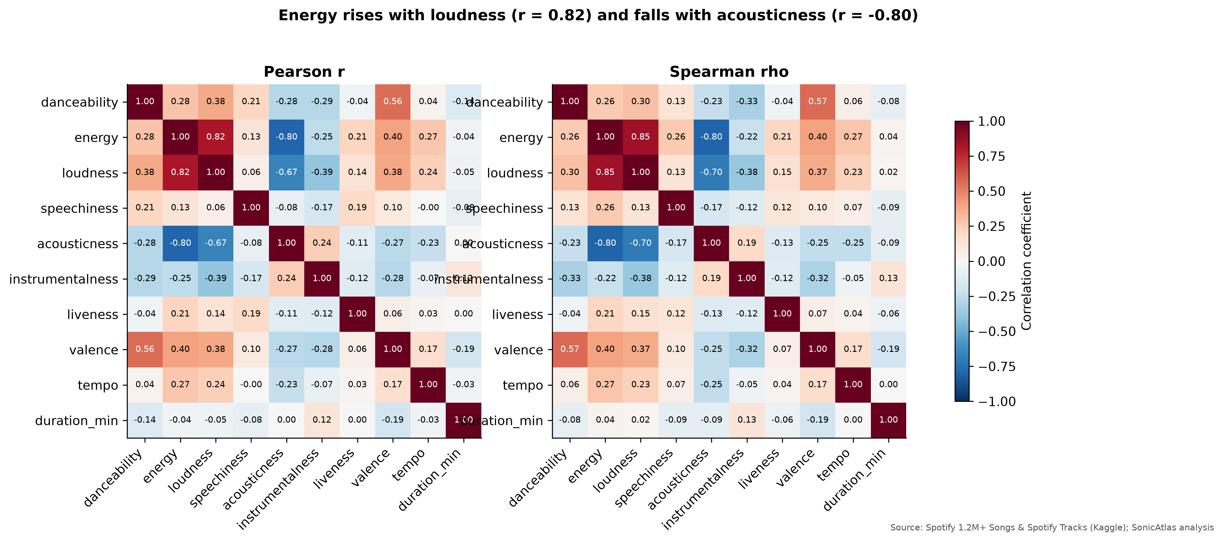
Fig. 2. Pearson (left) and Spearman (right) correlation matrices of ten audio descriptors.
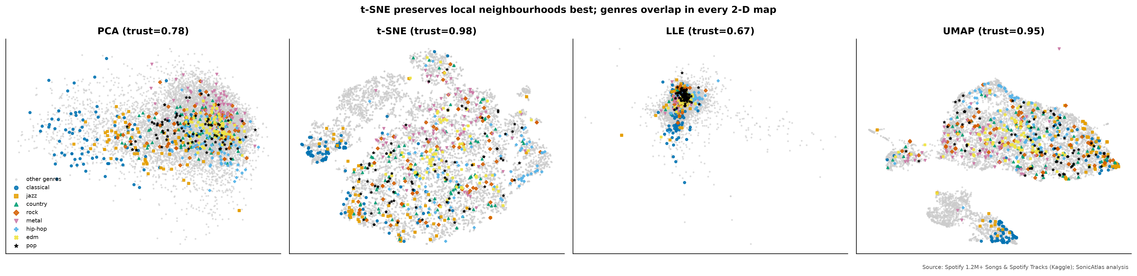
Fig. 3. PCA, t-SNE, LLE and UMAP projections of a genre-stratified 10,000-track sample; eight genres highlighted.
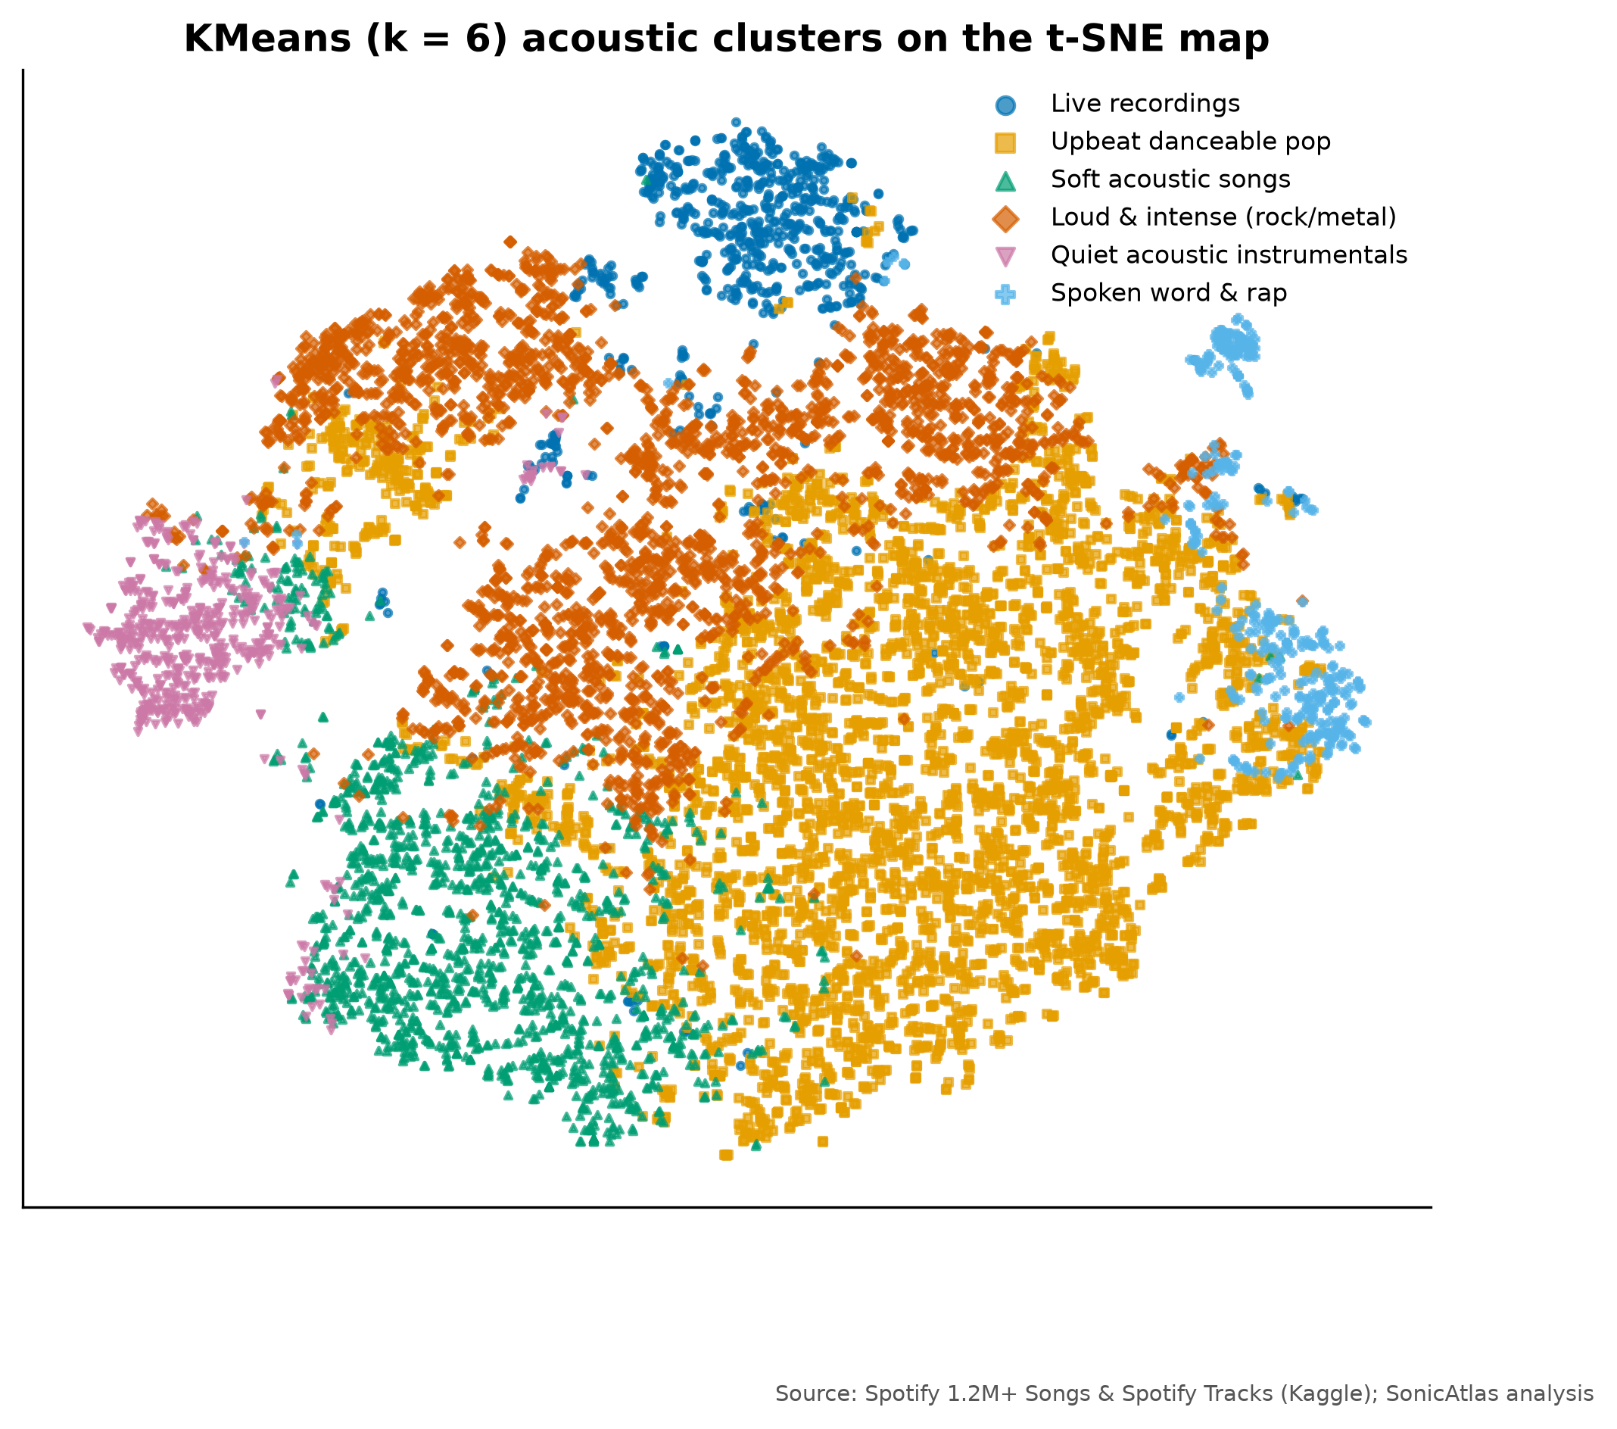
Fig. 4. Six named KMeans clusters on the t-SNE map of 10,000 tracks.
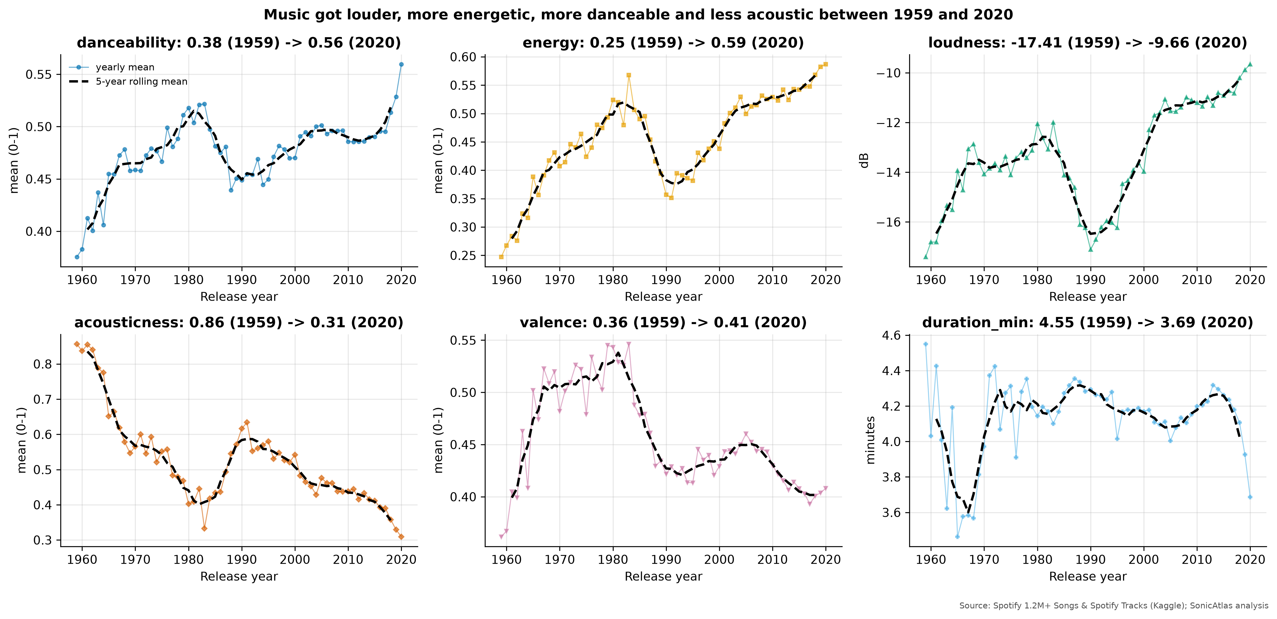
Fig. 5. Yearly means (thin) and 5-year rolling means (dashed) of six descriptors.
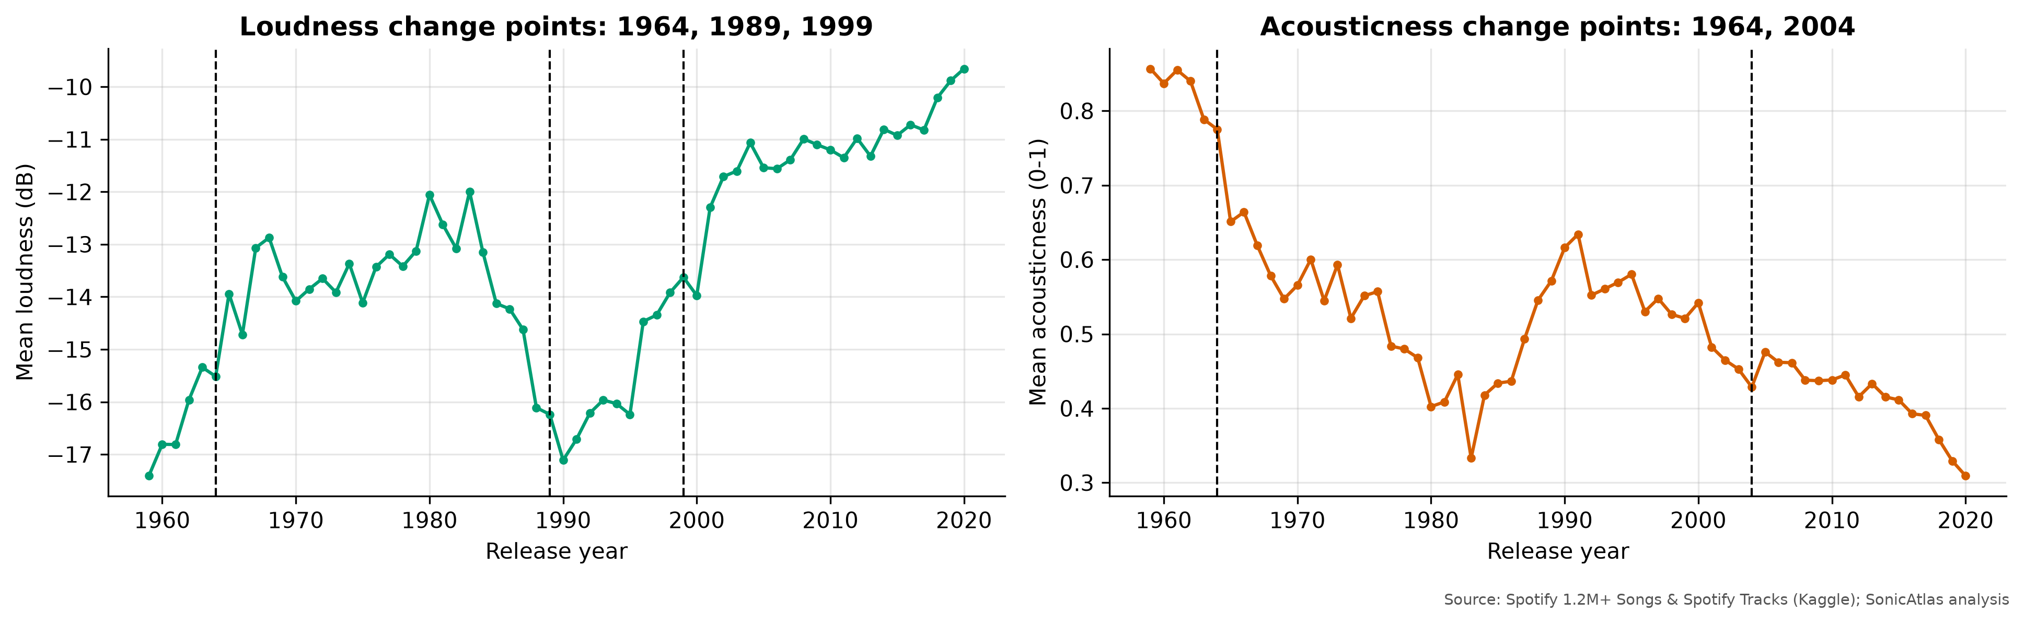
Fig. 6. PELT change points in yearly loudness and acousticness.
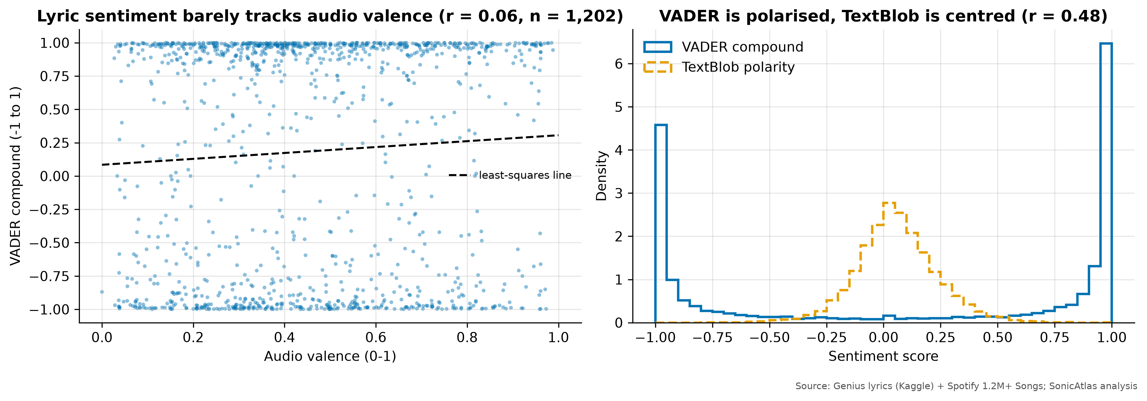
Fig. 7. Lyric sentiment versus audio valence (left) and VADER versus TextBlob score distributions (right).
VII. CONCLUSION AND FUTURE WORK
SonicAtlas shows that a careful, documented treatment of open music descriptors changes what can be said about them: impossible values and re-issues are common enough to matter, genre labels overlap far more than charts usually suggest, and the most robust temporal story is a rise in loudness and energy together with a decline of acoustic sound. Delivering the results through an in-browser SQL engine lets readers verify and extend each finding without installing anything.
Limitations include the proprietary nature of the descriptors, the catalogue's bias towards recent releases, the low match rate between sources and the English-only lyrics sample. Future work will add open audio features, multilingual lyrics and a user study comparing task completion in SonicAtlas and in notebooks.
ACKNOWLEDGMENT
The authors thank Vellore Institute of Technology, Vellore, and the faculty of the BACSE301 Exploratory Data Analysis course for their guidance, and the creators of the public datasets and open-source libraries used here.
REFERENCES
[1] J. Serrà, Á. Corral, M. Boguñá, M. Haro, J. Ll. Arcos, “Measuring the Evolution of Contemporary Western Popular Music,” Scientific Reports, vol. 2, Art. no. 521, Jul. 2012, doi: 10.1038/srep00521.
[2] M. Mauch, R. M. MacCallum, M. Levy, A. M. Leroi, “The evolution of popular music: USA 1960-2010,” Royal Society Open Science, vol. 2, no. 5, Art. no. 150081, 2015, doi: 10.1098/rsos.150081.
[3] M. Interiano, K. Kazemi, L. Wang, J. Yang, Z. Yu, N. L. Komarova, “Musical trends and predictability of success in contemporary songs in and out of the top charts,” Royal Society Open Science, vol. 5, no. 5, Art. no. 171274, 2018, doi: 10.1098/rsos.171274.
[4] N. Askin, M. Mauskapf, “What Makes Popular Culture Popular? Product Features and Optimal Differentiation in Music,” American Sociological Review, vol. 82, no. 5, pp. 910-944, Oct. 2017, doi: 10.1177/0003122417728662.
[5] T. Bertin-Mahieux, D. P. W. Ellis, B. Whitman, P. Lamere, “The Million Song Dataset,” Proc. 12th International Society for Music Information Retrieval Conference (ISMIR 2011), Miami, FL, USA, pp. 591-596, 2011. [Online]. Available: https://ismir2011.ismir.net/papers/OS6-1.pdf
[6] G. Tzanetakis, P. Cook, “Musical genre classification of audio signals,” IEEE Transactions on Speech and Audio Processing, vol. 10, no. 5, pp. 293-302, Jul. 2002, doi: 10.1109/TSA.2002.800560.
[7] A. van den Oord, S. Dieleman, B. Schrauwen, “Deep content-based music recommendation,” Advances in Neural Information Processing Systems 26 (NIPS 2013), 2013. [Online]. Available: https://papers.nips.cc/paper_files/paper/2013/hash/b3ba8f1bee1238a2f37603d90b58898d-Abstract.html
[8] C. O. Brand, A. Acerbi, A. Mesoudi, “Cultural evolution of emotional expression in 50 years of song lyrics,” Evolutionary Human Sciences, vol. 1, Art. no. e11, 2019, doi: 10.1017/ehs.2019.11.
[9] C. Hutto, E. Gilbert, “VADER: A Parsimonious Rule-Based Model for Sentiment Analysis of Social Media Text,” Proc. International AAAI Conference on Web and Social Media (ICWSM), vol. 8, no. 1, pp. 216-225, 2014, doi: 10.1609/icwsm.v8i1.14550.
[10] M. Schedl, H. Zamani, C.-W. Chen, Y. Deldjoo, M. Elahi, “Current challenges and visions in music recommender systems research,” International Journal of Multimedia Information Retrieval, vol. 7, no. 2, pp. 95-116, Jun. 2018, doi: 10.1007/s13735-018-0154-2.
[11] I. T. Jolliffe, J. Cadima, “Principal component analysis: a review and recent developments,” Philosophical Transactions of the Royal Society A: Mathematical, Physical and Engineering Sciences, vol. 374, no. 2065, Art. no. 20150202, Apr. 2016, doi: 10.1098/rsta.2015.0202.
[12] S. T. Roweis, L. K. Saul, “Nonlinear Dimensionality Reduction by Locally Linear Embedding,” Science, vol. 290, no. 5500, pp. 2323-2326, Dec. 2000, doi: 10.1126/science.290.5500.2323.
[13] L. van der Maaten, G. Hinton, “Visualizing Data using t-SNE,” Journal of Machine Learning Research, vol. 9, no. 86, pp. 2579-2605, 2008. [Online]. Available: https://www.jmlr.org/papers/v9/vandermaaten08a.html
[14] L. McInnes, J. Healy, J. Melville, “UMAP: Uniform Manifold Approximation and Projection for Dimension Reduction,” arXiv preprint arXiv:1802.03426, 2018. [Online]. Available: https://arxiv.org/abs/1802.03426
[15] T. Milo, A. Somech, “Automating Exploratory Data Analysis via Machine Learning: An Overview,” Proc. 2020 ACM SIGMOD International Conference on Management of Data, Portland, OR, USA, pp. 2617-2622, 2020, doi: 10.1145/3318464.3383126.
[16] A. Satyanarayan, D. Moritz, K. Wongsuphasawat, J. Heer, “Vega-Lite: A Grammar of Interactive Graphics,” IEEE Transactions on Visualization and Computer Graphics, vol. 23, no. 1, pp. 341-350, Jan. 2017, doi: 10.1109/TVCG.2016.2599030.
[17] M. Raasveldt, H. Mühleisen, “DuckDB: an Embeddable Analytical Database,” Proc. 2019 International Conference on Management of Data (SIGMOD '19), Amsterdam, Netherlands, pp. 1981-1984, 2019, doi: 10.1145/3299869.3320212.
[18] A. Kohn, D. Moritz, M. Raasveldt, H. Mühleisen, T. Neumann, “DuckDB-Wasm: Fast Analytical Processing for the Web,” Proceedings of the VLDB Endowment, vol. 15, no. 12, pp. 3574-3577, Aug. 2022, doi: 10.14778/3554821.3554847.
[19] J. Heer, D. Moritz, “Mosaic: An Architecture for Scalable & Interoperable Data Views,” IEEE Transactions on Visualization and Computer Graphics, vol. 30, no. 1, 2024 (early access 2023), doi: 10.1109/TVCG.2023.3327189.
[20] D. H. da Silva, L. R. da Silva Souza, C. T. Ribeiro, S. H. da Silva Brasileiro, J. R. M. Nardo, A. A. Pereira, A. de O. Andrade, “A Web Application for exploratory data analysis and classification of Parkinson's Disease patients using machine learning models on different datasets,” Software Impacts, vol. 23, Art. no. 100737, Mar. 2025, doi: 10.1016/j.simpa.2024.100737.
[21] rodolfofigueroa (Kaggle user), “Spotify 1.2M+ Songs,” Kaggle dataset. [Online]. Available: https://www.kaggle.com/datasets/rodolfofigueroa/spotify-12m-songs
[22] maharshipandya (Kaggle user), “Spotify Tracks Dataset,” Kaggle dataset. [Online]. Available: https://www.kaggle.com/datasets/maharshipandya/-spotify-tracks-dataset
[23] carlosgdcj (Kaggle user), “Genius Song Lyrics,” Kaggle dataset. [Online]. Available: https://www.kaggle.com/datasets/carlosgdcj/genius-song-lyrics-with-language-information
[24] S. van Buuren, K. Groothuis-Oudshoorn, “mice: Multivariate Imputation by Chained Equations in R,” Journal of Statistical Software, vol. 45, no. 3, 2011, doi: 10.18637/jss.v045.i03.
[25] F. T. Liu, K. M. Ting, Z.-H. Zhou, “Isolation Forest,” Proc. 2008 Eighth IEEE International Conference on Data Mining (ICDM), Pisa, Italy, pp. 413-422, 2008, doi: 10.1109/ICDM.2008.17.
[26] R. B. Cleveland, W. S. Cleveland, J. E. McRae, I. Terpenning, “STL: A Seasonal-Trend Decomposition Procedure Based on Loess,” Journal of Official Statistics, vol. 6, no. 1, pp. 3-73, 1990. [Online]. Available: https://www.statsmodels.org/dev/generated/statsmodels.tsa.seasonal.STL.html
[27] C. Truong, L. Oudre, N. Vayatis, “Selective review of offline change point detection methods,” Signal Processing, vol. 167, Art. no. 107299, Feb. 2020, doi: 10.1016/j.sigpro.2019.107299.
[28] S. Loria, “TextBlob: Simplified Text Processing (documentation),” Open-source Python library, docs at textblob.readthedocs.io (v0.20.1 on PyPI at time of check). [Online]. Available: https://textblob.readthedocs.io/en/dev/
[29] W. McKinney, “Data Structures for Statistical Computing in Python,” Proc. Python in Science Conference (SciPy 2010), pp. 56-61, 2010, doi: 10.25080/Majora-92bf1922-00a.
[30] F. Pedregosa, G. Varoquaux, A. Gramfort, V. Michel, B. Thirion, O. Grisel, M. Blondel, P. Prettenhofer, R. Weiss, V. Dubourg, J. Vanderplas, A. Passos, D. Cournapeau, M. Brucher, M. Perrot, É. Duchesnay, “Scikit-learn: Machine Learning in Python,” Journal of Machine Learning Research, vol. 12, no. 85, pp. 2825-2830, 2011. [Online]. Available: https://jmlr.org/papers/v12/pedregosa11a.html

