SonicAtlas: An Interactive In-Browser Exploratory Data Analysis Platform for Multi-Dimensional Audio Features and Lyrics of Spotify Tracks Across Genres and Eras
Submitted by
25BDS0318 Sharvesh Prabhu
25BDS0308 Nithin S
In partial fulfillment of the requirements for the completion of the
Project-based Course
BACSE301 EXPLORATORY DATA ANALYSIS
[Paste official VIT logo here]
SCHOOL OF COMPUTER SCIENCE AND ENGINEERING
VELLORE INSTITUTE OF TECHNOLOGY, VELLORE
October 2026

TABLE OF CONTENTS
Sl.No | Contents | Page No.
1. | ABSTRACT | 3
2. | INTRODUCTION | 4
 | 2.1 Background | 4
 | 2.2 Motivations | 4
 | 2.3 Scope of the Project | 5
3. | PROJECT DESCRIPTION AND GOALS | 6
 | 3.1 Literature Review | 6
 | 3.2 Gaps Identified | 11
 | 3.3 Objectives | 11
 | 3.4 Problem Statement | 12
4. | PROPOSED WORK | 13
 | 4.1 Data Acquisition, Cleaning and Preprocessing of Large-Scale Spotify Audio and Lyrics Data | 13
 | 4.2 Descriptive Statistics, Multivariate Visual Storytelling, Dimensionality Reduction and Time-Series Dynamics of Musical Characteristics | 17
 | 4.3 The SonicAtlas Interactive Query Platform: Architecture, Text Mining, Hypothesis Testing and Evaluation Framework | 30
5. | CONCLUSION | 38
6. | PROJECT OUTCOME | 39
7. | REFERENCES | 40

1. ABSTRACT
Streaming platforms describe every track with a vector of model-derived audio descriptors, yet most public analyses of these descriptors stay inside static notebooks that only their authors can explore. This project presents SonicAtlas, an exploratory data analysis (EDA) study and an in-browser query platform built on 1,204,025 Spotify tracks released between 1900 and 2020, a genre-labelled table of 89,740 unique tracks across 114 genres, and a sample of Genius lyrics. Impossible values were repaired with MICE imputation, skewed fields were transformed, and outliers were flagged rather than removed. Descriptive statistics follow the course conventions (n-1 variance, Tukey quartiles, G1 and G2). Energy is tightly tied to loudness (r = 0.82) and opposed to acousticness (r = -0.80). Between 1959 and 2020 mean loudness rose from -17.4 dB to -9.7 dB while acousticness fell from 0.86 to 0.31. PCA needs 7 components for 90% of the variance; t-SNE keeps local structure best (trustworthiness 0.98). Genre explains 42.5% of the variance in danceability (ANOVA, p < 0.001). All results are served through a static website that runs SQL on Parquet files inside the browser with DuckDB-WASM.
Keywords: exploratory data analysis, Spotify audio features, dimensionality reduction, time series, lyrics mining, DuckDB-WASM, interactive visual analytics

2. INTRODUCTION

2.1 Background
Digital music services now hold catalogues of tens of millions of recordings. To organise and recommend this material, Spotify and similar services compute numerical descriptors for each recording: danceability, energy, valence (musical positivity), acousticness, instrumentalness, speechiness, liveness, loudness in decibels, tempo in beats per minute, key, mode and duration. Until late 2024 these values were available through a public Web API, and researchers and hobbyists collected them into large open tables that are still shared on Kaggle. Because the audio-features endpoint is no longer open to new applications, these archived tables have become the main public window onto the acoustic profile of recorded music.
Musicologists and data scientists have used such descriptors to ask how popular music has changed over time [9], [10], whether success can be predicted from sound [6], [7], and how genres differ [3], [4]. Lyrics add a second, textual view of the same songs; sentiment tools such as VADER [11] make it possible to compare the emotion of the words with the emotion of the sound. Exploratory Data Analysis, the practice of summarising and visualising data before building models, is the natural framework for this kind of open-ended question, and modern dimensionality-reduction methods such as PCA, t-SNE and LLE [16], [17], [18] allow a ten-dimensional audio space to be drawn as a readable map.

2.2 Motivations
Three observations motivated this project. First, most published analyses of Spotify features are static: a paper or notebook shows a fixed set of charts, and a reader who wants a different genre, decade or feature has to download the data and repeat the work. Second, automated EDA tools such as YData-Profiling, Sweetviz and D-Tale [29], [30], [31], [42] produce useful overviews but know nothing about music, so they cannot answer domain questions such as “when did recorded music become louder?”. Third, a browser-based analytical database (DuckDB compiled to WebAssembly) now makes it possible to run SQL over hundreds of thousands of rows on the reader’s own laptop with no server, which removes the hosting cost that usually stops student projects from becoming shared tools.
The course itself provided a further motivation. The BACSE301 syllabus covers descriptive statistics, correlation, multivariate plots (parallel coordinates and Andrews curves), PCA, SVD, t-SNE, LLE and time-series decomposition. A music catalogue exercises every one of these techniques on real, messy, large-scale data, and the faculty’s reading on a Streamlit-based EDA web application [25] showed that packaging an analysis as an interactive application is itself a recognised research contribution.

2.3 Scope of the Project
The project covers the full path from public raw files to a published, queryable tool. Its scope is organised into three core areas: (i) data engineering, which includes acquisition of three public Kaggle datasets, auditing, type conversion, MICE imputation of impossible values, transformation, scaling, outlier flagging and joining genre labels to the main catalogue; (ii) statistical and visual exploration, which includes descriptive statistics in the course conventions, correlation analysis, multivariate genre fingerprints, PCA/SVD, t-SNE, LLE and UMAP maps, clustering, time-series trend, seasonality and change-point analysis, hypothesis tests, feature selection and lyrics text mining; and (iii) the SonicAtlas platform, a static web application in which users filter, query, compare and map the data inside their own browser.
The project does not collect new audio, does not call the restricted Spotify Web API, and does not train a production recommender. Spotify’s descriptors are themselves outputs of proprietary models, so all conclusions are about these descriptors rather than about the underlying sound waves.

3. PROJECT DESCRIPTION AND GOALS

3.1 Literature Review
The review below covers 25 published works that were opened and checked through their DOI, arXiv or publisher pages; candidate papers were located with the research-discovery tools listed in the course handout [43], and the serial number of each row in the table equals its reference number in Section 7. They span audio-feature analysis, genre classification, popularity and trend studies, the long-term evolution of loudness and timbre, lyrics sentiment, recommendation, dimensionality reduction, automated EDA and in-browser analytics. TABLE I summarises each work, why it matters for SonicAtlas, and the drawback that SonicAtlas tries to address.
Sr. No | Author's Name | Title of Paper | Journal Name and link | Why this paper matters? | Description of their Work | Drawbacks Found in that
1 | T. Bertin-Mahieux, D. P. W. Ellis, B. Whitman, P. Lamere | The Million Song Dataset | Proc. 12th International Society for Music Information Retrieval Conference (ISMIR 2011), Miami, FL, USA, pp. 591-596, 2011 https://ismir2011.ismir.net/papers/OS6-1.pdf | It is the large-scale ancestor of the Echo Nest/Spotify-style audio descriptors (loudness, tempo, timbre) that SonicAtlas profiles across genres and eras. | The authors release a free collection of pre-computed audio features and metadata for one million commercial popular-music tracks and describe how it was assembled and linked to other resources. As a showcase they predict a track's release year from its audio descriptors and report encouraging results. | Raw audio is not distributed and the features are frozen Echo Nest outputs, so the paper offers a dataset rather than any exploratory or interactive analysis of it.
2 | R. Panda, R. Malheiro, R. P. Paiva | Novel Audio Features for Music Emotion Recognition | IEEE Transactions on Affective Computing, vol. 11, no. 4, pp. 614-626, 2020 https://doi.org/10.1109/TAFFC.2018.2820691 | It links low-level audio descriptors to perceived emotion, which helps interpret Spotify's valence and energy fields that SonicAtlas maps. | The work audits which musical concepts existing feature extractors miss and proposes new descriptors for texture and expressive technique, evaluated on a new 900-clip dataset labelled by Russell's emotion quadrants. Adding the new features raised the F1-score of emotion classification by roughly nine points over a baseline-only feature set. | The dataset is small (900 clips) and focused on classification accuracy; it does not study genre or decade trends and provides no exploratory tool.
3 | G. Tzanetakis, P. Cook | Musical genre classification of audio signals | IEEE Transactions on Speech and Audio Processing, vol. 10, no. 5, pp. 293-302, Jul. 2002 https://doi.org/10.1109/TSA.2002.800560 | It is the canonical baseline showing that hand-crafted timbre, rhythm and pitch features separate genres, the same premise behind SonicAtlas's genre comparisons. | The paper proposes three feature families describing timbral texture, rhythmic content and pitch content, and uses them to classify audio into a hierarchy of genres. It analyses how much each feature set contributes and introduced the dataset later known as GTZAN. | It works on a few hundred short clips and reports classifier accuracy only, with no temporal (era) analysis, lyrics, or interactive exploration.
4 | K. Choi, G. Fazekas, M. Sandler, K. Cho | Convolutional recurrent neural networks for music classification | Proc. 2017 IEEE International Conference on Acoustics, Speech and Signal Processing (ICASSP), New Orleans, LA, USA, pp. 2392-2396, 2017 https://doi.org/10.1109/ICASSP.2017.7952585 | It represents the deep-learning route to genre/tag prediction that SonicAtlas contrasts with its transparent, feature-level EDA. | The authors combine convolutional layers for local feature extraction with recurrent layers that summarise the sequence over time for music tagging. Compared with three CNN designs at matched parameter counts, the hybrid model gave strong accuracy for its size and training cost. | The models learn opaque representations from spectrograms, which makes it hard to explain which musical properties drive a genre label, and no exploratory interface is offered.
5 | B. L. Sturm | The GTZAN dataset: Its contents, its faults, their effects on evaluation, and its future use | arXiv preprint arXiv:1306.1461, 2013 https://arxiv.org/abs/1306.1461 | It warns that genre datasets contain duplicates and mislabels, motivating the data-quality and duplicate checks SonicAtlas runs before comparing genres. | Sturm catalogues the repetitions, mislabelled excerpts and distortions in GTZAN and surveys how often prior work used it without noticing. He shows the faults change the evaluation of several genre-recognition systems in different ways and argues for careful rather than blind use of the dataset. | It is a critique of one small benchmark and does not provide tools for auditing large Spotify-scale tables interactively.
6 | M. Interiano, K. Kazemi, L. Wang, J. Yang, Z. Yu, N. L. Komarova | Musical trends and predictability of success in contemporary songs in and out of the top charts | Royal Society Open Science, vol. 5, no. 5, Art. no. 171274, 2018 https://doi.org/10.1098/rsos.171274 | It is the closest prior study to SonicAtlas, tracking acoustic descriptors across three decades and relating them to chart success. | Using over half a million UK releases from 1985-2015, the authors find long-term declines in 'happiness' and 'brightness' and a small rise in 'sadness', while chart hits tend to be happier, more party-like and less relaxed than typical releases. They then train random-forest models on acoustic features to estimate how predictable chart success is. | Findings are reported as static figures for one market, without lyrics content or an interactive environment for others to re-slice the data.
7 | N. Askin, M. Mauskapf | What Makes Popular Culture Popular? Product Features and Optimal Differentiation in Music | American Sociological Review, vol. 82, no. 5, pp. 910-944, Oct. 2017 https://doi.org/10.1177/0003122417728662 | It shows that a song's position in audio-feature space relative to its peers matters for success, supporting SonicAtlas's similarity-map view. | Building audio-feature profiles for about 27,000 Billboard Hot 100 songs, the authors test whether feature-space typicality predicts chart performance beyond artist and label effects. They find that songs that are somewhat, but not overly, distinct from contemporaries do best. | The analysis is a regression study on chart songs only, so non-hits, lyrics and interactive exploration are outside its scope.
8 | D. Herremans, D. Martens, K. Sörensen | Dance Hit Song Prediction | Journal of New Music Research, vol. 43, no. 3, pp. 291-302, 2014 https://doi.org/10.1080/09298215.2014.881888 | It is a reference point for using audio descriptors to separate hits from non-hits within a single genre, a slice SonicAtlas can reproduce. | The authors assemble dance chart songs from 1985 to 2013 with basic and temporally aware audio features and compare several classifiers. Their best model distinguishes top-10 dance hits from lower-ranked entries reasonably well. | It covers only one genre and frames popularity as binary classification, offering no cross-genre, cross-era or lyrics perspective.
9 | J. Serrà, Á. Corral, M. Boguñá, M. Haro, J. Ll. Arcos | Measuring the Evolution of Contemporary Western Popular Music | Scientific Reports, vol. 2, Art. no. 521, Jul. 2012 https://doi.org/10.1038/srep00521 | It provides the headline 'louder and more homogeneous' finding that SonicAtlas can check with Spotify loudness and timbre-like features by decade. | Analysing pitch, timbre and loudness descriptors over more than fifty years of Western pop, the authors find many statistical regularities are stable. They nonetheless report narrower pitch transitions, a more uniform timbral palette and steadily rising loudness. | It relies on Million Song Dataset descriptors and static plots, without genre-level breakdowns, lyrics, or an interactive way to verify the trends.
10 | M. Mauch, R. M. MacCallum, M. Levy, A. M. Leroi | The evolution of popular music: USA 1960-2010 | Royal Society Open Science, vol. 2, no. 5, Art. no. 150081, 2015 https://doi.org/10.1098/rsos.150081 | It models stylistic change and diversity across decades, directly informing SonicAtlas's era-level comparisons and change-point view. | Studying about 17,000 Billboard Hot 100 recordings, the authors extract harmonic and timbral topics, cluster songs into audio-based styles and measure diversity over time. They test classic theories of cultural change against measured diversity and find that evolution was largely continuous yet interrupted by a small number of rapid stylistic shifts. | Only US chart songs from 30-second previews are used and results are static; lyrics and non-chart music are not examined.
11 | C. Hutto, E. Gilbert | VADER: A Parsimonious Rule-Based Model for Sentiment Analysis of Social Media Text | Proc. International AAAI Conference on Web and Social Media (ICWSM), vol. 8, no. 1, pp. 216-225, 2014 https://doi.org/10.1609/icwsm.v8i1.14550 | VADER is a lightweight lexicon scorer suitable for computing lyric sentiment over many songs, one of the options SonicAtlas uses or compares against TextBlob. | The authors build and validate a sentiment lexicon with intensity scores and add grammatical rules for cues such as negation, capitalisation and punctuation. The resulting model rivals or beats eleven established lexicon and machine-learning baselines on short social-media text. | It was tuned on tweets and reviews, not poetic or slang-heavy lyrics, and handles only English, so lyric scores need caution.
12 | C. O. Brand, A. Acerbi, A. Mesoudi | Cultural evolution of emotional expression in 50 years of song lyrics | Evolutionary Human Sciences, vol. 1, Art. no. e11, 2019 https://doi.org/10.1017/ehs.2019.11 | It documents rising negativity in pop lyrics over 1965-2015, a trend SonicAtlas can test against lyric sentiment by decade. | Using two lyric corpora (about 4,900 chart songs and 159,000 songs) spanning 1965-2015, the authors test whether cultural-transmission biases explain the growth of negative emotional content. Negative lyrics fare somewhat better in charts, but much of the trend is explained by unbiased copying of past frequencies. | Audio features are not considered alongside the text, and the study is a modelling paper with no exploratory interface. Note: it appeared in Evolutionary Human Sciences, not Scientific Reports.
13 | M. Fell, C. Sporleder | Lyrics-based Analysis and Classification of Music | Proc. COLING 2014, the 25th International Conference on Computational Linguistics: Technical Papers, Dublin, Ireland, pp. 620-631, Aug. 2014 https://aclanthology.org/C14-1059/ | Its stylistic lyric features (vocabulary, style, semantics, structure) suggest which text statistics SonicAtlas can profile per genre and era. | The authors design lyric features capturing vocabulary, style, semantics, world orientation and song structure and combine them with n-gram models. The combination improves three tasks: genre detection, separating best from worst songs, and estimating publication period. | It uses lyrics only, ignoring audio features, and reports classification results rather than exploratory visual analysis.
14 | A. van den Oord, S. Dieleman, B. Schrauwen | Deep content-based music recommendation | Advances in Neural Information Processing Systems 26 (NIPS 2013), 2013 https://papers.nips.cc/paper_files/paper/2013/hash/b3ba8f1bee1238a2f37603d90b58898d-Abstract.html | It motivates content-based similarity from audio, which SonicAtlas offers as a nearest-neighbour 'songs like this' view over Spotify features. | To tackle the cold-start problem, the authors predict collaborative-filtering latent factors directly from audio, comparing bag-of-words audio features with deep CNNs on the Million Song Dataset. Predicted factors yield sensible recommendations and CNNs clearly outperform the traditional pipeline. | It targets recommendation accuracy with learned black-box embeddings, not interpretable exploration of features, and uses no lyrics.
15 | M. Schedl, H. Zamani, C.-W. Chen, Y. Deldjoo, M. Elahi | Current challenges and visions in music recommender systems research | International Journal of Multimedia Information Retrieval, vol. 7, no. 2, pp. 95-116, Jun. 2018 https://doi.org/10.1007/s13735-018-0154-2 | It frames why richer content descriptors (audio, lyrics, context) matter for music discovery, positioning SonicAtlas's multimodal EDA as groundwork. | This survey identifies the most pressing open problems for music recommenders from academic and industry viewpoints and reviews the state of the art for each. It then outlines future directions centred on listener intent, context and going beyond simple user-item signals. | As a survey it offers no new data analysis or tool; it discusses recommender evaluation rather than exploratory understanding of catalogues.
16 | L. van der Maaten, G. Hinton | Visualizing Data using t-SNE | Journal of Machine Learning Research, vol. 9, no. 86, pp. 2579-2605, 2008 https://www.jmlr.org/papers/v9/vandermaaten08a.html | t-SNE is one of the embedding options for SonicAtlas's 2-D 'sound map' of tracks. | The authors present a variant of Stochastic Neighbor Embedding that is easier to optimise and reduces the crowding of points in the map centre. It reveals structure at several scales and outperforms methods such as Sammon mapping, Isomap and LLE on many datasets. | Distances between clusters and global layout are not reliable, and the method scales poorly to millions of points without approximation, so maps need careful reading.
17 | S. T. Roweis, L. K. Saul | Nonlinear Dimensionality Reduction by Locally Linear Embedding | Science, vol. 290, no. 5500, pp. 2323-2326, Dec. 2000 https://doi.org/10.1126/science.290.5500.2323 | LLE is a classic manifold-learning baseline that SonicAtlas can cite when justifying non-linear maps over PCA. | LLE reconstructs each point from its neighbours with linear weights and then finds a low-dimensional embedding that preserves those weights. Because it avoids local minima and keeps neighbourhoods, it recovers the global structure of non-linear manifolds such as face images and text. | It is sensitive to the neighbourhood size and noise and is rarely used at the scale of million-track catalogues.
18 | L. McInnes, J. Healy, J. Melville | UMAP: Uniform Manifold Approximation and Projection for Dimension Reduction | arXiv preprint arXiv:1802.03426, 2018 https://arxiv.org/abs/1802.03426 | UMAP is a fast, scalable choice for precomputing the 2-D track map that SonicAtlas ships to the browser. | UMAP derives a manifold-learning algorithm from Riemannian geometry and algebraic topology and turns it into a practical, scalable method. It matches t-SNE's visual quality, arguably keeps more global structure, runs faster and supports any embedding dimension. | Embeddings depend on hyperparameters and random seeds and are still not distance-faithful, so cluster positions must not be over-interpreted.
19 | I. T. Jolliffe, J. Cadima | Principal component analysis: a review and recent developments | Philosophical Transactions of the Royal Society A: Mathematical, Physical and Engineering Sciences, vol. 374, no. 2065, Art. no. 20150202, Apr. 2016 https://doi.org/10.1098/rsta.2015.0202 | PCA gives SonicAtlas an interpretable linear baseline, with loadings that explain which audio features drive the map axes. | The review explains how PCA builds uncorrelated components that successively capture maximum variance via an eigen-decomposition. It then surveys adaptations of PCA for different data types and structures and discusses what the method can and cannot do. | Being linear, PCA can miss non-linear genre structure that t-SNE or UMAP reveal; the paper is methodological and has no music application.
20 | T. Milo, A. Somech | Automating Exploratory Data Analysis via Machine Learning: An Overview | Proc. 2020 ACM SIGMOD International Conference on Management of Data, Portland, OR, USA, pp. 2617-2622, 2020 https://doi.org/10.1145/3318464.3383126 | It situates SonicAtlas's automatic profiling and suggested views within the broader field of machine-assisted EDA. | This tutorial-style overview reviews the many systems built over the past decade to ease EDA, an iterative process of filtering, aggregating and visualising unfamiliar data. It organises them around how machine learning is used to recommend or automate the next analysis steps. | It is a survey for database researchers and is domain-agnostic, so it gives no guidance on music data or on running EDA fully in the browser.
21 | K. Wongsuphasawat, D. Moritz, A. Anand, J. Mackinlay, B. Howe, J. Heer | Voyager: Exploratory Analysis via Faceted Browsing of Visualization Recommendations | IEEE Transactions on Visualization and Computer Graphics, vol. 22, no. 1, pp. 649-658, Jan. 2016 https://doi.org/10.1109/TVCG.2015.2467191 | Its recommended-chart gallery is a model for SonicAtlas's auto-generated univariate and bivariate views. | Voyager complements manual chart building with a browsable gallery of automatically generated visualisations ranked by statistical and perceptual criteria. In a user study it helped analysts examine more variables of unfamiliar data than a manual specification tool. | It is a general tool evaluated on small tables, not tuned for million-row music datasets or text features like lyrics.
22 | M. Raasveldt, H. Mühleisen | DuckDB: an Embeddable Analytical Database | Proc. 2019 International Conference on Management of Data (SIGMOD '19), Amsterdam, Netherlands, pp. 1981-1984, 2019 https://doi.org/10.1145/3299869.3320212 | DuckDB is the analytical engine underneath SonicAtlas, compiled to WebAssembly for the browser. | The demo introduces DuckDB, an in-process database built for analytical SQL in the way SQLite serves transactional workloads. The authors benchmark it against other data-management systems in embedded-analytics scenarios and release it as open source. | It is a short systems demo with no visual-analytics layer and no in-browser deployment, which SonicAtlas has to add.
23 | J. Heer, D. Moritz | Mosaic: An Architecture for Scalable & Interoperable Data Views | IEEE Transactions on Visualization and Computer Graphics, vol. 30, no. 1, 2024 (early access 2023) https://doi.org/10.1109/TVCG.2023.3327189 | Mosaic shows how linked, cross-filtered views can push queries to DuckDB, the architecture SonicAtlas follows for interactive exploration. | Mosaic separates data processing from view specification: components publish declarative queries to a coordinator that optimises them against a scalable store such as DuckDB. Benchmarks show order-of-magnitude speed-ups over prior web visualisation systems, enabling real-time exploration of billion-row data. | It is a general architecture without domain analyses; it offers no ready-made EDA workflow for audio features or lyrics.
24 | A. Satyanarayan, D. Moritz, K. Wongsuphasawat, J. Heer | Vega-Lite: A Grammar of Interactive Graphics | IEEE Transactions on Visualization and Computer Graphics, vol. 23, no. 1, pp. 341-350, Jan. 2017 https://doi.org/10.1109/TVCG.2016.2599030 | Vega-Lite's declarative charts and selections are a natural specification layer for SonicAtlas's interactive plots. | Vega-Lite pairs a grammar of graphics for encodings and multi-view composition with a grammar of interaction built on composable selections. A compiler generates the data flow and event handling, letting concise specifications express panning, zooming, brushing and linking. | Rendering all data client-side becomes slow for very large tables unless paired with a database backend, and it provides no automated EDA logic.
25 | D. H. da Silva, L. R. da Silva Souza, C. T. Ribeiro, S. H. da Silva Brasileiro, J. R. M. Nardo, A. A. Pereira, A. de O. Andrade | A Web Application for exploratory data analysis and classification of Parkinson's Disease patients using machine learning models on different datasets | Software Impacts, vol. 23, Art. no. 100737, Mar. 2025 https://doi.org/10.1016/j.simpa.2024.100737 | It is a published example of packaging EDA plus machine learning as an accessible web application, the same deliverable style as SonicAtlas. | The authors present a Python/Streamlit web system that lets non-programmers explore biomedical voice, video and drawing datasets and run automated classification for Parkinson's disease. It uses PyCaret to compare 14 machine-learning algorithms with configurable preprocessing. | It runs as a server-side Streamlit app in a biomedical domain, unlike SonicAtlas's fully client-side DuckDB-WASM design for music data.
TABLE I: Literature review of related work

3.2 Gaps Identified
Reading the drawbacks column of Table I together gives five recurring gaps:
- Static presentation: trend and popularity studies publish fixed figures; readers cannot re-slice the data by genre, decade or feature without repeating the whole pipeline.
- Sound and words studied apart: audio-feature papers rarely look at lyrics, and lyrics papers rarely use audio descriptors, so the agreement between musical and lyrical mood is seldom measured.
- Little attention to data quality: impossible values (zero tempo, zero time signature), re-issued duplicates and outliers are usually dropped silently or not discussed, which can bias decade averages.
- No comparison of embedding methods on music descriptors: music maps typically use one method (often t-SNE) without reporting runtime, trustworthiness or cluster separation against PCA and LLE.
- Generic tools are not domain-aware: automated EDA libraries and the Streamlit EDA application describe columns but cannot answer music-specific questions, and most interactive tools need a running server.

3.3 Objectives
The objectives below are numbered and each has a measurable outcome:
1. Build a reproducible cleaning pipeline for at least 1 million tracks that repairs impossible values with MICE (validated by masking 5% of known values and comparing RMSE with mean imputation) and flags outliers with two methods.
2. Report per-feature descriptive statistics (mean, median, mode, n-1 variance, Tukey Q1/Q3/IQR, G1, G2, CV) for the whole catalogue, for eight representative genres and for every decade from the 1950s to the 2020s.
3. Quantify the main correlations and visualise genre fingerprints with parallel coordinates, Andrews curves, radar and violin plots.
4. Compare PCA, t-SNE, LLE and UMAP on a stratified 10,000-track sample using runtime, trustworthiness (k = 10) and silhouette, and name the acoustic clusters found by KMeans.
5. Measure long-term trends with yearly means, STL decomposition, change-point detection and a hold-out ARIMA forecast whose error is compared with a naive baseline.
6. Test genre differences formally (one-way ANOVA with Tukey HSD, Kruskal-Wallis, chi-square with Cramer's V) and compare filter and wrapper feature-selection rankings.
7. Publish a static web platform in which SQL queries on the lite dataset return in under one second on a normal laptop, with every result reproducible from the notebooks.

3.4 Problem Statement
Large public tables of Spotify audio features and song lyrics exist, but they are noisy, partly duplicated and split across sources that share no common key, and the knowledge extracted from them is locked inside static papers and notebooks. Students, researchers and open-data users therefore lack a trustworthy, reproducible and interactive way to ask how the sound of music differs across genres and how it has changed across eras. This project addresses that problem by building a documented EDA pipeline over more than one million tracks, applying the statistical, multivariate, dimensionality-reduction and time-series methods of the course, and delivering the results as SonicAtlas, a serverless in-browser platform where the cleaned data can be filtered, queried, mapped and compared by anyone.

4. PROPOSED WORK
The proposed work is organised in three blocks that follow the methodology in Fig. 1: data engineering (Section 4.1), statistical and visual exploration (Section 4.2), and the interactive platform together with formal testing and evaluation (Section 4.3).
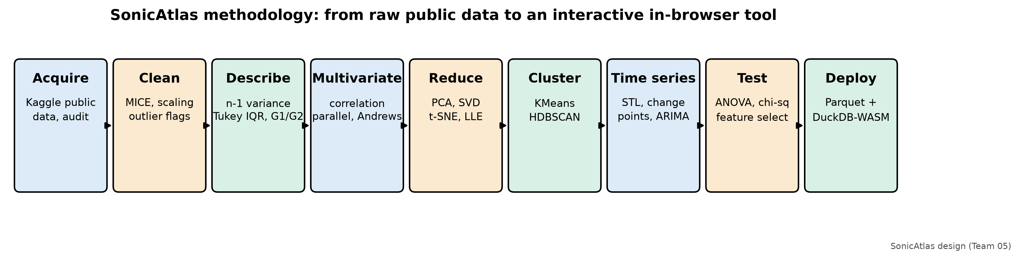
Fig. 1. Overall methodology of the SonicAtlas project

4.1 Data Acquisition, Cleaning and Preprocessing of Large-Scale Spotify Audio and Lyrics Data
This block turns three public downloads into analysis-ready Parquet tables while keeping the raw files untouched.

4.1.1 Data Sources
Three public Kaggle datasets were used (TABLE II): the Spotify 1.2M+ Songs table [36], the Spotify Tracks Dataset [37] and the Genius Song Lyrics dataset [38]. They were downloaded from the public Kaggle endpoint on 20 October 2026, checksummed, and stored unchanged in data/raw. All processing used pandas [27] and scikit-learn [26].
Dataset | Kaggle source | Rows | Role in SonicAtlas
Spotify 1.2M+ Songs | rodolfofigueroa/spotify-12m-songs | 1,204,025 | Main audio table with release year
Spotify Tracks Dataset | maharshipandya/-spotify-tracks-dataset | 114,000 | Genre labels (114 genres) and popularity
Genius Song Lyrics | carlosgdcj/genius-song-lyrics-with-language-information | 161,401 (English sample) | Lyrics text, language tag
TABLE II: Public datasets used in the project

4.1.2 Data Audit
The audit (notebook 01) checked shape, types, missing values, duplicates and physically impossible values. TABLE III lists what was found. Text columns had almost no gaps (14 missing names or album titles in the main table), but 2,777 tracks had a tempo of 0 BPM and 2,809 a time signature of 0, which cannot occur in real music.
Check | Spotify 1.2M+ | Spotify Tracks (genre)
Rows x columns | 1,204,025 x 24 | 114,000 x 20
Missing cells | 14 | 3
Duplicate track IDs | 0 | 24,259 (same track in several genres)
Duplicate title + artist | 71,694 | 35,595
Tempo = 0 BPM | 2,777 | 157
Time signature = 0 | 2,809 | 163
Loudness above 0 dB | 610 | -
Year recorded as 0 | 10 | no year column
Duration < 30 s / > 20 min | 7,675 / 3,383 | 17 / -
Popularity = 0 | no popularity column | 16,020
TABLE III: Data audit results

4.1.3 Type Conversion and Feature Engineering
Several columns were converted to proper types and a few readable features were derived:
- Release date: parsed to a datetime; 1,072,839 dates have day precision, 130,144 only a year and 1,042 a month. Year and decade columns were derived, and the 10 tracks recorded with year 0 were set to missing.
- Key and mode: integer pitch classes 0-11 and the binary mode were combined into readable labels such as “C# minor”.
- Artists: the stored Python-style list strings were parsed into real lists, giving a main artist and an artist count per track.
- Explicit flag and duration: explicit was cast to boolean and duration in milliseconds to minutes.

4.1.4 Missing Values and MICE Imputation
Zero tempo and zero time signature were recoded as missing and imputed with Multiple Imputation by Chained Equations (MICE) [34], using scikit-learn’s IterativeImputer [26] with the nine other audio features as predictors. Missing text fields were filled with the constant “Unknown”. Because the audio features themselves contain no gaps, the imputer was validated by hiding 5% of known values and measuring the error (TABLE IV). MICE beat mean imputation for every column, by 57.5% for energy, 25.2% for valence and 3.9% for tempo; tempo is hard to predict from the other features. Fig. 2 shows that imputation did not distort the tempo distribution.
Column | Masked values | RMSE (MICE) | RMSE (mean) | Improvement
tempo | 4,910 | 29.1791 | 30.3582 | 3.9%
valence | 4,920 | 0.2015 | 0.2695 | 25.2%
energy | 5,030 | 0.1244 | 0.2931 | 57.5%
TABLE IV: MICE validation on artificially masked values
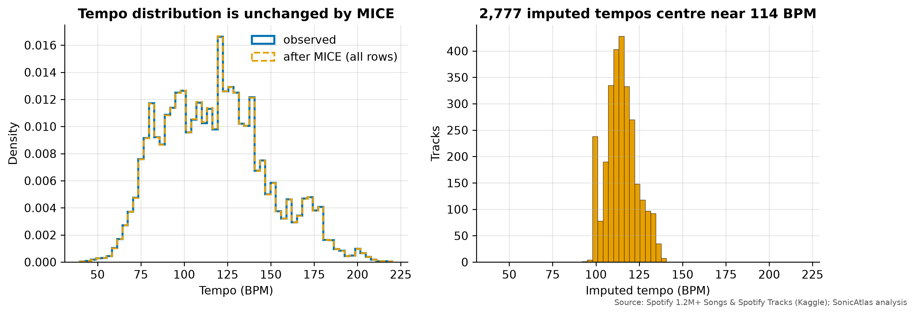
Fig. 2. Tempo distribution before and after MICE imputation

4.1.5 Re-releases and Joining the Genre Labels
The same song often appears on an original album, a deluxe edition and a compilation. The earliest release of each normalised title and main artist was marked as canonical (1,113,568 rows); the other 90,457 re-issues are kept but excluded from time trends so that re-releases do not count twice.
The genre table was first de-duplicated to 89,740 unique tracks (one track can carry several genre tags). It was then joined to the main table by Spotify track ID (4,729 matches) and, for the rest, by normalised title and main artist (4,915 more). The overall match rate is only 10.7%: the two datasets were collected at different times from different seed playlists. For this reason genre analyses use the genre table directly, and only 9,644 genre-labelled tracks also have a release year.

4.1.6 Transformations and Scaling
Min-Max scaling (0-1) and standard (z-score) scaling were applied to the ten acoustic metrics and saved as separate tables, because distance-based methods (PCA, KMeans, nearest-neighbour search) need comparable units. Skewed fields were transformed and their skewness G1 recorded before and after (TABLE V). Duration fell from G1 = 8.04 to 0.23 after log1p (Fig. 3). The genre table’s popularity score is a bounded 0-100 index with many zeros, not a count, and log1p made it more skewed (G1 0.07 to -1.65), so popularity is analysed untransformed. No stream counts exist in any of the datasets.
Feature | Transform | G1 before | G1 after
duration_min | log1p | 8.042 | 0.235
speechiness | Yeo-Johnson (lambda=-16.75) | 4.243 | 0.849
instrumentalness | Yeo-Johnson (lambda=-3.09) | 0.797 | 0.542
liveness | Yeo-Johnson (lambda=-6.64) | 2.267 | 0.400
acousticness | Yeo-Johnson (lambda=-0.09) | 0.163 | 0.016
popularity (genre table) | log1p | 0.071 | -1.655
TABLE V: Skewness before and after transformation
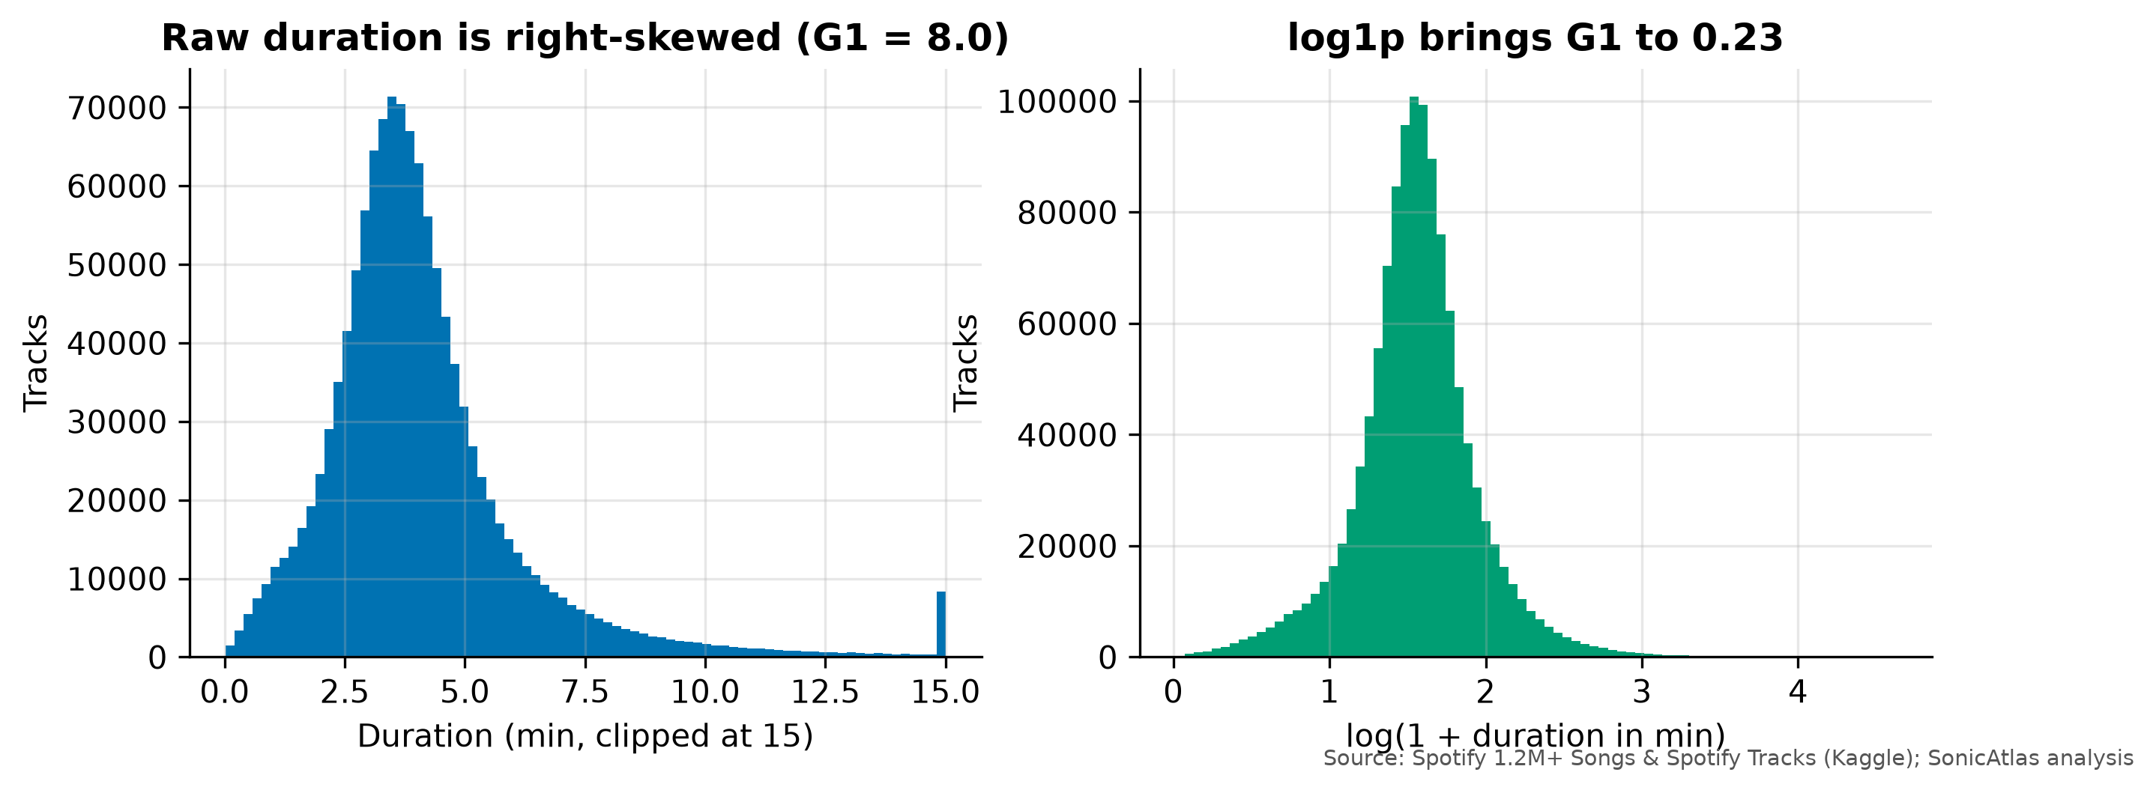
Fig. 3. Duration before and after the log1p transform

4.1.7 Outlier Detection
Outliers were detected in two complementary ways and flagged, never deleted, so the website can include or exclude them. Tukey fences (Q1 - 1.5 IQR, Q3 + 1.5 IQR) were applied per feature (TABLE VI), and an Isolation Forest [35] with 200 trees and 2% contamination was fitted on the standardised features, flagging 24,547 tracks (2.0%). The flagged tracks are mainly spoken word: their mean speechiness is 0.48 against 0.08 for the rest (Fig. 4).
Feature | Lower fence | Upper fence | Outliers | Share
danceability | -0.060 | 1.048 | 0 | 0.00%
energy | -0.519 | 1.537 | 0 | 0.00%
loudness | -28.059 | 6.088 | 38,727 | 3.22%
speechiness | -0.021 | 0.128 | 167,338 | 13.90%
acousticness | -1.198 | 2.096 | 0 | 0.00%
instrumentalness | -1.078 | 1.797 | 0 | 0.00%
liveness | -0.126 | 0.467 | 95,938 | 7.97%
valence | -0.488 | 1.324 | 0 | 0.00%
tempo | 30.164 | 201.177 | 5,549 | 0.46%
duration_min | 0.108 | 7.558 | 69,379 | 5.76%
TABLE VI: Tukey-fence (IQR) outliers per feature
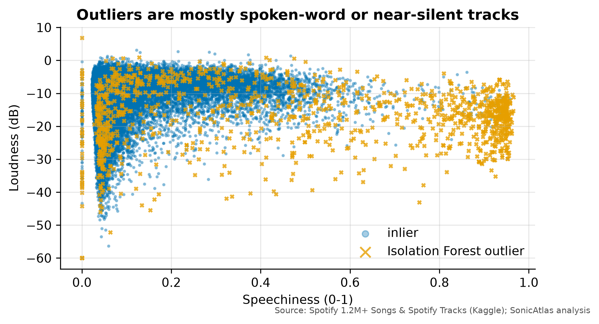
Fig. 4. Isolation Forest outliers in the speechiness-loudness plane
Real examples confirm that the flags pick out genuine special cases rather than errors:
- Extreme tempo: 118 tracks above 220 BPM, usually double-time readings of fast punk or drum-and-bass.
- Near-silent or ambient: 709 tracks quieter than -45 dB, such as field recordings, sleep sounds and silent tracks.
- Spoken word and comedy: 11,679 tracks with speechiness above 0.66 (the level Spotify associates with speech-only content), 6,025 of them above 0.9, mostly audiobooks, poetry and stand-up comedy.

4.2 Descriptive Statistics, Multivariate Visual Storytelling, Dimensionality Reduction and Time-Series Dynamics of Musical Characteristics
This block explores the cleaned data with the statistical and visual methods of the course, moving from single features to the full multivariate space and then to time.

4.2.1 Statistical Conventions
All summaries follow the conventions used in the course tutorials: sample variance with denominator n-1; Q1 and Q3 by Tukey’s median-of-halves (hinges); the adjusted Fisher-Pearson skewness G1; and the bias-corrected excess kurtosis G2, with Pearson kurtosis = G2 + 3. The functions live in the package module sonicatlas.stats and are unit-tested against SciPy. On the tutorial data set {4, 5, 5, 6, 6, 6, 7, 8, 9, 14} they reproduce the expected values (TABLE VII). The pandas default quartiles, which interpolate linearly, are shown for comparison; the report uses the Tukey values.
Statistic | Formula / rule | Value
Mean | sum(x) / n | 7.00
Median | middle value | 6.00
Mode | most frequent | 6
Sample variance | sum(x - mean)^2 / (n - 1) | 8.222
Standard deviation | sqrt(variance) | 2.867
Q1, Q3 (Tukey) | medians of lower and upper halves | 5.00, 8.00
Q1, Q3 (pandas default) | linear interpolation | 5.25, 7.75
IQR (Tukey) | Q3 - Q1 | 3.00
Skewness G1 | adjusted Fisher-Pearson | 1.8026
Excess kurtosis G2 | bias-corrected | 3.8414
Pearson kurtosis | G2 + 3 | 6.8414
TABLE VII: Worked example on the tutorial data set

4.2.2 Descriptive Statistics of the Audio Features
TABLE VIII gives the summary for all 1,204,025 tracks and Fig. 5 the distributions. Danceability and tempo are close to symmetric. Speechiness (G1 = 4.24, G2 = 22.3), liveness and duration are strongly right-skewed and heavy-tailed: most tracks are sung studio recordings of three to five minutes, with a long tail of spoken, live and very long pieces. Loudness is left-skewed (G1 = -1.28) because a minority of quiet classical and ambient tracks pulls the tail down. Acousticness and instrumentalness are platykurtic (G2 below -1) because they pile up near both 0 and 1.
Feature | Mean | Median | Mode | Var (n-1) | Q1 | Q3 | IQR | G1 | G2 | CV
danceability | 0.493 | 0.501 | 0.000 | 0.036 | 0.356 | 0.633 | 0.277 | -0.10 | -0.61 | 0.38
energy | 0.510 | 0.524 | 0.032 | 0.087 | 0.252 | 0.766 | 0.514 | -0.09 | -1.22 | 0.58
loudness | -11.809 | -9.791 | -60.000 | 48.750 | -15.254 | -6.717 | 8.537 | -1.28 | 1.78 | -0.59
speechiness | 0.084 | 0.045 | 0.034 | 0.013 | 0.035 | 0.072 | 0.037 | 4.24 | 22.35 | 1.37
acousticness | 0.447 | 0.389 | 0.000 | 0.148 | 0.038 | 0.861 | 0.823 | 0.16 | -1.64 | 0.86
instrumentalness | 0.283 | 0.008 | 0.000 | 0.142 | 0.000 | 0.719 | 0.719 | 0.80 | -1.18 | 1.33
liveness | 0.202 | 0.125 | 0.111 | 0.033 | 0.097 | 0.245 | 0.148 | 2.27 | 5.25 | 0.90
valence | 0.428 | 0.403 | 0.038 | 0.073 | 0.191 | 0.644 | 0.453 | 0.25 | -1.05 | 0.63
tempo | 117.899 | 116.838 | 120.001 | 925.307 | 94.294 | 137.047 | 42.753 | 0.40 | -0.29 | 0.26
duration_min | 4.147 | 3.739 | 4.000 | 7.309 | 2.901 | 4.764 | 1.863 | 8.04 | 146.28 | 0.65
TABLE VIII: Descriptive statistics of audio features (n = 1,204,025)
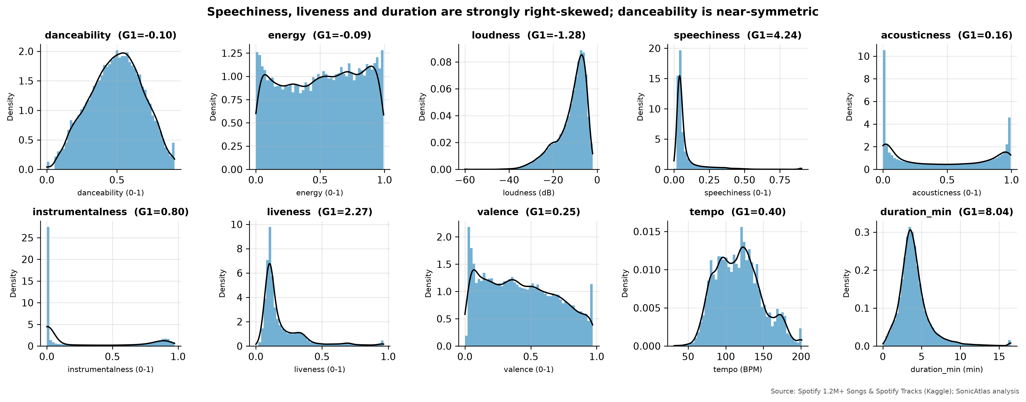
Fig. 5. Histograms with kernel density estimates of the ten audio features
The plain-English reading of each shape, generated from G1 and G2 with fixed thresholds (|G1| < 0.5 symmetric, G1 >= 1 strongly skewed; G2 > 1 heavy-tailed, G2 < -1 flat), is:
Feature | Shape interpretation
danceability | roughly symmetric, near-normal tails (mesokurtic)
energy | roughly symmetric, flat (platykurtic)
loudness | left-skewed (long tail of low values), heavy-tailed (leptokurtic)
speechiness | right-skewed (long tail of high values), heavy-tailed (leptokurtic)
acousticness | roughly symmetric, flat (platykurtic)
instrumentalness | moderately right-skewed, flat (platykurtic)
liveness | right-skewed (long tail of high values), heavy-tailed (leptokurtic)
valence | roughly symmetric, flat (platykurtic)
tempo | roughly symmetric, near-normal tails (mesokurtic)
duration_min | right-skewed (long tail of high values), heavy-tailed (leptokurtic)
TABLE IX: Interpretation of distribution shapes

4.2.3 Categorical Distributions
Fig. 6 shows the categorical fields. The three most common keys are G, C, D, which are easy keys on guitar and piano, and 67.1% of tracks are in a major mode. The share of tracks marked explicit stays below 1% before the 1980s, reaches 3.2% in the 1990s and 8.3% in the 2010s, and is 31.8% for 2020 releases, the single year available in the 2020s.
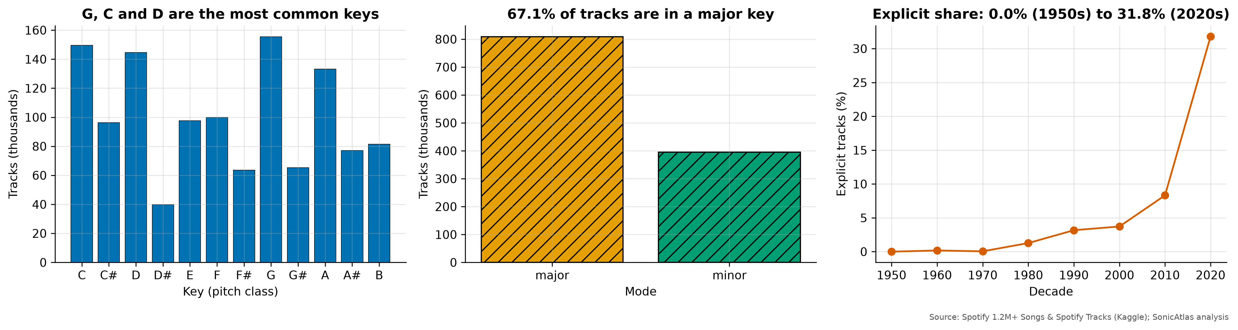
Fig. 6. Key, mode and explicit-content distributions
Per-decade means for canonical releases (TABLE X) already reveal the main historical story that Section 4.2.9 analyses formally.
Decade | Danceability | Energy | Acousticness | Valence | Loudness (dB) | Duration (min)
1950s | 0.427 | 0.296 | 0.834 | 0.426 | -15.63 | 4.12
1960s | 0.440 | 0.354 | 0.698 | 0.465 | -14.67 | 3.79
1970s | 0.482 | 0.452 | 0.531 | 0.514 | -13.57 | 4.22
1980s | 0.479 | 0.468 | 0.472 | 0.477 | -14.34 | 4.26
1990s | 0.465 | 0.411 | 0.553 | 0.428 | -15.05 | 4.19
2000s | 0.494 | 0.508 | 0.461 | 0.446 | -11.61 | 4.11
2010s | 0.497 | 0.547 | 0.399 | 0.409 | -10.78 | 4.18
2020s | 0.560 | 0.587 | 0.309 | 0.408 | -9.66 | 3.69
TABLE X: Mean audio features by decade (canonical releases)
TABLE XI gives the same summary for the eight representative genres used throughout the multivariate analysis.
Genre | Danceability | Energy | Acousticness | Valence | Loudness (dB) | Tempo (BPM)
classical | 0.386 | 0.197 | 0.920 | 0.392 | -19.92 | 108.0
country | 0.555 | 0.592 | 0.329 | 0.513 | -7.22 | 124.3
edm | 0.656 | 0.752 | 0.124 | 0.462 | -5.42 | 121.6
hip-hop | 0.730 | 0.695 | 0.198 | 0.553 | -5.95 | 118.4
jazz | 0.489 | 0.309 | 0.766 | 0.487 | -12.97 | 116.0
metal | 0.481 | 0.841 | 0.036 | 0.425 | -4.93 | 129.5
pop | 0.581 | 0.579 | 0.403 | 0.477 | -7.17 | 121.4
rock | 0.549 | 0.648 | 0.227 | 0.478 | -6.66 | 121.4
TABLE XI: Mean audio features of eight representative genres

4.2.4 Correlation Analysis
Pearson and Spearman correlation matrices were computed on a 300,000-track random sample (Fig. 7). Three trade-offs dominate the audio space:
- Loudness and energy: r = 0.819 (Spearman 0.850); Spotify’s energy measure is built partly from loudness, so the two move together.
- Energy and acousticness: r = -0.796; acoustic recordings are quieter and less intense.
- Valence and danceability: r = 0.562; happier-sounding tracks tend to be more danceable, but the link is only moderate.
Spearman values are close to Pearson values, so the relationships are monotonic and not driven by outliers. To connect with the tutorial formula, TABLE XII works through Pearson’s r for energy and loudness on ten tracks; the hand calculation gives r = 0.9396, identical to numpy (0.9396).
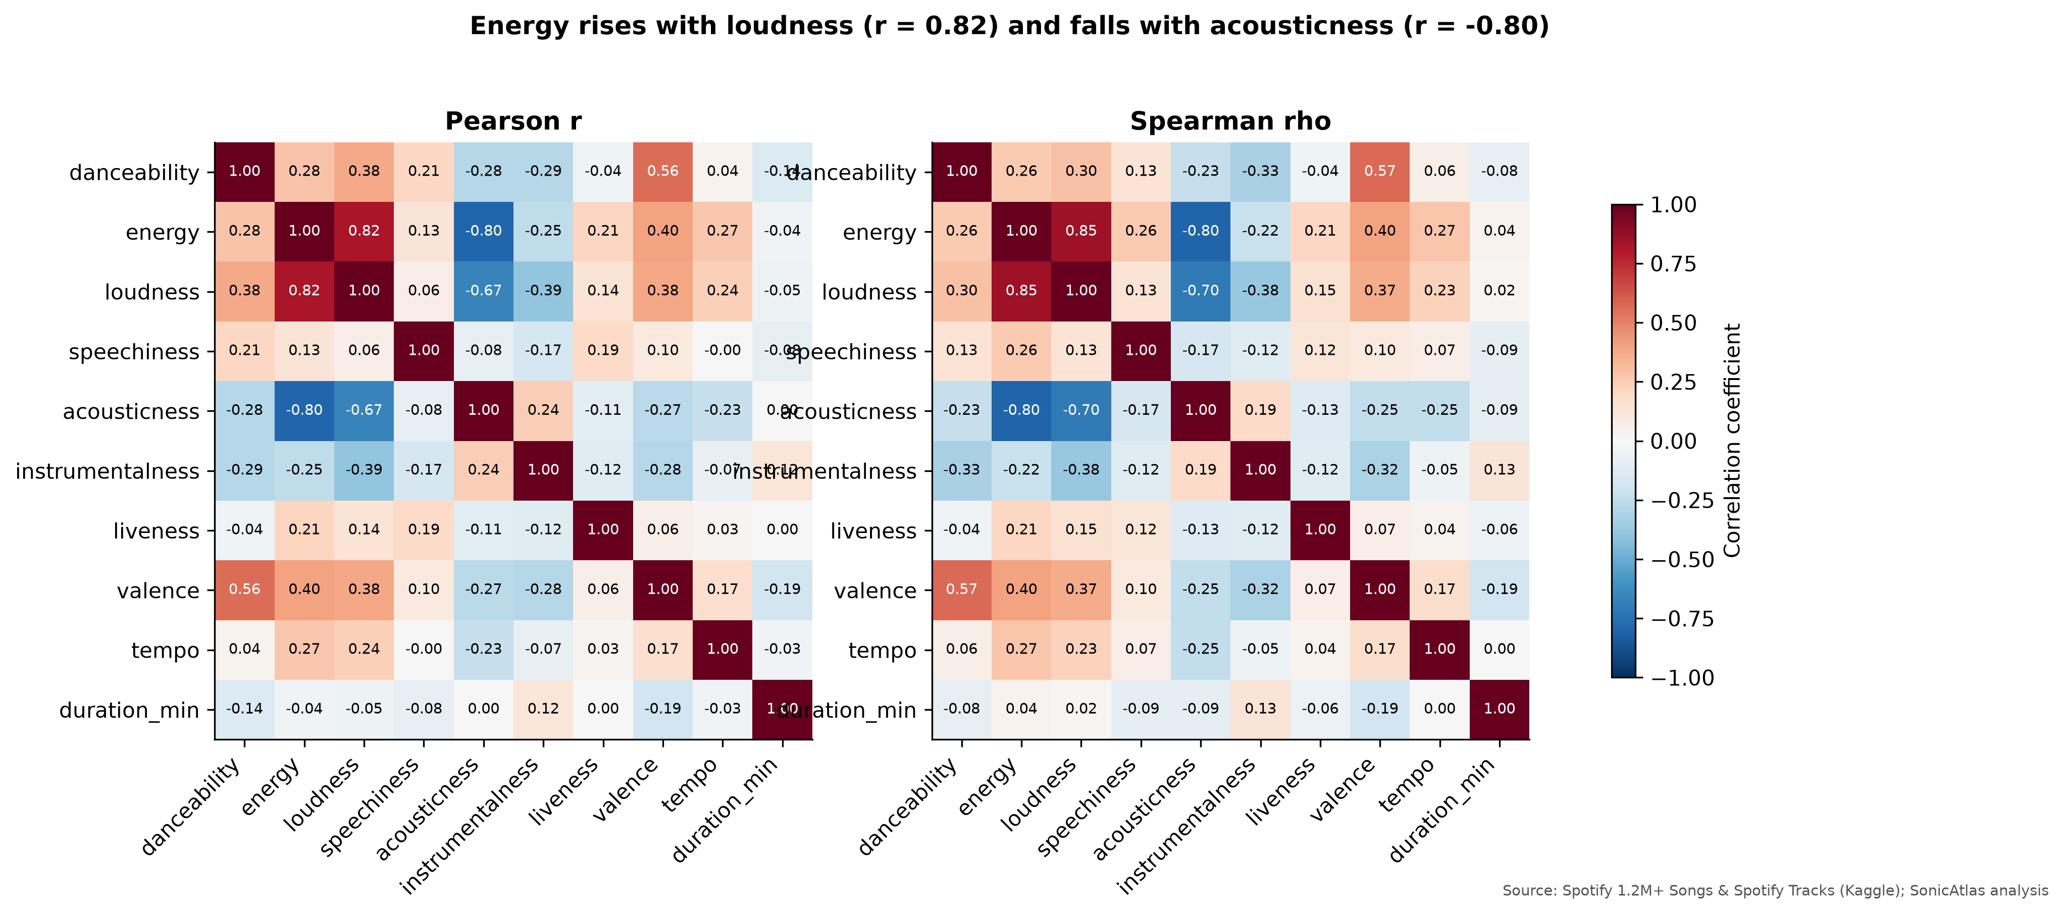
Fig. 7. Pearson and Spearman correlation heatmaps of the audio features
Track | Energy x | Loudness y | dx | dy | dx*dy | dx^2 | dy^2
1 | 0.736 | -3.657 | 0.1245 | 5.3595 | 0.6673 | 0.0155 | 28.7242
2 | 0.639 | -9.641 | 0.0275 | -0.6245 | -0.0172 | 0.0008 | 0.3900
3 | 0.466 | -14.287 | -0.1455 | -5.2705 | 0.7668 | 0.0212 | 27.7782
4 | 0.856 | -2.970 | 0.2445 | 6.0465 | 1.4784 | 0.0598 | 36.5602
5 | 0.373 | -13.929 | -0.2385 | -4.9125 | 1.1716 | 0.0569 | 24.1327
6 | 0.794 | -4.360 | 0.1825 | 4.6565 | 0.8499 | 0.0333 | 21.6830
7 | 0.081 | -19.828 | -0.5306 | -10.8115 | 5.7365 | 0.2815 | 116.8885
8 | 0.209 | -13.506 | -0.4025 | -4.4895 | 1.8070 | 0.1620 | 20.1556
9 | 0.977 | -3.356 | 0.3655 | 5.6605 | 2.0690 | 0.1336 | 32.0413
10 | 0.984 | -4.631 | 0.3725 | 4.3855 | 1.6336 | 0.1388 | 19.2326
Sum |  |  |  |  | 16.1629 | 0.9034 | 327.5863
TABLE XII: Worked Pearson correlation by formula (energy vs loudness, 10 tracks)

4.2.5 Multivariate Visualisation of Genres
To see all features at once, a balanced sample of 60 tracks from each of the eight genres (classical, jazz, country, rock, metal, hip-hop, edm, pop) was drawn so that no genre dominates the picture. In the parallel-coordinates plot (Fig. 8) each track is a line across seven axes, and the thick lines are genre means. Classical stands apart with high acousticness (0.92) and instrumentalness (0.60); metal has the highest energy (0.84); hip-hop has the highest speechiness (0.13) and danceability (0.73).
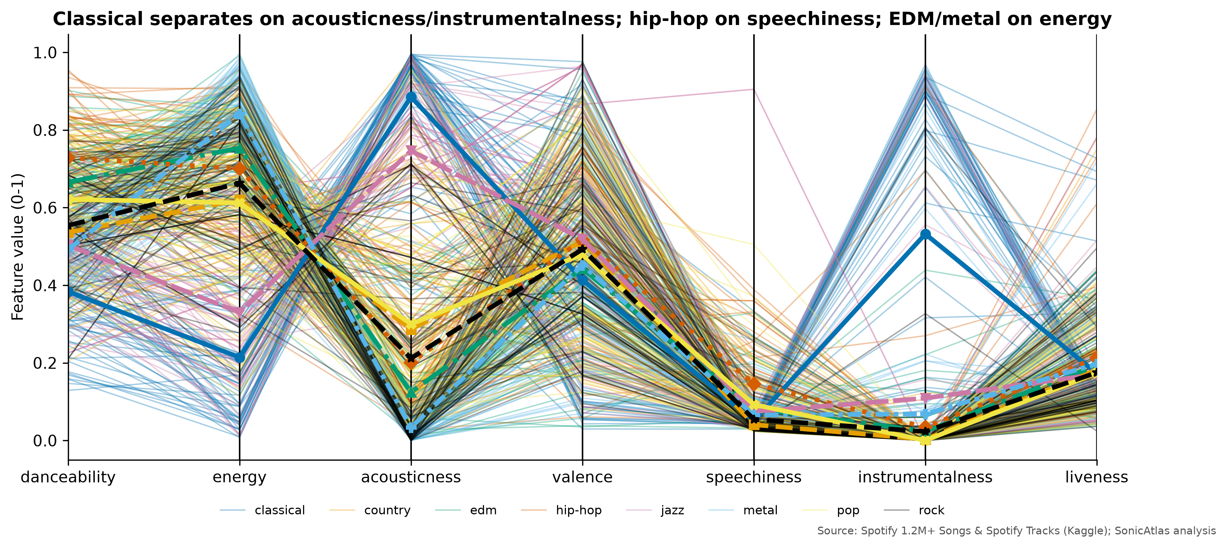
Fig. 8. Parallel coordinates of eight genres (balanced sample, genre means in bold)
Andrews curves (Fig. 9) turn each track into a Fourier series f(t) = x1/sqrt(2) + x2 sin t + x3 cos t + ..., so tracks with similar features draw similar waves. Classical curves form a clearly separate band (deep dips near t = -2.8 and t = 1.8), while the other seven genres overlap heavily, which agrees with the parallel-coordinates view and the silhouette results in Section 4.2.7.
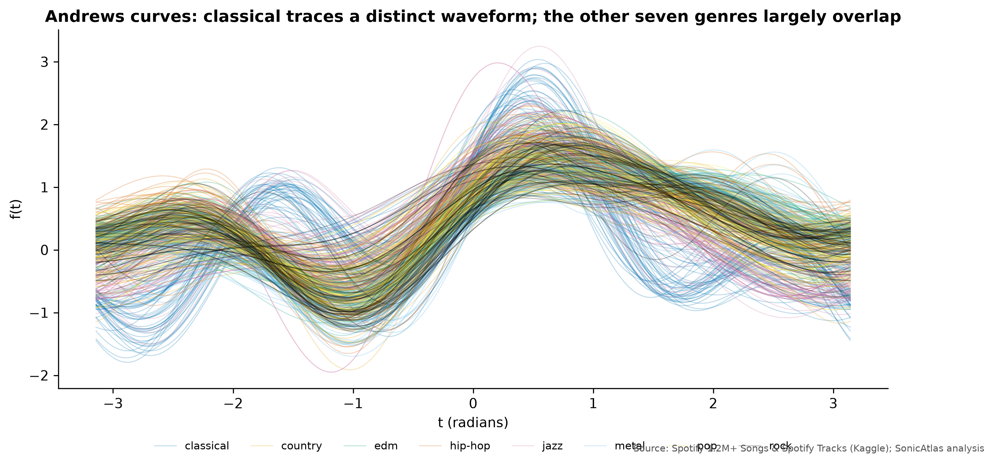
Fig. 9. Andrews curves of eight genres
Radar fingerprints (Fig. 10) give each genre a compact visual signature, and violin plots (Fig. 11) show the full distributions behind the means. EDM and hip-hop have narrow, high danceability distributions, while classical has the lowest energy (mean 0.20).
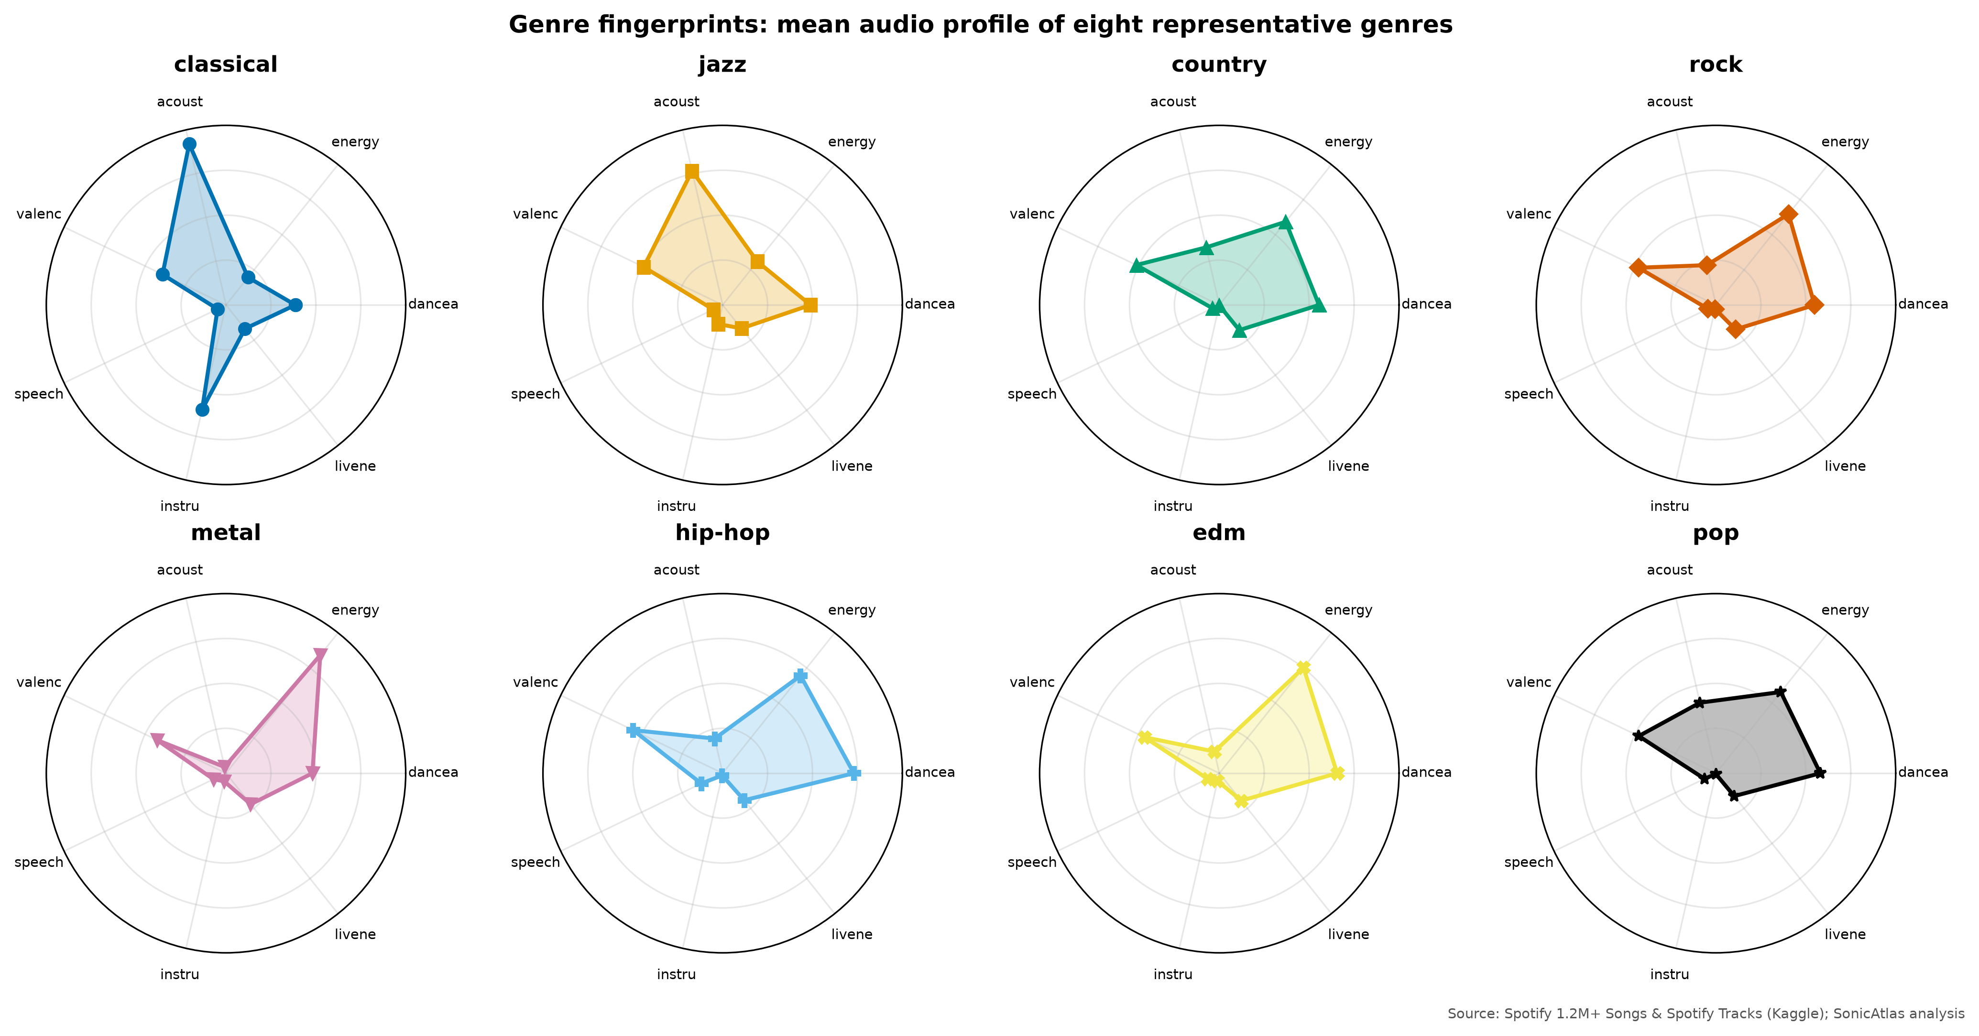
Fig. 10. Radar fingerprints of mean audio profiles per genre
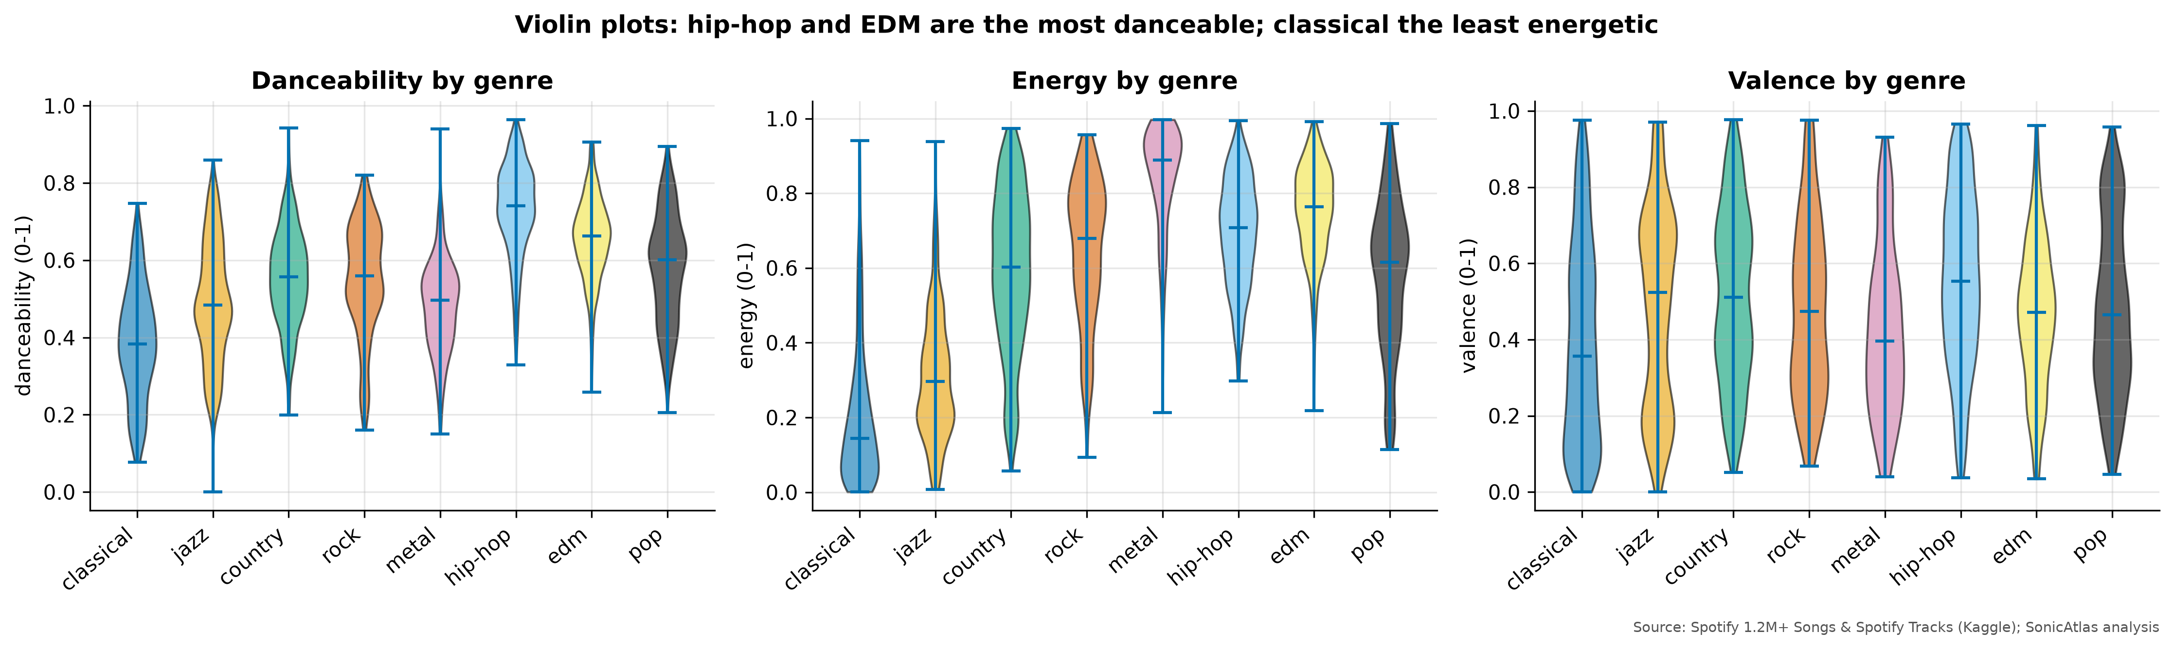
Fig. 11. Violin plots of danceability, energy and valence by genre

4.2.6 Principal Component Analysis and SVD
PCA was fitted on all 1,204,025 tracks using the ten standardised features (with log duration). PC1 explains 33.5% of the variance and PC2 14.0%; 7 components are needed to reach 90% (Fig. 12). The loadings in TABLE XIII show that PC1 is an “electric versus acoustic” axis (energy 0.48, loudness 0.47, acousticness -0.43); PC2 contrasts long, instrumental pieces (log duration 0.52) with danceable, wordy tracks (danceability -0.40, speechiness -0.40); PC3 is dominated by liveness (0.75). The link to SVD was checked numerically: the squared singular values of the centred data matrix, divided by their sum, equal PCA’s explained-variance ratios (match confirmed).
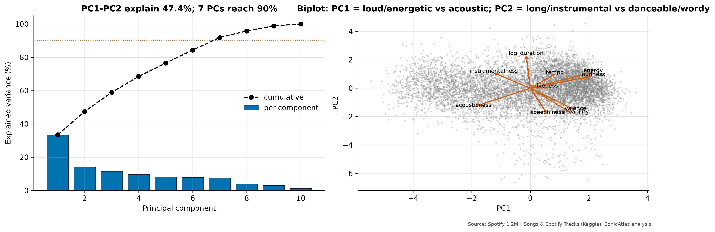
Fig. 12. PCA scree plot and biplot
Feature | PC1 | PC2 | PC3
danceability | 0.316 | -0.397 | -0.323
energy | 0.477 | 0.252 | 0.081
loudness | 0.473 | 0.189 | -0.030
speechiness | 0.129 | -0.404 | 0.491
acousticness | -0.432 | -0.294 | -0.020
instrumentalness | -0.278 | 0.240 | -0.075
liveness | 0.123 | 0.009 | 0.746
valence | 0.343 | -0.343 | -0.280
tempo | 0.185 | 0.220 | -0.065
log_duration | -0.032 | 0.519 | -0.040
TABLE XIII: PCA loadings of the first three components

4.2.7 Non-linear Maps: t-SNE, LLE and UMAP
Non-linear methods were run on a stratified sample of 10,000 tracks (up to 90 per genre, all 114 genres) because their cost grows quickly with the number of points. t-SNE used perplexity 30; LLE used 15 neighbours; UMAP was added as a bonus. Fig. 13 compares the maps and TABLE XIV the metrics. t-SNE preserves local neighbourhoods best (trustworthiness 0.976), followed by UMAP (0.947), PCA (0.779) and LLE (0.671). Silhouette scores computed with the eight focus genres as labels are slightly negative for every method and even in the original space (-0.029): genres overlap heavily in Spotify’s feature space, so no projection can separate them cleanly. This is an important honest finding: genre is partly a cultural label that audio descriptors capture only in part.
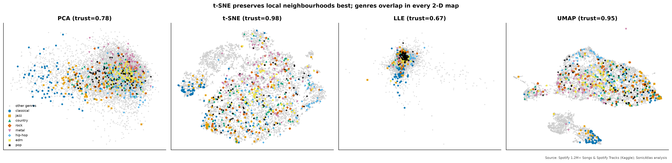
Fig. 13. PCA, t-SNE, LLE and UMAP maps of a stratified 10,000-track sample
Method | Runtime (s) | Trustworthiness (k=10) | Silhouette (8 genres)
PCA | 0.00 | 0.779 | -0.085
t-SNE | 49.84 | 0.976 | -0.061
LLE | 42.41 | 0.671 | -0.140
UMAP | 32.22 | 0.947 | -0.055
Original 10-D | 0.00 | 1.000 | -0.029
TABLE XIV: Comparison of dimensionality-reduction methods
Colouring a decade-stratified t-SNE map (1,000 canonical tracks per decade, 1950s-2010s) by release decade gives a silhouette of -0.082 (Fig. 14): eras blend into each other gradually rather than forming islands, consistent with the slow trends in Section 4.2.9.
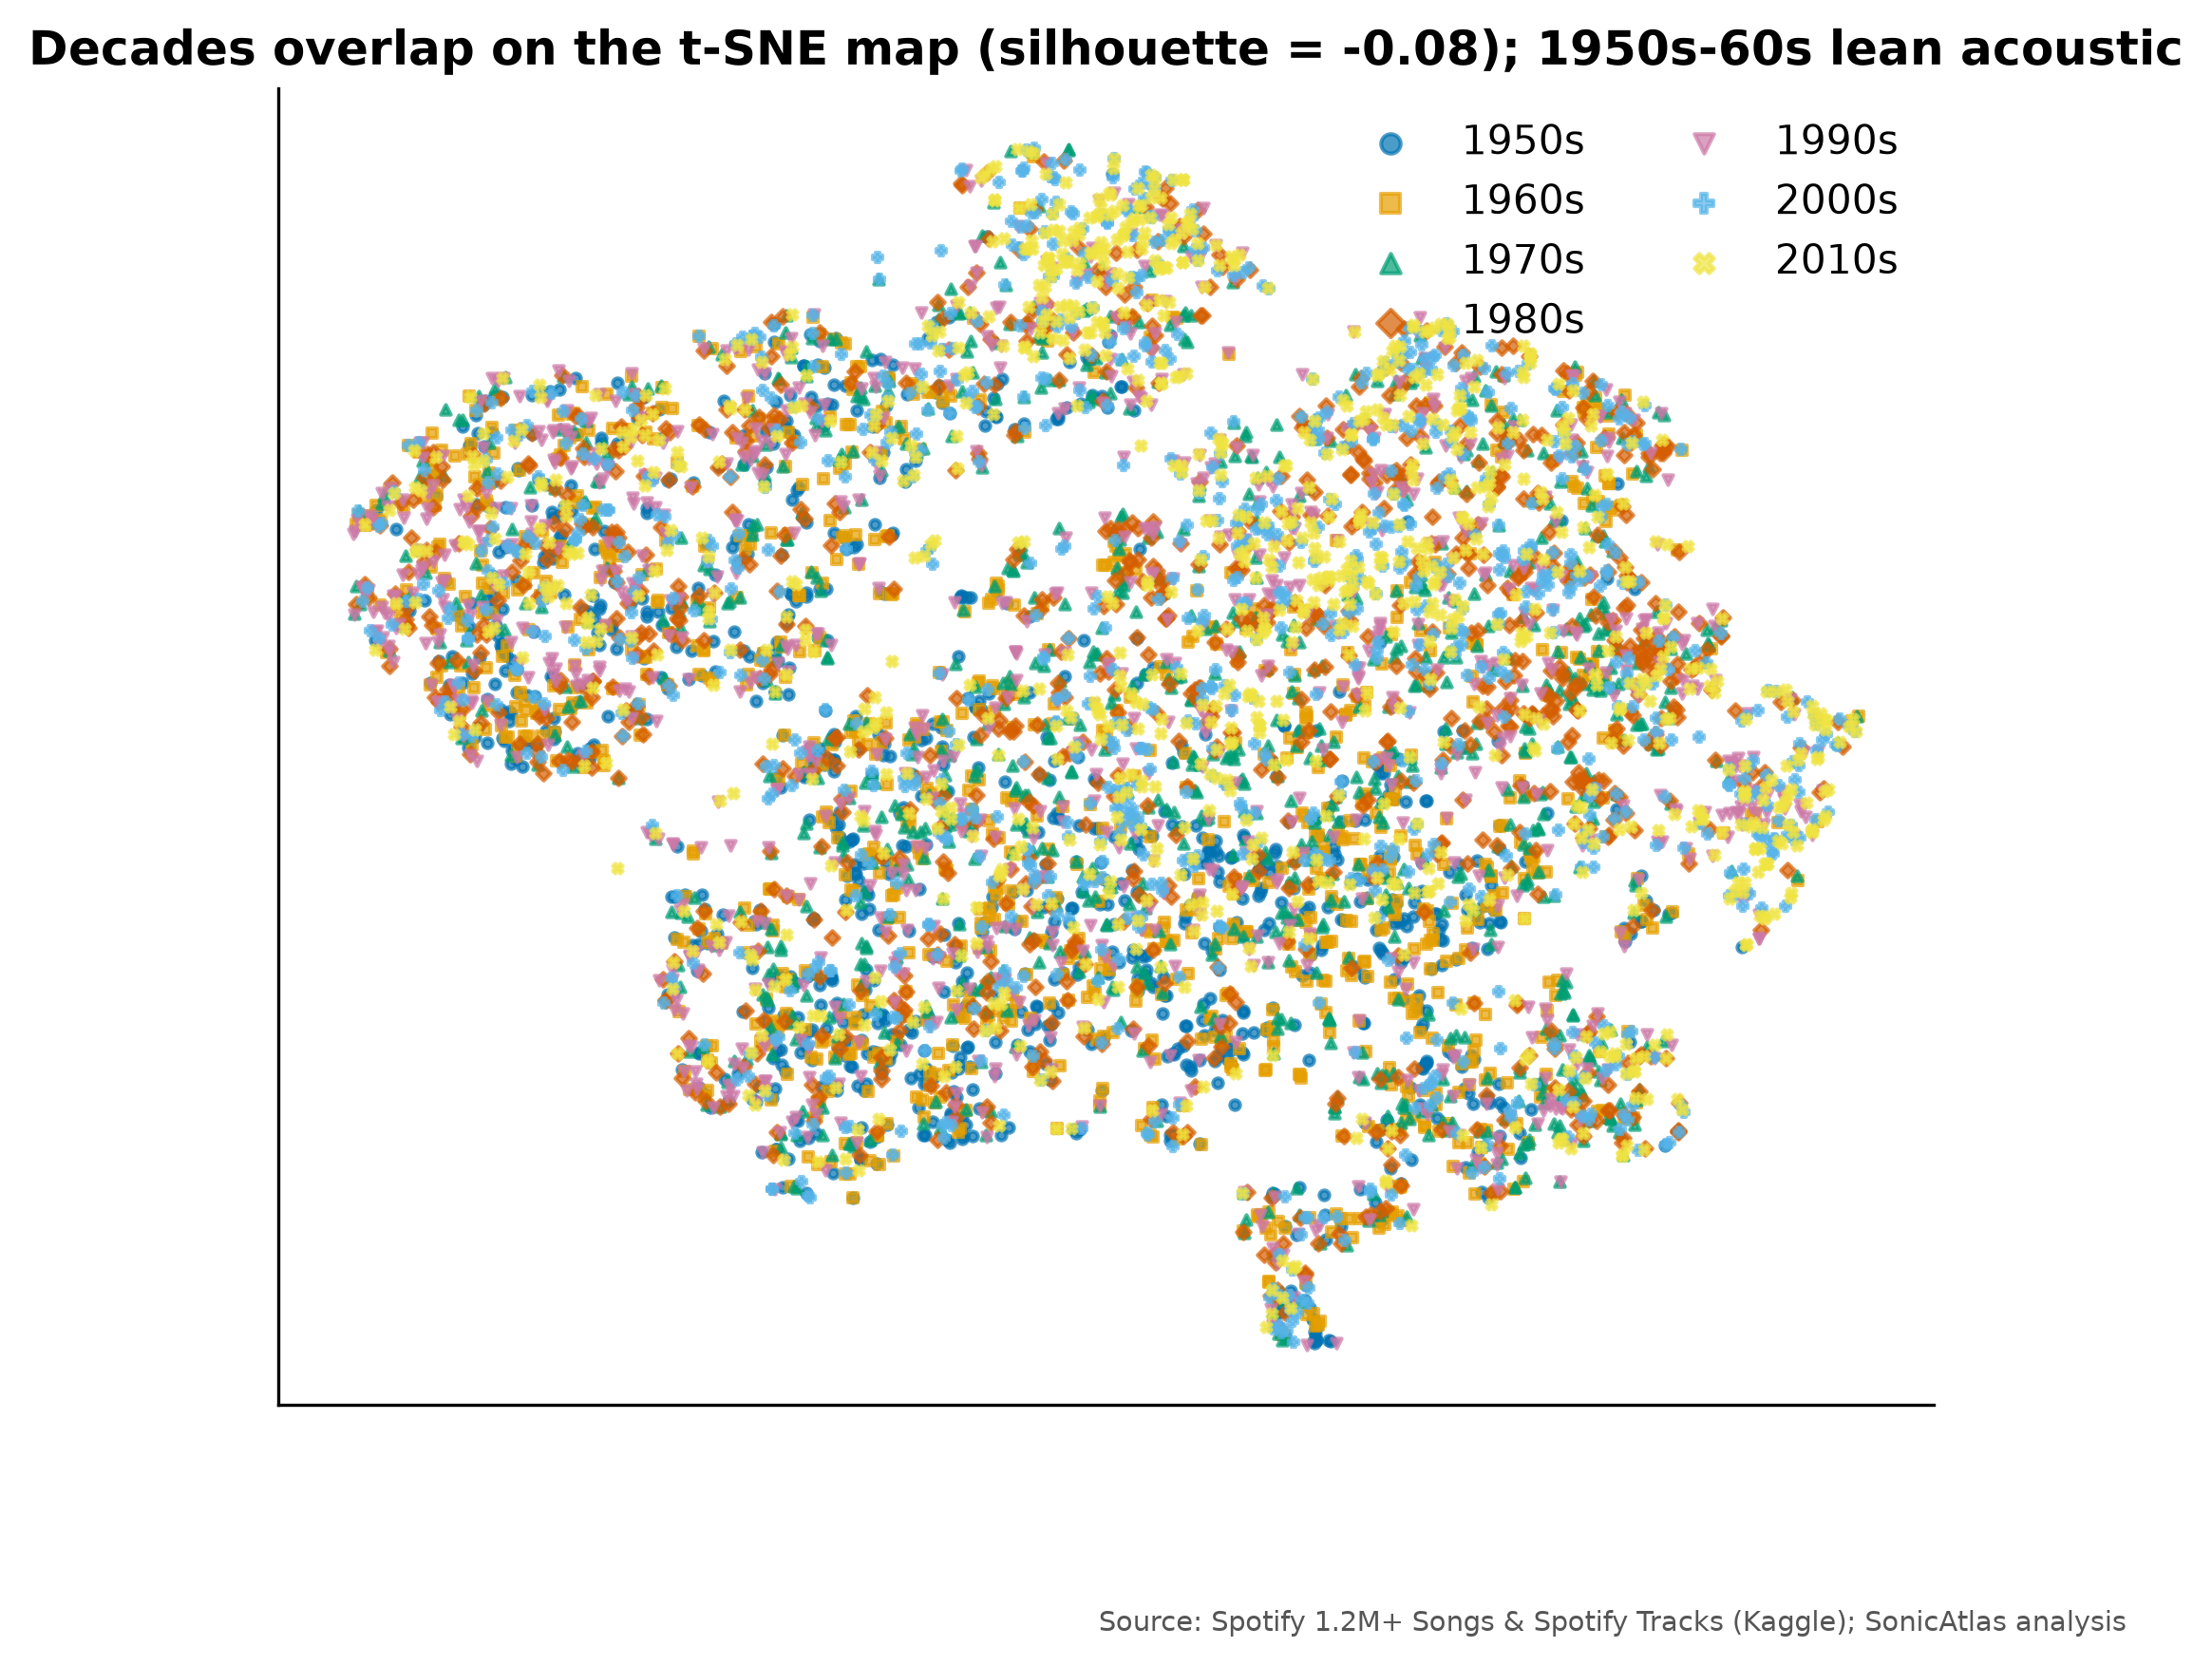
Fig. 14. t-SNE map coloured by release decade

4.2.8 Acoustic Clusters
KMeans was run on the first 7 principal components for k = 2 to 10 (Fig. 15). The silhouette is highest at k = 2 (0.268), which only splits acoustic from electric music; k = 6 sits on the next plateau and produces groups that can be described in plain words, so it was chosen. Each cluster was named from its centroid and the most frequent genres of genre-table tracks assigned to it (TABLE XV). HDBSCAN on a 20,000-track subsample found only 2 dense clusters and labelled 64.8% of points as noise, confirming that the audio space is a continuum with a few dense cores rather than well-separated islands.
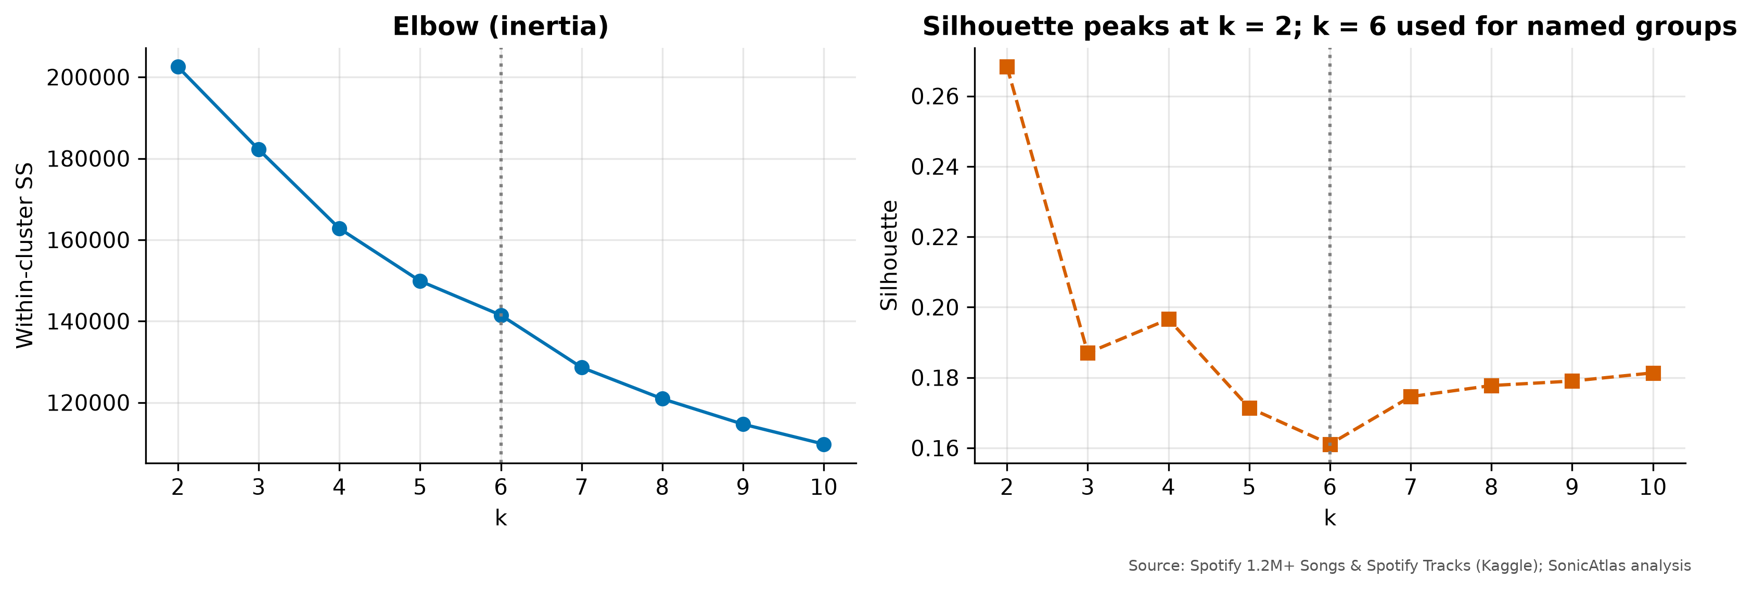
Fig. 15. Elbow and silhouette curves for choosing k
Cluster name | Share | Top genres | Energy | Acoust. | Speech. | Instr. | Dance.
Live recordings | 6.2% | pagode, sertanejo, samba | 0.67 | 0.33 | 0.09 | 0.18 | 0.46
Upbeat danceable pop | 28.5% | salsa, dance, forro | 0.68 | 0.23 | 0.08 | 0.12 | 0.66
Soft acoustic songs | 20.5% | romance, tango, honky-tonk | 0.28 | 0.76 | 0.05 | 0.13 | 0.49
Loud & intense (rock/metal) | 21.9% | black-metal, grindcore, death-metal | 0.76 | 0.09 | 0.07 | 0.33 | 0.42
Quiet acoustic instrumentals | 18.7% | new-age, ambient, sleep | 0.14 | 0.88 | 0.05 | 0.73 | 0.30
Spoken word & rap | 4.2% | comedy, j-dance, dancehall | 0.54 | 0.42 | 0.52 | 0.05 | 0.64
TABLE XV: KMeans (k = 6) acoustic clusters with plain-language names
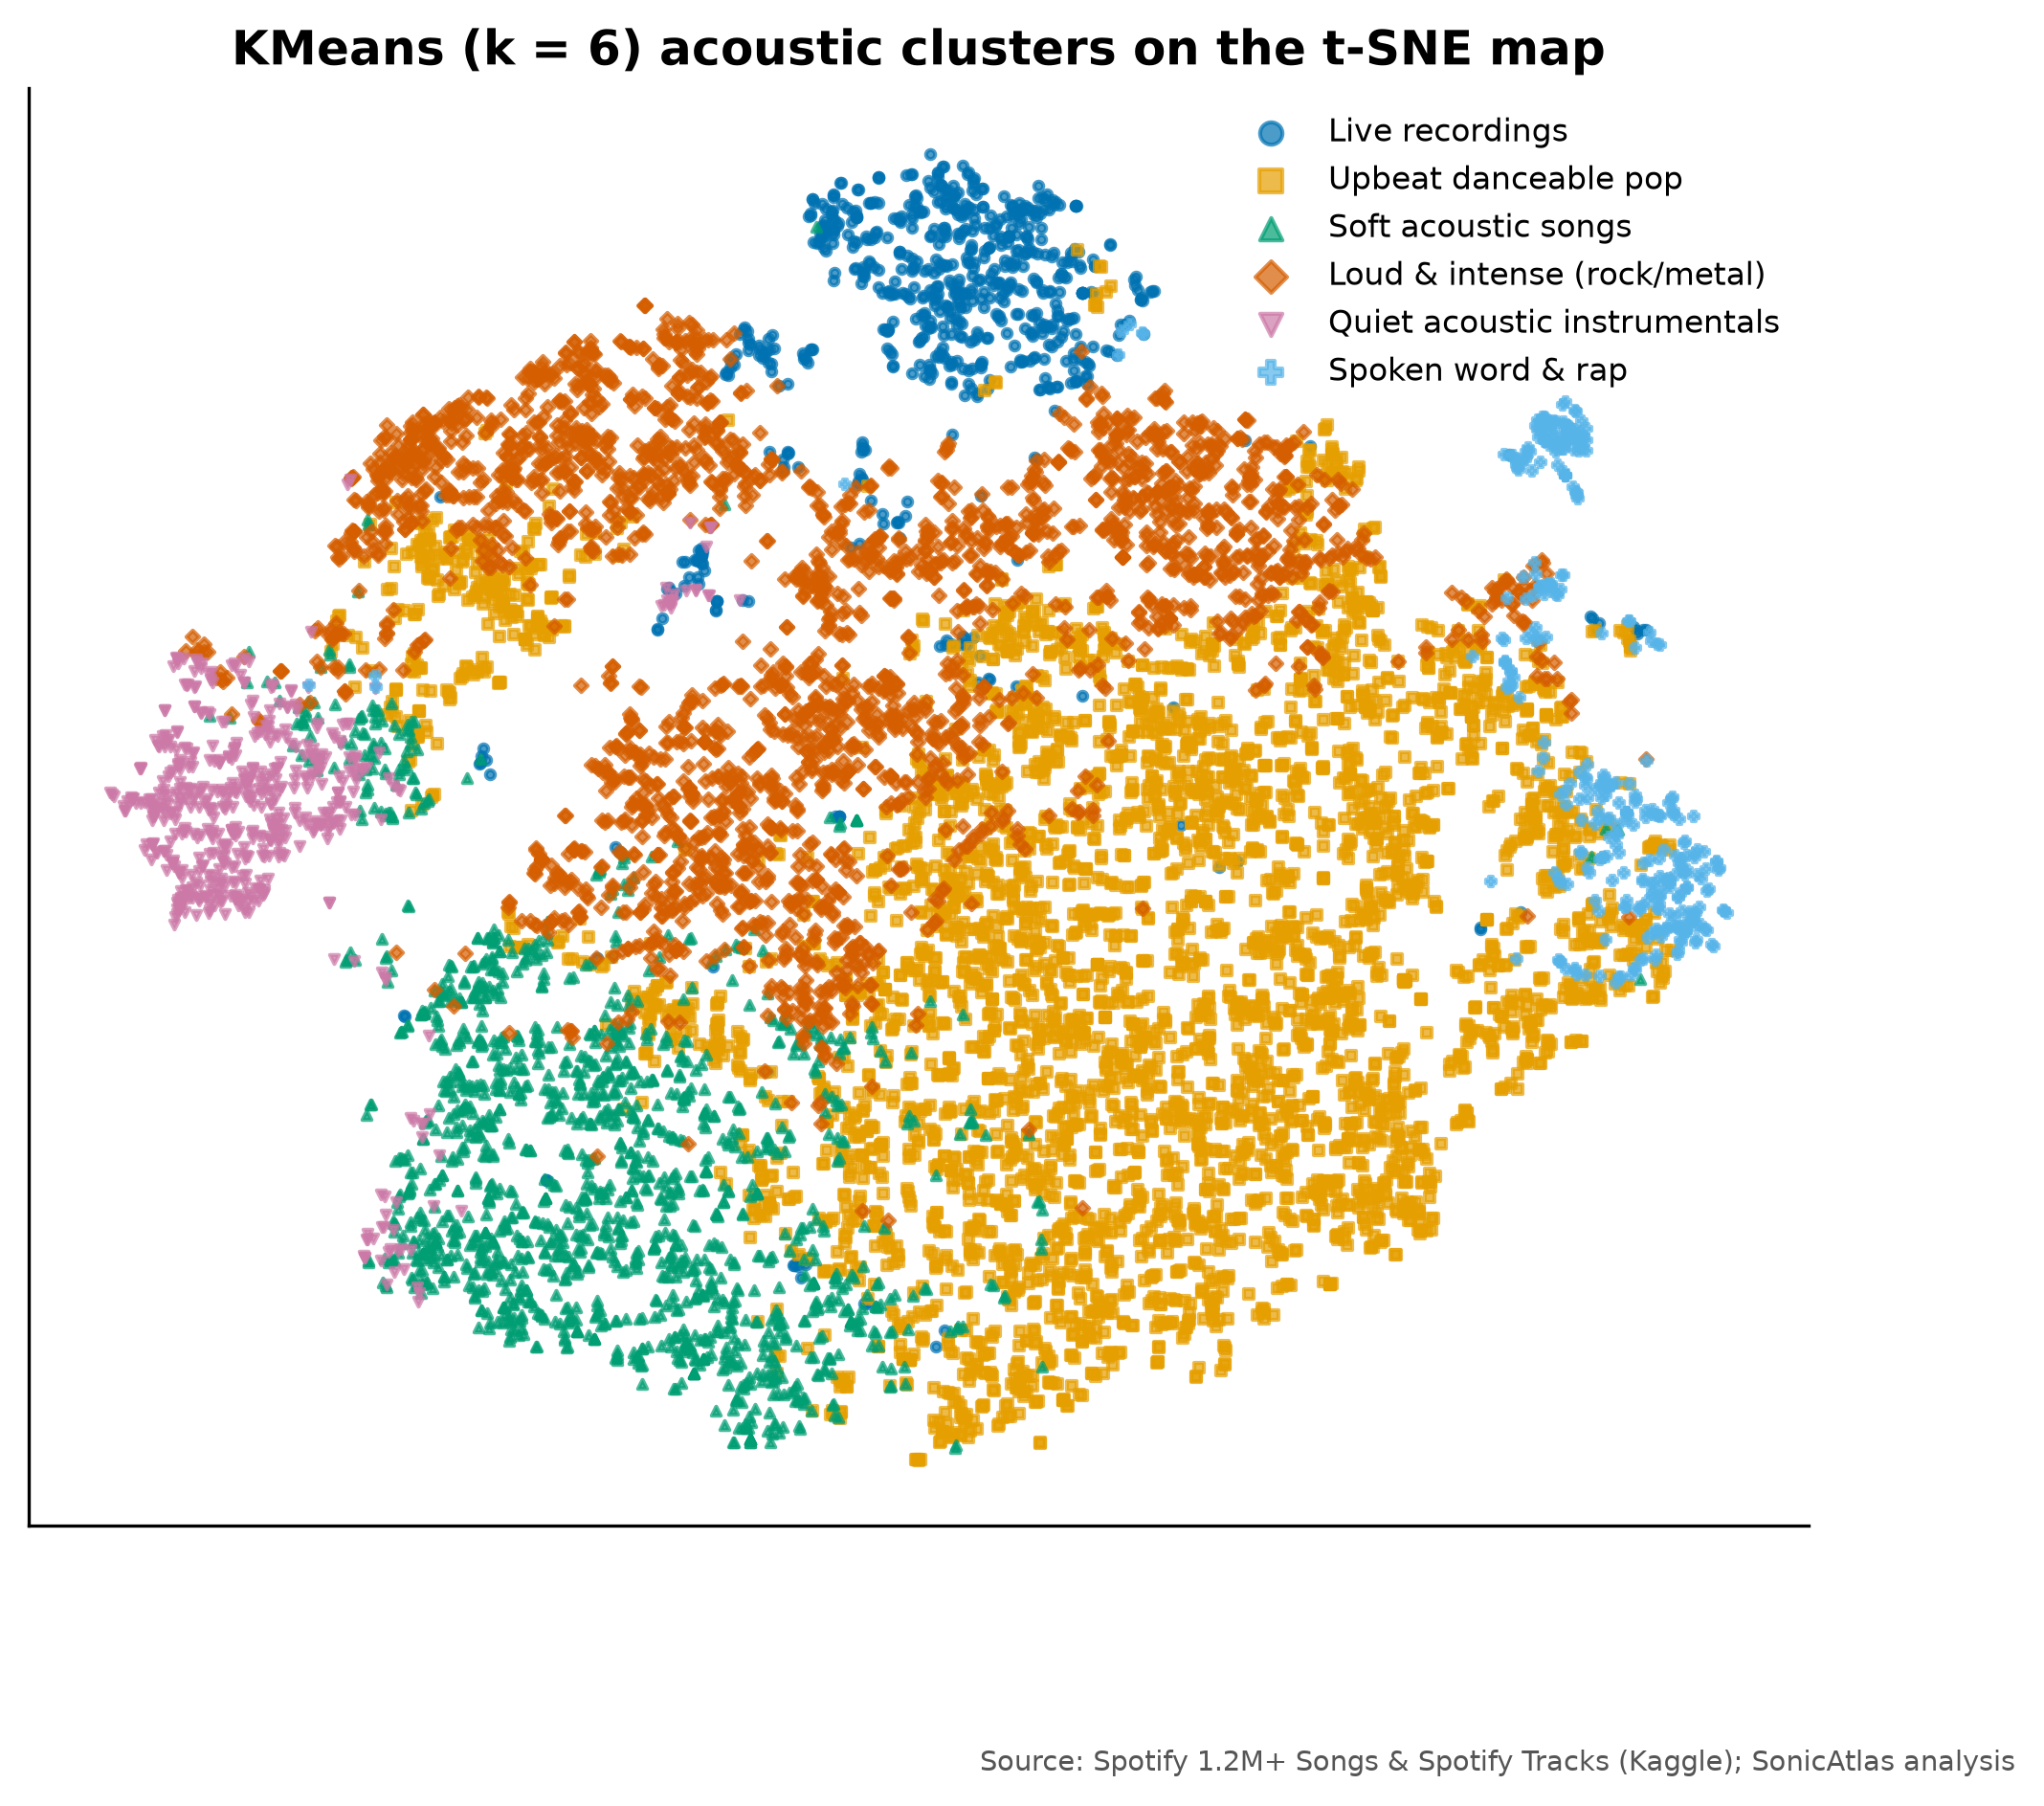
Fig. 16. Named KMeans clusters on the t-SNE map

4.2.9 Time-Series Dynamics and Decade Trends
Years with at least 500 canonical releases (1959-2020, 1,109,736 tracks) form the analysis window (Fig. 17); the catalogue is heavily weighted towards recent years, so early decades rest on smaller samples.
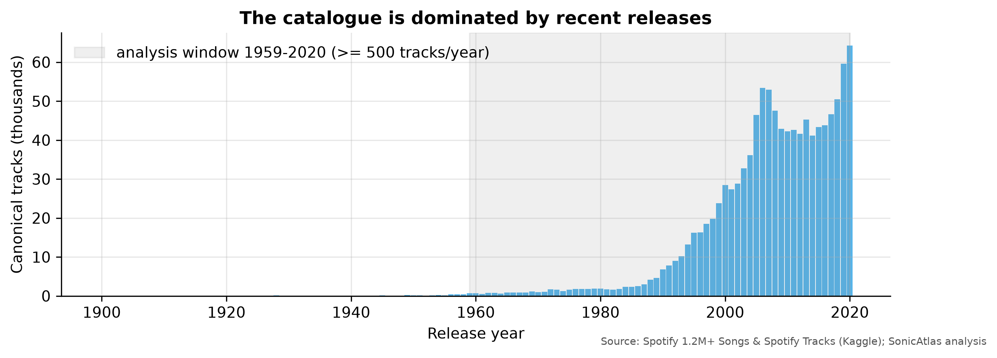
Fig. 17. Number of canonical tracks per release year
Yearly means with 5-year rolling averages (Fig. 18) show clear long-run movements. From 1959 to 2020 mean loudness rose from -17.4 dB to -9.7 dB, energy from 0.25 to 0.59 and danceability from 0.38 to 0.56, while acousticness fell from 0.86 to 0.31 and average duration shrank from 4.55 to 3.69 minutes. Valence moved much less (0.36 to 0.41).
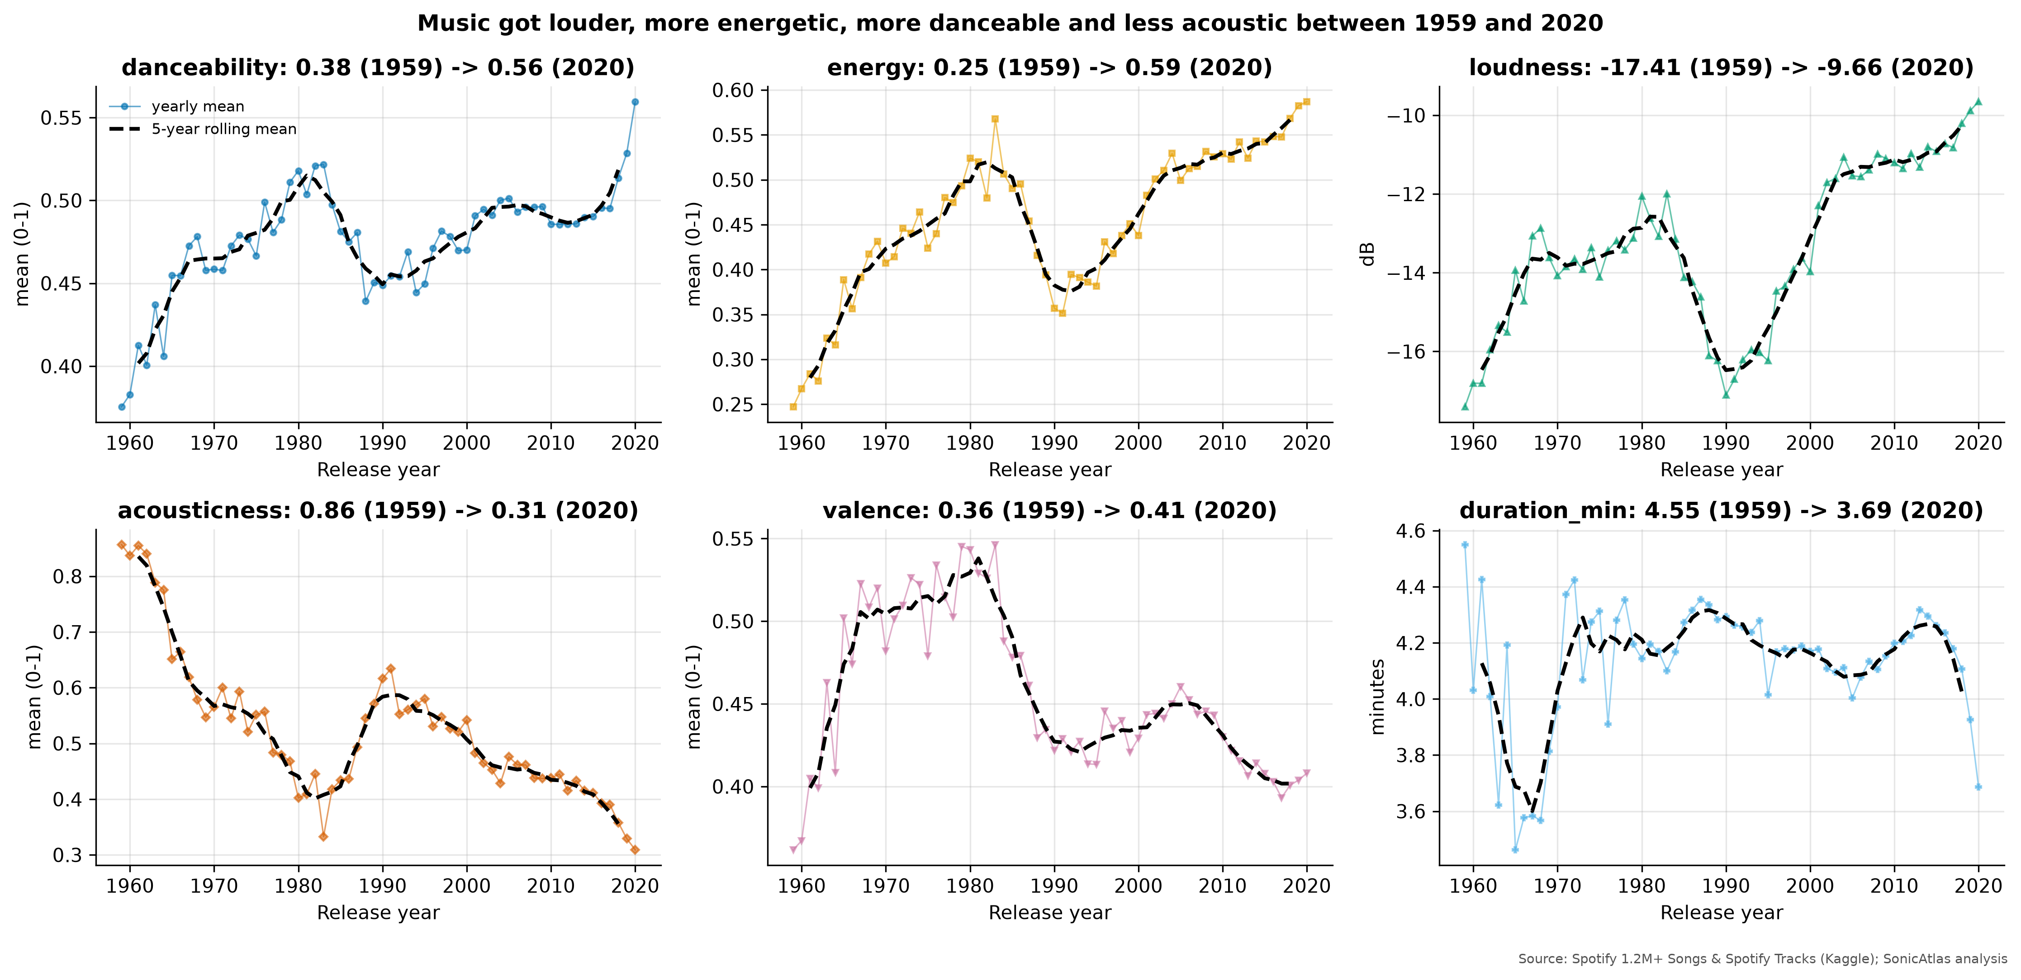
Fig. 18. Yearly means and 5-year rolling means of six audio features
Change points were located with the PELT algorithm and an RBF cost from the ruptures library [32] (Fig. 19). For loudness the breaks fall at 1964, 1989, 1999; the 1989 and 1999 breaks match the period that audio engineers call the “loudness war”, when mastering for CDs pushed average levels up. Energy and acousticness both break in 2004. The break at 1964 appears in every feature and mainly separates the thin late-1950s sample from the rest, so it should be read with care.
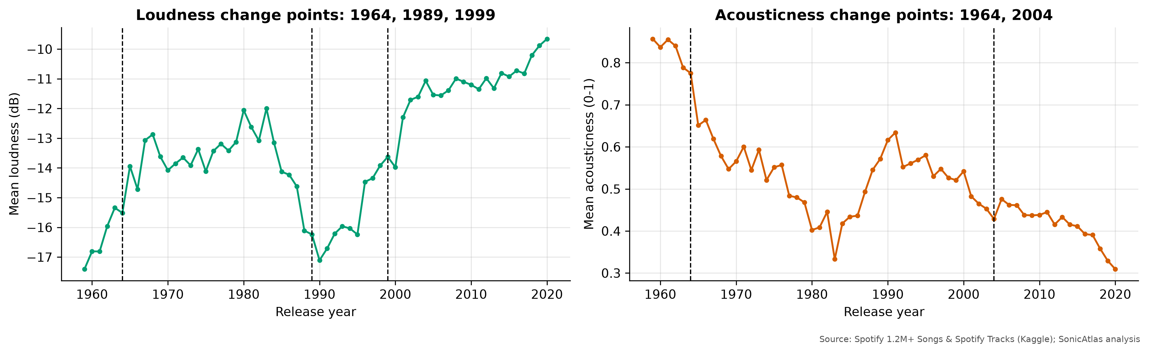
Fig. 19. Change points in yearly loudness and acousticness
Seasonality was examined with STL decomposition [33] of monthly means (1990-2020) using only day-precision dates. Releases dated 1 January were excluded because 11.8% of day-precision dates fall on that day, a typical placeholder. The seasonal component of valence (Fig. 20) has strength 0.40 on a 0-1 scale, peaking in month 7 and lowest in month 12; energy behaves similarly (strength 0.34). These are modest effects: summer releases sound slightly brighter, but the trend dominates.
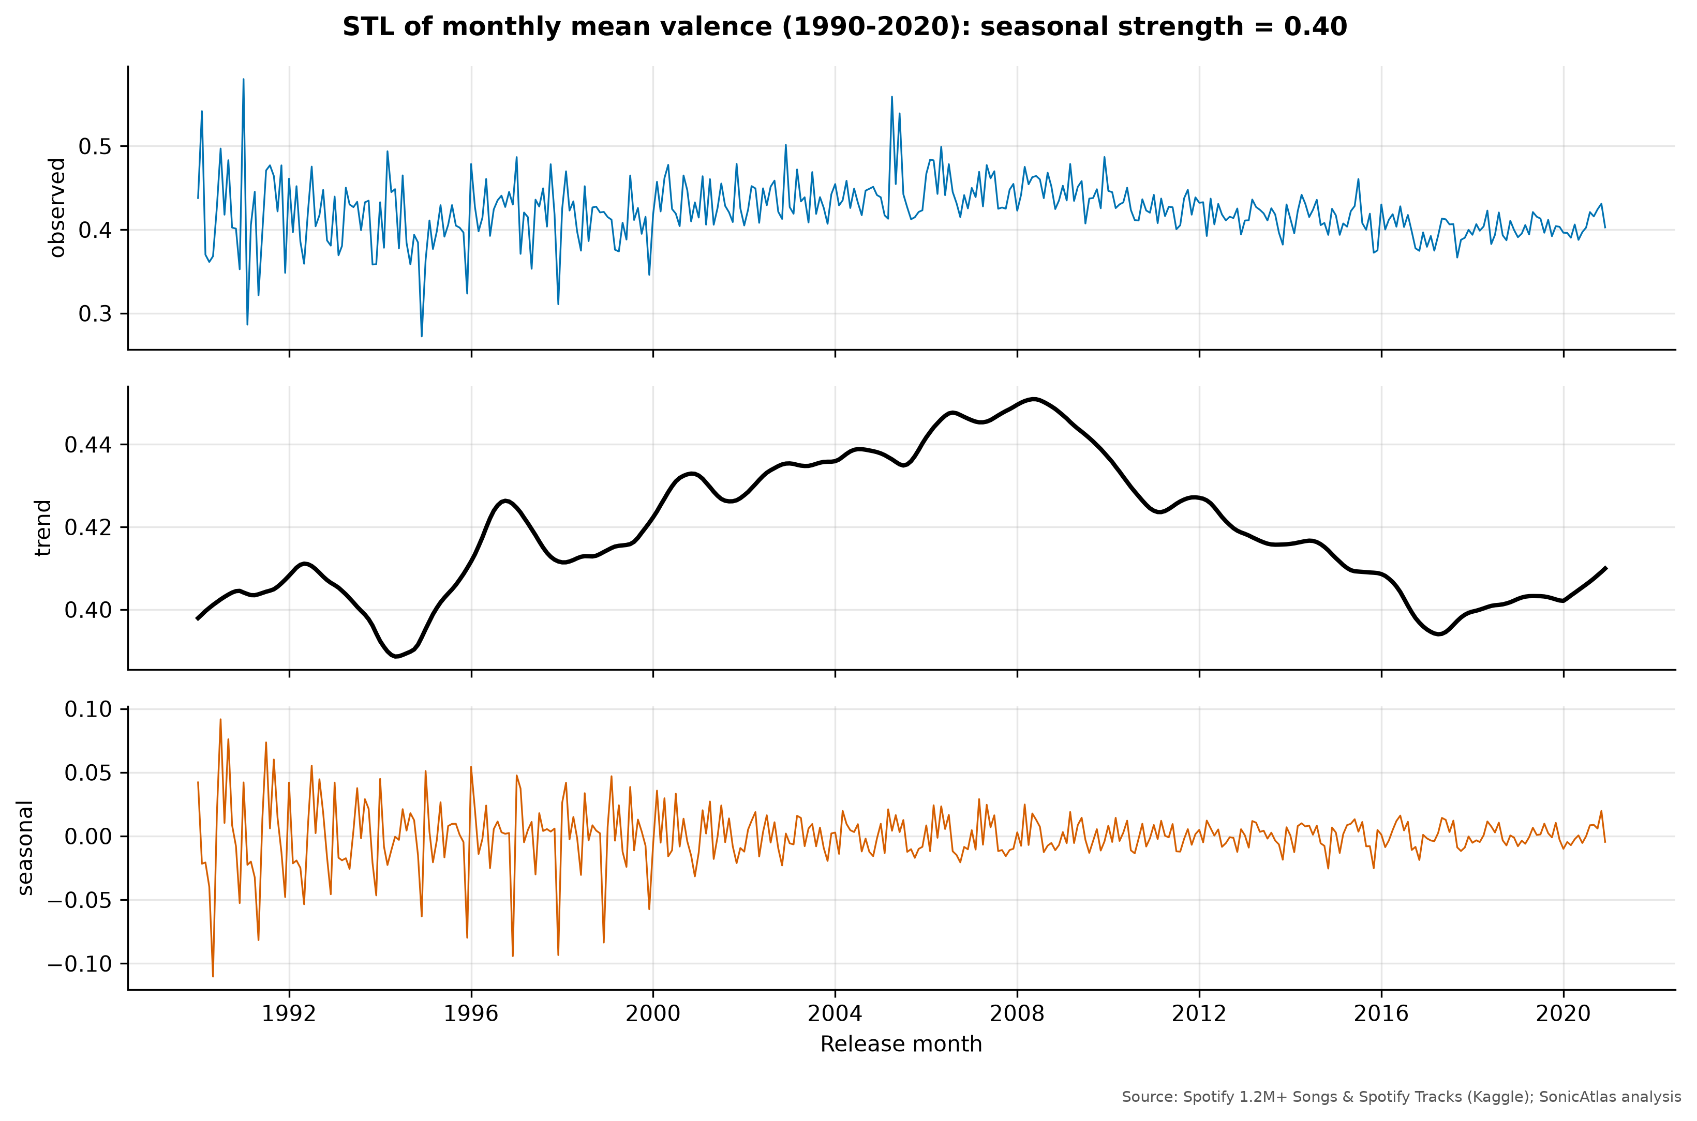
Fig. 20. STL decomposition of monthly mean valence (1990-2020)
A simple ARIMA(1,1,1) model was trained on yearly loudness up to 2010 and tested on the next 10 years (Fig. 21). Its mean absolute error is 0.58 dB, almost the same as a naive forecast that repeats the last training value (0.59 dB). Loudness levelled off after about 2010, so a trend model gains little: an honest reminder that past trends do not guarantee future ones.
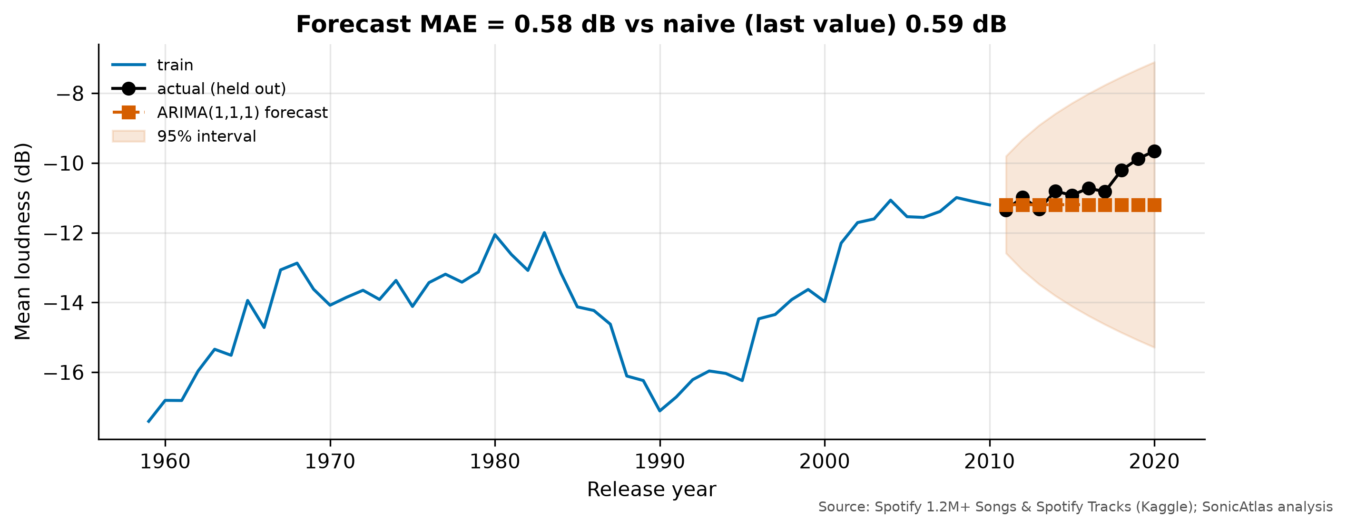
Fig. 21. ARIMA forecast of yearly loudness against held-out years
Fig. 22 condenses the decade story. The 1950s were acoustic and calm (acousticness 0.83, energy 0.30). The 1960s and 1970s brought the electric era: by the 1970s energy had reached 0.45 and acousticness had dropped to 0.53. The 1980s held steady, and the 1990s decade mean actually dips (energy 0.41, acousticness 0.55), which reflects the mix of releases catalogued for that decade rather than a change in mainstream production. From the 2000s the rise resumes: the 2010s average energy 0.55 and loudness -10.8 dB, and the 2020 releases are the most danceable (0.56) and least acoustic (0.31) in the data.
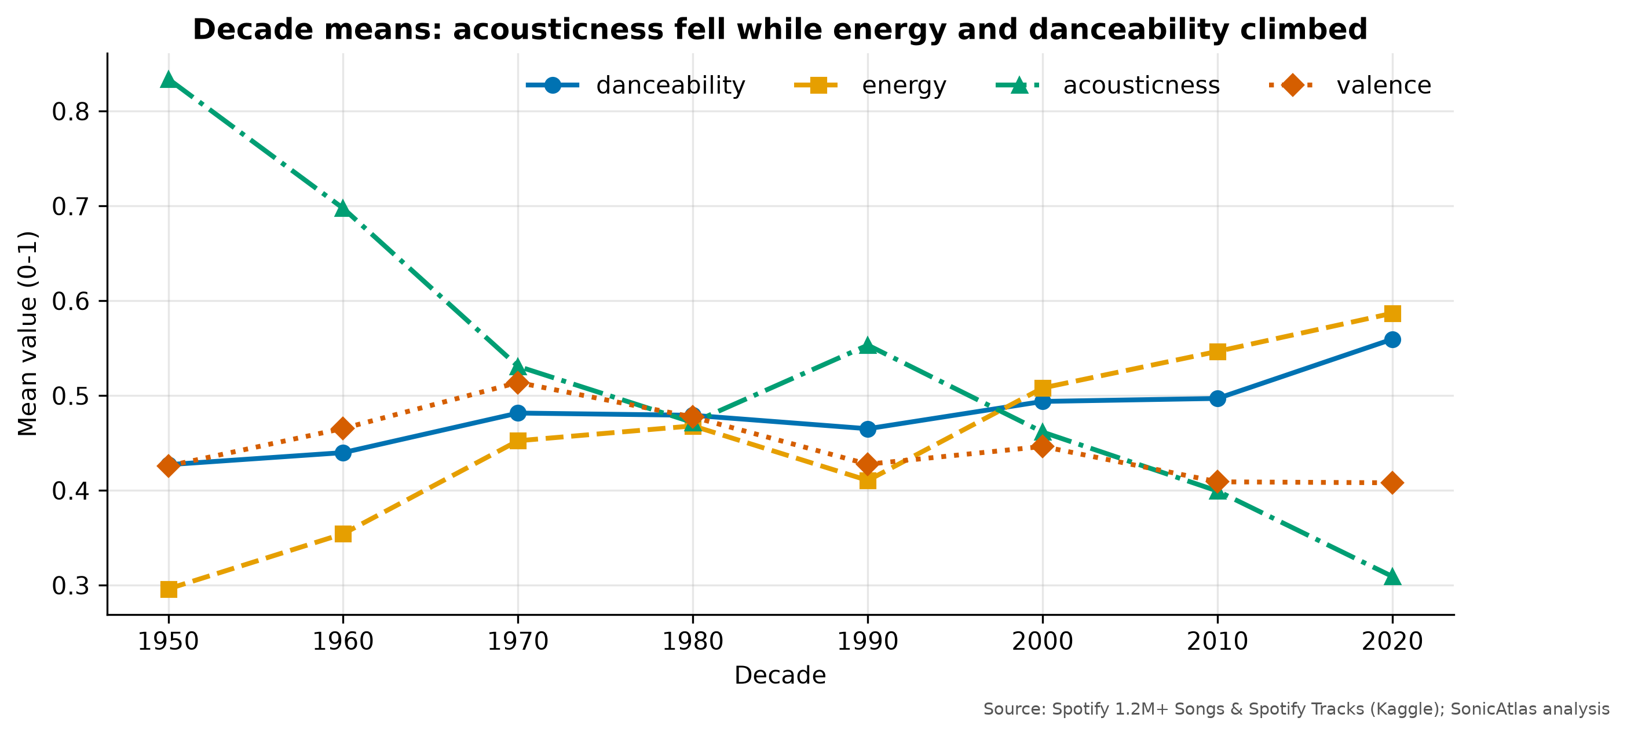
Fig. 22. Decade means of danceability, energy, acousticness and valence

4.3 The SonicAtlas Interactive Query Platform: Architecture, Text Mining, Hypothesis Testing and Evaluation Framework
This block describes the platform that delivers the analysis to users, the text and statistical tests that complete the exploration, and the framework used to evaluate the whole system.

4.3.1 System Architecture
SonicAtlas separates heavy computation from interaction (Fig. 23). All cleaning, embeddings, clustering and statistics run offline in Python and are exported as compact Parquet files and a single results.json. The website is a static bundle: when it opens, DuckDB-WASM [28] starts in a Web Worker, fetches the Parquet file over HTTP and answers SQL queries locally, so no data leaves the user’s machine and the site can be hosted for free on GitHub Pages.
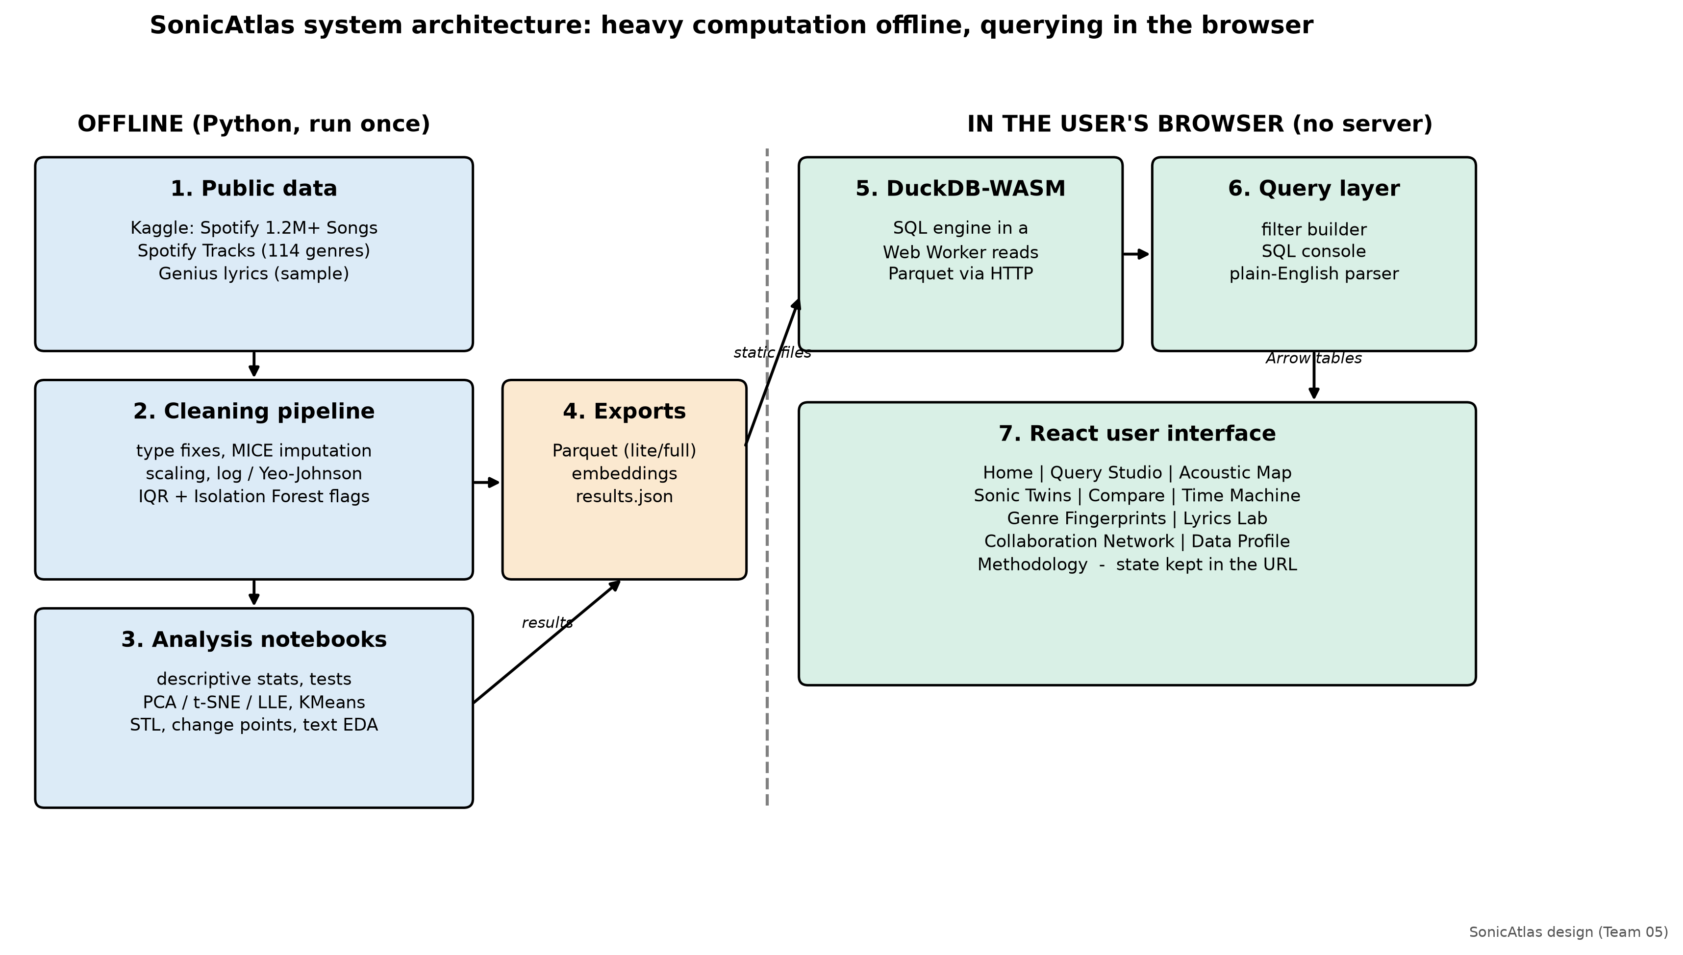
Fig. 23. System architecture of SonicAtlas

4.3.2 Platform Modules
TABLE XVI lists the modules of the platform and their purpose. Charts follow the grammar-of-graphics approach of Vega-Lite [24], and the Collaboration Network module is computed with NetworkX [40] and Louvain community detection [41].
Module | Purpose | Status
Home | headline statistics, mini acoustic map, three key findings | done
Query Studio | visual filter builder, SQL console with examples and history, plain-English query box that shows its SQL, export to CSV/JSON | done
Acoustic Map | PCA / t-SNE / LLE / UMAP switch, colour by genre, cluster or feature, hover details, click for similar tracks | done
Sonic Twins | nearest tracks by cosine similarity on scaled features with a radar comparison | done
Compare | two or three groups side by side with G1/G2/IQR table, Welch t / Mann-Whitney / ANOVA and effect size | done
Time Machine | yearly trends, STL components and change points per feature | done
Genre Fingerprints | parallel coordinates, radar profiles and Andrews curves | done
Lyrics Lab | n-grams, sentiment versus valence, vocabulary diversity | done
Collaboration Network | artist graph with communities | done
Data Profile | embedded automated profiling reports and quick profile of any query | done
Methodology | sources, cleaning steps, statistical conventions, limitations | done
TABLE XVI: Modules of the SonicAtlas platform
The website is complete: all eleven modules are implemented in React and TypeScript on DuckDB-WASM, with 65 unit tests and 8 end-to-end tests passing, a measured SQL console query time of 4.7 ms on the 150,000-track lite dataset, and Lighthouse scores of 98-99 for performance and 100 for accessibility, best practices and SEO on the four pages audited (Home, Query Studio, Compare, About). An early audit of the Compare page scored 75 for performance because of layout shift while data loaded; matching the loading skeleton to the final layout raised it to 99.

4.3.3 Hypothesis Testing
Three formal tests were carried out in the step-by-step style of the course tutorials, at significance level alpha = 0.05.
Test 1 - One-way ANOVA on danceability across eight genres. H0: all eight genre means are equal; H1: at least one differs. F = MS_between / MS_within = [SS_B / (k - 1)] / [SS_W / (N - k)]. With k = 8 and N = 4,863, SS_B = 61.27 and SS_W = 82.99, giving F(7, 4,855) = 512.1 and p < 0.001. Decision: reject H0. Effect size eta squared = 0.425, a large effect: genre explains about 42% of the variation in danceability. Tukey’s HSD post-hoc test found 26 of 28 genre pairs significantly different (TABLE XVII lists the group means).
Genre | n | Mean danceability
classical | 867 | 0.386
jazz | 524 | 0.489
country | 946 | 0.555
rock | 342 | 0.549
metal | 232 | 0.481
hip-hop | 842 | 0.730
edm | 694 | 0.656
pop | 416 | 0.581
TABLE XVII: Group sizes and means used in the ANOVA
Test 2 - Kruskal-Wallis check. Danceability is bounded and Levene’s test rejects equal variances (W = 21.33, p < 0.001), so the rank-based Kruskal-Wallis test was run as a robustness check: H = 2060.5, p < 0.001, epsilon squared = 0.423. The conclusion of the ANOVA is unchanged.
Test 3 - Chi-square test of independence between mode and genre. H0: mode (major/minor) is independent of genre. chi2 = sum (O - E)^2 / E with E = row total x column total / N. Result: chi2(7) = 539.4, p < 0.001, Cramer’s V = 0.333 (moderate). Country is the most major-key genre (89.3%) and hip-hop the least (48.3%) (TABLE XVIII). Mode versus decade on the full catalogue is also significant (chi2(6) = 3089, p < 0.001) but with a tiny effect (V = 0.054): the major share slipped from 75.6% in the 1960s to 64.9% in the 2010s. With over a million rows almost any difference is significant, so effect sizes are the better guide.
Genre | Major-key share
classical | 76.2%
jazz | 78.6%
country | 89.3%
rock | 68.1%
metal | 58.2%
hip-hop | 48.3%
edm | 52.7%
pop | 50.0%
TABLE XVIII: Share of major-key tracks per genre

4.3.4 Feature Selection: Filter versus Wrapper Methods
To find which audio features best separate the eight genres, four filter criteria (variance after Min-Max scaling, ANOVA F, mutual information, and pairwise correlation as a redundancy check) were compared with a wrapper method, recursive feature elimination (RFE) around multinomial logistic regression (TABLE XIX, Fig. 24). Acousticness ranks first or second in every method, and loudness ranks in the top two for ANOVA F, mutual information and RFE. Top three by ANOVA F: acousticness, loudness, energy; by mutual information: loudness, acousticness, energy; by RFE: acousticness, loudness, instrumentalness. Liveness is last in three methods, so it carries little genre information.
Feature | Variance rank | ANOVA F rank | Mutual info rank | RFE rank
danceability | 5 | 5 | 6 | 4
energy | 3 | 3 | 3 | 5
loudness | 7 | 2 | 1 | 2
speechiness | 9 | 6 | 7 | 8
acousticness | 1 | 1 | 2 | 1
instrumentalness | 2 | 4 | 8 | 3
liveness | 8 | 10 | 10 | 10
valence | 4 | 7 | 9 | 6
tempo | 6 | 8 | 5 | 9
duration_min | 10 | 9 | 4 | 7
TABLE XIX: Feature rankings from filter and wrapper methods (1 = most useful)
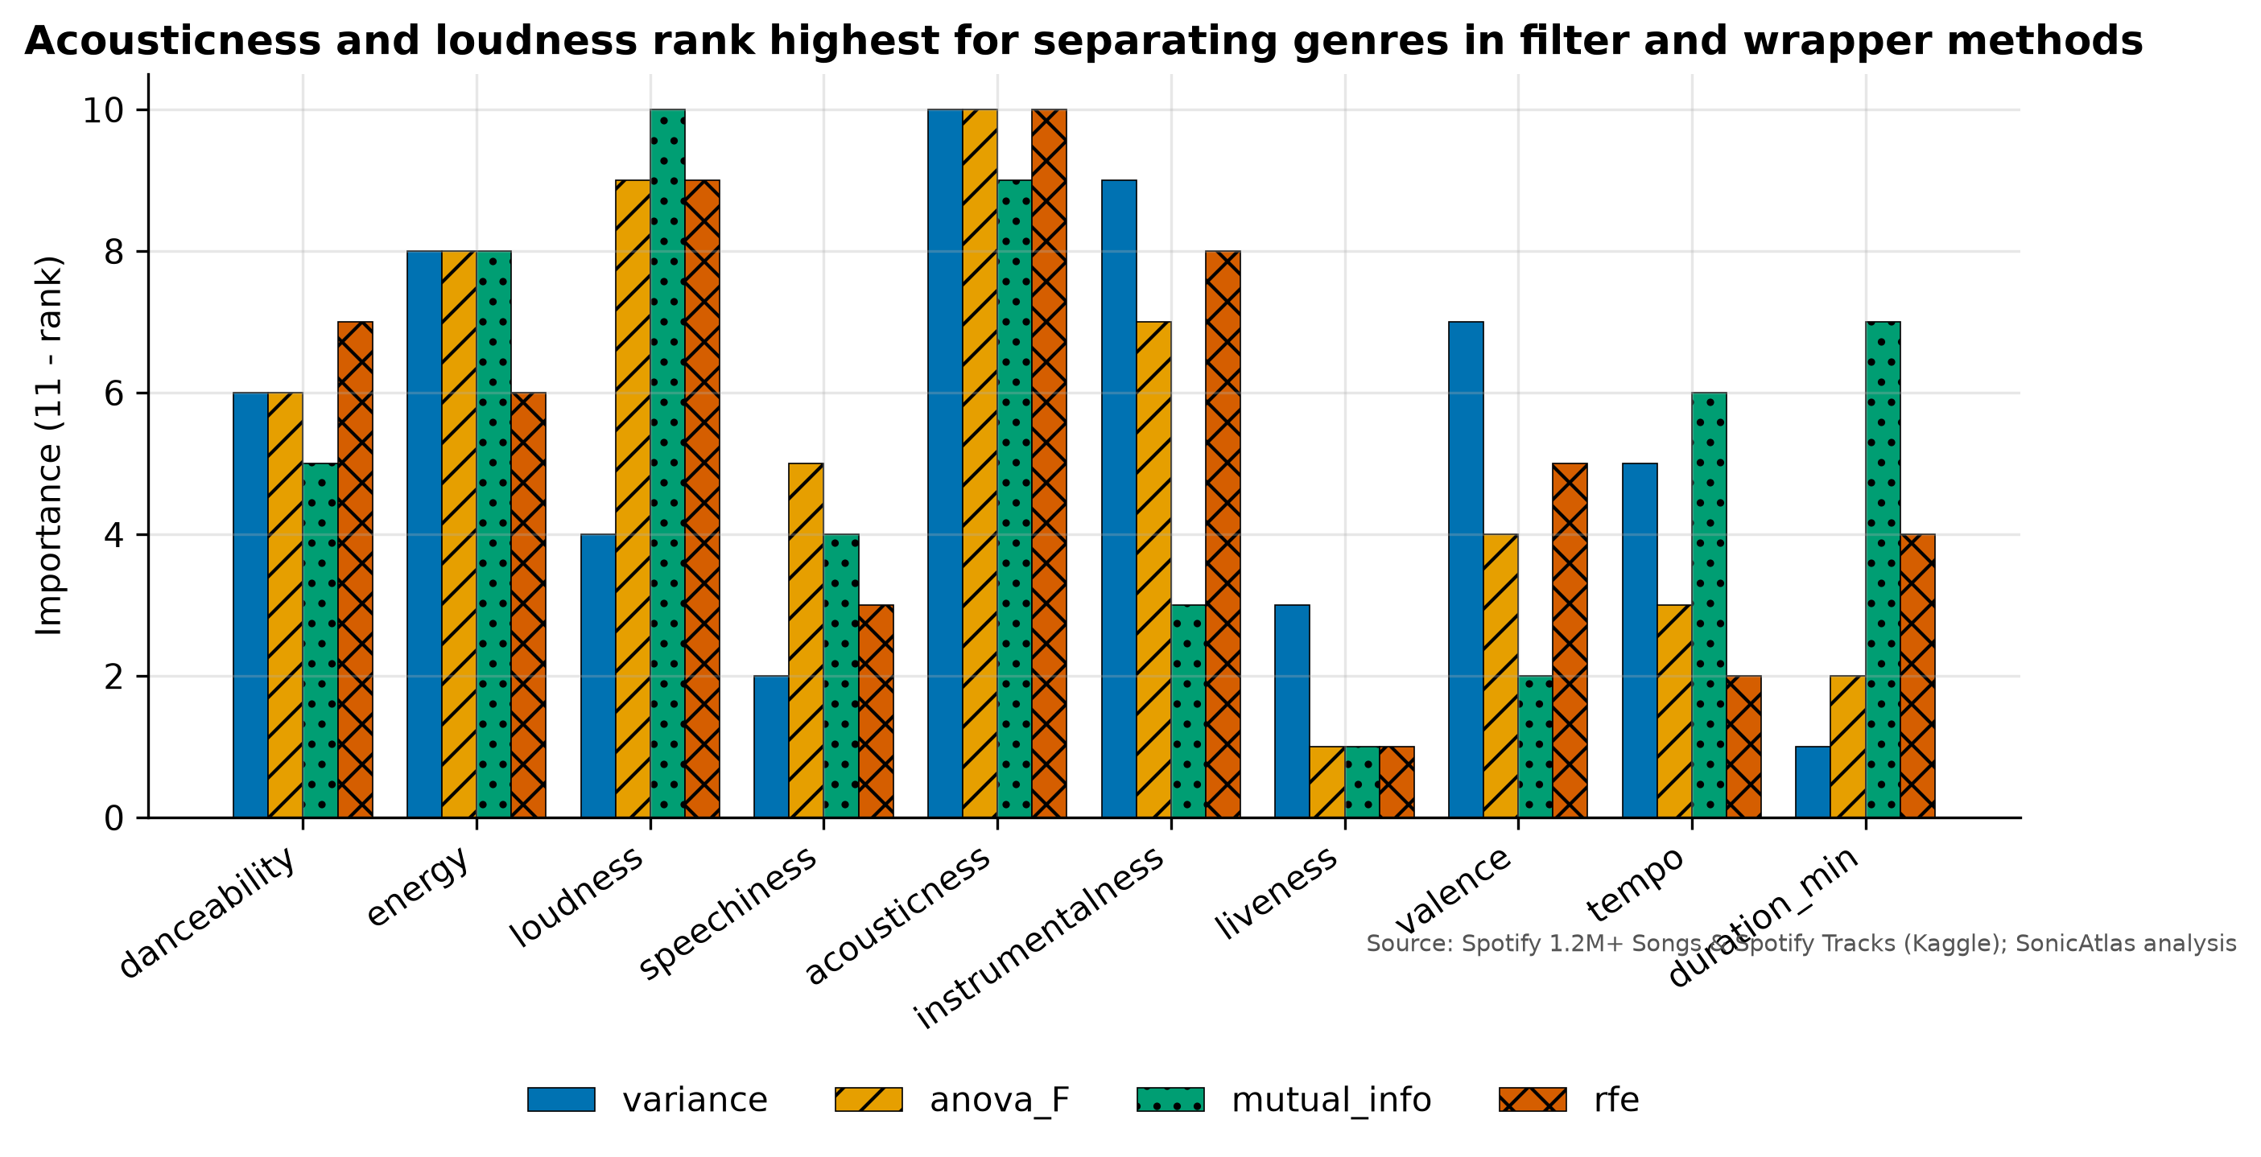
Fig. 24. Feature importance ranks from filter and wrapper methods

4.3.5 Lyrics Text Mining
The Genius dataset holds 5,134,856 texts, of which 3,374,198 are tagged as English and 3,233,212 remain after removing the non-song 'misc' tag. A 5% random sample was streamed from the 9 GB file in chunks; after dropping texts shorter than 20 words it contains 161,401 songs. Section headers such as [Chorus] were removed, the text was lower-cased and tokenised, and Genius page views (a true count, G1 = 59.0) were log-transformed (G1 = 0.66).
Songs have a median of 243 words and a median type-token ratio of 0.43; the median song repeats 24% of its lines, which is typical of choruses. Rap lyrics are by far the longest (median 412 words), rock lyrics have the highest vocabulary diversity (median TTR 0.46), and R&B lyrics the lowest (TTR 0.36). The most frequent content words are love, time, want, make, say; the top bigrams are love love, want want, hey hey.
Sentiment was scored on 20,000 songs with VADER and TextBlob. The two agree on the sign for 71.0% of songs and correlate at r = 0.48; VADER spreads scores towards -1 and +1 because long texts accumulate many polar words, whereas TextBlob averages them towards zero. Country is the most positive tag (mean VADER 0.48) and rap the most negative (-0.15).
Joining lyrics to the audio catalogue by normalised title and artist matched 5.9% of the lyric sample. On the 1,202 matched songs, lyric sentiment and audio valence are only weakly related (VADER r = 0.06, TextBlob r = 0.04): a cheerful-sounding track can carry sad words and vice versa, so the two modalities give complementary information.
Sentiment scores come from the VADER lexicon [11] and the TextBlob library [39]. Fig. 25 plots lyric sentiment against audio valence and compares the two sentiment tools; Fig. 26 breaks sentiment down by genre tag and decade and shows vocabulary diversity per tag.
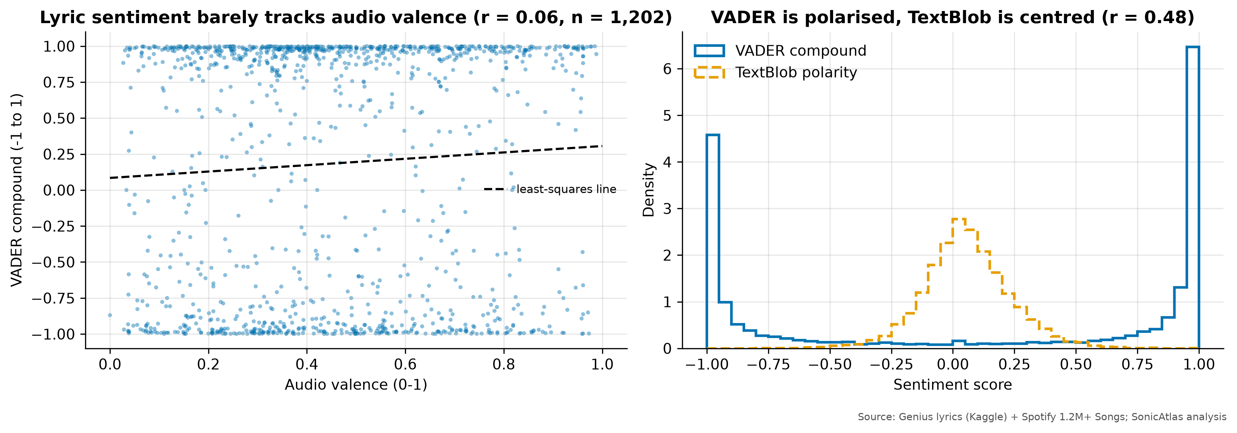
Fig. 25. Lyric sentiment versus audio valence, and VADER versus TextBlob score distributions
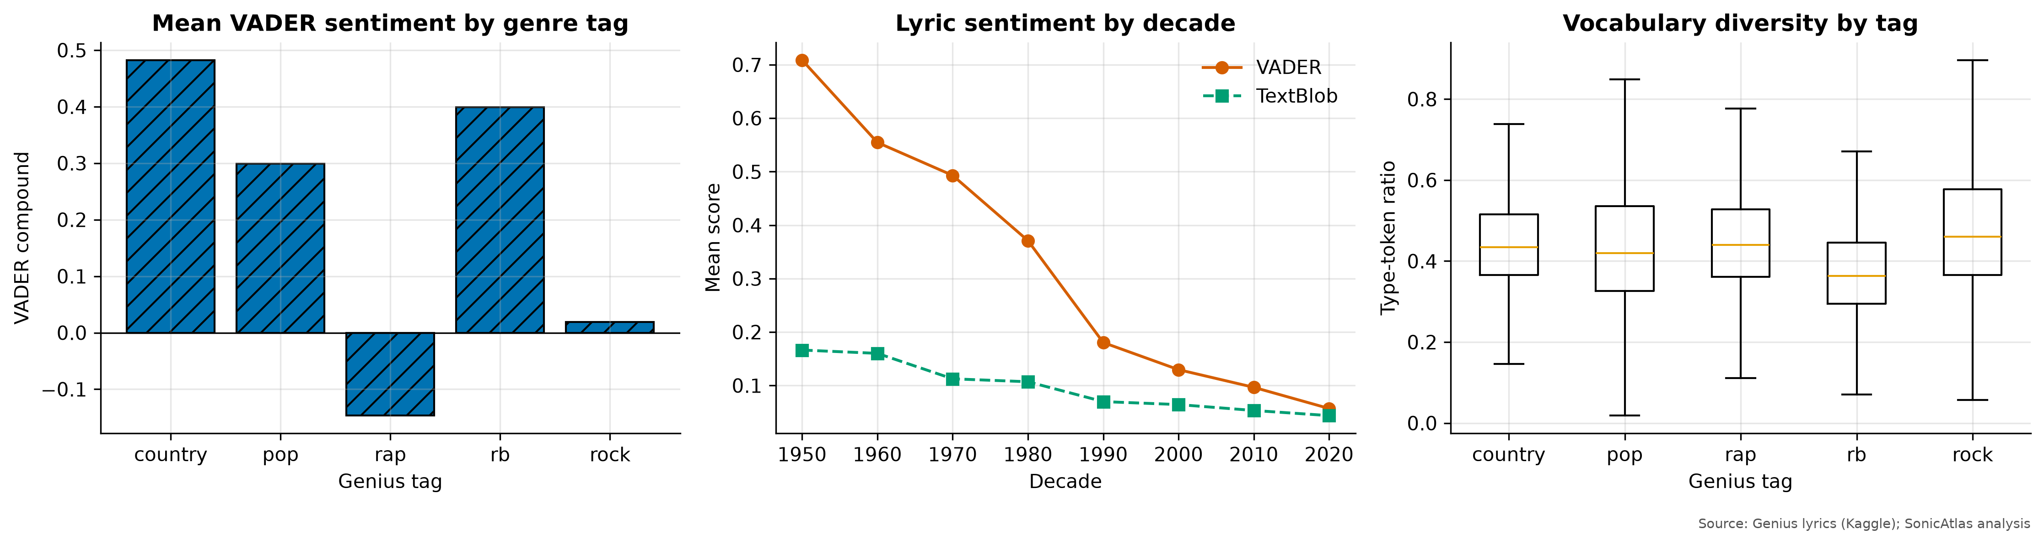
Fig. 26. Lyric sentiment by genre tag and decade, and vocabulary diversity by tag

4.3.6 Artist Collaboration Network
Artists who share a canonical track were linked to form a collaboration graph with 84,132 artists and 235,196 edges, built from 251,382 multi-artist tracks. The graph is very sparse (density 6.6e-05) but 76.3% of artists sit in one giant connected component. Louvain community detection [41] found 189 communities with a high modularity of 0.83, meaning collaborations stay mostly inside scenes. The highest-degree nodes are Johann Sebastian Bach (1066), Traditional (1066), Wolfgang Amadeus Mozart (802), Ludwig van Beethoven (696), Anonymous (664): classical recordings credit the composer together with many performers, and placeholder names such as “Traditional” and “Anonymous” act as hubs. Betweenness (approximated with 1000 sampled sources) is highest for Various Artists, Traditional, Wolfgang Amadeus Mozart, which bridge otherwise separate communities. Fig. 27 shows the largest connected group among the 300 most connected artists; the same subgraph is explorable on the website.
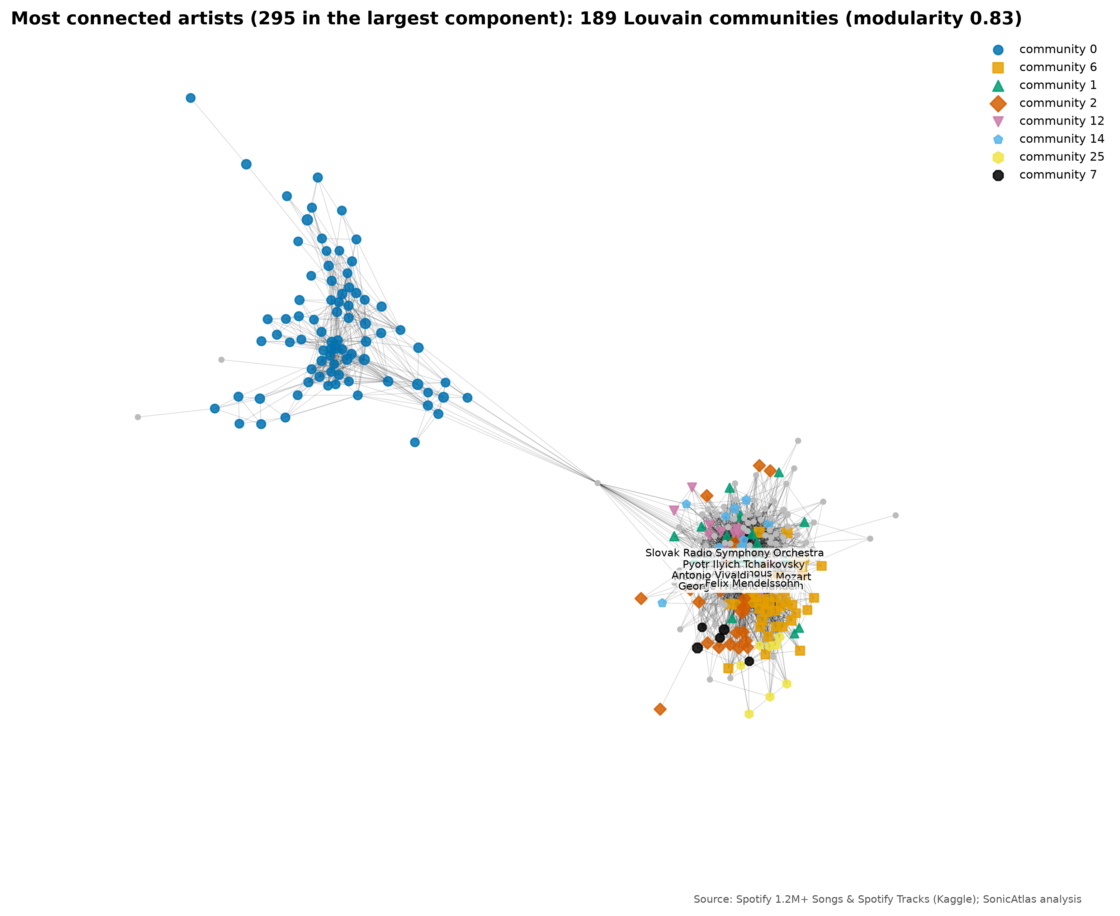
Fig. 27. Largest connected component of the 300 most connected artists, coloured by Louvain community

4.3.7 Automated EDA Tools
The three automated EDA tools from the course handout were run on the same random sample of 20,000 canonical tracks. YData-Profiling produced a full HTML report in 4.8 s with 10 automatic alerts, including skewness and high-correlation warnings that agree with Sections 4.2.2 and 4.2.4. Sweetviz compared the 2,582 tracks from the 1990s with the 8,067 from the 2010s in 6.3 s and visibly showed the shift towards higher energy and lower acousticness. D-Tale started an interactive grid server in 4.1 s and can export pandas code for each operation.
None of the tools knows that a tempo of 0 BPM or a time signature of 0 is impossible, none reports Tukey quartiles or the bias-corrected kurtosis used in the course, and none performs significance tests, dimensionality reduction or time-series decomposition. They are fast first-look tools; the music-specific questions still needed the manual workflow, which is why SonicAtlas embeds the generated reports in its Data Profile page instead of relying on them alone.
TABLE XX summarises the comparison.
Tool | Runtime (s) | Output | What it found | What it missed
YData-Profiling | 4.8 | static HTML report | distributions, missing values, correlations, alerts (skew, zeros, high correlation) | no domain meaning (e.g. tempo = 0 is impossible), no Tukey quartiles or G2, no time trends, no genre comparison
Sweetviz | 6.3 | static HTML, two-group comparison | side-by-side 1990s vs 2010s distributions and associations | no statistical test of the difference, no effect sizes, only two groups at a time
D-Tale | 4.1 | live server grid in the browser | sortable grid, describe, charts and pandas code export | needs a running Python server, not shareable as a static page, no music-specific views
Manual EDA (SonicAtlas) | minutes per notebook | notebooks + static website | everything above plus MICE, outlier cases, PCA/t-SNE/LLE, STL, change points, tests, lyrics | takes more effort to build; requires domain knowledge
TABLE XX: Automated EDA tools compared with the manual EDA

4.3.8 Evaluation Framework
Each part of the system is evaluated with an explicit, reproducible criterion (TABLE XXI).
Component | Criterion | Result
Data quality | MICE RMSE vs mean imputation on 5% masked values | MICE better for all 3 columns (energy 57.5%)
Statistics code | unit tests against SciPy and the tutorial data | 7/7
Embeddings | trustworthiness (k = 10), silhouette, runtime | t-SNE 0.976 best
Clustering | silhouette and elbow over k = 2-10 | k = 6 chosen, named clusters
Forecasting | hold-out MAE vs naive baseline | 0.58 vs 0.59 dB
Tests | p-value plus effect size | eta squared 0.425, V 0.333
Website | query latency on lite data, Lighthouse, end-to-end tests | 65/65 unit and 8/8 end-to-end tests pass; SQL console query 4.7 ms; Lighthouse performance 98-99 and accessibility, best practices and SEO all 100 (four pages)
TABLE XXI: Evaluation framework and results

4.3.9 Summary and Method Selection Guide
TABLE XXII summarises which method answered which question and when a reader should choose it.
Question | Method | When to use it
Describe one feature | Mean/median, Tukey IQR, G1, G2 | Always first; use median and IQR for skewed fields such as speechiness
Repair impossible values | MICE (IterativeImputer) | When other columns predict the gap; validate by masking
Find unusual tracks | Tukey fences + Isolation Forest | Fences per feature; Isolation Forest for multivariate oddities
Relate two features | Pearson / Spearman | Spearman when relationships are monotonic but not linear
Compare genres visually | Parallel coordinates, radar, Andrews | Use a balanced sample to avoid clutter
Global structure | PCA / SVD | Fast, interpretable loadings, works on all rows
Local neighbourhoods | t-SNE / UMAP | Best trustworthiness; distances between far clusters are not meaningful
Manifold unfolding | LLE | Only for smooth manifolds; weakest here
Group tracks | KMeans / HDBSCAN | KMeans for nameable groups; HDBSCAN shows density and noise
Trends over time | Rolling means, STL, PELT, ARIMA | Use canonical releases; check against a naive forecast
Test differences | ANOVA + Tukey, Kruskal-Wallis, chi-square | Report effect sizes; large n makes tiny effects significant
Rank features | ANOVA F, MI, RFE | Agreement across methods signals robust features
TABLE XXII: Method selection guide

5. CONCLUSION
This project set out to understand how the sound of recorded music differs across genres and how it has changed across eras, and to make that understanding explorable by anyone. A reproducible pipeline cleaned 1,204,025 Spotify tracks, repaired 2,777 impossible tempos with validated MICE imputation, marked 90,457 re-issues so they do not distort trends, and flagged 24,547 multivariate outliers instead of deleting them.
The exploration produced clear, quantified findings. Energy is almost a restatement of loudness (r = 0.82) and the opposite of acousticness (r = -0.80). Over 1959-2020 music became about 7.8 dB louder, more energetic (0.25 to 0.59) and far less acoustic (0.86 to 0.31), with loudness change points in 1989, 1999. Genre explains 42% of the variation in danceability, and acousticness and loudness are the most useful features for telling genres apart.
The dimensionality-reduction comparison showed that t-SNE keeps local neighbourhoods best (trustworthiness 0.98) while PCA gives the most interpretable global axes, and that genres overlap in every projection. 6 named acoustic clusters (Live recordings, Upbeat danceable pop, Soft acoustic songs, Loud & intense (rock/metal), Quiet acoustic instrumentals, Spoken word & rap) give users a vocabulary for navigating the map. SonicAtlas packages these results in a serverless website where SQL runs inside the browser.
The work has limitations. Spotify’s descriptors are outputs of proprietary models, not direct measurements; the catalogue over-represents recent releases; the genre and audio tables matched for only 10.7% of genre-labelled tracks, so genre-by-decade questions rest on 9,644 tracks; the lyrics analysis is limited to English songs; and the 2020s contain a single year.
Future work includes adding newer open audio descriptors (for example from AcousticBrainz-style feature extractors) to replace the closed Spotify features, multilingual lyrics analysis, learned audio embeddings, and user studies that measure how quickly students and researchers answer questions with SonicAtlas compared with notebooks.

6. PROJECT OUTCOME
(a) Research paper. A six-page paper in the official IEEE conference format, titled “SonicAtlas: An Interactive In-Browser Exploratory Data Analysis Platform for Multi-Dimensional Audio Features and Lyrics of Spotify Tracks Across Genres and Eras”, has been written from the results of this project. Status: prepared for submission. [Paper Link]
(b) Target conferences. Three suitable venues:
- IEEE CONECCT 2027 (13th IEEE International Conference on Electronics, Computing and Communication Technologies): An IEEE Bangalore Section conference on computing and communication technologies, suitable for an applied data-analytics paper and still open for submissions. Dates: 29-31 July 2027, Bangalore, India; paper submission deadline 15 December 2026. Website: https://www.ieee-conecct.org.ieeebangalore.org/
- ISMIR (International Society for Music Information Retrieval Conference): The leading venue for music information retrieval research and the closest thematic fit for SonicAtlas, including its late-breaking demo track. Dates: ISMIR 2026 runs 8-12 November 2026 in Abu Dhabi; its deadlines have passed, so the target is the 2027 edition once its call is published. Website: https://ismir2026.ismir.net/
- IEEE VIS (IEEE Visualization and Visual Analytics Conference): The premier conference on visualization and visual analytics, whose short-paper track suits an interactive in-browser EDA system. Dates: VIS 2026 runs 9-13 November 2026 in Boston; its deadlines have passed, so the target is the VIS 2027 short-paper track once announced. Website: https://ieeevis.org/year/2026/welcome/
(c) Software and data.
- GitHub repository: [GitHub Link]
- Live website: [Live Website Link]
- Demo video: [Demo Video Link]
- Key features: in-browser SQL (DuckDB-WASM), filters and plain-English queries, switchable embedding maps, group comparison with live tests, time-series explorer, shareable URLs.

7. REFERENCES
[1] T. Bertin-Mahieux, D. P. W. Ellis, B. Whitman, P. Lamere, “The Million Song Dataset,” Proc. 12th International Society for Music Information Retrieval Conference (ISMIR 2011), Miami, FL, USA, pp. 591-596, 2011. Available: https://ismir2011.ismir.net/papers/OS6-1.pdf
[2] R. Panda, R. Malheiro, R. P. Paiva, “Novel Audio Features for Music Emotion Recognition,” IEEE Transactions on Affective Computing, vol. 11, no. 4, pp. 614-626, 2020, doi: 10.1109/TAFFC.2018.2820691. Available: https://doi.org/10.1109/TAFFC.2018.2820691
[3] G. Tzanetakis, P. Cook, “Musical genre classification of audio signals,” IEEE Transactions on Speech and Audio Processing, vol. 10, no. 5, pp. 293-302, Jul. 2002, doi: 10.1109/TSA.2002.800560. Available: https://doi.org/10.1109/TSA.2002.800560
[4] K. Choi, G. Fazekas, M. Sandler, K. Cho, “Convolutional recurrent neural networks for music classification,” Proc. 2017 IEEE International Conference on Acoustics, Speech and Signal Processing (ICASSP), New Orleans, LA, USA, pp. 2392-2396, 2017, doi: 10.1109/ICASSP.2017.7952585. Available: https://doi.org/10.1109/ICASSP.2017.7952585
[5] B. L. Sturm, “The GTZAN dataset: Its contents, its faults, their effects on evaluation, and its future use,” arXiv preprint arXiv:1306.1461, 2013. Available: https://arxiv.org/abs/1306.1461
[6] M. Interiano, K. Kazemi, L. Wang, J. Yang, Z. Yu, N. L. Komarova, “Musical trends and predictability of success in contemporary songs in and out of the top charts,” Royal Society Open Science, vol. 5, no. 5, Art. no. 171274, 2018, doi: 10.1098/rsos.171274. Available: https://doi.org/10.1098/rsos.171274
[7] N. Askin, M. Mauskapf, “What Makes Popular Culture Popular? Product Features and Optimal Differentiation in Music,” American Sociological Review, vol. 82, no. 5, pp. 910-944, Oct. 2017, doi: 10.1177/0003122417728662. Available: https://doi.org/10.1177/0003122417728662
[8] D. Herremans, D. Martens, K. Sörensen, “Dance Hit Song Prediction,” Journal of New Music Research, vol. 43, no. 3, pp. 291-302, 2014, doi: 10.1080/09298215.2014.881888. Available: https://doi.org/10.1080/09298215.2014.881888
[9] J. Serrà, Á. Corral, M. Boguñá, M. Haro, J. Ll. Arcos, “Measuring the Evolution of Contemporary Western Popular Music,” Scientific Reports, vol. 2, Art. no. 521, Jul. 2012, doi: 10.1038/srep00521. Available: https://doi.org/10.1038/srep00521
[10] M. Mauch, R. M. MacCallum, M. Levy, A. M. Leroi, “The evolution of popular music: USA 1960-2010,” Royal Society Open Science, vol. 2, no. 5, Art. no. 150081, 2015, doi: 10.1098/rsos.150081. Available: https://doi.org/10.1098/rsos.150081
[11] C. Hutto, E. Gilbert, “VADER: A Parsimonious Rule-Based Model for Sentiment Analysis of Social Media Text,” Proc. International AAAI Conference on Web and Social Media (ICWSM), vol. 8, no. 1, pp. 216-225, 2014, doi: 10.1609/icwsm.v8i1.14550. Available: https://doi.org/10.1609/icwsm.v8i1.14550
[12] C. O. Brand, A. Acerbi, A. Mesoudi, “Cultural evolution of emotional expression in 50 years of song lyrics,” Evolutionary Human Sciences, vol. 1, Art. no. e11, 2019, doi: 10.1017/ehs.2019.11. Available: https://doi.org/10.1017/ehs.2019.11
[13] M. Fell, C. Sporleder, “Lyrics-based Analysis and Classification of Music,” Proc. COLING 2014, the 25th International Conference on Computational Linguistics: Technical Papers, Dublin, Ireland, pp. 620-631, Aug. 2014. Available: https://aclanthology.org/C14-1059/
[14] A. van den Oord, S. Dieleman, B. Schrauwen, “Deep content-based music recommendation,” Advances in Neural Information Processing Systems 26 (NIPS 2013), 2013. Available: https://papers.nips.cc/paper_files/paper/2013/hash/b3ba8f1bee1238a2f37603d90b58898d-Abstract.html
[15] M. Schedl, H. Zamani, C.-W. Chen, Y. Deldjoo, M. Elahi, “Current challenges and visions in music recommender systems research,” International Journal of Multimedia Information Retrieval, vol. 7, no. 2, pp. 95-116, Jun. 2018, doi: 10.1007/s13735-018-0154-2. Available: https://doi.org/10.1007/s13735-018-0154-2
[16] L. van der Maaten, G. Hinton, “Visualizing Data using t-SNE,” Journal of Machine Learning Research, vol. 9, no. 86, pp. 2579-2605, 2008. Available: https://www.jmlr.org/papers/v9/vandermaaten08a.html
[17] S. T. Roweis, L. K. Saul, “Nonlinear Dimensionality Reduction by Locally Linear Embedding,” Science, vol. 290, no. 5500, pp. 2323-2326, Dec. 2000, doi: 10.1126/science.290.5500.2323. Available: https://doi.org/10.1126/science.290.5500.2323
[18] L. McInnes, J. Healy, J. Melville, “UMAP: Uniform Manifold Approximation and Projection for Dimension Reduction,” arXiv preprint arXiv:1802.03426, 2018. Available: https://arxiv.org/abs/1802.03426
[19] I. T. Jolliffe, J. Cadima, “Principal component analysis: a review and recent developments,” Philosophical Transactions of the Royal Society A: Mathematical, Physical and Engineering Sciences, vol. 374, no. 2065, Art. no. 20150202, Apr. 2016, doi: 10.1098/rsta.2015.0202. Available: https://doi.org/10.1098/rsta.2015.0202
[20] T. Milo, A. Somech, “Automating Exploratory Data Analysis via Machine Learning: An Overview,” Proc. 2020 ACM SIGMOD International Conference on Management of Data, Portland, OR, USA, pp. 2617-2622, 2020, doi: 10.1145/3318464.3383126. Available: https://doi.org/10.1145/3318464.3383126
[21] K. Wongsuphasawat, D. Moritz, A. Anand, J. Mackinlay, B. Howe, J. Heer, “Voyager: Exploratory Analysis via Faceted Browsing of Visualization Recommendations,” IEEE Transactions on Visualization and Computer Graphics, vol. 22, no. 1, pp. 649-658, Jan. 2016, doi: 10.1109/TVCG.2015.2467191. Available: https://doi.org/10.1109/TVCG.2015.2467191
[22] M. Raasveldt, H. Mühleisen, “DuckDB: an Embeddable Analytical Database,” Proc. 2019 International Conference on Management of Data (SIGMOD '19), Amsterdam, Netherlands, pp. 1981-1984, 2019, doi: 10.1145/3299869.3320212. Available: https://doi.org/10.1145/3299869.3320212
[23] J. Heer, D. Moritz, “Mosaic: An Architecture for Scalable & Interoperable Data Views,” IEEE Transactions on Visualization and Computer Graphics, vol. 30, no. 1, 2024 (early access 2023), doi: 10.1109/TVCG.2023.3327189. Available: https://doi.org/10.1109/TVCG.2023.3327189
[24] A. Satyanarayan, D. Moritz, K. Wongsuphasawat, J. Heer, “Vega-Lite: A Grammar of Interactive Graphics,” IEEE Transactions on Visualization and Computer Graphics, vol. 23, no. 1, pp. 341-350, Jan. 2017, doi: 10.1109/TVCG.2016.2599030. Available: https://doi.org/10.1109/TVCG.2016.2599030
[25] D. H. da Silva, L. R. da Silva Souza, C. T. Ribeiro, S. H. da Silva Brasileiro, J. R. M. Nardo, A. A. Pereira, A. de O. Andrade, “A Web Application for exploratory data analysis and classification of Parkinson's Disease patients using machine learning models on different datasets,” Software Impacts, vol. 23, Art. no. 100737, Mar. 2025, doi: 10.1016/j.simpa.2024.100737. Available: https://doi.org/10.1016/j.simpa.2024.100737
[26] F. Pedregosa, G. Varoquaux, A. Gramfort, V. Michel, B. Thirion, O. Grisel, M. Blondel, P. Prettenhofer, R. Weiss, V. Dubourg, J. Vanderplas, A. Passos, D. Cournapeau, M. Brucher, M. Perrot, É. Duchesnay, “Scikit-learn: Machine Learning in Python,” Journal of Machine Learning Research, vol. 12, no. 85, pp. 2825-2830, 2011. Available: https://jmlr.org/papers/v12/pedregosa11a.html
[27] W. McKinney, “Data Structures for Statistical Computing in Python,” Proc. Python in Science Conference (SciPy 2010), pp. 56-61, 2010, doi: 10.25080/Majora-92bf1922-00a. Available: https://doi.org/10.25080/Majora-92bf1922-00a
[28] A. Kohn, D. Moritz, M. Raasveldt, H. Mühleisen, T. Neumann, “DuckDB-Wasm: Fast Analytical Processing for the Web,” Proceedings of the VLDB Endowment, vol. 15, no. 12, pp. 3574-3577, Aug. 2022, doi: 10.14778/3554821.3554847. Available: https://doi.org/10.14778/3554821.3554847
[29] YData (ydataai), “ydata-profiling (formerly pandas-profiling),” Open-source Python package, GitHub / PyPI (v4.18.4 on PyPI at time of check). Available: https://github.com/ydataai/ydata-profiling
[30] F. Bertrand (fbdesignpro), “Sweetviz,” Open-source Python package, GitHub / PyPI (v2.3.3 on PyPI at time of check). Available: https://github.com/fbdesignpro/sweetviz
[31] Man Group (man-group), “D-Tale,” Open-source Python package, GitHub / PyPI (v3.22.0 on PyPI at time of check). Available: https://github.com/man-group/dtale
[32] C. Truong, L. Oudre, N. Vayatis, “Selective review of offline change point detection methods,” Signal Processing, vol. 167, Art. no. 107299, Feb. 2020, doi: 10.1016/j.sigpro.2019.107299. Available: https://doi.org/10.1016/j.sigpro.2019.107299
[33] R. B. Cleveland, W. S. Cleveland, J. E. McRae, I. Terpenning, “STL: A Seasonal-Trend Decomposition Procedure Based on Loess,” Journal of Official Statistics, vol. 6, no. 1, pp. 3-73, 1990. Available: https://www.statsmodels.org/dev/generated/statsmodels.tsa.seasonal.STL.html
[34] S. van Buuren, K. Groothuis-Oudshoorn, “mice: Multivariate Imputation by Chained Equations in R,” Journal of Statistical Software, vol. 45, no. 3, 2011, doi: 10.18637/jss.v045.i03. Available: https://doi.org/10.18637/jss.v045.i03
[35] F. T. Liu, K. M. Ting, Z.-H. Zhou, “Isolation Forest,” Proc. 2008 Eighth IEEE International Conference on Data Mining (ICDM), Pisa, Italy, pp. 413-422, 2008, doi: 10.1109/ICDM.2008.17. Available: https://doi.org/10.1109/ICDM.2008.17
[36] rodolfofigueroa (Kaggle user), “Spotify 1.2M+ Songs,” Kaggle dataset. Available: https://www.kaggle.com/datasets/rodolfofigueroa/spotify-12m-songs
[37] maharshipandya (Kaggle user), “Spotify Tracks Dataset,” Kaggle dataset. Available: https://www.kaggle.com/datasets/maharshipandya/-spotify-tracks-dataset
[38] carlosgdcj (Kaggle user), “Genius Song Lyrics,” Kaggle dataset. Available: https://www.kaggle.com/datasets/carlosgdcj/genius-song-lyrics-with-language-information
[39] S. Loria, “TextBlob: Simplified Text Processing (documentation),” Open-source Python library, docs at textblob.readthedocs.io (v0.20.1 on PyPI at time of check). Available: https://textblob.readthedocs.io/en/dev/
[40] A. A. Hagberg, D. A. Schult, P. J. Swart, “Exploring Network Structure, Dynamics, and Function using NetworkX,” Proc. 7th Python in Science Conference (SciPy 2008), Pasadena, CA, USA, pp. 11-15, 2008, doi: 10.25080/TCWV9851. Available: https://doi.org/10.25080/TCWV9851
[41] V. D. Blondel, J.-L. Guillaume, R. Lambiotte, E. Lefebvre, “Fast unfolding of communities in large networks,” Journal of Statistical Mechanics: Theory and Experiment, vol. 2008, no. 10, Art. no. P10008, Oct. 2008, doi: 10.1088/1742-5468/2008/10/P10008. Available: https://doi.org/10.1088/1742-5468/2008/10/P10008
[42] BACSE301 course faculty, “Automated EDA Tools in Python (YData-Profiling, Sweetviz, D-Tale),” Course handout, Exploratory Data Analysis, Vellore Institute of Technology, 2026.
[43] BACSE301 course faculty, “AI Tools for Every Step of Your Research Journey,” Course handout, Exploratory Data Analysis, Vellore Institute of Technology, 2026.

